- In the top right corner of the workspace, click the button and then the New button.
In the workspace, select , and then select <uicontrol>New</uicontrol>.
- Enter the field values of the Recommendation as desired..
Optional: In the Recommendation pane, enter the field values.
- In the left pane, which contains the list of components, you can perform the following tasks.
  - Create a new component.
  - Search for an existing one.
  - Link the component to an analysis.
In the pane containing a list of components, you can perform the following tasks:
  - Create a Component
  - Search for an Existing Component
  - Add a Component to an Analysis
- To view the asset strategy linked to an asset, select the hyperlink in the Asset Strategy column.
Select <uicontrol>Asset Strategy</uicontrol> to access the asset strategy linked to an asset.
- This topic describes how to add a Recommendation and link it to an analysis. You can’t, however, link a Recommendation to an inactive analysis.
This topic illustrates the process of adding a recommendation to an analysis. However, you cannot link a recommendation to an inactive analysis.
- In order to create a user name, enter a value in the User Name text box in the format – first name, last name.
In the <uicontrol>User Name</uicontrol> box enter the value in: first name, last name format.
- In the Date box, enter the date in the DD-MM-YYYY hh:mm:sss format. For example, 12-11-2016 12:00:00.Or, you can select the date using the Calendar feature.

In the Date list, select the date.
- On the Analysis Summary screen, on the left pane, select the Instrumented Function record that you want to edit.
In the <wintitle>Analysis Summary</wintitle> page, select the <uicontrol>Instrumented Function</uicontrol> field whose value you want to modify.
- Once you have entered a value for Template ID, to create another record, hit the Tab Key.
After you have entered a value for <uicontrol>Template ID</uicontrol>, you can select the <uicontrol>Tab</uicontrol> key to create another record.
- In the example below, assume that you have created a Deviation record.
The following example suppose that you have created a deviation record.
- Choose the type of calibration that you want to create in the drop-down in the top left corner of the Identification tab.
Tip: This is the page referenced by this sentence.
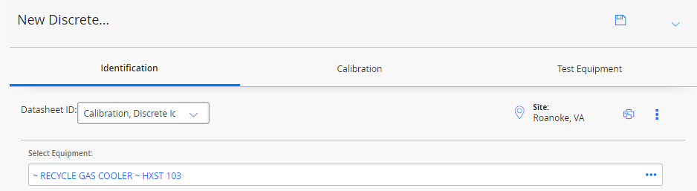
In the Identification tab, access the <uicontrol>Datasheet ID</uicontrol> drop-down list to select the type of Calibration that you want to create.
- Click Yes in the Calculate Error list in the Calculations tile.
In the Calculations tile, select the Calculate Error list, and then select <uicontrol>Yes<uicontrol>.
- As required, enter values in the boxes available on the datasheet. Once you enter values, select Save.
Optional: In the datasheet, enter values in the necessary boxes, and then select <uicontrol>Save</uicontrol>.

