College LaSalle
Project – Introduction To Programming (JAVA) – 420-JP5 Documentation
Presented to:….

Shaik Reshma
13/12/2018

The Trivia application I have coded will present a menu composed of a six different trivia category games, each trivia game have around10 questions and answers. Some conditions applied: like the user cannot choose more than one time a particular Trivia category.
Also, I have an option to manage the Trivia application (Special code:143) that is to give access to the administrator to add/remove/modify questions and/or answers.
Finally, have the option to quit the game and presenting the percentage of right/wrong answers of all trivia categories (statistics) choose by the user (the user can choose only one time a specific category).
These are the categories I have used in the Trivia game:
Enter the value of category between 1 and 6
1: Game of Thrones
2:Programming
3:History
4:Dance
5:Friends Tv
6:Geography
7:Exit this section with confirmation
The user can 7 to quit the game , user can press any number to quit and 1 to continue the game.
If the user quits the game , the application stops running and shows the number of correct answers and the percentage user has been scored.

Languages/tools/editors:
To make this trivia game I have used Java coding.
- Java 10
- Using Eclipse Java EE IDE for Web Developers.
3.Version: Photon Release (4.8.0)

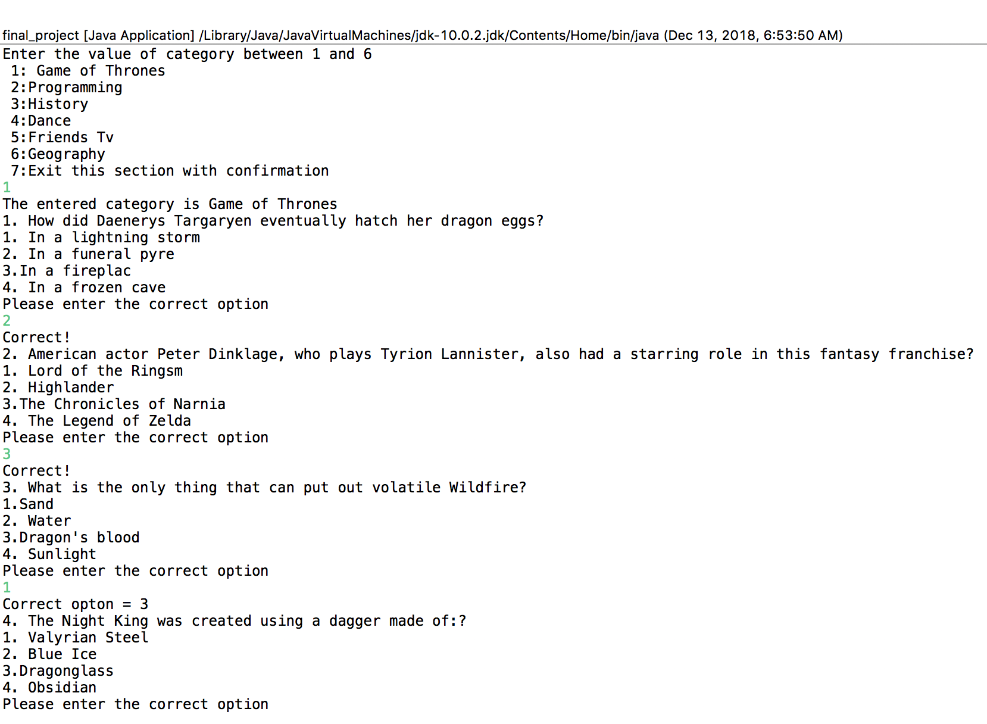
In this it shows the percentage of the category that has been played and if the user wants to quit , it shows ‘You wanted to quit’(The user can press any number to quit and 1 to continue the game)

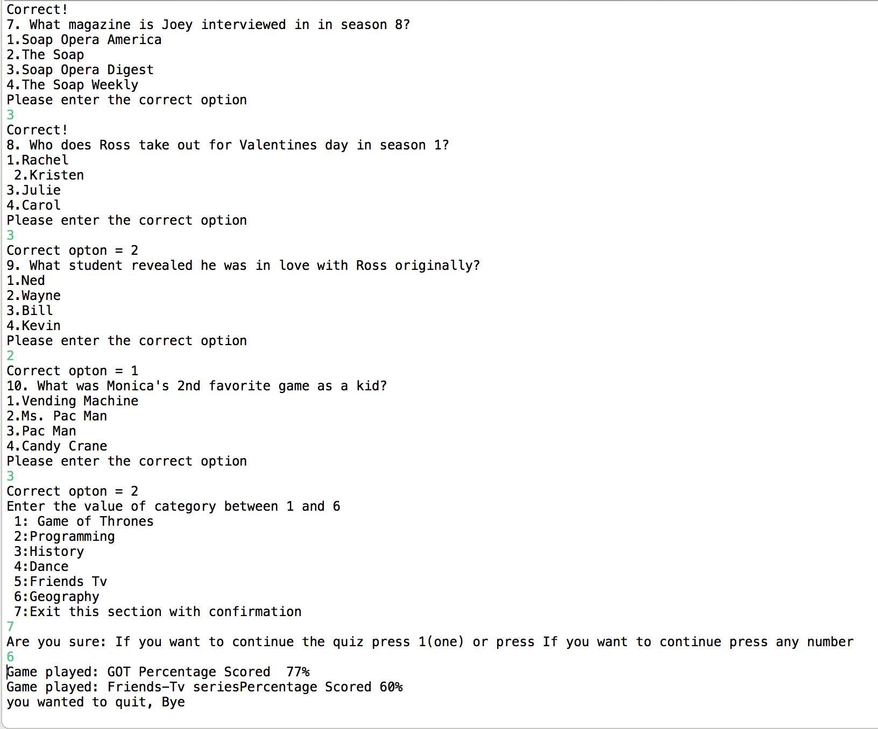

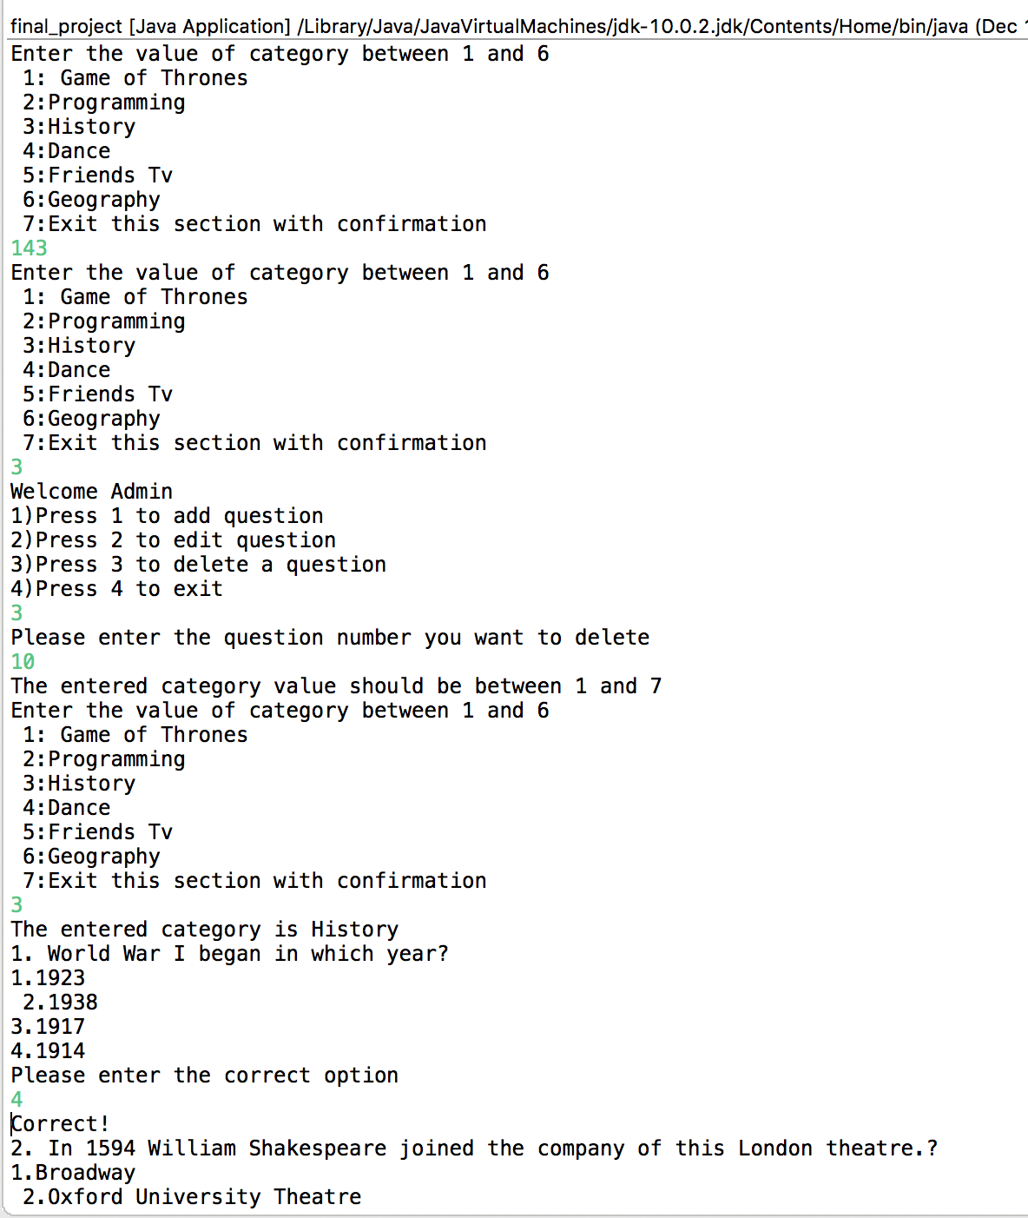

In this it shows the admin functionalities , It shows the delete, add, edit functions.
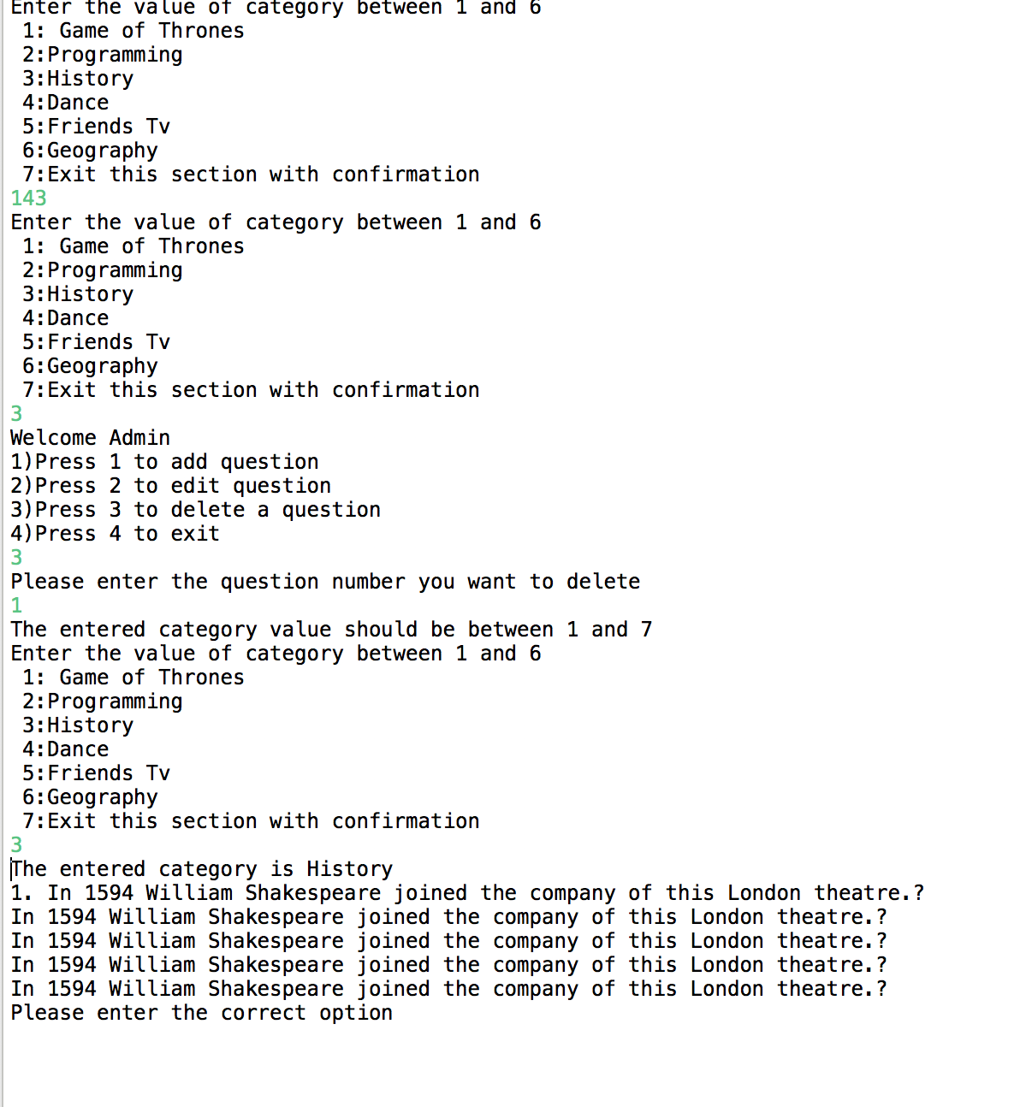

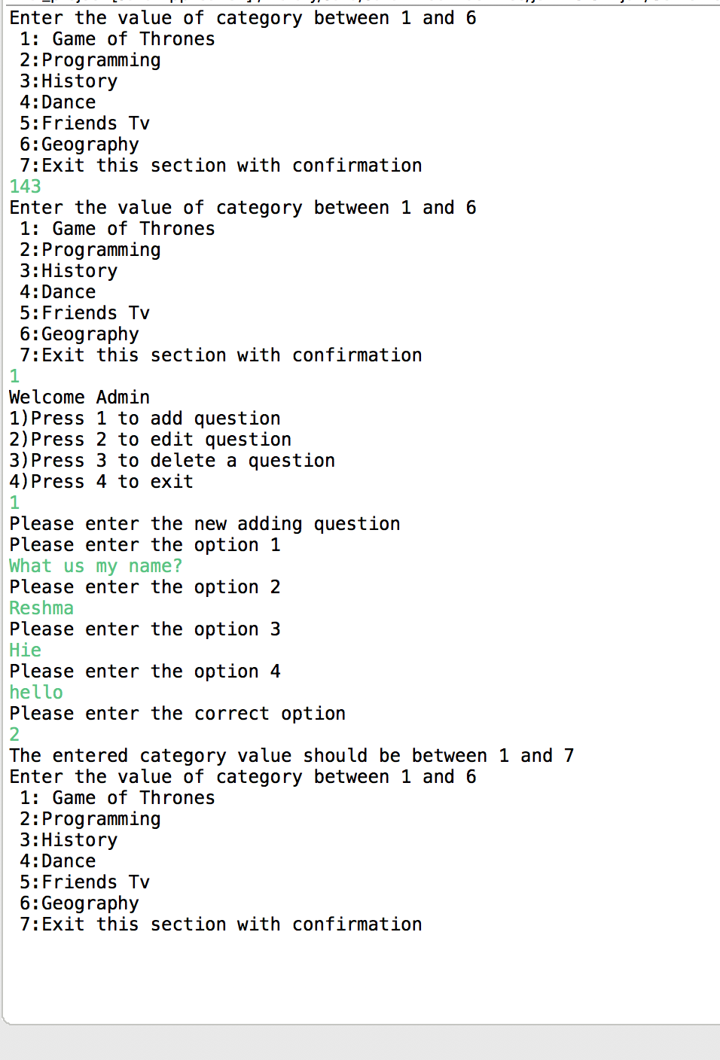

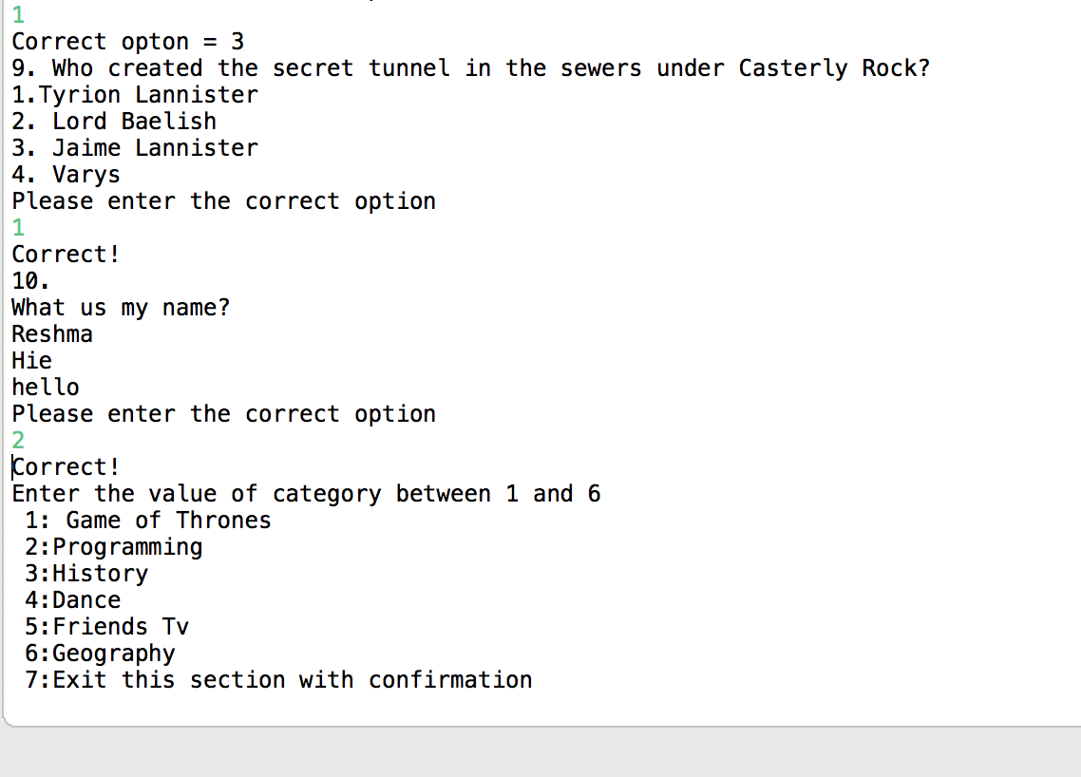

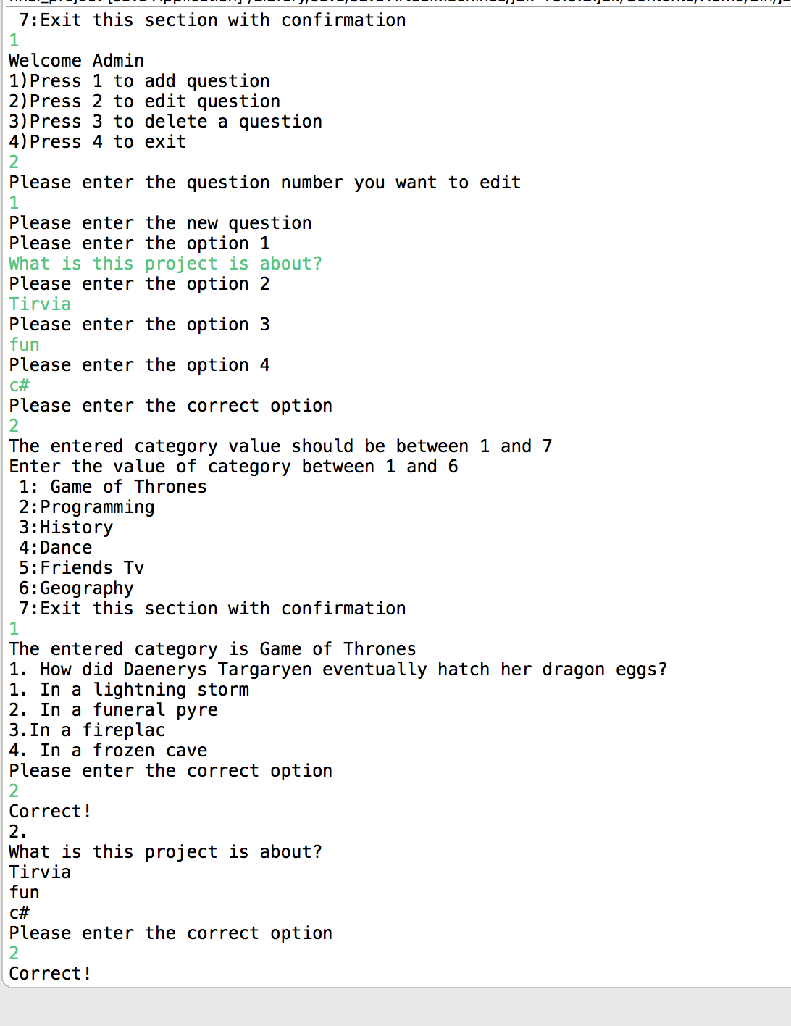

The methods (classes) that create or you did use in the project.
Method/Class Name | Description
Public static void printCategories() | It has the categories names
Public class Programming | Has the programming category questions and answers and correct options
Public class Game_of_thrones | Has the Game of thrones category questions and answers and correct options
Public class History | Has the History category questions and answers and correct options
Public class Dance | Has the programming Dance questions and answers and correct options
Public class Geography | Has the Geography category questions and answers and correct options
Public class Friends_tv | Has the Friends tv series category questions and answers and correct options
Public class Final_project | It is used for the categories and looping the questions and options and taking the input of the correct options  Taking the input of the category entered
Public class AdminFunctionality | It has the all the admin functionalities like adding , editing and deleting the questions and options
Public static void add(Scanner scan, int Category) | It takes the input from the user of the question and options and correct option to be added .  Scanner scan: Takes the input from the user, int Category: Takes the input category from the user
Public static void edit(Scanner scan, int Category) | It takes the input from the user of the question and options and correct option to be Edited .  Scanner scan: Takes the input from the user, int Category: Takes the input category from the user
Public static void delete(Scanner scan, int Category) | It takes the input from the user of the question to be deleted.  Scanner scan: Takes the input from the user, int Category: Takes the input category from the user
Public static String programmingArray[30][6] | Takes the array of questions and answers from the user
Public static String HistoryArray[30][6] | Takes the array of questions and answers from the user
Public static String DanceArray[30][6] | Takes the array of questions and answers from the user
Public static String GotArray[30][6] | Takes the array of questions and answers from the user
Public static String GeographyArray[30][6] | Takes the array of questions and answers from the user
Public static String FriendsArray[30][6] | Takes the array of questions and answers from the user
Public static int Gottracker | It counts the reference position of the array . Its initial value is 0
Public static int Dancetracker | It counts the reference position of the array . Its initial value is 0
Public static int Programmingtracker | It counts the reference position of the array . Its initial value is 0
Public static int Historytracker | It counts the reference position of the array . Its initial value is 0
Public static int Friendstracker | It counts the reference position of the array . Its initial value is 0
Public static int Geographytracker | It counts the reference position of the array . Its initial value is 0
Public static void GotQandA() | It takes the array of questions , options and correct option.
Public static void  HistoryQandA() | It takes the array of questions , options and correct option.
Public static void FriendsQandA() | It takes the array of questions , options and correct option.
Public static void GeographyQandA() | It takes the array of questions , options and correct option.
Public static void ProgrammingQandA() | It takes the array of questions , options and correct option.
Public static void DanceQandA() | It takes the array of questions , options and correct option.

