SIMATS ENGINEERING
ASSESSMENT TOOL 1
COURSE NAME: COMPUTER NETWORKS
COURSE CODE: CSA07
COURSE OUTCOME COVERED
CO4:
Design network topologies star, mesh, bus, and hybrid using networking devices, transmission media, and cabling standards
(BL2,BL6)
Assessment Tool Weightage: 40%

Annexure A
Coding challenge

1.Develop a Python program that generates a Star Topology for a given number of hosts connected to a central switch. The program should accept the number of hosts as input and display the topology either in ASCII format or a graphical representation. For each host, print the host label, the name of the central switch, and the corresponding Cat6 UTP cable length connecting the host to the switch. Verify that all hosts are connected through the central switch and explain how the star topology facilitates reliable communication in a local area network.
Program:
import random
n = int(input("Enter the number of hosts: "))
switch = "Switch-1"
print("\nSTAR TOPOLOGY")
print(" ", switch)

cables = {}
for i in range(1, n + 1):
host = "Host-" + str(i)
length = random.randint(5, 30)
cables[host] = length
print(" |")
print(" ", host)
print("\nHost Connection Details")
print("----------------------------")
for host, length in cables.items():
print(host, "->", switch, "->", length, "m Cat6 UTP")
print("\nVerification")
if len(cables) == n:
print("All hosts are connected through the central switch.")
else:
print("Connection failed.")
print("\nStar topology provides reliable communication because")
print("each host has a separate connection to the central switch.")
print("If one cable or host fails, the other hosts can still communicate.")

Output:
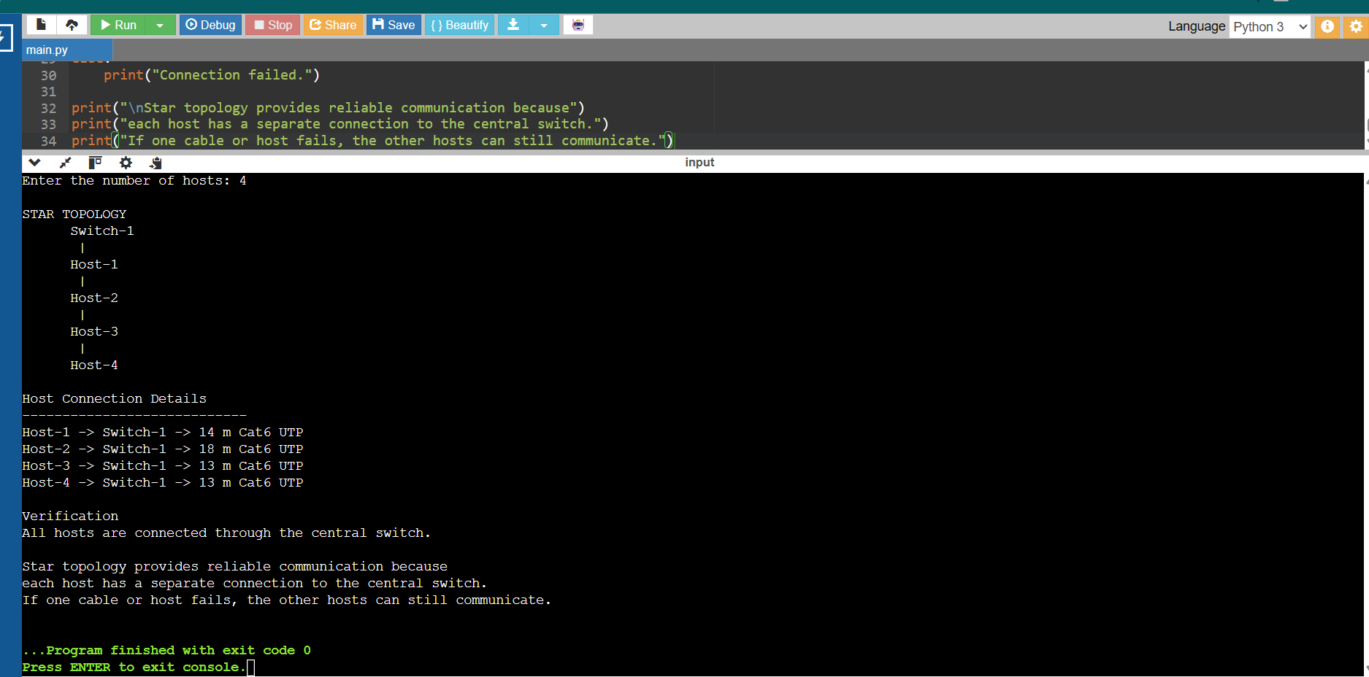

2.Write a Python function named validate_segment(length_m) to verify whether a given UTP cable segment satisfies the IEEE 802.3 Ethernet standard, which specifies a maximum cable length of 100 meters. The function should return True for valid cable lengths and return False along with an appropriate error message for invalid lengths exceeding the permissible limit. Demonstrate the correctness of the program by executing it with at least three different test cases and interpret the results.
Program:
def validate_segment(length_m):
if length_m <= 100:
return True
else:
print("Error: Cable length exceeds the maximum limit of 100 meters.")
return False
test_cases = [50, 100, 120]
for length in test_cases:
result = validate_segment(length)
print("Cable Length:", length, "meters")
print("Valid:", result)
print()

Output:
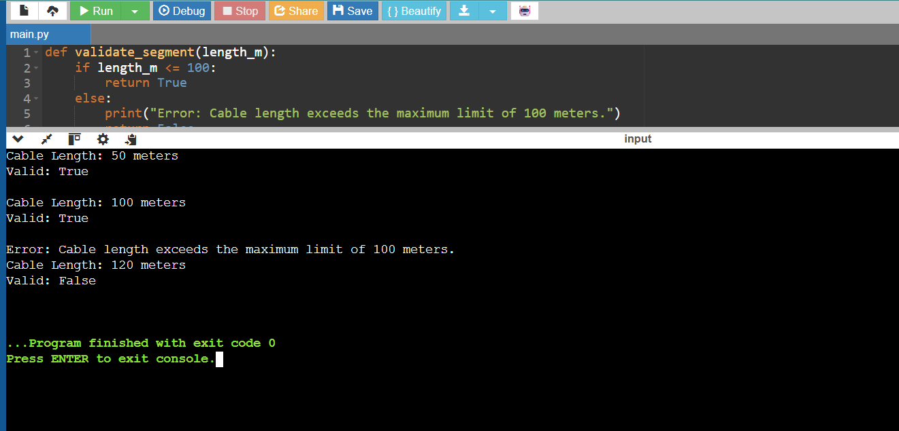

3.Develop a Python program to simulate the operation of the Carrier Sense Multiple Access with Collision Detection (CSMA/CD) protocol in a star topology consisting of four hosts connected through a central switch. The program should simulate frame transmission attempts, detect transmission collisions, calculate random back-off intervals, and continue transmission after the waiting period. Record every collision event, transmission attempt, and back-off interval in a log file named csma_log.txt, and analyze how CSMA/CD minimizes data transmission conflicts in Ethernet networks.
Program:
import random
import time
hosts = ["Host-1", "Host-2", "Host-3", "Host-4"]
frames = 3
log = open("csma_log.txt", "w")
for frame in range(1, frames + 1):
print("\nFrame", frame)
remaining = hosts.copy()
attempt = 0
while remaining:
attempt += 1
transmitting = []
for host in remaining:
if random.choice([True, False]):
transmitting.append(host)
if len(transmitting) == 0:
print("No host transmitted. Waiting...")
log.write("No transmission in attempt " + str(attempt) + "\n")
continue
print("Transmission attempt:", attempt)
log.write("Transmission attempt " + str(attempt) + ": " +
", ".join(transmitting) + "\n")
if len(transmitting) == 1:
host = transmitting[0]
print(host, "transmission successful")
log.write(host + " transmission successful\n")
remaining.remove(host)
else:
print("Collision detected:", ", ".join(transmitting))
log.write("Collision detected: " +
", ".join(transmitting) + "\n")
for host in transmitting:
backoff = random.randint(1, 10)
print(host, "Back-off:", backoff)
log.write(host + " Back-off interval: " +
str(backoff) + "\n")
time.sleep(1)
log.write("\nCSMA/CD simulation completed.\n")
log.close()
print("\nSimulation completed.")
print("Collision and transmission details are stored in csma_log.txt")

Output:
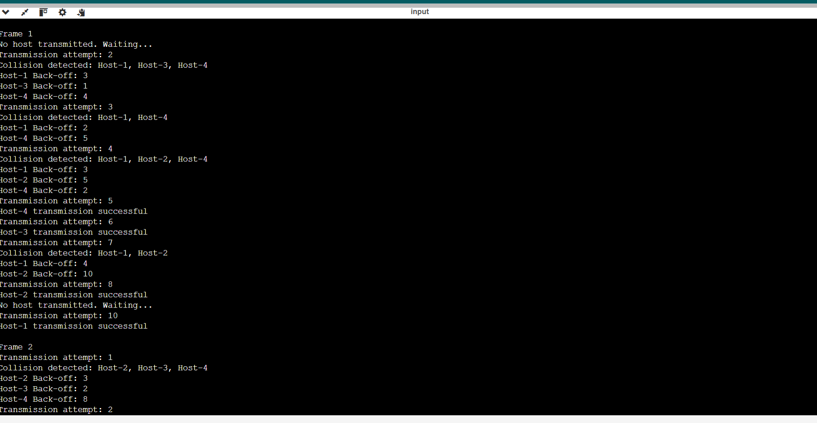
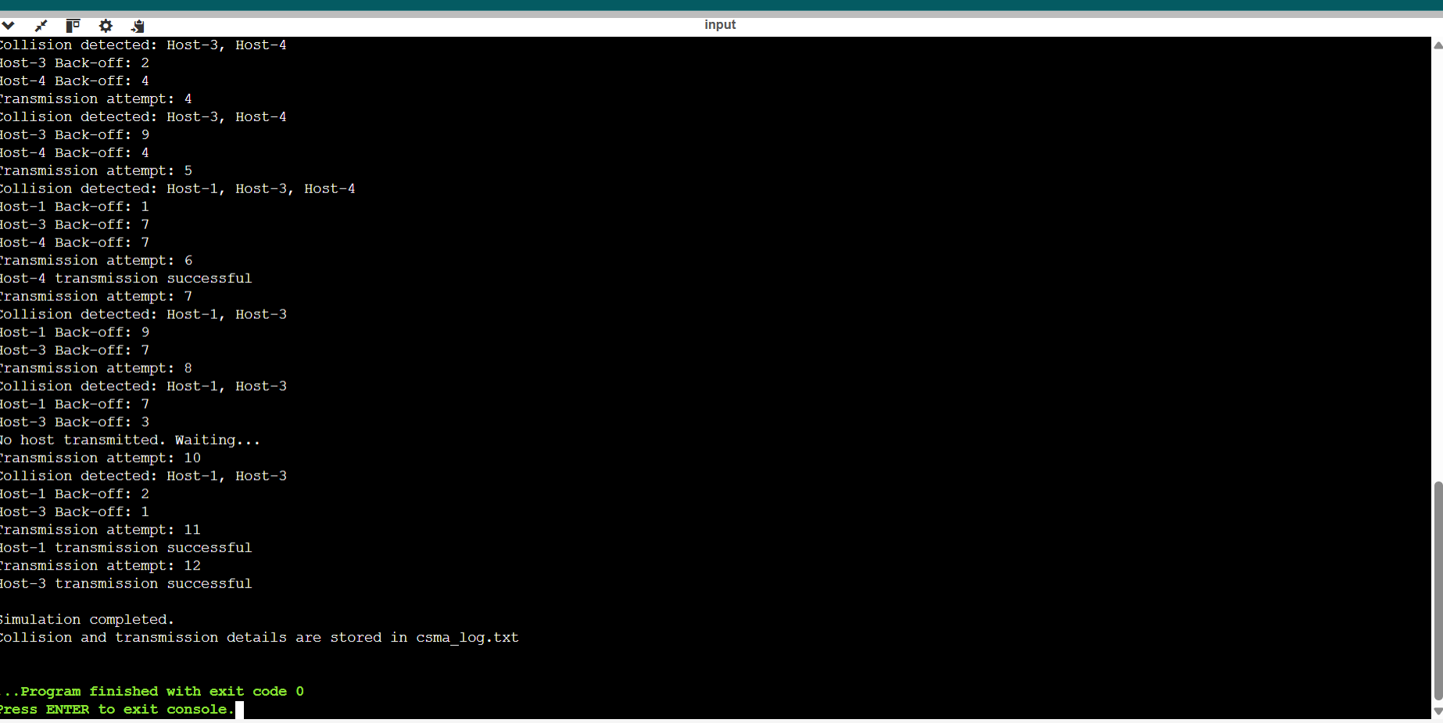

4.Develop a client-server application using Python's socket library to simulate communication between two hosts connected through a central switch in a star topology. The server should receive frames from the client, forward them appropriately, and maintain a simulated MAC Address Table. After each successful frame transmission, display the updated MAC address table showing the learned MAC addresses and associated ports. Explain how MAC learning and frame forwarding are performed in Ethernet switches.
Program:
import socket
import threading
import time
mac_table = {}
def server():
server_socket = socket.socket(socket.AF_INET, socket.SOCK_STREAM)
server_socket.bind(("localhost", 5000))
server_socket.listen(5)
print("Central Switch Started")
print("Waiting for hosts...\n")
while True:
connection, address = server_socket.accept()
data = connection.recv(1024).decode()
if data:
parts = data.split(",")
source_mac = parts[0]
destination_mac = parts[1]
message = parts[2]

port = "Port-" + str(address[1]
mac_table[source_mac] = port
print("Frame Received")
print("Source MAC:", source_mac)
print("Destination MAC:", destination_mac)
print("Message:", message)
if destination_mac in mac_table:
print("Destination MAC found")
print("Frame forwarded through", mac_table[destination_mac])
else:
print("Destination MAC not found")
print("Frame broadcast to other ports")
print("\nUpdated MAC Address Table")
print("-------------------------------")
print("MAC Address\t\tPort")
for mac, port in mac_table.items():
print(mac, "\t", port)
connection.send("Frame transmission successful".encode())
connection.close()
def client(source_mac, destination_mac, message):
time.sleep(1)
client_socket = socket.socket(socket.AF_INET, socket.SOCK_STREAM)
client_socket.connect(("localhost", 5000))

data = source_mac + "," + destination_mac + "," + message
client_socket.send(data.encode())
response = client_socket.recv(1024).decode()
print("\nHost Response:", response)
client_socket.close()
server_thread = threading.Thread(target=server)
server_thread.daemon = True
server_thread.start()
time.sleep(1)
client("AA:BB:CC:DD:EE:01",
"AA:BB:CC:DD:EE:02",
"Hello from Host-1")
client("AA:BB:CC:DD:EE:02",
"AA:BB:CC:DD:EE:01",
"Hello from Host-2"
time.sleep(2)
print("\nSimulation Completed")

Output: 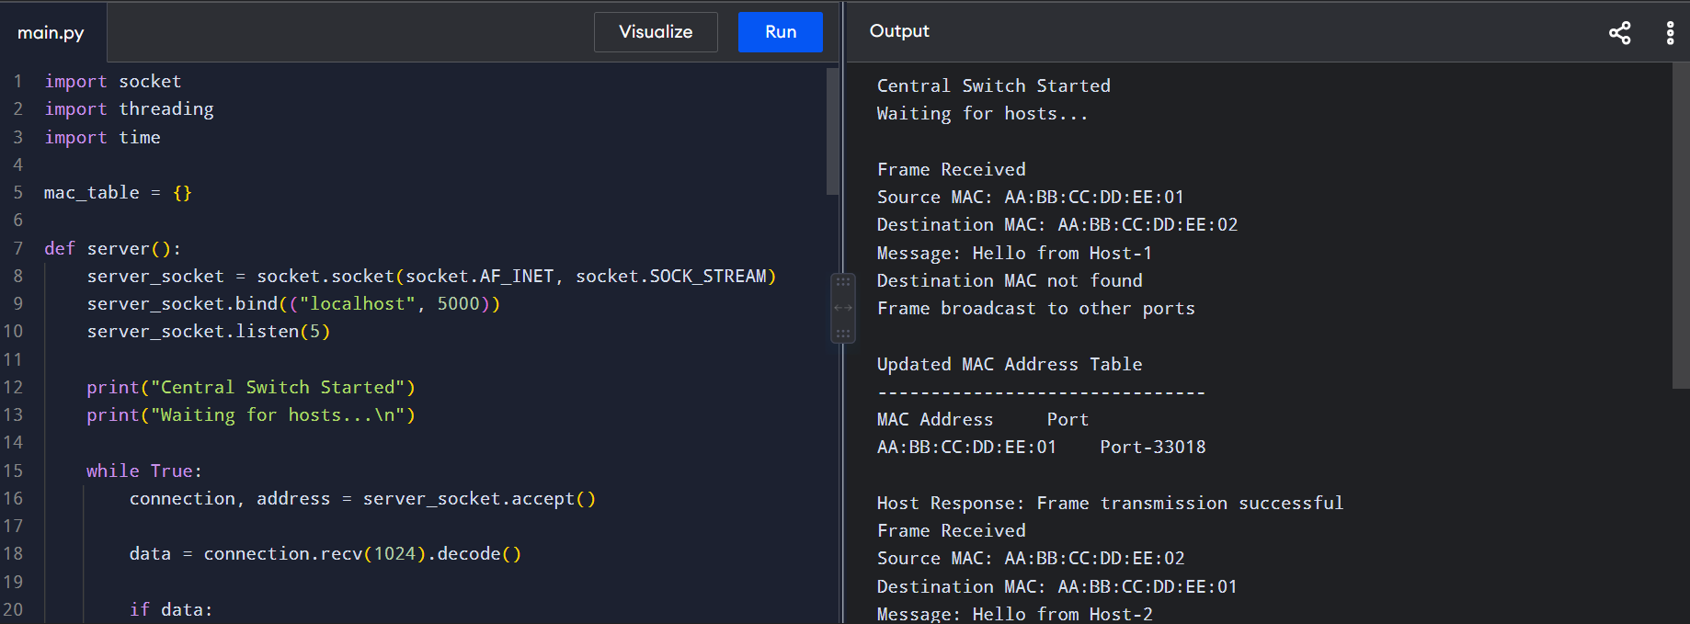
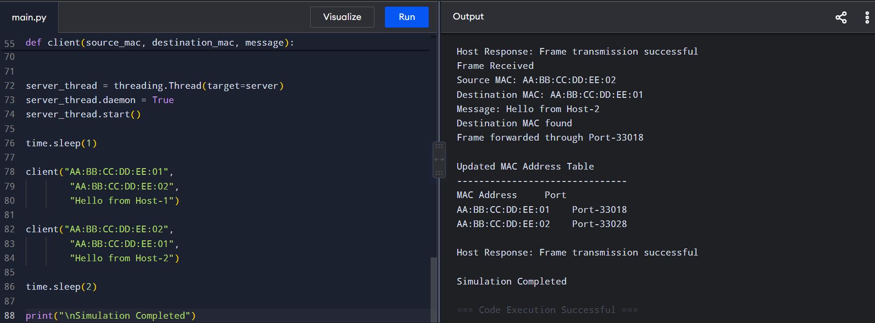

5.Design and implement a Python class named StarSwitch that models the basic functionality of an Ethernet switch. The class should include methods such as add_port(host_id) to connect a host, remove_port(host_id) to disconnect a host, and broadcast(frame) to transmit a frame to all connected ports except the source port. The program should maintain a record of active ports and log every broadcast operation, indicating the source host and the destination hosts that successfully receive the frame. Demonstrate the implementation using multiple hosts and explain the significance of broadcasting in Ethernet communication
Program:
class StarSwitch:
def __init__(self):
self.ports = []
self.log = []
def add_port(self, host_id):
if host_id not in self.ports:
self.ports.append(host_id)
print(host_id, "connected to the switch")
def remove_port(self, host_id):
if host_id in self.ports:
self.ports.remove(host_id)
print(host_id, "disconnected from the switch")
def broadcast(self, frame):
source = frame["source"]
message = frame["message"]
destinations = []
for host in self.ports:
if host != source:
destinations.append(host)
print("\nBroadcast Operation")
print("Source Host:", source)
print("Frame:", message)
print("Destination Hosts:", destinations)
self.log.append({
"source": source,
"destinations": destinations,
"frame": message
})
switch = StarSwitch()
switch.add_port("Host-1")
switch.add_port("Host-2")
switch.add_port("Host-3")
switch.add_port("Host-4")
frame1 = {
"source": "Host-1",
"message": "Hello from Host-1"
}
switch.broadcast(frame1)
switch.remove_port("Host-3")
frame2 = {
"source": "Host-2",
"message": "Hello from Host-2"
}
switch.broadcast(frame2
print("\nActive Ports")
print(switch.ports)
print("\nBroadcast Log")
for entry in switch.log:
print("Source:", entry["source"])
print("Destinations:", entry["destinations"])
print("Frame:", entry["frame"])

Output:
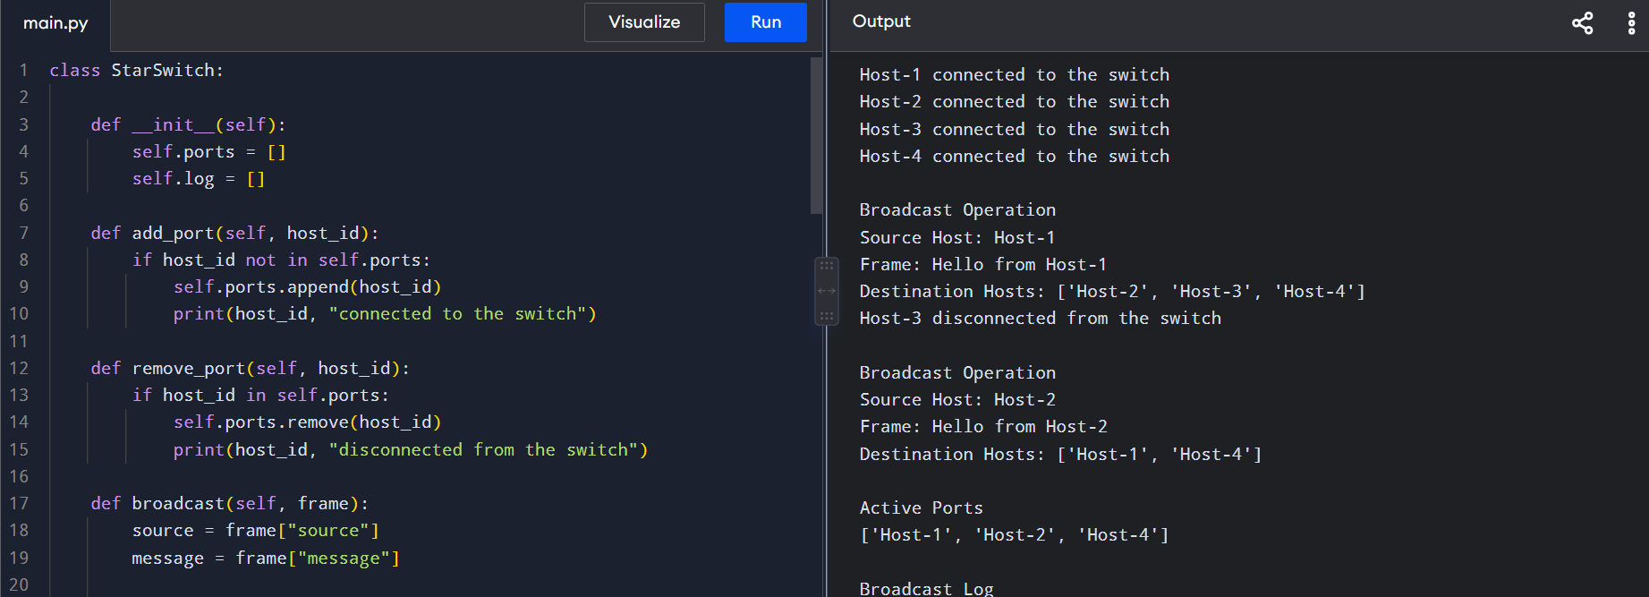
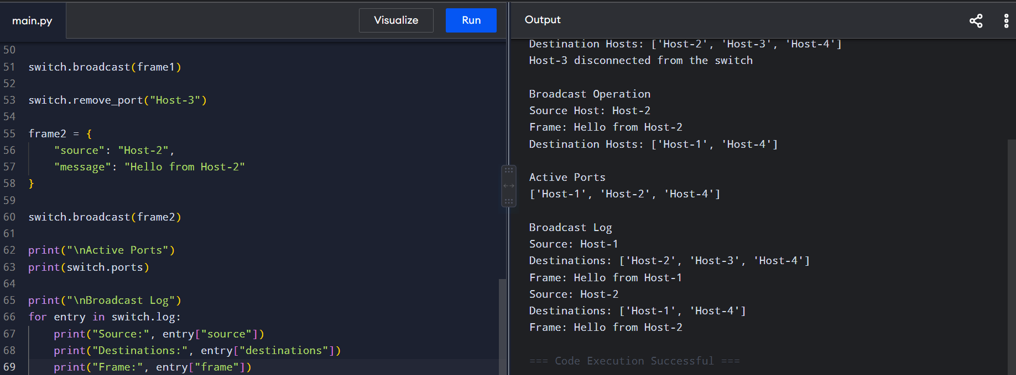

RUBRICS FOR CALCULATION
Criteria |  | Weightage Exemplary (4) Proficient (3) Developing (2) Beginning (1)
Problem  Understanding | 15% | Fully  understands the problem and requirements; no clarification  needed | Understands most  requirements with minor  clarification | Partial  understanding; misses some requirements | Poor  understanding of the problem
Algorithm  Design | 20% | Efficient,  optimal, and well-structured algorithm | Correct  algorithm with minor  inefficiencies | Basic approach but not optimal | Incorrect or no clear algorithm
Code Quality | 15% | Clean, well  organized,  readable, and properly  formatted code | Mostly clean code with  minor issues | Code is  somewhat  unclear or  inconsistent | Poorly written, unreadable  code
Functionality | 20% | Code works  perfectly for all test cases | Works for  most test cases | Works for  limited cases | Does not run or fails major cases
Error Handling 10% |  | Handles all edge cases and errors effectively | Handles some edge cases | Limited error handling | No error  handling
Efficiency | 10% | Highly  optimized in time and space complexity | Reasonably efficient | Some  inefficiencies | Highly  inefficient
Documentation & Comments | 5% | Clear and  meaningful  comments and documentation | Adequate  comments | Few or unclear comments | No comments
Testing &  Debugging | 5% | Thoroughly  tested with  multiple cases; no bugs | Tested with some cases | Minimal testing | No testing  done

