3-Month Fitness Tracker: SQL Analysis & Power BI Dashboard

**INTRODUCTION:**

This project focuses on analyzing fitness tracking data over a period of three months using SQL for querying and Power BI for visualization. The primary objective is to understand the relationship between gym attendance, calorie intake/burn, sleep patterns, and their effect on weight loss. The insights aim to help build a sustainable, data-driven fitness plan.

**SQL QUERIES AND THEIR INSIGHTS**

1. **Average Calories Burned by Workout**

SELECT workout ,

round(avg(calories_burned) , 2) as avg_burned

from fitness_tracking where attended_gym = 'TRUE'

GROUP BY workout ORDER by avg_burned desc;

**Result :**

**Workout avg_burned**

"Cardio" "425.67"

"Legs" "337.69"

"Shoulder" "250.27"

"Biceps & Triceps" "240.85"

"Abs" "200.58"

"None" "0"

Insight: Cardio workout burns more calories.

2. **Comparing calorie intake vs burn by month**

SELECT STRFTIME('%Y-%m' , date) AS month,

ROUND(SUM(calorie_intake), 0) as total_intake,

ROUND(SUM(calories_burned), 0) as total_burned from fitness_tracking GROUP by month;

**Result:**

**month total_intake total_burned**

"2025-02" "44206" "6097"

"2025-03" "48355" "5959"

"2025-04" "48021" "5733"

Insight: Total calorie intake and total calories burned according to months is shown.

**3. High Calorie Intake + No Gym = Likely Weight Gain Days**

SELECT

date,

calorie_intake,

calories_burned,

attended_gym, weight_kg

FROM fitness_tracking

WHERE attended_gym = 'FALSE' AND calorie_intake > 1600

ORDER BY calorie_intake DESC;

**Result:**

**Date Calorie_Intake Calories_Burned Attended_Gym Weight_kg**

"2025-02-25" "1977" "0" "FALSE" "54.3"

"2025-04-23" "1970" "0" "FALSE" "52.9"

"2025-04-29" "1911" "0" "FALSE" "53.2"

"2025-04-04" "1869" "0" "FALSE" "53.3"

"2025-04-03" "1862" "0" "FALSE" "53.4"

"2025-03-28" "1861" "0" "FALSE" "53.7"

"2025-04-22" "1813" "0" "FALSE" "53.4"

"2025-02-24" "1810" "0" "FALSE" "54.5"

"2025-03-15" "1807" "0" "FALSE" "54.1"

"2025-04-12" "1770" "0" "FALSE" "53.7"

Insight: Shown on which days high calorie intake and gym not attended days that lead to put on weight.

**4. Weekly Consistency and Impact on Weight**

SELECT

STRFTIME('%Y-%W', date) AS week,

COUNT(CASE WHEN attended_gym THEN 1 END) AS gym_days,

ROUND(AVG(weight_kg), 2) AS avg_weight

FROM fitness_tracking

GROUP BY week

ORDER BY week;

**Result :**

**week gym_days avg_weight**

"2025-04" "0" "55.2"

"2025-05" "0" "54.81"

"2025-06" "0" "54.79"

"2025-07" "0" "54.67"

"2025-08" "0" "54.39"

"2025-09" "0" "54.3"

"2025-10" "0" "54.17"

"2025-11" "0" "53.99"

"2025-12" "0" "53.79"

"2025-13" "0" "53.53"

Insight: Monitors consistency and weight trends weekly and observed decrease in weight.

**5. Cumulative Weight Loss Trend Over Time**

WITH base AS (

SELECT

date,

weight_kg,

FIRST_VALUE(weight_kg) OVER (ORDER BY date) AS start_weight

FROM fitness_tracking

)

SELECT

date,

weight_kg,

ROUND(start_weight - weight_kg, 2) AS cumulative_weight_loss

FROM base

ORDER BY date;

**Result:**

**date weight_kg cumulative_weight_loss**

"2025-02-01" "55.2" "0"

"2025-02-02" "55.2" "0"

"2025-02-03" "54.7" "0.5"

"2025-02-04" "54.7" "0.5"

"2025-02-05" "54.9" "0.3"

"2025-02-06" "54.7" "0.5"

"2025-02-07" "54.9" "0.3"

"2025-02-08" "54.8" "0.4"

"2025-02-09" "55" "0.2"

"2025-02-10" "55.1" "0.1"

Insight: Shows there is weight loss .

**POWER BI DASHBOARD COMPONENTS**

## Title Banner:

Text: "3-Month Fitness Progress"

## Top KPI Cards:

- Total Gym Days: COUNT(attended_gym = TRUE)

- Sum of Calories Burned: AVG(calories_burned)

- Sum of Sleep Hours: AVG(sleep_hours)

- Weight Change: MAX(weight_kg) - MIN(weight_kg)

## Charts and Graphs:

- Line Chart: Daily Weight vs. Date

- Area line Chart: Calories Burned Vs Calorie Intake on day wise

- Pie Chart: Calories Burned by Workout Type

- Slicers: Date Range, Workout Type, Day

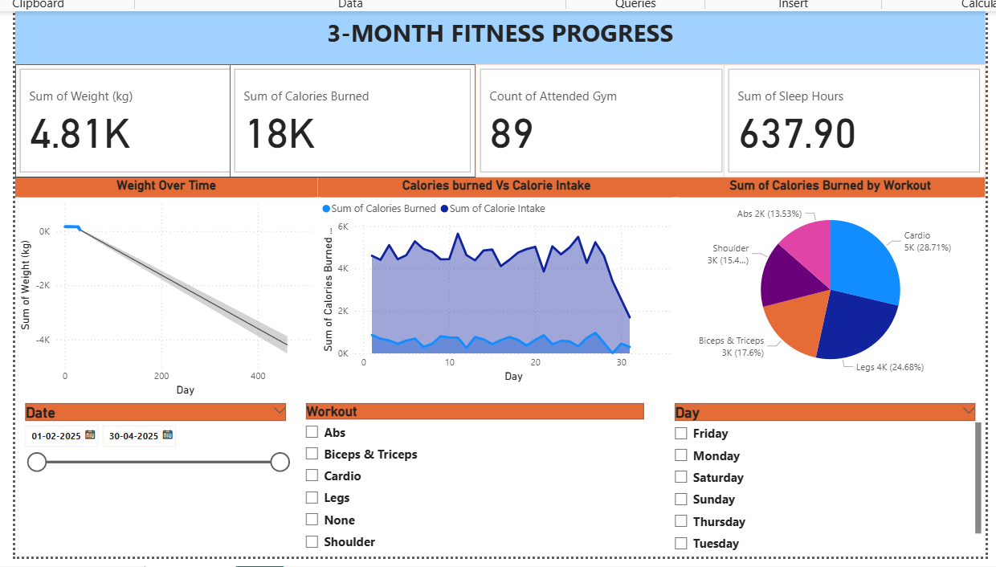

**Conclusion**

The analysis highlights how workout consistency, dietary control, and adequate sleep collectively contribute to effective weight management. SQL helps extract actionable insights from raw data, while Power BI provides visual clarity and also forecast how many days are needed to decrease weight. This approach enables informed fitness decisions for sustainable health outcomes.