1. Retrieve all products in the “electronics” category.

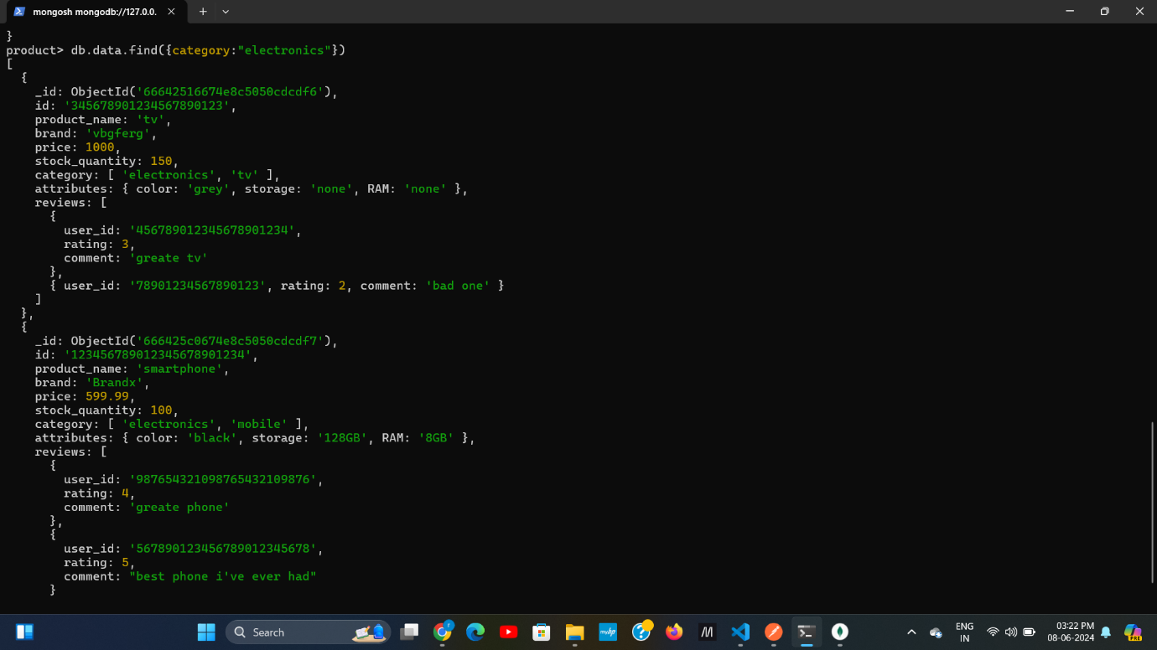

1. Retrieve all products with rating greater than 4

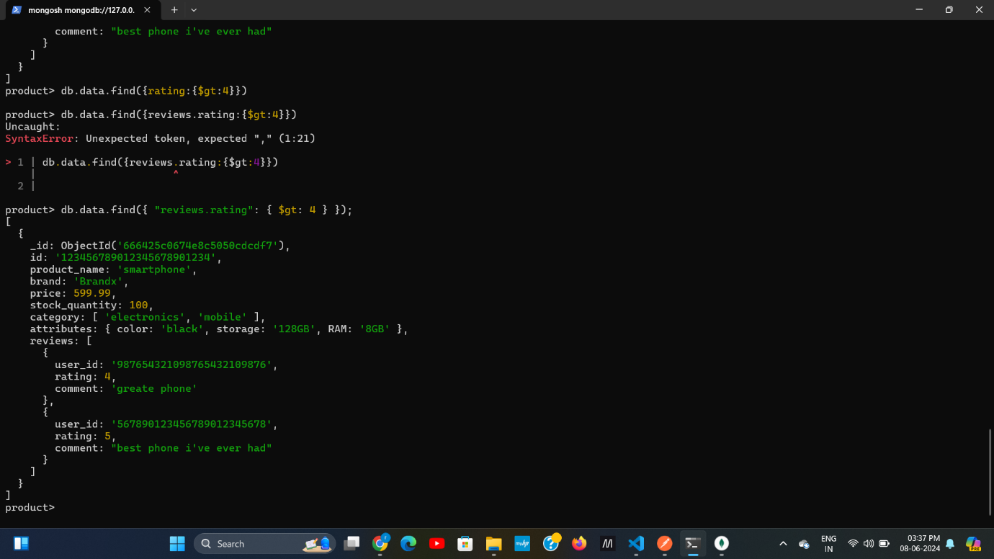

1. Find all the product with a specific colour (e.g., black)

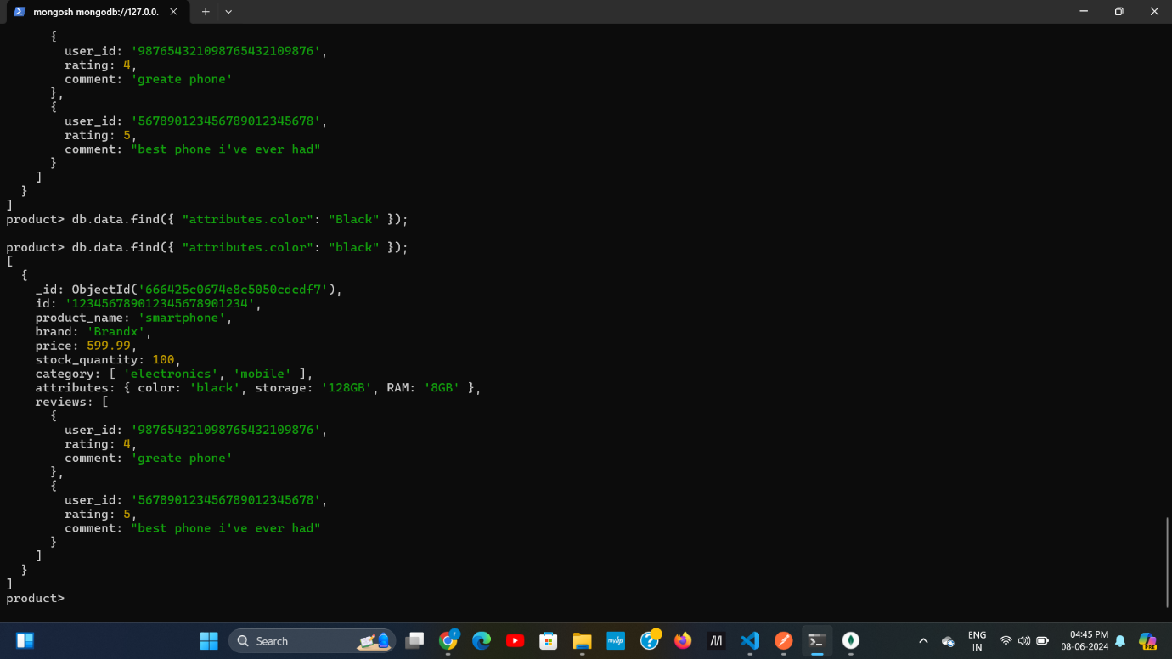

1. Retrieve all product with sorted by price in descending order

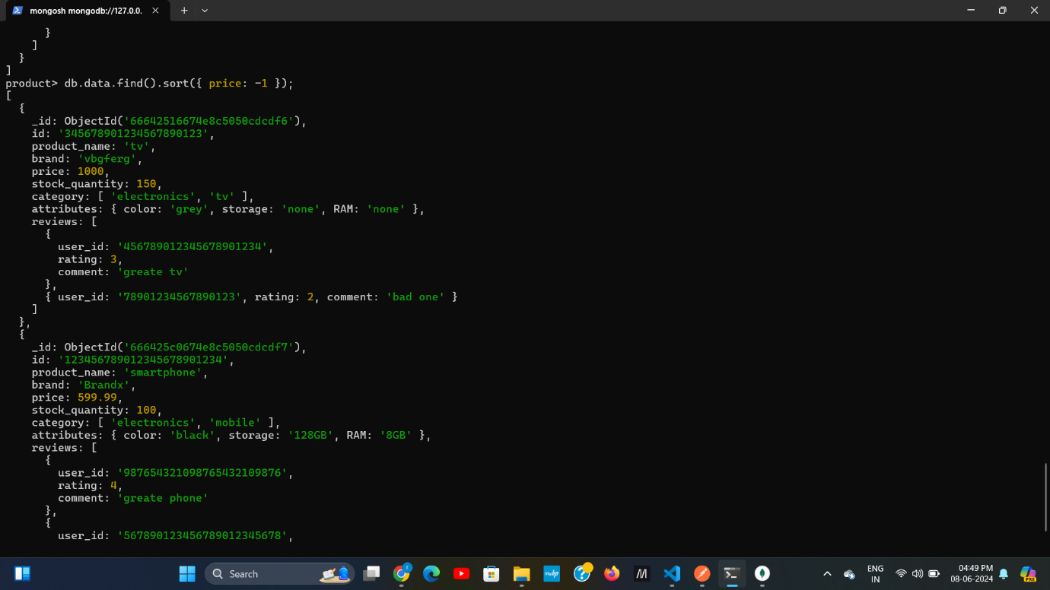

1. Calculate the average rating of all products

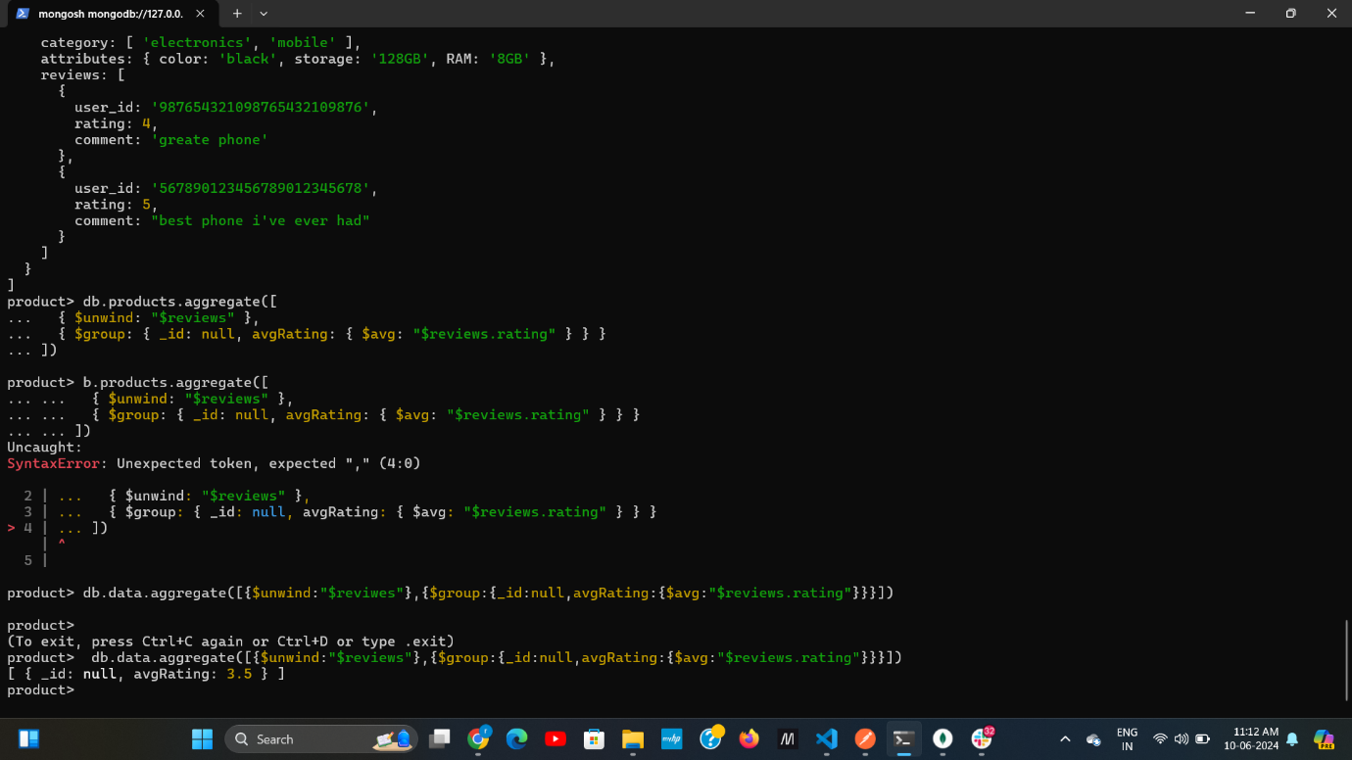

6.retrieve all products with a specific brand (e.g.,Brandx)

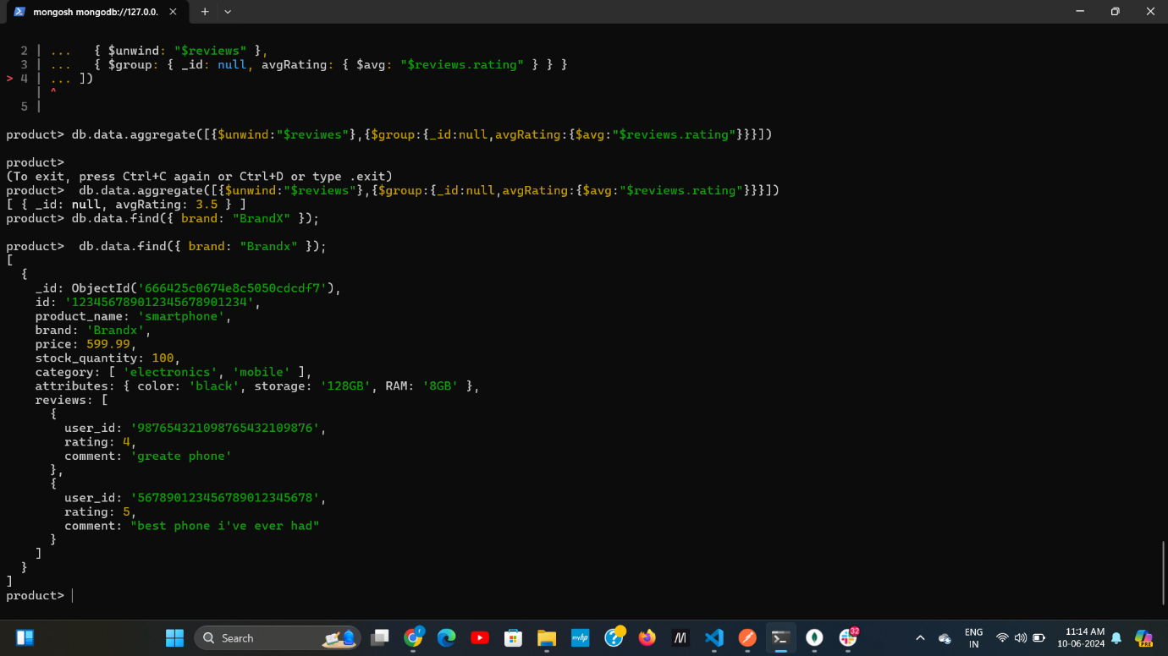

1. Find all products where the storage is 128GB and RAMis 8GB

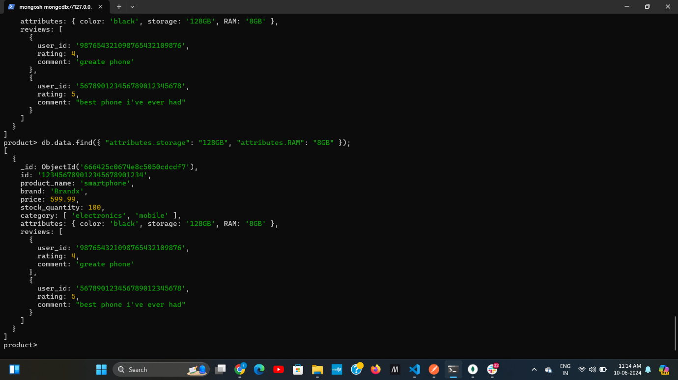

8.retrieve all products wuth specific users id

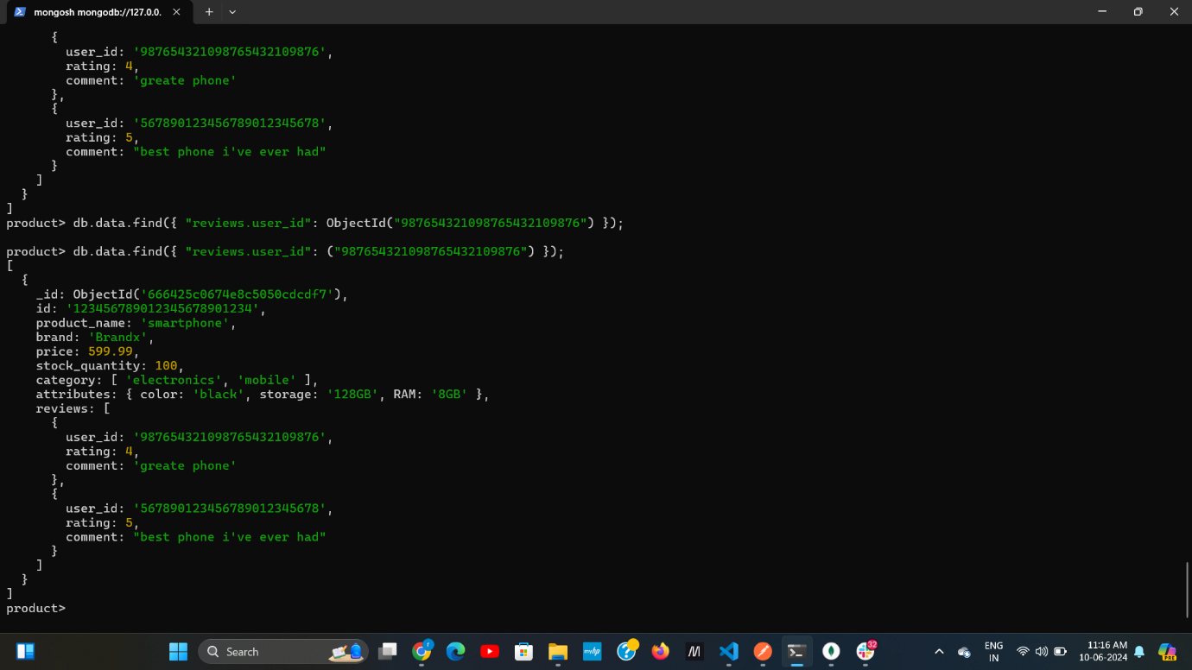

9. calculate total number of riviews for each product

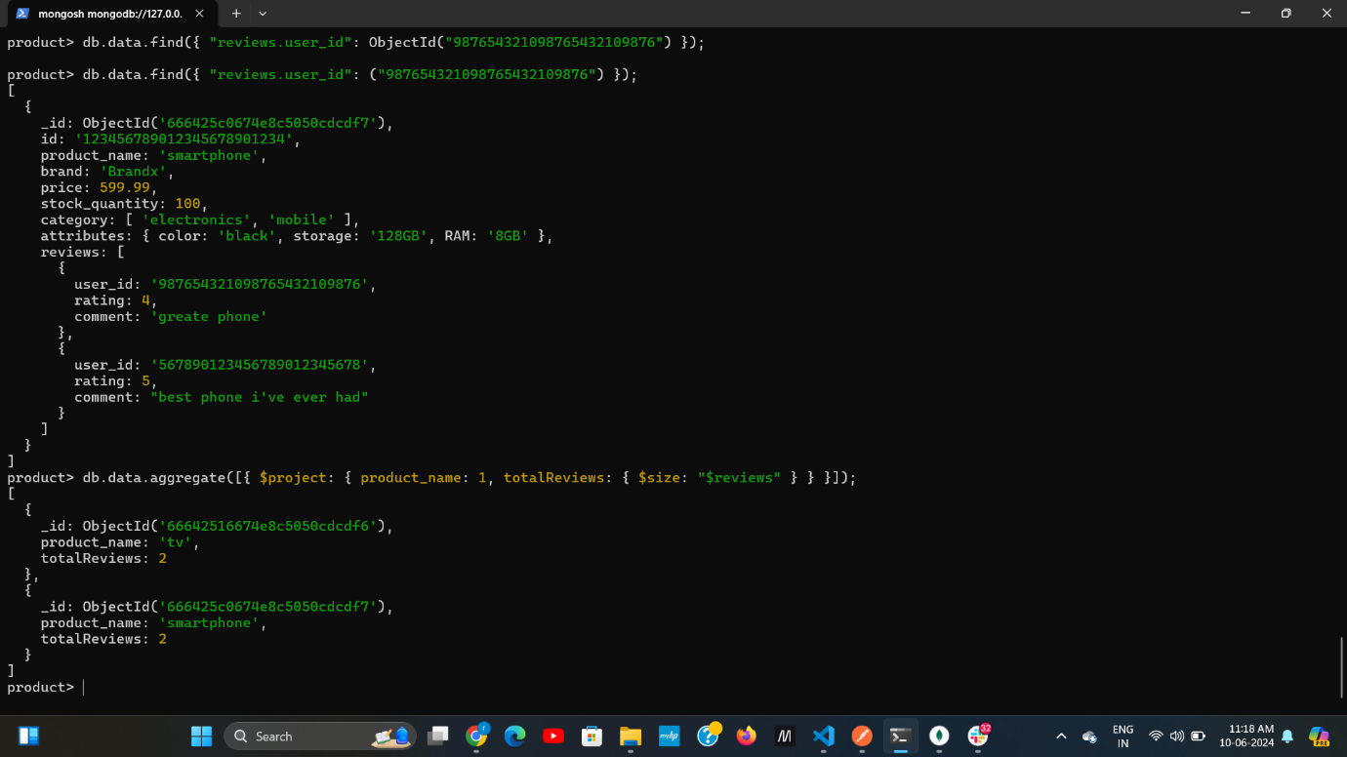

10. find all produts with a price between $400 and $600

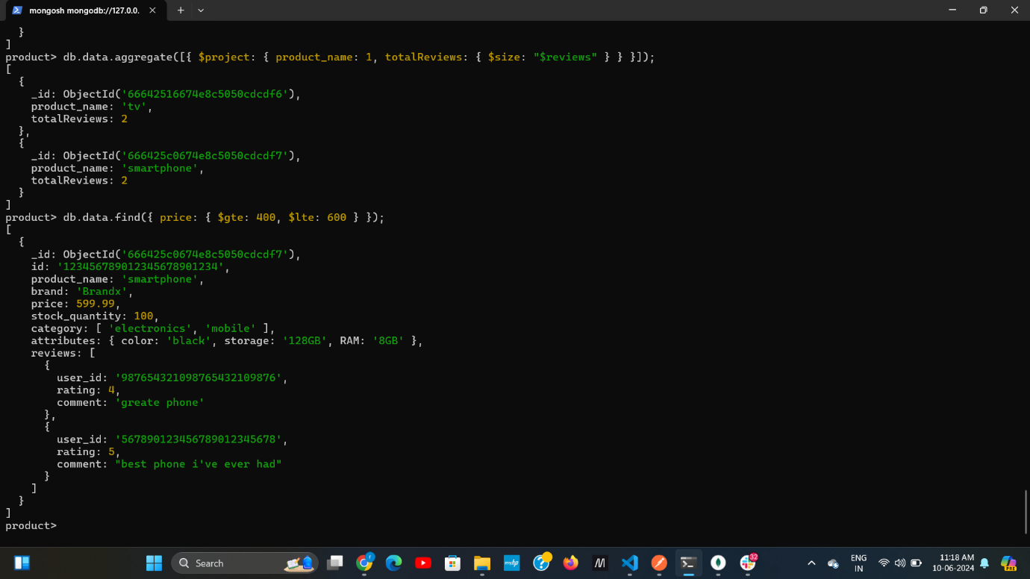

11. find all products with a specific category and stock quantity greater than 50.

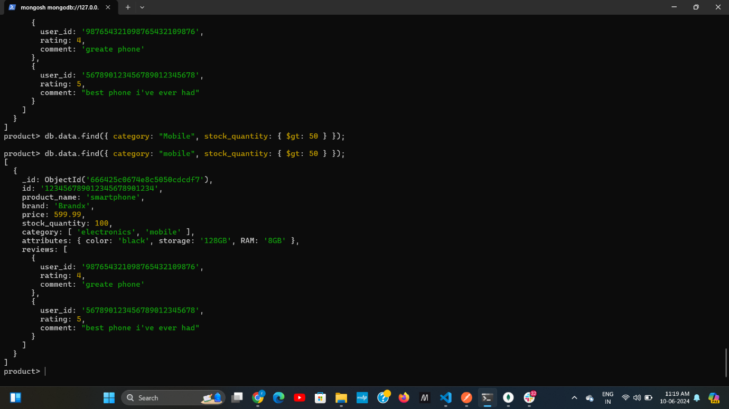

12. find the highest rated product

13. retrieve all products sorted by brand in ascending order and then by price in decending order

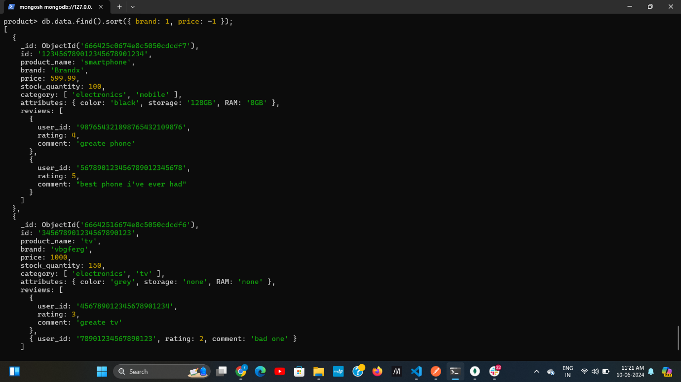

14. find all product with a specific comment in their reviews(e.g., “great phone”)

