**Python Topics**

**Built-in Data Types**

In programming, data type is an important concept.

Variables can store data of different types, and different types can do different things.

Python has the following data types built-in by default, in these categories:

|  |  |
| --- | --- |
| Text Type: | str |
| Numeric Types: | int, float, complex |
| Sequence Types: | list, tuple, range |
| Mapping Type: | dict |
| Set Types: | set, frozenset |
| Boolean Type: | bool |
| Binary Types: | bytes, bytearray, memoryview |
| None Type: | NoneType |

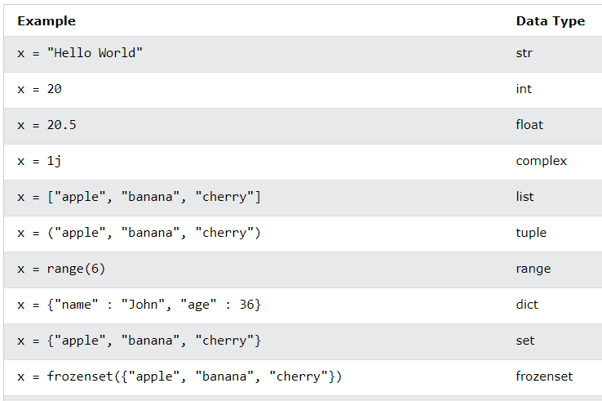

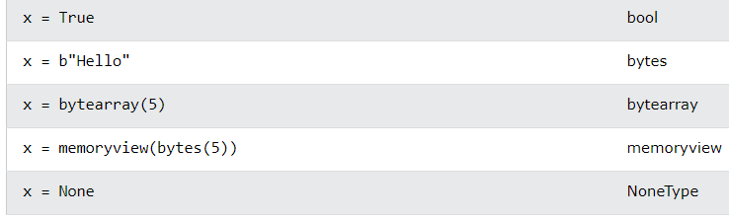

**Data Structures**

It is a way of organizing data in a computer memory. It can be classified as mutable and immutable. Mutable data structures can be modified by adding, removing or changing their elements. For example, Mutable data structures are Lists, Dictionaries and Sets. Immutable data structure is Tuple.

**Lists** in python are implemented as dynamic mutable arrays which has an ordered collection of items. Lists can contain all type of data types like integers, strings, float.

**Tuples** are immutable, so modifications cannot be done in tuples. It contains ordered collection of items.

**Sets** in python can be defined as mutable dynamic collection of unique elements. Sets can be used to remove duplicates from a list. Set operations include set union, intersection, difference and many more. Sets are unordered collection of items. We cannot change set elements by indexing as we can with lists.

In **Set Union**, it’s the merging of 2 sets together. If two sets have two or more identical values, the resulting set will contain only one of these values.

In **Set Intersection**, we check for the values that appear in both sets.

In **Set Difference**, it will return all the elements that are present in the first set, but not in the second one.

**Dictionaries** are mutable data structure that contain a collection of keys and associated values. Dictionaries are used to quickly access certain data associated with a unique key.

**Conditions and If statements**

Python supports the usual logical conditions from mathematics:

* Equals: a == b
* Not Equals: a != b
* Less than: a < b
* Less than or equal to: a <= b
* Greater than: a > b
* Greater than or equal to: a >= b

**If-Else If-Else Statements**

Conditional statements allow you to control the flow of your program based on certain conditions. The structure is typically:

if condition:

# code to execute if the condition is true

elif another_condition:

# code to execute if another_condition is true

else:

# code to execute if none of the conditions are true

These conditions can be used in several ways, most commonly in "if statements" and loops.

An "if statement" is written by using the if keyword.

**Elif**

The **elif** keyword is Python's way of saying "if the previous conditions were not true, then try this condition".

a = 33

b = 33

if b > a:

print("b is greater than a")

elif a == b:

print("a and b are equal")

**Else**

The **else** keyword catches anything which isn't caught by the preceding conditions.

a = 200

b = 33

if b > a:

print("b is greater than a")

elif a == b:

print("a and b are equal")

else:

print("a is greater than b")

**Loops**

**For Loop**

A for loop is used for iterating over a sequence (that is either a list, tuple, dictionary, string, or range). It has the following structure:

for variable in sequence:

# code to execute for each iteration

Here variable accesses each item of the sequence on each iteration. The loop continues until we reach the last item in the sequence.

**While Loop**

A while loop is used to repeatedly execute a block of code as long as the specified condition is true. It has the following structure:

while condition:

# code to execute as long as the condition is true

A while loop evaluates the condition. If the condition evaluates to True, the code inside the while loop is executed. Condition is evaluated again. This process continues until the condition is False. When the condition evaluates to False, the loop stops.

**Functions**

A function is a block of code which only runs when it is called. You can pass data, known as parameters, into a function. A function can return data as a result.

**Creating a Function**

In Python a function is defined using the def keyword:

def my_function():

print("Hello from a function")

**Calling a Function**

To call a function, use the function name followed by parenthesis:

def my_function():

print("Hello from a function")

my_function()

**Arguments**

Information can be passed into functions as arguments.

Arguments are specified after the function name, inside the parentheses. We can add as many arguments as we want, just need to separate them with a comma.

From a function's perspective:

A parameter is the variable listed inside the parentheses in the function definition. An argument is the value that is sent to the function when it is called.

**Positional Arguments:**

Positional arguments are passed to a function in the order they are defined. For example:

def add(x, y):

return x + y

sum_result = add(3, 5)

**Keyword Arguments:**

Keyword arguments are passed to a function using the parameter names. This allows you to pass arguments out of order. For example:

def person_info(name, age):

print("Name:", name)

print("Age:", age)

person_info(age=25, name="John")

**Arbitrary Arguments, *args:**

If we do not know how many arguments that will be passed into the function, we should add a * before the parameter name in the function definition.

**Arbitrary Keyword Arguments, **kwargs:**

If we do not know how many keyword arguments that will be passed into the function, add two asterisk: ** before the parameter name in the function definition.

**Recursion Function**

Python also accepts function recursion, which means a defined function can call itself.

Recursion is a common mathematical and programming concept. It means that a function calls itself. This has the benefit of meaning that we can loop through data to reach a result.

It should be very careful with recursion as it can be quite easy to slip into writing a function which never terminates, or one that uses excess amounts of memory or processor power. However, when written correctly recursion can be a very efficient and mathematically-elegant approach to programming.

In this example, tri_recursion() is a function that we have defined to call itself ("recurse"). We use the k variable as the data, which decrements (-1) every time we recurse. The recursion ends when the condition is not greater than 0 (i.e. when it is 0).

def tri_recursion(k):

if(k > 0):

result = k + tri_recursion(k - 1)

print(result)

else:

result = 0

return result

print("\n\nRecursion Example Results")

tri_recursion(6)

**Lambda Function**

A lambda function is a small anonymous function. A lambda function can take any number of arguments, but can only have one expression.

**lambda arguments: expression**

**lambda:** Keyword indicating the start of a lambda function.

**arguments:** Input parameters for the function.

**expression:** The operation or computation performed by the function.

They are defined using the lambda keyword. For example:

square = lambda x: x**2

# Using the lambda function

result = square(5)

print("Result:", result)

**lambda x:** Defines a lambda function with one parameter x.

**x**2:** Squares the value of x.

**square(5):** Invokes the lambda function with the argument 5.

Lambda functions are often used in situations where a small, one-time-use function is needed, such as in functions like map(), filter(), or sorted(). Here's an example using map():

numbers = [1, 2, 3, 4, 5]

squared_numbers = list(map(lambda x: x**2, numbers))

print("Squared Numbers:", squared_numbers)

This applies the lambda function to each element of the numbers list, resulting in a new list of squared numbers:

Squared Numbers: [1, 4, 9, 16, 25]

Lambda functions provide a concise and convenient way to express simple operations without the need for a full function definition.

**OOPS Concepts**

**Object oriented Programming (OOPs)** - Is a programming that uses objects and classes. The main concept is to bind the data and the functions that work on that together as a Single unit so that no other part of the code can access this data.

**OOPs concepts in Python**

1. Class
2. Objects
3. Polymorphism
4. Encaspsulation
5. Inheritance
6. Data Abstraction

**Class** - A class is a collection of objects. What is the need for creating classes?

* Classes are created by keyword class
* Attributes are the variables that belongs to a class
* Attributes are always public and can be accessed using the dot (.) operator.

Object-oriented programming (OOP) is a programming paradigm that uses objects – instances of classes – for structuring code. Here are some key OOP concepts with examples:

**The __init__() Function**

To understand the meaning of classes we have to understand the built-in __init__() function.

All classes have a function called __init__(), which is always executed when the class is being initiated

Use the __init__() function to assign values to object properties, or other operations that are necessary to do when the object is being created:

Create a class named Person, use the __init__() function to assign values for name and age:

class Person:

def __init__(self, name, age):

self.name = name

self.age = age

p1 = Person("John", 36)

print(p1.name)

print(p1.age)

**Example:**

class Car:

def __init__(self, brand, model):

self.brand = brand

self.model = model

def display_info(self):

print(f"{self.brand} {self.model}")

**Object Methods**

Object is an entity that has a state and behavior associated with it. Objects can also contain methods. Methods in objects are functions that belong to the object.

State: Represented by the attributes of an object. It also reflects properties of an object.

Behaviour: Represented by methods of an object. It also reflects the response of an object to other objects.

Identity: It gives a unique name to an object and enables one object to interact with other objects.

The **self parameter** is a reference to the current instance of the class, and is used to access variables that belongs to the class.

It does not have to be named self, we can call it whatever you like, but it has to be the first parameter of any function in the class.

**Inheritance**

Inheritance allows us to define a class that inherits all the methods and properties from another class.

Parent class is the class being inherited from, also called base class.

Child class is the class that inherits from another class, also called derived class.

class ElectricCar(Car):

def __init__(self, brand, model, battery_capacity):

super().__init__(brand, model)

self.battery_capacity = battery_capacity

**Encaspsulation**

Bundling data (attributes) and methods that operate on the data into a single unit (class).

Example: The Car class encapsulates the brand and model attributes along with the display_info method.

**Polymorphism**

The ability of a single entity (method or operator) to operate on different types or classes. The word "polymorphism" means "many forms", and in programming it refers to methods/functions/operators with the same name that can be executed on many objects or classes.

Function Polymorphism

An example of a Python function that can be used on different objects is the len() function.

String

For strings len() returns the number of characters

def display_vehicle_info(vehicle):

vehicle.display_info()

my_electric_car = ElectricCar("Tesla", "Model S", "100 kWh")

display_vehicle_info(my_car)

display_vehicle_info(my_electric_car)

**Multiple Inheritance**

Multiple inheritance occurs when a class inherits from more than one parent class.

class A:

def method_A(self):

print("Method A from class A")

class B:

def method_B(self):

print("Method B from class B")

class C(A, B):

def method_C(self):

print("Method C from class C")

obj_C = C()

obj_C.method_A()

obj_C.method_B()

obj_C.method_C()

**Multilevel Inheritance**

Multilevel inheritance occurs when a class inherits from a base class, and another class inherits from the derived class.

class A:

def method_A(self):

print("Method A from class A")

class B(A):

def method_B(self):

print("Method B from class B")

class C(B):

def method_C(self):

print("Method C from class C")

obj_C = C()

obj_C.method_A()

obj_C.method_B()

obj_C.method_C()

**Abstraction**

Hiding the complex implementation details and showing only the necessary features of an object. Example: Using methods like display_info without knowing the internal implementation details.

**Pyspark**

**PySpark** is a Python library for Apache Spark, an open-source, distributed computing system used for big data processing and analytics. It allows you to write Spark applications using Python, providing high-level APIs for distributed data processing.

**Data warehousing** is a process of collecting, storing, and managing data from different sources to support business intelligence and reporting. It involves organizing data in a centralized repository, typically a data warehouse, for efficient analysis and decision-making.

A **data lake** is a storage repository that can hold vast amounts of raw data in its native format until it is needed. Unlike a data warehouse, a data lake allows for the storage of diverse data types, including structured, semi-structured, and unstructured data. It provides a more flexible and scalable approach to data storage.

**Big data** refers to large and complex datasets that traditional data processing applications struggle to handle. This data is characterized by the three Vs: volume (large amounts of data), velocity (fast data processing), and variety (different types of data). Technologies like Apache Spark, Hadoop, and others are used to process and analyze big data efficiently.

In summary, PySpark is a Python library for Apache Spark, which is a tool for processing big data. Data warehousing involves centralized storage for structured data, while data lakes store diverse data types in a more flexible manner. Big data refers to large and complex datasets with specific characteristics.

**Hadoop and Spark**

Hadoop and Spark are both big data frameworks, but they serve different purposes and have distinct architectures. Here are the key differences between Hadoop and Spark:

**1. Processing Paradigm:**

**Hadoop:**

Primarily designed for batch processing using the MapReduce programming model.

Batch processing involves processing data in fixed-size chunks or batches.

**Spark:**

Supports both batch processing and real-time data processing.

Provides high-level APIs for batch processing, machine learning, graph processing, and stream processing.

**2. Data Processing Speed:**

**Hadoop:**

MapReduce is known for disk-based processing, which can lead to slower performance due to intermediate data writes to disk.

**Spark:**

Spark performs in-memory processing, which significantly speeds up iterative algorithms and applications.

**3. Ease of Use:**

**Hadoop:**

Writing MapReduce programs can be complex and requires more low-level coding.

**Spark:**

Provides higher-level APIs in Scala, Java, Python, and R, making it more user-friendly and easier to develop applications.

**4. Data Storage:**

**Hadoop:**

Uses Hadoop Distributed File System (HDFS) for storage.

**Spark:**

While Spark can use HDFS, it is not limited to it and can work with other storage systems, such as HBase, Amazon S3, and more.

**5. Data Processing Model:**

**Hadoop:**

MapReduce processes data in a series of map and reduce stages.

**Spark:**

DAG (Directed Acyclic Graph) execution engine allows for more complex and flexible data processing workflows.

**6. Fault Tolerance:**

**Hadoop:**

Achieves fault tolerance through data replication.

**Spark:**

Uses lineage information and recomputes lost data in case of node failure.

In summary, while both Hadoop and Spark are part of the big data landscape, Spark is known for its speed, ease of use, and support for multiple processing paradigms, making it suitable for a broader range of applications. However, Hadoop continues to be a crucial component in many big data ecosystems. The choice between Hadoop and Spark often depends on specific use case requirements and considerations.

**Kerberos Architecture**

**Kerberos** is a widely used authentication protocol that provides a secure way to authenticate users and services in a networked environment. In the context of Hadoop, Kerberos is often used to secure the Hadoop ecosystem by providing a secure and trusted authentication mechanism.

**Key Components:**

KDC (Key Distribution Center): The KDC is a central component in the Kerberos architecture. It consists of two main parts: the Authentication Server (AS) and the Ticket Granting Server (TGS).

AS (Authentication Server): Responsible for authenticating users and providing them with a Ticket Granting Ticket (TGT).

TGS (Ticket Granting Server): Once a user is authenticated, they can request service tickets from the TGS using their TGT.

**Authentication Process:**

Authentication Request: When a user wants to access a Hadoop cluster, they first authenticate themselves with the AS by providing their credentials (username and password).

TGT Issuance: If the credentials are valid, the AS issues a TGT to the user. The TGT is a credential that the user can use to request service tickets.

Service Ticket Request: When the user wants to access a specific Hadoop service (such as HDFS or MapReduce), they request a service ticket from the TGS using their TGT.

Service Ticket Issuance: The TGS verifies the user's TGT and issues a service ticket for the requested service.

**Service Access:**

Service Ticket Usage: The user presents the service ticket to the Hadoop service they want to access.

Verification: The Hadoop service verifies the service ticket with the help of the TGS. If the ticket is valid, the user is granted access to the service.

**Key Distribution:**

Session Keys: To secure communication between the user and Hadoop services, session keys are generated. These keys are distributed securely during the authentication process.

In the context of Hadoop, implementing Kerberos helps ensure that only authenticated and authorized users and services can access the Hadoop cluster. It enhances the overall security of the cluster by preventing unauthorized access and protecting the confidentiality and integrity of data.

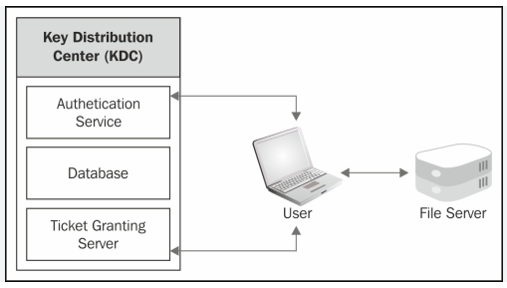

**YARN Architecture**

**Apache YARN** **(Yet Another Resource Negotiator)** is a cluster management technology in the Hadoop ecosystem that enables multiple data processing engines to share resources and coexist on the same cluster. YARN's primary goal is to separate the resource management and job scheduling/monitoring functions, allowing for a more flexible and scalable architecture. Here are the key components of YARN architecture:

**ResourceManager (RM):**

Overview: The ResourceManager is the central authority that manages and arbitrates resources among all the applications in the cluster.

Components:

Scheduler: Responsible for allocating resources to various applications based on policies.

ApplicationManager: Manages the lifecycle of applications and negotiates resources from the Scheduler.

**NodeManager (NM):**

Overview: NodeManagers run on each machine (node) in the cluster and are responsible for managing resources on that node.

Components:

Container: Represents resources (CPU, memory, etc.) allocated on a node for running a specific application's tasks.

**ApplicationMaster (AM):**

Overview: Each application running on the cluster has its own ApplicationMaster.

Functionality:

Coordinates the execution of tasks for a specific application.

Communicates with the ResourceManager to request and release resources.

Monitors task execution and reports progress and status.

Container:

Overview: A generic and logical representation of resources (CPU, memory) on a node.

Functionality:

Created by the ResourceManager on a specific NodeManager.

Assigned to an ApplicationMaster for the execution of tasks related to a specific application.

**Workflow:**

* An application is submitted to the ResourceManager, specifying the location of its resources and the ApplicationMaster class.
* The ResourceManager negotiates resources for the application from the cluster's available resources through the Scheduler.
* The ResourceManager launches an ApplicationMaster on a chosen NodeManager, which is responsible for coordinating the application's tasks.
* The ApplicationMaster requests containers from the ResourceManager to run tasks on various nodes.
* Containers are allocated, and the tasks are executed on the allocated resources.
* The ApplicationMaster monitors the progress of tasks and reports back to the ResourceManager.

Once the application completes, the ApplicationMaster is released, and the allocated resources are returned to the ResourceManager for future use.

This architecture allows for multi-tenancy, scalability, and efficient resource utilization in a Hadoop cluster, making it possible for various data processing frameworks, including Apache Spark, Apache Flink, and Apache MapReduce, to coexist and share resources.

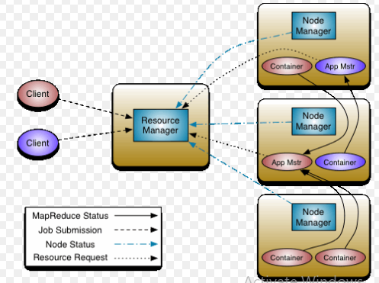

**Spark Architecture**

**Apache Spark** is an open-source, distributed computing system that provides a fast and general-purpose cluster-computing framework for big data processing. It has a flexible and extensible architecture that enables parallel and distributed data processing across a cluster of machines. Here is an overview of the key components and layers in the architecture of Apache Spark:

**Driver Program:**

Overview: The driver program is the entry point of a Spark application. It runs the main function and creates a SparkContext to coordinate the execution of tasks on the cluster.

Functionality:

Manages the execution flow of the Spark application.

Divides the application into tasks and schedules them for execution.

**SparkContext:**

Overview: SparkContext is the heart of a Spark application and serves as the client to connect to the Spark cluster manager.

Functionality:

Coordinates the execution of tasks on the cluster.

Manages the distribution of code and data across the worker nodes.

**Cluster Manager:**

Overview: The cluster manager is responsible for managing resources across the cluster and scheduling tasks.

Options: Spark supports different cluster managers, including Spark's standalone cluster manager, Apache Mesos, and Apache Hadoop YARN.

**Executor:**

Overview: Executors are worker nodes responsible for executing tasks on the cluster.

Functionality:

Runs tasks assigned by the driver program or ApplicationMaster (in the case of running on YARN).

Manages the execution environment and caches data in memory for iterative and interactive processing.

**Task:**

Overview: Tasks represent units of work that are sent to the executor nodes for execution.

Functionality:

Tasks perform computations on the data partitions distributed across the cluster.

Results of tasks are sent back to the driver program.

**RDD (Resilient Distributed Dataset):**

Overview: RDD is the fundamental data structure in Spark, representing an immutable, distributed collection of objects.

Functionality:

Provides fault tolerance through lineage information, allowing for the reconstruction of lost data.

Supports parallel processing and transformations through a series of transformations and actions.

**DAG (Directed Acyclic Graph):**

Overview: Spark's execution engine builds a directed acyclic graph to represent the logical execution plan of a Spark application.

Functionality:

Represents the sequence of transformations and actions on RDDs.

Optimizes the execution plan for better performance.

**Spark SQL, MLlib, GraphX:**

Overview: Spark includes high-level libraries for SQL, machine learning (MLlib), and graph processing (GraphX).

Functionality:

Provides APIs for performing SQL queries, machine learning tasks, and graph algorithms within the Spark framework.

Spark's architecture is designed to support various workloads, including batch processing, iterative algorithms, interactive queries, and machine learning. Its in-memory processing capabilities, fault tolerance, and ease of use make it a popular choice for big data analytics and data processing tasks. The flexibility to run on different cluster managers further enhances its versatility in different environments.

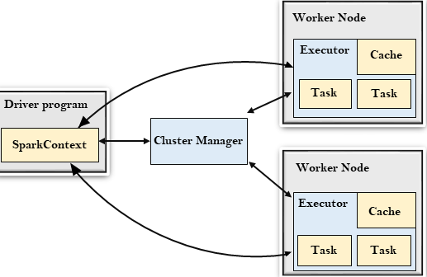

**Logical database plan and Physical database plan**

The terms "logical database plan" and "physical database plan" refer to different aspects of database design and implementation. Let's explore each concept and discuss how to choose the best plan for a particular scenario:

**Logical Database Plan:**

Overview:

The logical database plan focuses on the high-level organization and structure of the data without considering the specific implementation details.

It defines the relationships between data entities, attributes, and the constraints on the data.

It often involves the creation of entity-relationship diagrams (ERD) and the definition of data models, such as relational or NoSQL models.

Considerations:

Entity relationships (e.g., one-to-many, many-to-many).

Data integrity constraints (e.g., primary keys, foreign keys).

Normalization to reduce redundancy and improve data integrity.

Choice of data model (relational, NoSQL, etc.).

**Physical Database Plan:**

Overview:

The physical database plan involves the actual implementation details, including how data is stored, indexed, and accessed.

It considers factors like storage structures, indexing strategies, and optimization techniques for query performance.

It includes decisions about partitioning, indexing, clustering, and other physical storage considerations.

Considerations:

Storage structures (e.g., tables, indexes).

Indexing strategies for efficient data retrieval.

Partitioning of tables for scalability and performance.

Clustering of data to optimize certain types of queries.

Hardware considerations (e.g., disk types, memory, CPU).

**Transformations and Actions**

In Apache Spark, transformations and actions are two fundamental types of operations that can be applied to Resilient Distributed Datasets (RDDs), which are the primary abstraction for representing distributed collections of data. Understanding the distinction between transformations and actions is crucial for designing and building Spark applications.

**Transformations:**

Definition: Transformations are operations that create a new RDD from an existing one. They are performed lazily, meaning they are not executed immediately when called, but Spark keeps track of the transformation operations in a directed acyclic graph (DAG).

Characteristics:

Transformations are typically operations that transform the data, such as filtering, mapping, or aggregating.

Examples of transformations include map, filter, flatMap, union, reduceByKey, and groupByKey.

Transformations are immutable, meaning they create a new RDD rather than modifying the existing one.

Lazy Evaluation:

Transformations are lazily evaluated, meaning they are not executed until an action is called. This allows Spark to optimize the execution plan.

**Actions:**

Definition: Actions are operations that trigger the execution of transformations and return a value or produce a side effect, such as writing data to an external system. Actions are the operations that actually trigger the computation of the RDD lineage.

Characteristics:

Actions are operations that initiate the computation and return a result to the driver program or write data to an external storage system.

Examples of actions include collect, count, reduce, saveAsTextFile, foreach, and take.

Eager Evaluation:

Actions lead to the actual execution of the DAG of transformations. They are not lazily evaluated; instead, they force the computation of the entire lineage.

**Execution Flow:**

Transformations:

Transformations build a DAG of execution plans, specifying how data should be transformed.

Spark optimizes this DAG for efficient execution but doesn't actually compute the result until an action is called.

Actions:

Actions trigger the execution of the DAG created by transformations.

The execution plan is translated into a physical execution plan, and the computation is performed.

Choosing Between Transformations and Actions:

Use Transformations for Data Transformation:

Apply transformations to shape and process the data into the desired format.

Use Actions to Trigger Computations:

Use actions when you need to retrieve results or perform operations that require the execution of transformations.

Lazy Evaluation Benefit:

The lazy evaluation of transformations allows Spark to optimize the execution plan, leading to more efficient processing.

Understanding the distinction between transformations and actions is crucial for designing efficient and optimized Spark applications. Transformations define the logical structure of the computation, and actions trigger the actual execution of that computation.

**RDD and DAG**

**RDD (Resilient Distributed Dataset):**

Definition:

RDD is a fundamental data structure in Apache Spark, representing an immutable, distributed collection of objects that can be processed in parallel across a cluster.

Characteristics:

Resilient: RDDs are fault-tolerant. If a partition is lost due to node failure, Spark can recover the lost data by recomputing the partition using lineage information.

Distributed: RDDs are distributed across multiple nodes, allowing for parallel processing.

Immutable: RDDs are read-only and cannot be modified once created. Transformations on RDDs create new RDDs.

Lazy Evaluation: Transformations on RDDs are lazily evaluated, executed only when an action is triggered.

Partitioning: RDDs are divided into partitions, and each partition can be processed independently on a separate node.

Use Cases:

Low-level, fine-grained control over distributed data processing.

Complex and custom data processing scenarios.

Situations where explicit control over data partitions and processing is required.

**DAG (Directed Acyclic Graph):**

Definition:

A DAG is a graph data structure that consists of nodes (vertices) and directed edges. In the context of Apache Spark, a DAG represents the logical execution plan of a computation.

Characteristics:

Directed: Edges in the graph have a direction, indicating the flow of data or dependencies between stages of computation.

Acyclic: The graph has no cycles, meaning there is no circular dependency in the computation flow.

Stages: The DAG is divided into stages, where each stage represents a set of transformations that can be executed in parallel.

Optimization: Spark's Catalyst optimizer generates an optimized execution plan in the form of a DAG to improve performance.

Use Cases:

Representing the logical execution plan of Spark applications.

Visualizing and understanding the dependencies and flow of data in a distributed computation.

Optimization of execution plans by Spark's query optimizer.

**Relationship Between RDD and DAG:**

RDDs are the fundamental data abstraction in Spark, representing distributed collections of data.

When transformations are applied to RDDs, Spark creates a logical execution plan in the form of a DAG.

The DAG represents the sequence of transformations and actions needed to compute the final result.

Spark's Catalyst optimizer generates an optimized DAG, taking advantage of optimizations such as predicate pushdown, filter pushdown, and more.

The DAG is then translated into a physical execution plan, and the actual computation is performed on the cluster.

In summary, RDDs are the distributed data structures on which Spark computations are based, and the DAG is the logical and optimized execution plan that orchestrates the execution of transformations and actions on these RDDs in a distributed and fault-tolerant manner.