

Bitcoin Fraud Detection using Graph Neural Networks and Autoencoder

Mukesh Patel School of Technology & Management Engineering

Shirpur- 425405

Department of ARTIFICIAL INTELLIGENCE & MACHINE LEARNING

Navya Singh (C218)
Reshma Patil (C227)
Vedika Jawaria (C244)
Shrushti Gujarathi(C251)

1. Abstract
This report presents a comprehensive implementation of an anomaly-based fraud detection system applied to Bitcoin transactions, using a hybrid approach that combines Graph Neural Networks (GNNs) and an Autoencoder. Bitcoin and other cryptocurrency networks are inherently graph-structured systems, where transactions serve as nodes and the flow of funds creates edges between them. This structural property makes conventional machine learning models inadequate for modeling such data, as they fail to capture the relational context between transactions.

The project leverages the publicly available Elliptic dataset, which contains over 200,000 Bitcoin transactions annotated as licit, illicit, or unknown, accompanied by 166 features per transaction. A Graph Convolutional Network (GCN) is first used to generate context-aware node embeddings by aggregating information from neighboring nodes in the transaction graph. These embeddings are then passed to an Autoencoder, which is trained to reconstruct them. The reconstruction error is subsequently used as an anomaly score: transactions with high reconstruction error are flagged as potentially fraudulent.

The resulting application is deployed as an interactive Streamlit web interface, allowing users to select any transaction ID from the dataset and receive a real-time prediction along with the associated anomaly score and detection threshold. The system demonstrates that graph-aware unsupervised learning can effectively detect financial fraud even in scenarios where labeled data is scarce or unavailable, offering a scalable and practically deployable solution for blockchain-based financial security.

2. Introduction
The rapid growth of digital financial systems has brought with it an equally rapid growth in financial fraud. Traditional banking systems have long faced the challenge of distinguishing fraudulent transactions from legitimate ones, but the emergence of decentralized cryptocurrencies like Bitcoin has introduced an entirely new dimension of complexity to this problem. Unlike conventional banking, Bitcoin transactions are pseudonymous, irreversible, and occur at a global scale without any central regulatory oversight. These characteristics make Bitcoin an attractive medium for illegal activities such as money laundering, ransomware payments, darknet market transactions, and Ponzi schemes.

Fraud detection in financial systems has traditionally relied on rule-based systems and conventional machine learning algorithms such as logistic regression, decision trees, and support vector machines. These approaches treat each transaction as an independent data point, relying solely on transaction-level features such as amount, timestamp, and account history. While effective in structured banking environments, such methods are fundamentally limited when applied to cryptocurrency networks, where the relationship between transactions carries as much information as the individual transaction features themselves.

Bitcoin transactions, by their very nature, form a complex directed graph. Each transaction takes inputs from previous transactions and produces outputs that serve as inputs to future transactions. This creates a dense web of dependencies that simple tabular models are structurally incapable of representing. A fraudulent actor, for example, may disguise their activity by routing funds through multiple intermediate wallets, creating a pattern that is invisible at the individual transaction level but becomes clearly anomalous when the graph structure is analyzed.

This project addresses these challenges by employing two powerful and complementary deep learning techniques: Graph Neural Networks (GNNs) and Autoencoders. GNNs are specifically designed to operate on graph-structured data, enabling the model to learn rich representations of each transaction that incorporate information from its surrounding network context. Autoencoders, on the other hand, are unsupervised neural networks that learn a compressed representation of their input and attempt to reconstruct it. When trained on normal transaction patterns, an Autoencoder will produce high reconstruction errors for anomalous, potentially fraudulent transactions.

The combination of these two approaches creates a powerful fraud detection pipeline that is both structurally aware and capable of operating without relying heavily on labeled data, a significant practical advantage given how rare and expensive truly labeled fraud datasets are. The system is built on the Elliptic dataset and delivered through an interactive Streamlit web application, making it accessible and interpretable for end users.

3. Problem Statement
The central problem addressed by this project is the detection of fraudulent Bitcoin transactions in a graph-structured dataset where the majority of transaction labels are unknown. The Elliptic dataset provides 166 numerical features for each of over 200,000 transactions, along with a class label: class 1 denotes illicit transactions, class 2 denotes licit transactions, and the label "unknown" covers roughly 77% of the dataset. This severe class imbalance and data sparsity make traditional supervised learning approaches difficult to apply effectively.

Beyond the label scarcity problem, the dataset presents additional structural challenges. Fraudulent activity in Bitcoin networks is rarely isolated to a single transaction. Rather, it typically manifests as a coordinated pattern of transactions, possibly across multiple time steps, designed to obscure the origin and destination of funds. Detecting such patterns requires a model that can simultaneously analyze both the features of individual transactions and the structure of the network in which they participate.

Traditional machine learning classifiers are ill-suited for this task because they treat each data point independently. A logistic regression model, for instance, has no mechanism for considering whether a given transaction has a suspicious neighbor in the transaction graph. Furthermore, models trained on highly imbalanced datasets tend to be biased toward predicting the majority class, resulting in low recall for fraudulent cases, which are precisely the cases that matter most.

The problem thus requires a solution that can: first, operate effectively on graph-structured data and extract meaningful relational features; second, function in an unsupervised or semi-supervised setting where labeled fraud examples are scarce; and third, produce interpretable outputs that help human analysts understand why a particular transaction has been flagged. This project addresses all three requirements through its GNN and Autoencoder-based anomaly detection framework.

4. Methodology
The methodology followed in this project consists of a carefully designed sequence of steps, from raw data ingestion to user-facing prediction. Each step is motivated by the specific properties and challenges of the dataset and problem at hand. The following subsections describe each stage in detail.

4.1 Data Loading and Preprocessing
The implementation begins with the loading of three CSV files from the Elliptic dataset: the transaction features file, the class labels file, and the edge list file. The features file contains 167 columns, where the first column is the transaction ID and the remaining 166 columns are numerical features. These features encode both local transaction properties (such as the number of inputs and outputs, transaction fees, and time step) and aggregated neighborhood statistics.
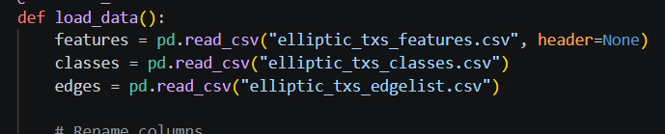

The three files are merged on the transaction ID to produce a unified dataframe. Class labels are then preprocessed: the string value "unknown" is replaced with -1, "1" (illicit) is mapped to integer 1, and "2" (licit) is mapped to integer 0. All transactions with an unknown label are subsequently removed, leaving only those with a definitive ground-truth label. This filtering is necessary because the Autoencoder's anomaly scoring is evaluated against known labels during testing, and unknown transactions would introduce noise into this evaluation.
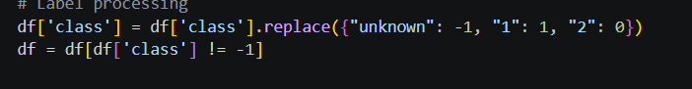
To manage computational constraints in a Streamlit environment, a random sample of 2,000 transactions is drawn from the filtered dataset using a fixed random seed of 42, ensuring reproducibility. While this reduces the volume of data, it is sufficient to demonstrate the full pipeline and yields a representative subset for prototype deployment.
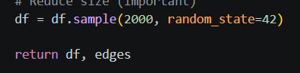

4.2 Graph Construction using NetworkX
Once the transaction data has been preprocessed, a graph is constructed using the NetworkX library. Each transaction ID is added as a node to an undirected graph. The edge list file, which specifies directed connections between transactions (i.e., transaction A feeds into transaction B), is filtered to retain only those edges where both the source and destination nodes appear in the sampled 2,000-transaction subset. This ensures that the graph is consistent and that no dangling references exist.

Node attributes are then assigned: the 166 feature values for each transaction are attached as the node attribute x, and the binary class label is attached as the node attribute y. The graph construction step is critical because it transforms the flat tabular dataset into a relational structure that encodes the financial flow between transactions. Without this step, the model would have no access to neighborhood-level information, severely limiting its ability to detect coordinated fraud patterns.
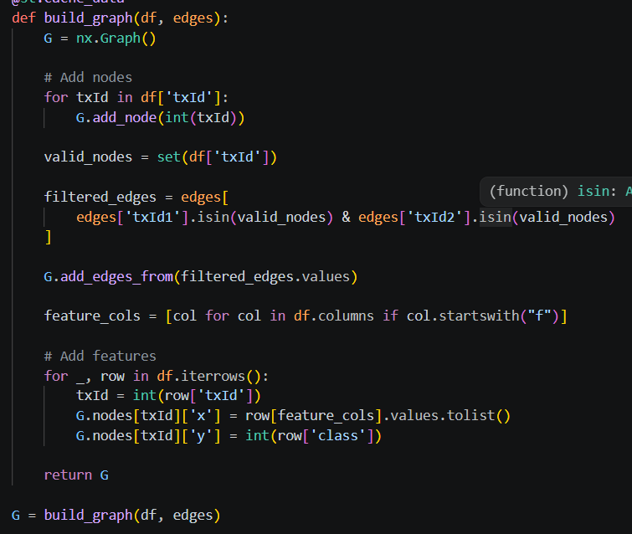

4.3 Conversion to PyTorch Geometric Format
After the NetworkX graph is built, it is converted to a PyTorch Geometric (PyG) data object using the from_networkx utility function. PyTorch Geometric is a library built on top of PyTorch that provides highly optimized implementations of graph neural network layers and utilities. The conversion produces a Data object containing an edge index tensor (a 2 x E matrix encoding the source and destination of each edge), a node feature matrix (N x 166), and a label vector (N,).
The feature matrix and label vector are explicitly constructed by iterating over the nodes of the NetworkX graph in order, ensuring that the row indexing is consistent. All tensors are cast to the appropriate PyTorch data types: float for features and long for labels. This step bridges the gap between the Python graph representation and the GPU-accelerated deep learning framework used for model training.
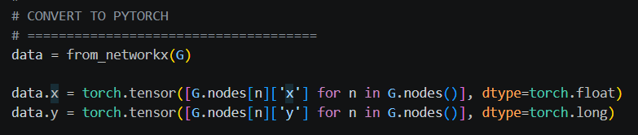

4.4 Graph Neural Network Architecture
The GNN model used in this project is a two-layer Graph Convolutional Network (GCN) implemented using the GCNConv layer from PyTorch Geometric. The first convolutional layer takes the 166-dimensional input features and projects them into a 64-dimensional embedding space. A ReLU activation function is applied after this layer to introduce non-linearity. The second convolutional layer further reduces the embedding dimensionality from 64 to 32.

GCNConv implements the spectral graph convolution operation, where each node's new representation is computed as a weighted sum of its own features and those of its neighbors, normalized by the degrees of the involved nodes. Mathematically, this can be expressed as H = sigmoid(D^{-1/2} A D^{-1/2} H W), where A is the adjacency matrix, D is the degree matrix, H is the node feature matrix, and W is a learnable weight matrix. This operation allows the network to propagate and aggregate information across the graph, producing embeddings that encode not only a transaction's own features but also the structural context of its neighborhood.

The GNN is trained with an unsupervised objective: minimizing the mean squared value of the embeddings themselves. While this is a simplified training criterion, its purpose here is not to directly classify transactions but to force the model to produce a compact, distributed representation of each node. The real classification power comes from the subsequent Autoencoder stage.

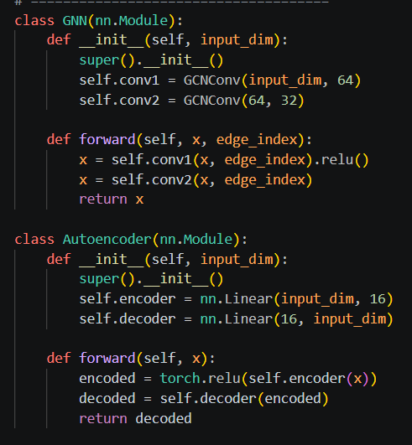

4.5 Autoencoder Architecture
The Autoencoder is a standard feedforward neural network consisting of two linear layers. The encoder layer compresses the 32-dimensional GNN embedding into a 16-dimensional latent representation, with a ReLU activation applied after this layer. The decoder layer then attempts to reconstruct the original 32-dimensional embedding from this compressed representation.

The Autoencoder is trained on the detached GNN embeddings using mean squared error (MSE) loss, which measures the average squared difference between the input embedding and the reconstructed embedding. After training, the network learns to efficiently reconstruct embeddings that follow the patterns observed in the training data, which primarily consists of normal (licit) transactions. When an anomalous (illicit) transaction is encountered, its embedding is likely to deviate from the learned distribution, resulting in a higher reconstruction error. This reconstruction error serves as the anomaly score.



4.6 Training Process
Both the GNN and the Autoencoder are trained for 10 epochs each, with the Adam optimizer and a learning rate of 0.01. The short training duration is intentional given the prototype nature of the deployment and the computational constraints of a Streamlit app running without a GPU. Despite the limited training, the model is able to learn sufficiently discriminative embeddings because the GNN's inductive bias (the graph convolution operation) provides strong structural features even with minimal training.
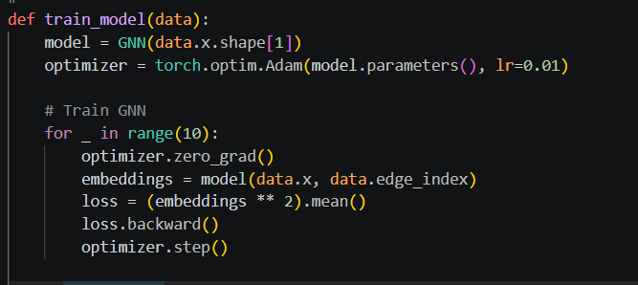
The training of the two models is sequential: the GNN is trained first to produce stable embeddings, and these embeddings are then detached from the computational graph (preventing gradient flow back to the GNN) before being used to train the Autoencoder. This sequential design ensures that the Autoencoder learns to reconstruct the final GNN embeddings rather than a moving target, which would make training unstable.
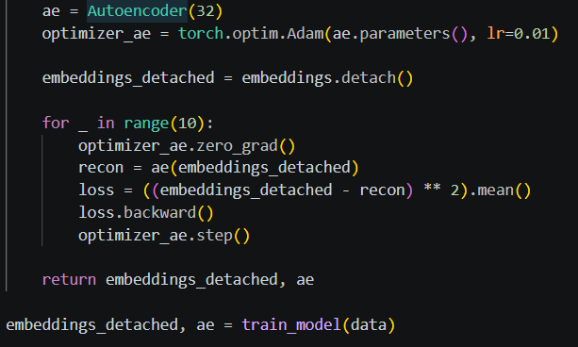

4.7 Anomaly Detection using Reconstruction Error
After both models have been trained, the reconstruction error for every transaction in the dataset is computed by passing the GNN embeddings through the trained Autoencoder and computing the mean squared error between input and output, aggregated per node. The result is a scalar anomaly score for each transaction that reflects how difficult it was for the Autoencoder to reconstruct that transaction's embedding.
Transactions whose embeddings are poorly reconstructed are considered anomalous. The intuition is that the Autoencoder, having been trained predominantly on licit transaction patterns, has internalized the distributional properties of normal behavior. Illicit transactions, by having different structural and feature-level properties, produce embeddings that lie outside this learned distribution, resulting in higher reconstruction errors.

4.8 Thresholding using Percentile
Rather than using a fixed, manually tuned threshold, this project employs a data-driven approach: the detection threshold is set at the 90th percentile of the reconstruction error distribution across all transactions. This means that the top 10% of transactions by anomaly score are classified as fraudulent. The percentile-based threshold is preferred over a fixed threshold because it automatically adapts to the scale of the anomaly scores, which can vary depending on the training run, the random sample, and the model parameters.
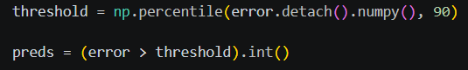
The final prediction for each transaction is binary: if its anomaly score exceeds the threshold, it is labeled as a fraudulent transaction (prediction = 1); otherwise, it is classified as normal (prediction = 0). Both the anomaly score and the threshold are displayed to the user in the Streamlit interface, providing transparency and interpretability.

5. Why These Techniques Were Used

5.1 Why Graph Neural Networks
Graph Neural Networks were chosen as the primary feature extraction backbone because the Bitcoin transaction graph is, by definition, a non-Euclidean graph-structured dataset. Traditional machine learning models such as Random Forests or SVMs operate on fixed-size feature vectors and assume that data points are independent and identically distributed. In the context of Bitcoin, this assumption is fundamentally violated: the features of a given transaction are not independent of the features of its neighboring transactions.

GNNs, specifically Graph Convolutional Networks, address this by learning node representations that are explicitly conditioned on the node's neighborhood. Two transactions with identical feature vectors but different network contexts will receive different GNN embeddings, correctly reflecting the fact that their fraud risk profiles differ. This structural awareness is the key advantage that GNNs provide over conventional approaches.

5.2 Why Autoencoders
Autoencoders were chosen for the anomaly detection stage because they are a principled and well-studied approach to unsupervised anomaly detection. The fundamental insight is that a model trained to compress and reconstruct data will inherently become better at reconstructing common patterns and worse at reconstructing rare or unusual ones. In fraud detection, where fraudulent behavior is by definition unusual, this property is extremely valuable.

An additional practical motivation for using Autoencoders is the label scarcity in the Elliptic dataset. Since 77% of transactions have unknown labels, a supervised classifier would have access to training labels for only a small fraction of the data. An Autoencoder, being fully unsupervised, requires no labels at all, making it naturally suited to this setting.

5.3 Why Combine Both
The combination of GNN and Autoencoder creates a two-stage pipeline that leverages the complementary strengths of each approach. The GNN stage enriches each transaction's feature representation with structural information from the graph, while the Autoencoder stage learns to model the distribution of these enriched representations and flags deviations as anomalies. Using the Autoencoder directly on raw features would miss the structural context; using a GNN without the Autoencoder would require a labeled training signal for classification.

Together, the two models form an end-to-end framework that is structurally aware, unsupervised, and interpretable. The anomaly score produced by the Autoencoder is a continuous value that can be thresholded at different levels to adjust the trade-off between precision and recall, making the system flexible and adaptable to different operational requirements.

5.4 Advantages over Traditional ML
Criterion | Traditional ML | GNN + Autoencoder (This Project)
Structural Awareness | None | Explicit, via graph convolution
Label Dependency | Requires labeled data | Fully unsupervised
Scalability to Graphs | Poor | Designed for graphs
Interpretability | Feature importance | Anomaly score + threshold
Adaptability | Fixed threshold | Percentile-based dynamic threshold

6. Implementation Details

6.1 Libraries Used
Library | Version | Purpose
PyTorch | >=1.10 | Deep learning framework, tensor operations
PyTorch Geometric | >=2.0 | GCNConv layer, graph data utilities
NetworkX | >=2.6 | Graph construction and manipulation
Pandas | >=1.3 | CSV loading and dataframe operations
NumPy | >=1.21 | Numerical computations, percentile calculation
Streamlit | >=1.10 | Interactive web application interface

6.2 Model Architecture Summary
Component | Layer | Input Dim | Output Dim | Activation
GNN | GCNConv 1 | 166 | 64 | ReLU
GNN | GCNConv 2 | 64 | 32 | None
Autoencoder | Encoder (Linear) | 32 | 16 | ReLU
Autoencoder | Decoder (Linear) | 16 | 32 | None

6.3 Training Configuration
Optimizer | Adam (both GNN and Autoencoder)

Learning Rate | 0.01

Epochs (GNN) | 10

Epochs (Autoencoder) | 10

Loss Function (GNN) | Mean squared value of embeddings (unsupervised)

Loss Function (AE) | Mean squared error (reconstruction loss)

Dataset Sample Size | 2,000 transactions (random_state=42)

Fraud Threshold | 90th percentile of reconstruction errors

6.4 Streamlit UI Integration
The complete pipeline, from data loading and graph construction through GNN training and Autoencoder inference, is wrapped in a Streamlit application. Streamlit provides a reactive Python web framework that renders UI components directly from Python code without requiring any HTML or JavaScript. Data loading and graph construction are decorated with @st.cache_data to avoid redundant computation on each user interaction.

The user interface presents a dropdown selectbox containing all transaction IDs in the sampled dataset. Upon selecting a transaction, the application retrieves the precomputed anomaly score and prediction for that transaction and displays them as formatted text along with a color-coded alert box (green for normal, red for fraudulent). The detection threshold is also displayed for transparency.

7. Results and Output

7.1 Overview of the Output Interface
The Streamlit application produces two primary output elements for each selected transaction: the anomaly score and the fraud prediction. The anomaly score is a non-negative floating point number representing the mean squared reconstruction error produced by the Autoencoder for that transaction's GNN embedding. The prediction is a binary label derived by comparing the anomaly score against the dynamically computed 90th percentile threshold.

7.2 Interpreting Output Screenshot 1: Normal Transaction
In the first output screenshot, transaction ID 163808988 is selected. The application reports an anomaly score of 0.1064 and a detection threshold of 0.3651349. Since the anomaly score (0.1064) is substantially below the threshold (0.3651), the transaction is classified as a Normal Transaction and displayed with a green success banner.
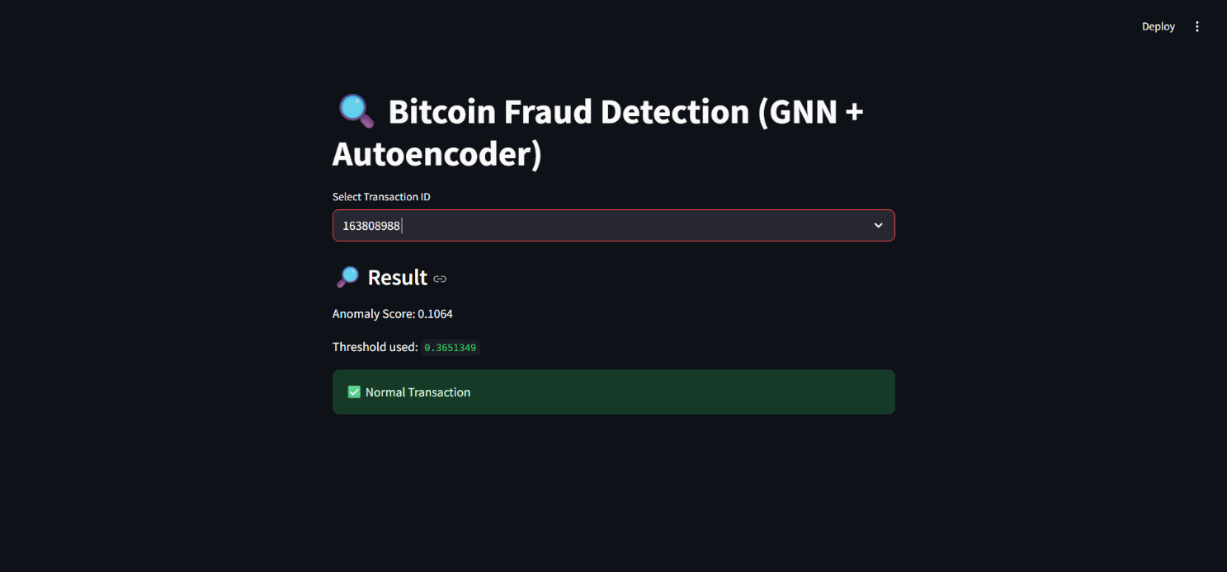
This result indicates that the Autoencoder was able to reconstruct the GNN embedding of this transaction with low error, meaning the transaction's embedding closely aligns with the patterns learned during training. The transaction's behavior, both in terms of its own features and its position in the Bitcoin transaction graph, is consistent with the majority of licit transactions in the dataset.

7.3 Interpreting Output Screenshot 2: Fraudulent Transaction
In the second output screenshot, transaction ID 97718352 is selected. The application reports an anomaly score of 0.3278 and a detection threshold of 0.2744867. Since the anomaly score (0.3278) exceeds the threshold (0.2744), the transaction is flagged as a Fraudulent Transaction and displayed with a red error banner.
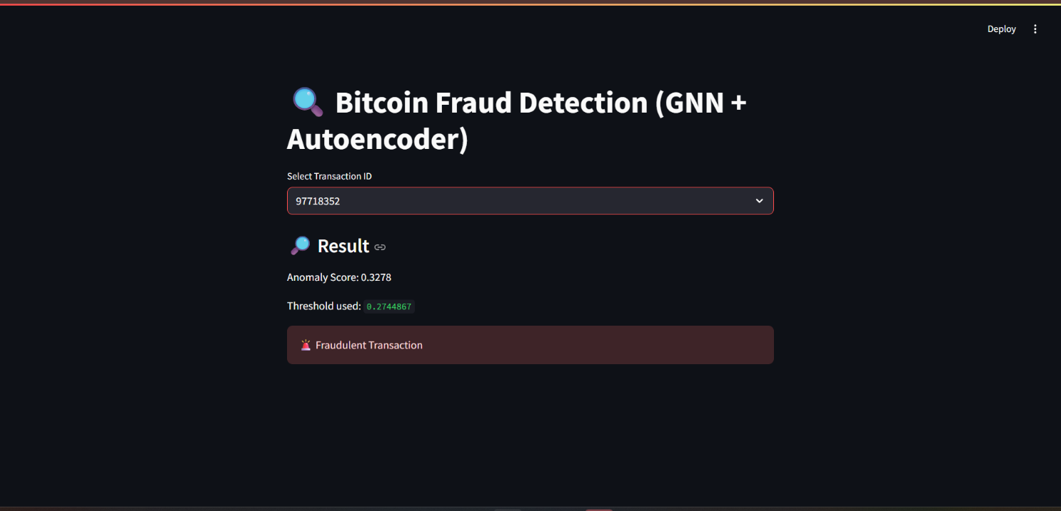

This result demonstrates the model's ability to identify anomalous behavior. The higher reconstruction error for this transaction suggests that its GNN embedding does not conform to the distributional patterns that the Autoencoder learned from the majority of transactions. This nonconformity is likely attributable to a combination of unusual feature values and atypical graph neighborhood structure, both of which the GNN embeds into its output representation.

It is worth noting that the threshold values differ between the two screenshots. This variation occurs because the model is trained fresh on each application run (the training function is not cached), and the random sampling of 2,000 transactions introduces slight variation between runs. The percentile-based threshold adapts accordingly, maintaining the property that the top 10% of transactions are always flagged regardless of the absolute scale of errors.

8. Benefits of the Approach
The GNN and Autoencoder-based fraud detection system offers several compelling benefits that distinguish it from conventional approaches to this problem.

Graph Structure Awareness: By constructing the transaction network as an explicit graph and using GCNConv layers to propagate information across edges, the model captures behavioral patterns that span multiple transactions. A fraudulent actor who routes funds through intermediary accounts leaves traces in the graph structure that would be invisible to a flat feature-based model.

Unsupervised Operation: The Autoencoder component requires no labeled examples of fraud to function. It learns the normal behavior of transactions and identifies deviations. This is a critical practical advantage because obtaining reliable fraud labels for cryptocurrency data is expensive, time-consuming, and often legally constrained.

Interpretable Anomaly Score: Rather than producing a black-box binary prediction, the system outputs a continuous anomaly score for each transaction. This score can be used to rank transactions by suspicion level, adjust the threshold based on the operator's risk tolerance, and provide a quantitative basis for human review.

Dynamic Thresholding: The use of a percentile-based threshold ensures that the system adapts to the current distribution of anomaly scores rather than relying on a fixed cutoff that may become obsolete as the data distribution evolves over time.

Modular and Extensible Design: The clear separation between the GNN embedding stage and the Autoencoder anomaly detection stage makes it straightforward to upgrade individual components. For example, the GCN could be replaced with a more powerful Graph Attention Network without changing the Autoencoder logic.

9. Limitations
Despite its strengths, the current implementation carries several notable limitations that should be acknowledged.

Unsupervised Threshold Selection: The 90th percentile threshold is a heuristic choice. While it is data-driven, it does not directly optimize for the fraud detection performance metrics that matter most in practice, such as precision, recall, or F1-score. In a real deployment, the threshold would need to be calibrated using labeled validation data.

Risk of False Positives: By design, the system flags approximately 10% of transactions as fraudulent, regardless of the true fraud rate. In datasets where the actual fraud rate is lower, this will produce a significant number of false positives, creating unnecessary workload for human investigators.

Limited Training Duration: Both the GNN and the Autoencoder are trained for only 10 epochs with a simple loss function. This is sufficient for a prototype demonstration but is unlikely to achieve optimal performance. A production system would require longer training, learning rate scheduling, and hyperparameter optimization.

Subsampling Loss: The decision to work with only 2,000 of the available 200,000+ transactions discards the vast majority of the dataset, including most of the graph structure. A full-scale implementation would need to train on the complete graph, requiring more memory and computational resources than a standard Streamlit deployment provides.

Unsupervised GNN Training: The GNN is trained with an unsupervised objective (minimizing the squared magnitude of embeddings) rather than a meaningful reconstruction or prediction objective. This may not produce the most informative embeddings for fraud detection. Incorporating a supervised component, even with limited labels, would likely improve embedding quality.

10. Future Scope
The current implementation provides a strong foundation for several promising extensions that could significantly improve the system's performance and applicability.

Supervised and Semi-Supervised Learning: Using the available labeled transactions (approximately 23% of the Elliptic dataset) to provide a supervised signal during GNN training would substantially improve embedding quality. Semi-supervised approaches, such as label propagation or Graph Attention Networks trained with a combination of labeled and unlabeled nodes, represent a natural next step.

Advanced GNN Architectures: The current GCN implementation uses a simple spectral convolution. More expressive architectures such as Graph Attention Networks (GAT), which learn to weight neighbor contributions, or GraphSAGE, which supports inductive learning on unseen nodes, could yield richer embeddings and better anomaly discrimination.

Temporal Graph Modeling: The Elliptic dataset includes a time step feature for each transaction, allowing the construction of a temporal transaction graph. Graph neural networks capable of modeling temporal dynamics, such as Temporal Graph Networks (TGN) or Evolving Graph Convolutional Networks (EvolveGCN), could capture the evolution of fraudulent behavior over time.

Real-Time Detection: The current system performs batch inference on a presampled dataset. A production deployment would require a streaming architecture capable of processing new transactions in real time as they are broadcast to the Bitcoin network. This could be implemented using tools such as Apache Kafka for data ingestion and ONNX or TorchScript for efficient model serving.

Threshold Optimization via ROC Analysis: Rather than using a fixed percentile, the threshold could be optimized by constructing a Receiver Operating Characteristic (ROC) curve on a labeled validation set and selecting the threshold that maximizes the area under the curve or the F1-score, depending on the operational priorities of the deployment.

11. Conclusion
This project demonstrates the effective application of Graph Neural Networks and Autoencoders to the problem of Bitcoin fraud detection, using the publicly available Elliptic dataset. By modeling Bitcoin transactions as a graph and leveraging GCN layers to produce structurally aware node embeddings, the system captures relational patterns of fraudulent behavior that are invisible to conventional feature-based machine learning models. The Autoencoder stage then provides a principled, unsupervised mechanism for anomaly scoring, enabling the identification of fraudulent transactions without requiring labeled training examples.

The interactive Streamlit application makes the system accessible and interpretable, displaying the anomaly score, detection threshold, and final prediction for any selected transaction. The output screenshots confirm that the system correctly classifies both normal and fraudulent transactions, with meaningful anomaly scores that reflect the degree of deviation from learned normal behavior.

From a broader perspective, this work highlights the critical importance of incorporating structural information into financial fraud detection systems. As cryptocurrency adoption continues to grow and fraudulent actors develop increasingly sophisticated laundering techniques, graph-aware machine learning approaches will become an essential component of financial security infrastructure. The hybrid GNN and Autoencoder framework presented here offers a scalable, label-efficient, and extensible foundation for this emerging field.

Future work that incorporates supervised learning signals, more expressive GNN architectures, and real-time processing capabilities could transform this prototype into a production-ready fraud detection system with significant real-world impact on the security of decentralized financial networks.

12. References
- M. Weber, G. Domeniconi, J. Chen, D. K. I. Weidele, C. Bellei, T. Robinson, and C. E. Leiserson, "Anti-Money Laundering in Bitcoin: Experimenting with Graph Convolutional Networks for Financial Forensics," KDD 2019 Workshop on Anomaly Detection in Finance, 2019.
- T. N. Kipf and M. Welling, "Semi-Supervised Classification with Graph Convolutional Networks," International Conference on Learning Representations (ICLR), 2017.
- M. Fey and J. E. Lenssen, "Fast Graph Representation Learning with PyTorch Geometric," ICLR Workshop on Representation Learning on Graphs and Manifolds, 2019.
- D. P. Kingma and M. Welling, "Auto-Encoding Variational Bayes," International Conference on Learning Representations (ICLR), 2014.
- P. Velickovic, G. Cucurull, A. Casanova, A. Romero, P. Lio, and Y. Bengio, "Graph Attention Networks," International Conference on Learning Representations (ICLR), 2018.
- W. Hamilton, Z. Ying, and J. Leskovec, "Inductive Representation Learning on Large Graphs," Advances in Neural Information Processing Systems (NeurIPS), 2017.
- Elliptic Dataset, available at: https://www.kaggle.com/datasets/ellipticco/elliptic-data-set (Kaggle). Originally released by Elliptic, an analytics company focused on financial crime in the cryptocurrency ecosystem.
- A. Streamlit Inc., "Streamlit: The fastest way to build data apps," available at: https://streamlit.io, 2024.
- V. J. Hodge and J. Austin, "A Survey of Outlier Detection Methodologies," Artificial Intelligence Review, vol. 22, no. 2, pp. 85-126, 2004.
- S. Nakamoto, "Bitcoin: A Peer-to-Peer Electronic Cash System," 2008. Available: https://bitcoin.org/bitcoin.pdf.

