

**Placement Empowerment Program**

***Cloud Computing and DevOps Centre***

Write a Shell Script to Manage Cloud Resources: Create a script to launch, stop, and terminate cloud VMs using the CLI.

Name: Reshma P Department: ADS



# Introduction

Managing cloud resources efficiently is critical in today's clouddriven IT landscape. AWS Command Line Interface (CLI) provides a powerful tool for interacting with AWS services programmatically. By leveraging shell scripting, we can automate repetitive tasks like launching, stopping, and terminating virtual machines (VMs). This Proof of Concept (POC) demonstrates the use of AWS CLI integrated with a shell script to simplify VM management, showcasing automation's role in reducing manual effort and increasing productivity.

# Overview

This POC focuses on creating a shell script to manage AWS EC2 instances using the AWS CLI. The script allows users to:

1. Launch new EC2 instances with pre-configured settings.
2. Stop running EC2 instances to optimize costs.
3. Terminate EC2 instances when no longer needed.
4. List currently running EC2 instances for better resource tracking.

The script uses a menu-driven approach, where users can choose specific actions, making it user-friendly and flexible. It is tested using Git Bash on Windows and adheres to AWS Free Tier limitations to ensure cost-effective implementation.

# Objective

The primary objective of this POC is to:

1. Automate the management of AWS EC2 instances through shell scripting.
2. Provide an easy-to-use interface for launching, stopping, terminating, and listing instances.
3. Demonstrate the capabilities of AWS CLI and shell scripting for cloud resource management.
4. Build a foundational understanding of automation practices in cloud computing.

# Importance

1. **Efficiency**: Automating cloud resource management reduces time and effort spent on manual tasks.
2. **Cost Optimization**: The ability to stop or terminate unused VMs prevents unnecessary expenses, adhering to best practices in cloud cost management.
3. **Scalability**: Scripting provides a scalable solution for managing multiple resources simultaneously.
4. **Skill Development**: Enhances your technical expertise in AWS CLI, scripting, and cloud automation, which are in high demand in the IT industry.
5. **Foundation for Advanced Automation**: Serves as a stepping stone to more complex automation tasks, such as infrastructure as code (e.g., using tools like Terraform or CloudFormation).

**Step-by-Step Overview** Step 1:

* 1. Go to [AWS Management Console.](https://aws.amazon.com/console/)
  2. Enter your username and password to log in.

Step 2:

Make sure your AWS CLI is installed and configured.

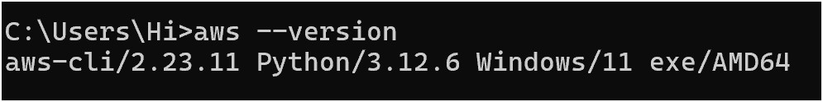

Step 3:

1. Go to the **EC2 Dashboard**.

1. In the left sidebar, click **Key Pairs** under **Network & Security**.

1. Click **Create Key Pair**.

1. Enter a name (e.g., MyKeyPair) and choose **.pem** format.

1. Download the .pem file and keep it safe—you’ll need it to SSH into your instance.

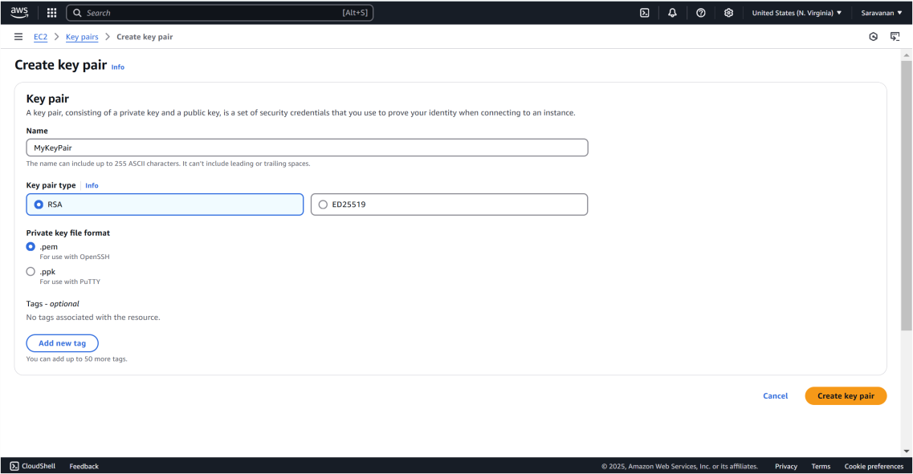

Step 4:

1. Go to the **AWS EC2 Dashboard**.

1. In the left sidebar, click **Security Groups**.

1. Click **Create Security Group**.

1. Enter a name (e.g., MySecurityGroup) and a description.

1. Add the following inbound rule:

* **Type**: SSH
* **Protocol**: TCP
* **Port Range**: 22
* **Source**: Anywhere (0.0.0.0/0) (Note the Id after created)

Step 5:

1. In the **AWS EC2 Dashboard**, click **Subnets** in the left sidebar.

1. Note the **Subnet ID** of one of your subnets. Example: subnet0abcd1234.

Step 6:

1. In the **AWS EC2 Dashboard**, click **Launch Instance**.

1. Search for "Amazon Linux 2" and select it.

1. Note the **AMI ID** (e.g., ami-0c02fb55956c7d316).

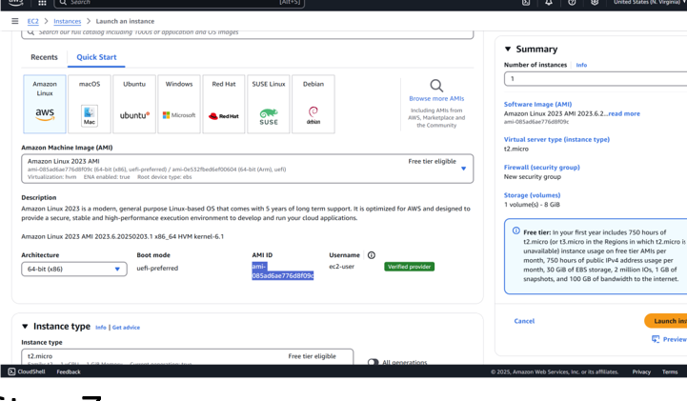

Step 7:

Here's a simple shell script to manage cloud resources (launch, stop, and terminate VMs) using the AWS CLI.

Open **Notepad.**

Paste the script into the Notepad.

Replace the placeholders (YourKeyPairName, YourSecurityGroupID, etc.) with your actual values:

* **Key Pair Name**: Replace with the name of your key pair.
* **Security Group ID**: Replace with your security group ID.
* **Subnet ID**: Replace with your subnet ID. •**AMI ID**: Replace with the AMI ID.

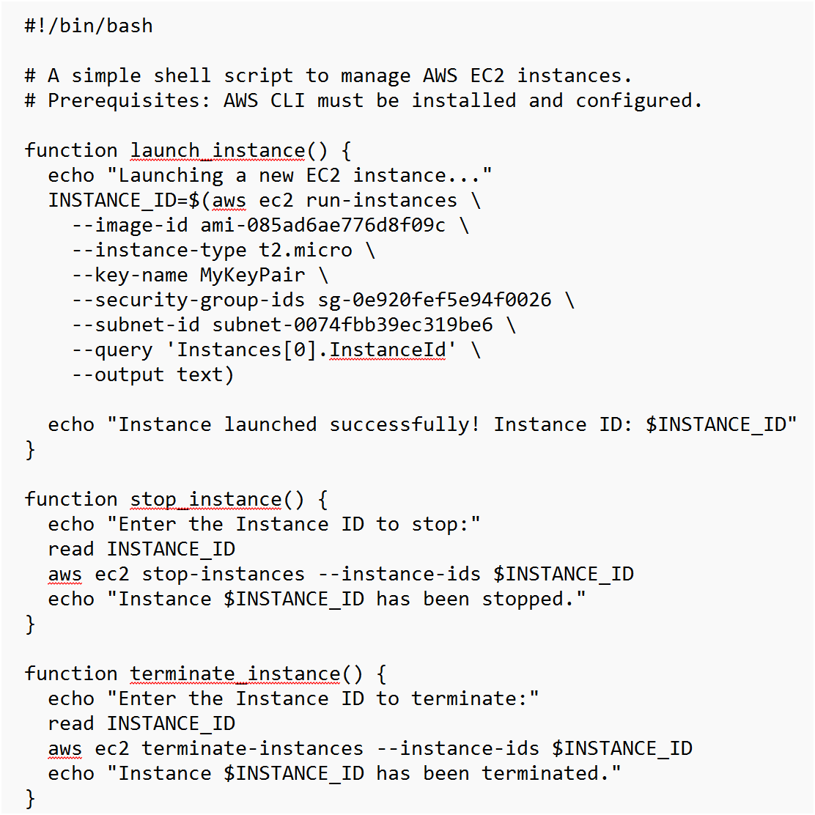

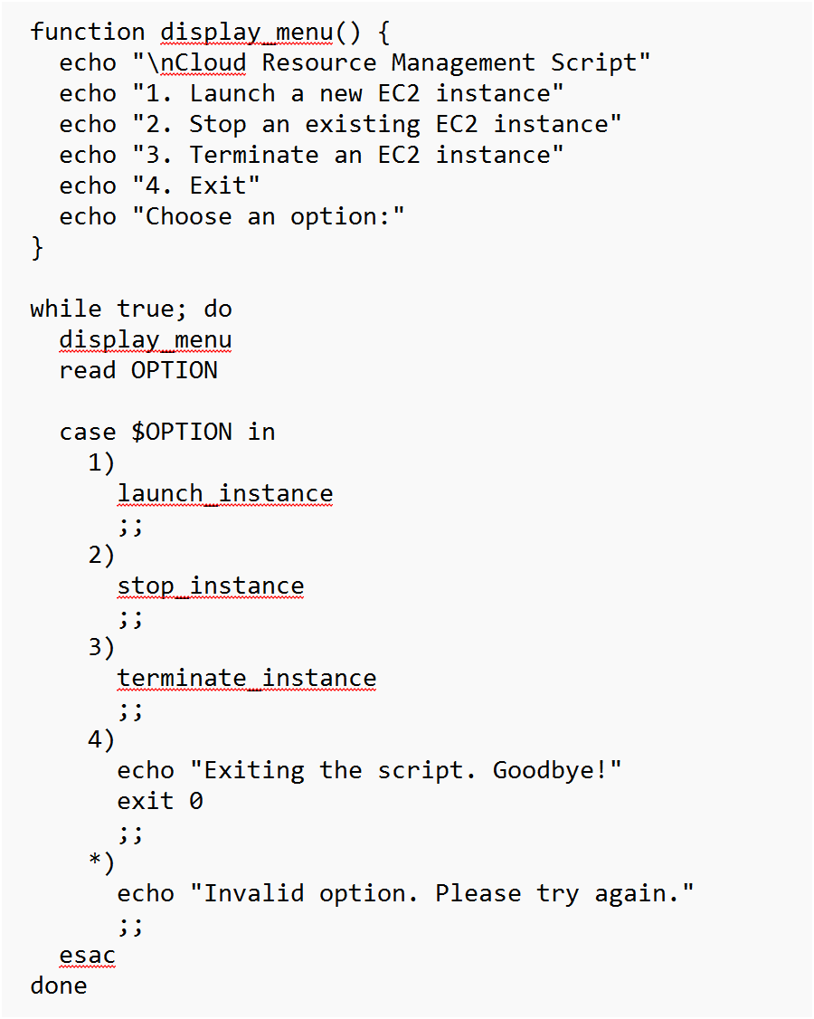

Step 8:

1. Click **File → Save As**.

1. In the **Save As** window:
   * **File Name**: Enter manage_cloud_resources.sh.
   * **Save as type**: Select **All Files** from the dropdown.
   * **Encoding**: Select **UTF-8** (if available). •**Location**: Save it in Desktop.

**Important**: Make sure the file has the .sh

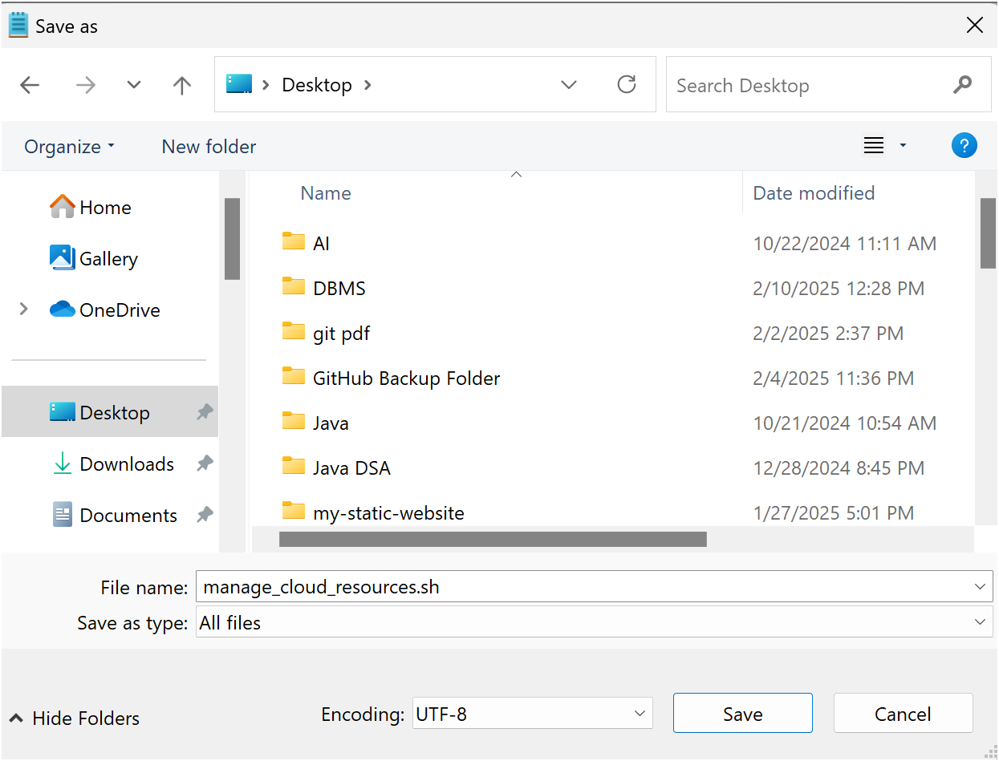

Step 9:

1. Open Git Bash
2. Run the following command in Git Bash:

**chmod +x manage_cloud_resources.sh**

Run the script using:

**./manage_cloud_resources.sh**

Step 10:

1. Select 1 to launch an instance.
2. The script will create an EC2 instance and display its **Instance ID**. Make a note of this ID for the next steps.

1. Select 2 to stop an instance.

1. Enter the **Instance ID** of the instance you launched earlier.
2. The script will stop the instance.

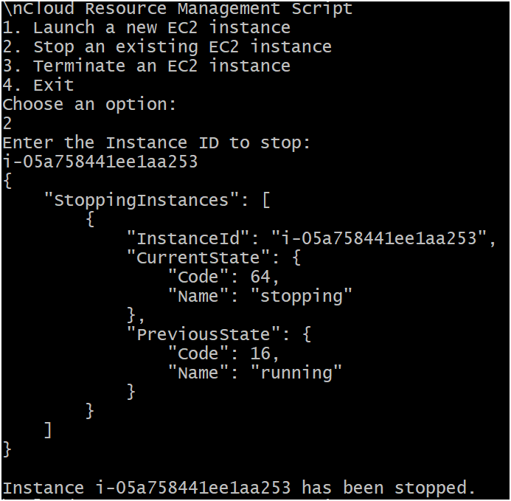

1. Select 3 to terminate an instance.

1. Enter the **Instance ID** of the instance you launched earlier.
2. The script will terminate the instance.

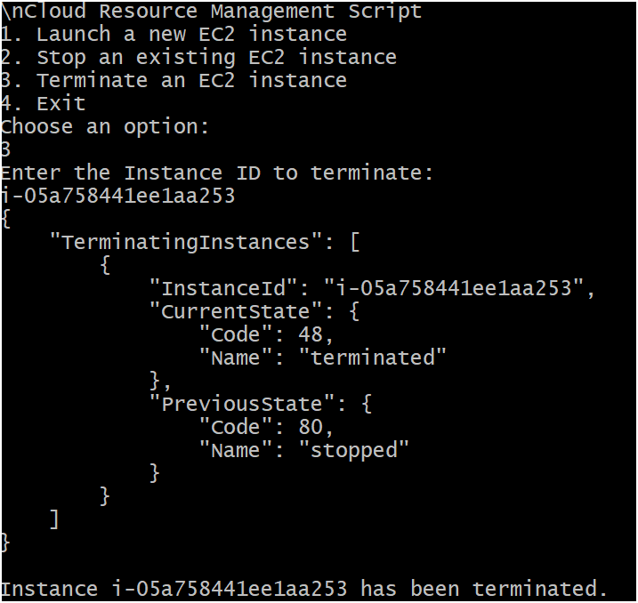

Successfully completed the PoC!

# Outcome

By completing this POC on managing AWS cloud resources using the CLI and a shell script, you will:

1. Automate essential EC2 instance management tasks, including launching, stopping, and terminating VMs, through a menu-driven shell script.
2. Efficiently manage multiple EC2 instances using AWS CLI commands integrated with shell scripting, ensuring scalability and consistency.
3. Gain hands-on experience with AWS CLI for interacting with cloud resources programmatically, building your foundation for advanced automation.
4. Enhance your skills in shell scripting and cloud resource management, critical for DevOps and cloud engineering roles.
5. Understand key AWS services like EC2, IAM (for key pairs), and security groups, along with best practices in cloud cost optimization.
6. Validate the practical implementation of a script by successfully launching, stopping, and terminating multiple EC2 instances.