EXERCISE – INTRODUCTION TO DATABASES

Problem Statement:

There can be multiple customers, who can place multiple orders on the site. Now a sales person can handle these orders will distribute into multiple sales persons (One order will be assign to one salesperson only). So a sales person can have multiple orders of multiple customers

- Create Database

Database named dbsalesexec created.

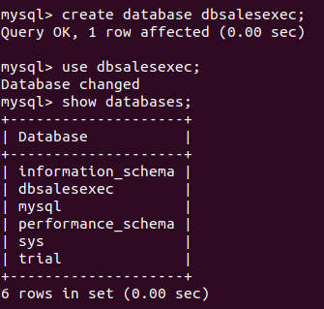

- Design Schema

Schema of 5 tables described using the comman desc
5 tables -

1.customer – containing the basic details of customer
2.Order - containing basic details of order along with customerId and salespersonId
3.Salesperson – containing the basic details of salesperson
4.Product – contains basic detail of product which are ordered by customer
5.OrderProdMapper – contains the productId coressponding to each order along with the quantity.

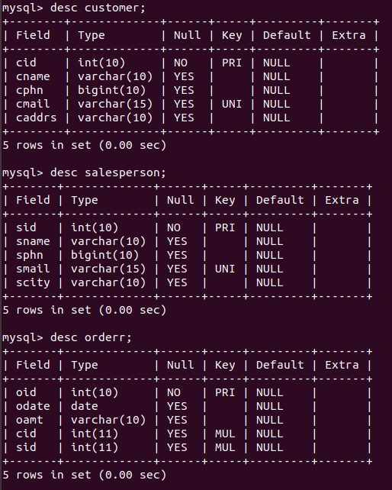
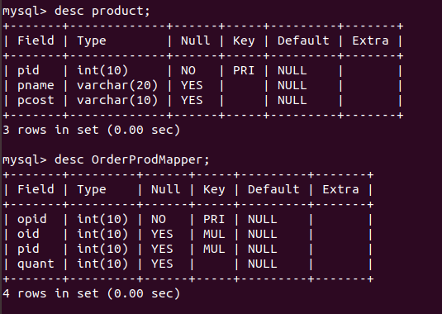
- Create tables

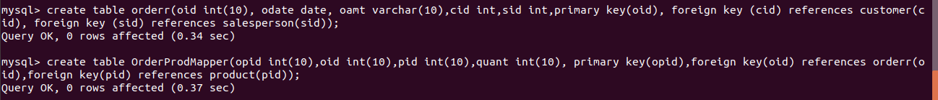

- Insert sample data

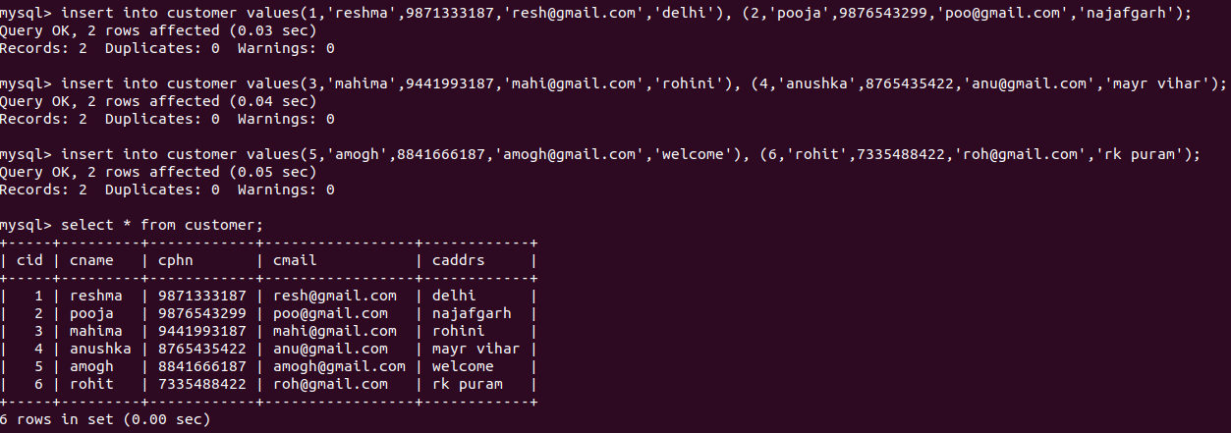
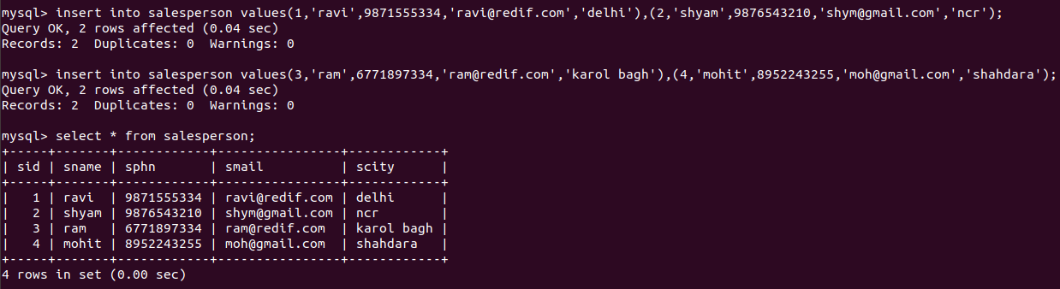

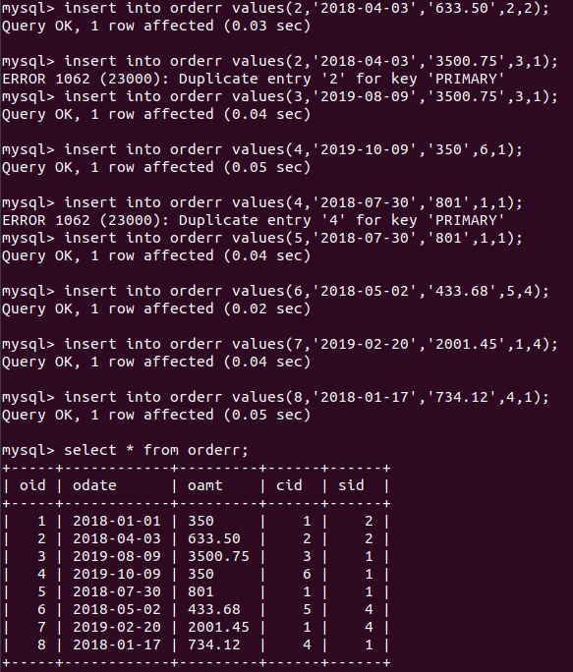
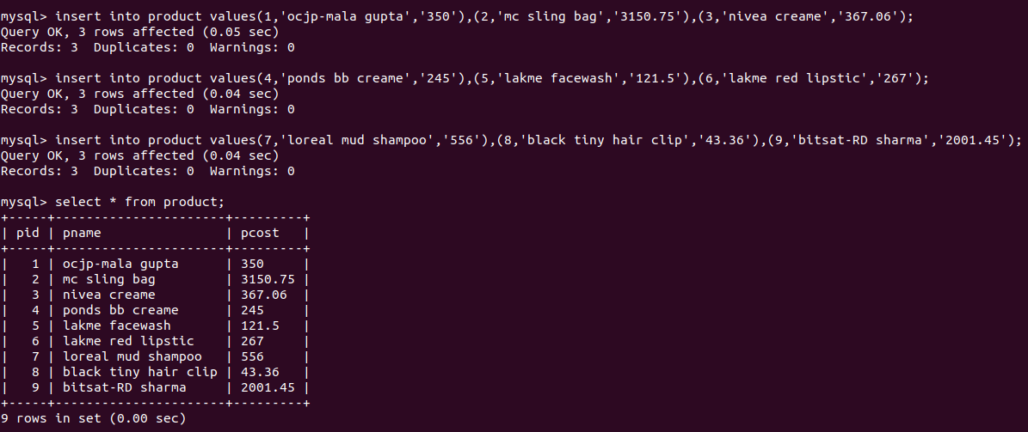
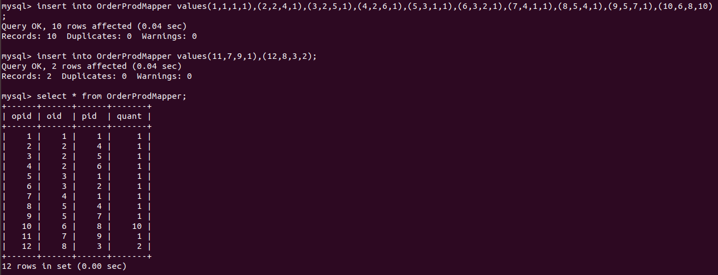

- Find the sales person have multiple orders.

Here performed join on two tables - order and salesperson.

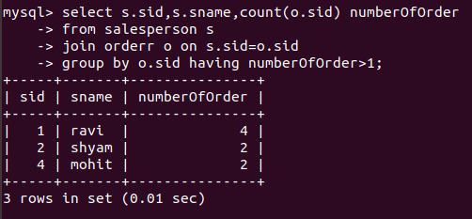

- Find the all sales person details along with order details

Here performed left join on two tables – salesperson and order

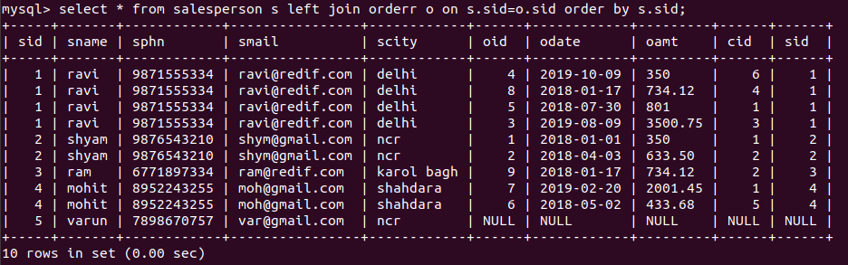
- Create index

created two index on table order.

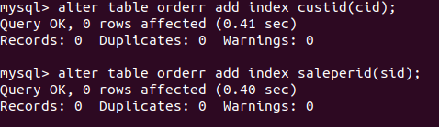

- How to show index on a table

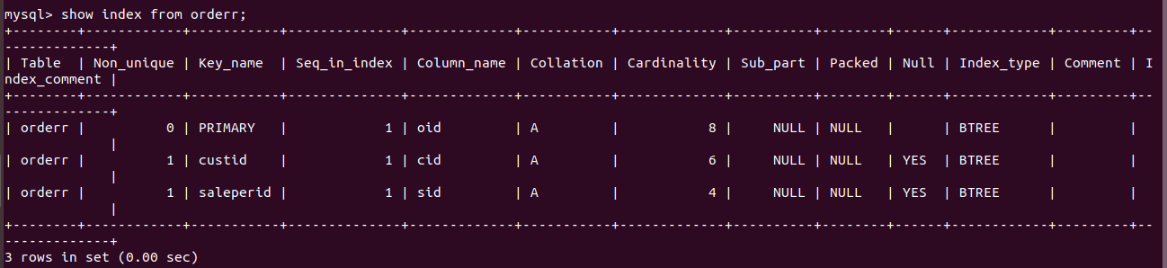

- Find the order number, sale person name, along with the customer to whom that order belongs to
here join on three tables - order , salesperson and customer.
