Project Title:
Bluestock Mutual Fund Analytics: Performance, Risk Analysis and Business Intelligence Dashboard
Submitted By:
Reshma J
Technology Stack:
Python | SQL | Power BI | SQLite
Project Type:
Capstone Project
Submission Date:
June 15th 2026

Executive Summary
The Bluestock Mutual Fund Analytics Capstone Project aims to analyze mutual fund performance, investor behavior, and risk-return characteristics using data analytics techniques. The project involves collecting and processing mutual fund datasets through an ETL pipeline, storing the processed data in a structured database, and performing exploratory and advanced analytics.
Python was used for data cleaning, transformation, and performance metric calculations, while SQL was used for data storage and querying. Power BI was utilized to create interactive dashboards that provide insights into fund performance, risk measures, investor trends, and portfolio analytics.
The analysis includes metrics such as CAGR, Sharpe Ratio, Sortino Ratio, Maximum Drawdown, Value at Risk (VaR), and Conditional Value at Risk (CVaR). The project helps investors and financial analysts understand fund performance and make data-driven investment decisions.

Project Objectives
The primary objectives of this project are:
- Collect and integrate mutual fund datasets from multiple sources.
- Design and implement an ETL pipeline for data processing.
- Store processed data in a structured database.
- Perform exploratory data analysis to identify trends and patterns.
- Analyze mutual fund performance using return-based metrics.
- Evaluate risk using advanced risk analytics techniques.
- Develop interactive Power BI dashboards for visualization.
- Generate actionable insights and recommendations for investors.
Data Sources

The project uses multiple mutual fund datasets collected in CSV format. These datasets contain information related to fund details, NAV history, assets under management, SIP inflows, investor transactions, portfolio holdings, and benchmark indices.
The primary datasets used in this project are:
1) 01_fund_master.csv – Contains mutual fund scheme details and category information.
2) 02_nav_history.csv – Historical Net Asset Value (NAV) records for mutual fund schemes.
3) 03_aum_by_fund_house.csv – Assets Under Management (AUM) data for fund houses.
4) 04_monthly_sip_inflows.csv – Monthly SIP investment inflow data.
5) 05_category_inflows.csv – Category-wise inflow and outflow information.
6) 06_industry_folio_count.csv – Investor folio statistics across categories.
7) 07_scheme_performance.csv – Scheme-level performance metrics.
8) 08_investor_transactions.csv – Investor transaction records.
9) 09_portfolio_holdings.csv – Portfolio composition and holdings data.
10) 10_benchmark_indices.csv – Benchmark market index data.
The datasets were stored in CSV format and processed using Python. After cleaning and transformation, the processed datasets were used for exploratory analysis, risk analytics, and dashboard creation.

ETL Design

The project follows an Extract, Transform, and Load (ETL) architecture to ensure data quality and consistency.
Extract
The raw mutual fund datasets were collected from CSV files and loaded into Python using the Pandas library. Multiple datasets containing NAV history, investor transactions, scheme information, and benchmark data were extracted.
Transform
Data transformation involved several preprocessing steps:
• Removal of duplicate records.
• Handling of missing values.
• Date format standardization.
• Data type conversion.
• Calculation of daily returns.
• Computation of performance metrics such as CAGR, Sharpe Ratio, Sortino Ratio, Maximum Drawdown, VaR, and CVaR.
• Feature engineering for investor analytics and cohort analysis.
Load
After transformation, the cleaned datasets were loaded into a SQLite database for structured storage and efficient querying. The processed data was then connected to Power BI for dashboard development and visualization.
The ETL pipeline ensured reliable and analysis-ready data for advanced analytics and reporting.

Database Design
A SQLite database was created to store the processed mutual fund datasets. The database acts as the central repository for analytics and dashboard reporting.
The main entities in the database include:
• Fund Master
• NAV History
• Scheme Performance
• Investor Transactions
• Portfolio Holdings
• Benchmark Indices
Primary keys were used to uniquely identify records, while scheme identifiers were used to establish relationships between tables.
The database design enables efficient retrieval of mutual fund performance data, investor activity records, and benchmark comparisons. This structured design supports both analytical queries and dashboard reporting requirements.

EDA Findings
1. Risk vs Return Analysis
The Risk vs Return scatter plot was used to evaluate the relationship between annualized return and risk across different mutual fund categories.
Observation:
- Small-cap and mid-cap funds generally delivered higher returns but exhibited higher volatility.
- Large-cap funds showed moderate returns with comparatively lower risk.
- Debt-oriented categories such as Liquid and Short Duration funds demonstrated lower risk and lower returns.
Business Insight:
Investors seeking higher returns must be willing to accept increased risk. Conservative investors may prefer large-cap or debt funds, while aggressive investors can consider small-cap and mid-cap funds.

2. AUM vs Expense Ratio Analysis
The scatter plot compares Assets Under Management (AUM) with expense ratios across different mutual fund categories.
Observation:
- Funds with higher AUM are spread across a range of expense ratios.
- Some large funds maintain competitive expense ratios despite managing substantial assets.
- Higher expense ratios do not necessarily correspond to higher AUM.
Business Insight:
Investors should not select funds solely based on size. Expense ratio should be considered alongside performance and risk-adjusted returns when evaluating investment options.

3. Portfolio Holdings Analysis
The bar chart displays the top portfolio holdings across mutual fund schemes.
Observation:
- Major companies such as Grasim Industries, NTPC, Axis Bank, HCL Technologies, and Bharti Airtel appear among the most heavily weighted holdings.
- Financial services, technology, and industrial sectors dominate portfolio allocations.
Business Insight:
Mutual funds tend to allocate significant portions of their portfolios to large, fundamentally strong companies, reflecting confidence in their long-term growth potential.

4. Sector Allocation Analysis
The sector allocation chart illustrates the distribution of investments across industry sectors.
Observation:
- Banking represents the largest allocation within the portfolio.
- Information Technology, Pharmaceuticals, and Automobile sectors also contribute significantly.
- Consumer Goods and Telecom sectors have comparatively smaller allocations.
Business Insight:
Sector diversification helps reduce concentration risk. The prominence of Banking and IT indicates strong confidence in these sectors as drivers of portfolio growth.

5. SIP Year-over-Year Growth Analysis
The SIP YoY Growth chart tracks annual growth in systematic investment plan contributions.
Observation:
- SIP growth increased steadily throughout the observation period.
- Growth peaked during 2024 before moderating slightly in subsequent months.
- Overall investor participation continued to rise.
Business Insight:
The increasing adoption of SIPs reflects growing investor awareness of disciplined long-term investing and wealth creation through mutual funds.

6. Monthly SIP Inflow Trend
The Monthly SIP Inflow Trend chart shows changes in total SIP investments over time.
Observation:
- Monthly SIP inflows increased consistently from approximately ₹12,000 crore to nearly ₹29,000 crore.
- Minor fluctuations were observed, but the overall trend remained positive.
- Investor confidence in mutual funds strengthened throughout the study period.
Business Insight:
Sustained growth in SIP inflows demonstrates increasing retail investor participation and highlights the importance of SIPs as a key source of mutual fund industry growth.

Performance Analytics Findings
1. Fund Scorecard Ranking
- Nippon Large Cap achieved the highest overall score.
- ICICI Bluechip and Kotak Bluechip followed closely.
- SBI Bluechip recorded the lowest composite score among the selected funds.
2. CAGR Comparison
- ICICI Bluechip generated the highest 3-Year CAGR.
- Nippon Large Cap also delivered strong long-term growth.
- SBI Bluechip showed comparatively lower CAGR performance.
3. Sharpe Ratio Analysis
- Nippon Large Cap exhibited the highest Sharpe Ratio.
- Higher Sharpe Ratios indicate superior risk-adjusted returns.
- SBI Bluechip had the weakest risk-adjusted performance.
4. Maximum Drawdown Analysis
- Bluechip category funds experienced the largest drawdowns during market downturns.
- Lower drawdown values indicate better downside protection.
- Drawdown analysis highlights the importance of risk management in fund selection.
5. Risk-Return Relationship
- Funds delivering higher returns generally assumed greater levels of risk.
- Risk-adjusted metrics helped identify funds that balanced return and volatility effectively.
- Investors seeking stability may prefer lower-risk categories, while growth-oriented investors may favor higher-risk funds.

Advanced Analytics Findings
1. Value at Risk (VaR) Analysis
- Historical VaR (95%) was calculated to estimate the maximum expected loss under normal market conditions.
- Equity-oriented funds exhibited higher VaR values compared to debt-oriented funds.
- Small Cap funds showed the highest downside risk due to greater market volatility.
- VaR provides investors with an estimate of potential losses during adverse market movements.
2. Conditional Value at Risk (CVaR)
- CVaR measured the average loss beyond the VaR threshold.
- Funds with high CVaR values are exposed to greater extreme downside risk.
- Equity funds generally recorded higher CVaR than debt funds.
- CVaR offers a more comprehensive assessment of tail risk than VaR alone.
3. Rolling 90-Day Sharpe Ratio
- Rolling Sharpe Ratios were used to evaluate risk-adjusted performance over time.
- Top-performing funds maintained consistently positive Sharpe Ratios.
- Market fluctuations caused temporary declines in Sharpe Ratios during volatile periods.
- Stable Sharpe Ratios indicate better consistency in returns relative to risk.
4. Investor Cohort Analysis
- Investors were grouped based on their first investment year.
- Recent cohorts demonstrated higher average SIP contributions than earlier cohorts.
- Equity-oriented schemes remained the preferred investment choice across cohorts.
- The analysis revealed increasing investor participation over time.
5. SIP Continuity Analysis
- SIP continuity was analyzed to measure investor retention and discipline.
- A majority of investors continued their SIPs regularly without interruption.
- Long-term SIP investors contributed significantly to total fund inflows.
- Consistent SIP participation supports wealth creation through rupee-cost averaging.
6. Fund Recommendation Engine
- A rule-based recommendation system was developed using risk, return, Sharpe Ratio, and expense ratio metrics.
- Conservative investors were matched with low-risk funds.
- Moderate investors received balanced fund recommendations.
- Aggressive investors were recommended high-growth, high-risk funds.
- The recommendation engine demonstrates practical application of analytics for investment decision-making.
7. Risk Categorization
- Funds were classified into Low, Medium, and High-Risk categories.
- Risk classification helps investors select funds according to their risk tolerance.
- High-return funds were generally associated with higher risk categories.
- The categorization simplifies fund comparison and portfolio construction.
Power BI Dashboard
Dashboard Overview
A Power BI dashboard was developed to provide an interactive visualization platform for mutual fund performance analysis. The dashboard integrates ETL outputs and advanced analytics results into user-friendly visual reports. Users can compare fund performance, evaluate risk metrics, and analyze return trends through dynamic filters and charts.
Executive Summary Dashboard
Objectives
- Present overall fund performance at a glance.
- Display key performance indicators.
- Enable quick comparison among funds.
Components
- Total Funds KPI
- Average 1-Year CAGR
- Average 3-Year CAGR
- Average Sharpe Ratio
- Average Maximum Drawdown
- CAGR Comparison Chart
- Fund Ranking Score Chart
- Fund Selection Slicer
Insights
- Provides a quick overview of mutual fund performance.
- Helps identify top-performing funds based on CAGR and rankings.
- Allows users to filter and analyze specific funds.

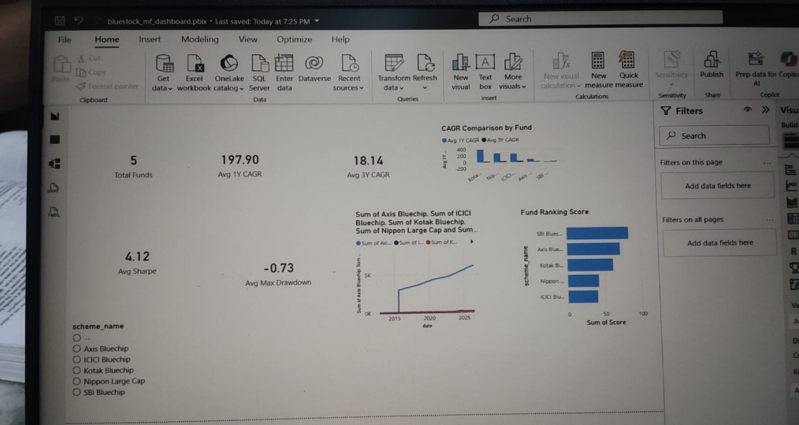

Performance Analytics Dashboard
Objectives
- Analyze fund performance using risk-adjusted metrics.
- Compare downside risk among funds.
- Monitor return trends over time.
Components
- Fund Performance Scorecard
- Sharpe Ratio Comparison
- Maximum Drawdown Comparison
- Return Trend Analysis
- Fund Filter Slicer
Insights
- Sharpe Ratio helps identify superior risk-adjusted returns.
- Maximum Drawdown highlights potential investment risk.
- Trend charts reveal long-term fund behavior.
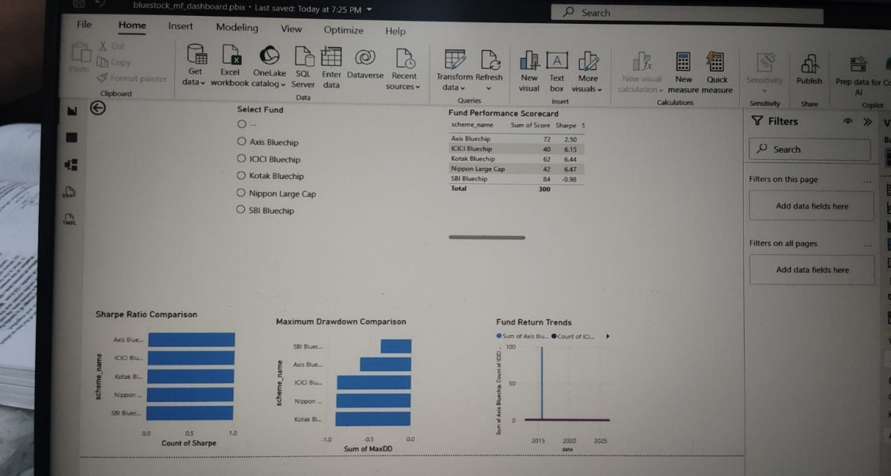

Fund Comparison Dashboard
Objectives
- Compare multiple funds simultaneously.
- Evaluate growth and risk characteristics.
- Support investment decision-making.
Components
- CAGR Comparison
- Sharpe Ratio Comparison
- Fund Ranking Visualization
- Risk vs Return Analysis
Insights
- Identifies funds with higher returns and manageable risk.
- Shows differences in fund performance across key metrics.
- Helps investors select suitable investment options.

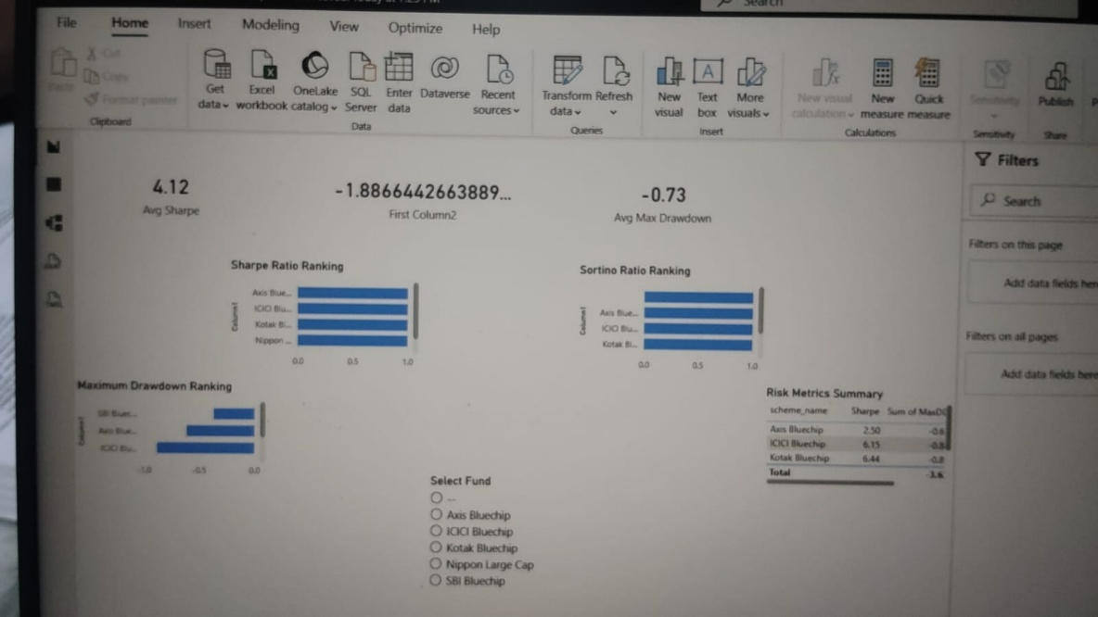

Investor Insights Dashboard
Objectives
- Present actionable investment insights.
- Summarize key performance indicators.
- Provide a consolidated analytical view.
Components
- Fund Rankings
- Performance Summary Cards
- Risk Metrics
- Trend Analysis Visuals
Insights
- Highlights top-performing funds.
- Provides comprehensive performance evaluation.
- Supports informed investment decisions.
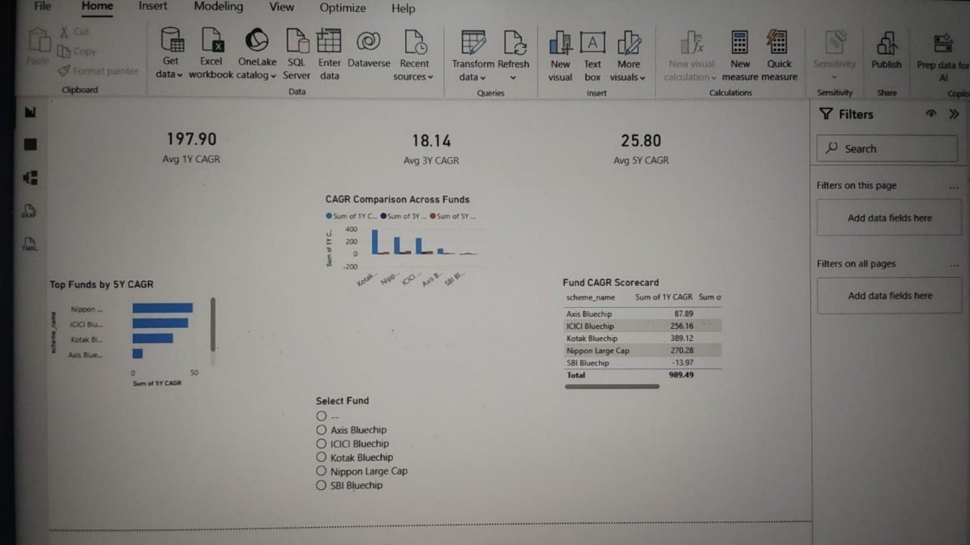
Key Findings
The analysis of mutual fund performance data revealed several important insights regarding returns, risk, and overall fund quality.
1. Strong Growth in Selected Funds
- ICICI Bluechip and Nippon Large Cap demonstrated the highest long-term growth among the analyzed funds.
- The 3-Year CAGR comparison showed that these funds consistently generated superior returns.
2. Risk-Adjusted Performance
- Sharpe Ratio analysis indicated that ICICI Bluechip, Kotak Bluechip, and Nippon Large Cap delivered better returns relative to the risk taken.
- SBI Bluechip recorded a lower Sharpe Ratio, indicating weaker risk-adjusted performance.
3. Maximum Drawdown Analysis
- Maximum Drawdown values highlighted significant differences in downside risk among funds.
- Funds with lower drawdown values exhibited greater resilience during market downturns.
4. Fund Ranking Evaluation
- The scorecard ranking model successfully combined multiple performance metrics into a single evaluation framework.
- Top-ranked funds achieved strong scores across CAGR, Sharpe Ratio, and risk measures.
5. Return Trend Analysis
- Historical NAV trends showed that most funds experienced long-term growth despite short-term market fluctuations.
- Consistent upward trends indicate the benefits of long-term investment strategies.
6. Dashboard Insights
- The Power BI dashboard provided an interactive platform for comparing funds and exploring performance metrics.
- Users can easily identify top-performing funds and evaluate investment risks through dynamic visualizations.
7. Data-Driven Investment Decisions
- Combining ETL processing, exploratory data analysis, advanced analytics, and dashboard visualization enabled comprehensive mutual fund evaluation.
- The project demonstrates how data analytics can support informed investment decision-making.
Limitations
Despite providing valuable insights into mutual fund performance, this project has certain limitations:
1. Limited Dataset
- The analysis was conducted using a selected set of mutual funds rather than the entire mutual fund market.
- Results may differ when additional schemes are included.
2. Historical Data Dependency
- All calculations and performance metrics are based on historical NAV data.
- Past performance does not guarantee future returns.
3. Market Volatility
- Mutual fund performance is influenced by changing market conditions, economic factors, and investor sentiment.
- Sudden market events may affect future performance differently.
4. Simplified Risk Measures
- Risk evaluation primarily used Sharpe Ratio, Maximum Drawdown, VaR, and CVaR.
- Other advanced risk indicators were not included in the current analysis.
5. Data Quality Constraints
- Missing values, inconsistencies, or limited historical records may impact analytical accuracy.
- Results depend on the quality of the source data.
6. Limited Investment Factors
- Factors such as fund manager performance, expense ratio, portfolio composition, and macroeconomic indicators were not considered.
- These factors can significantly influence investment outcomes.
7. Dashboard Scope
- The Power BI dashboard focuses on performance comparison and risk analysis.
- Real-time market updates and live fund tracking are not supported.
8. Predictive Analysis Constraints
- The project emphasizes descriptive and performance analytics.
- Future fund performance predictions were not extensively modeled using advanced machine learning techniques.
Recommendations
Based on the analysis conducted in this project, the following recommendations are proposed:
1. Focus on Risk-Adjusted Returns
- Investors should evaluate mutual funds using risk-adjusted performance measures such as the Sharpe Ratio rather than relying solely on returns.
- Funds with higher Sharpe Ratios generally offer better compensation for the risk undertaken.
2. Consider Long-Term Performance
- Long-term metrics such as 3-Year CAGR provide a more reliable indication of fund performance than short-term returns.
- Investors should prioritize funds with consistent growth over multiple years.
3. Monitor Downside Risk
- Maximum Drawdown, VaR, and CVaR should be considered before making investment decisions.
- Funds with lower downside risk may be more suitable for conservative investors.
4. Diversify Investment Portfolio
- Investors should avoid concentrating investments in a single fund.
- Diversification across multiple funds can help reduce overall portfolio risk and improve stability.
5. Utilize Data-Driven Decision Making
- Investment decisions should be supported by analytical insights rather than market speculation.
- Performance dashboards and analytical reports can assist investors in evaluating fund quality objectively.
6. Enhance Dashboard Functionality
- Future versions of the dashboard can include real-time NAV updates, portfolio tracking, and automated alerts.
- Additional filters and drill-down features can improve user experience.
7. Expand Analytical Scope
- Future studies can incorporate factors such as expense ratios, benchmark comparisons, fund manager performance, and sector allocation.
- Including these variables can provide a more comprehensive evaluation framework.
8. Integrate Predictive Analytics
- Machine learning and forecasting models can be used to predict future fund performance.
- Predictive analytics may help investors identify potential investment opportunities and risks in advance.
9. Regular Data Updates
- The dataset should be updated periodically to ensure that analyses and dashboard insights remain relevant and accurate.
- Automated ETL pipelines can support continuous data refresh.
Conclusion
This project successfully developed a comprehensive Mutual Fund Analytics System using ETL processes, exploratory data analysis, performance analytics, advanced risk analysis, and Power BI visualization. The integration of multiple datasets enabled a detailed evaluation of mutual fund performance, investor trends, and risk-return characteristics.
Through the ETL pipeline, raw mutual fund data was extracted, transformed, and loaded into a structured database for analysis. Exploratory Data Analysis (EDA) provided insights into fund performance, portfolio allocation, sector distribution, and SIP investment trends. Advanced performance metrics such as CAGR, Sharpe Ratio, Maximum Drawdown, VaR, and CVaR were used to assess fund quality and risk-adjusted returns.
The Power BI dashboard transformed analytical results into interactive visualizations, enabling users to compare funds, evaluate risk, and monitor investment performance effectively. The dashboard serves as a valuable decision-support tool for investors, analysts, and financial professionals.
Overall, the project demonstrates the practical application of data analytics and business intelligence techniques in the financial domain. The findings highlight the importance of risk-adjusted performance evaluation and portfolio diversification in mutual fund investments. Future enhancements may include real-time data integration, predictive analytics, and machine learning models to further improve investment analysis and decision-making capabilities.

