Git Commands:

- Git init : Initializes a new Git repository.

Powershell:

Powershell is a command-line shell and scripting language that helps to automate the system tasks on windows,Linux. It helps in administrators operators,used by a DevOps engineer. It is a Open Windows powershell(ISE)

Commands used in Powershell:

- Get-Help : It helps how to specify the command.

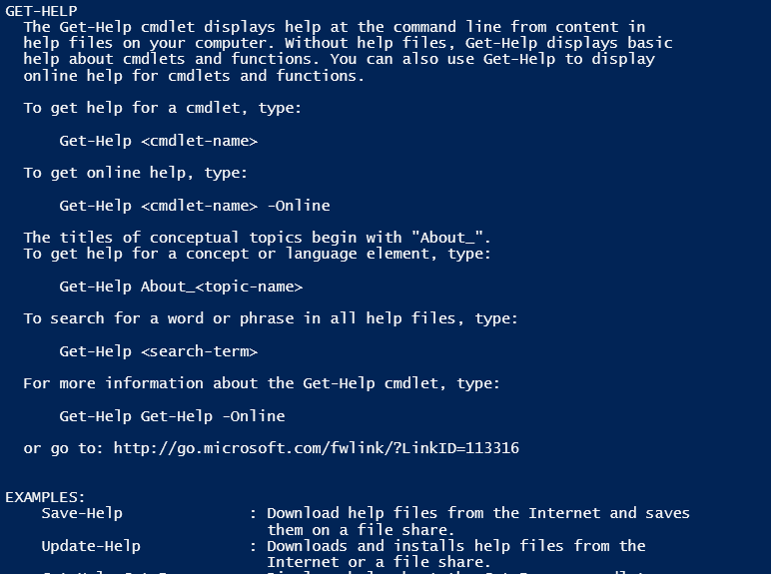

- Get-Command: It display all the commands in the powershell.

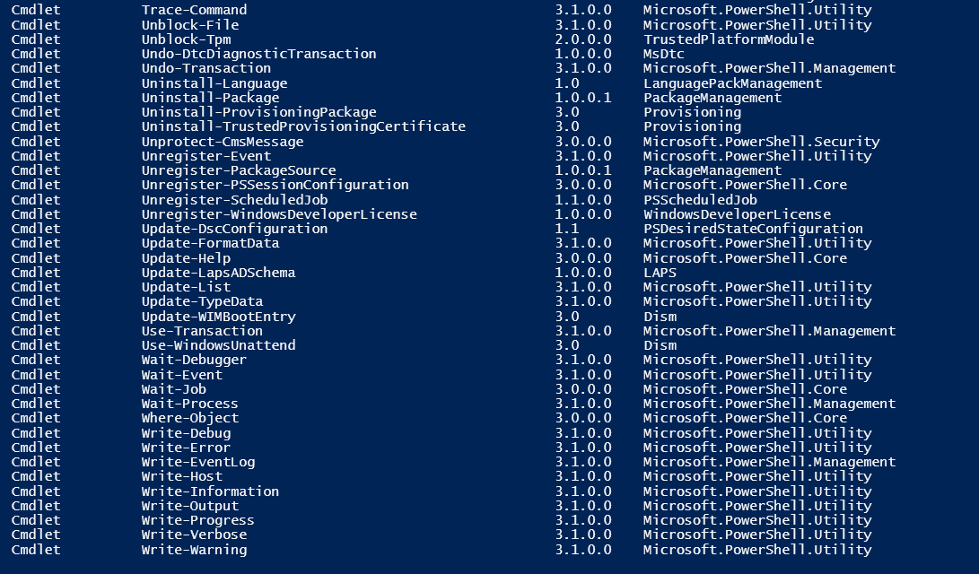

- Get-Process: Lists all the running processes which are currently running in a local system.

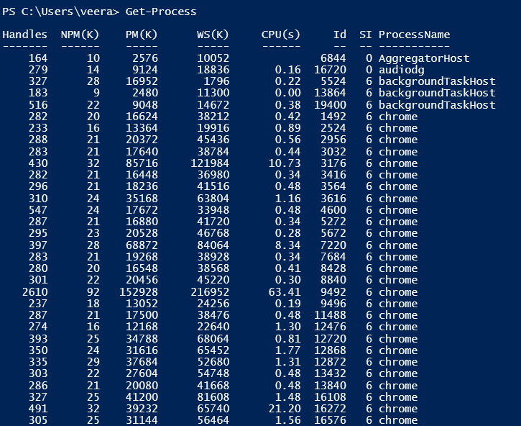

- Stop-Process -Id <process ID> :It Stops the process.
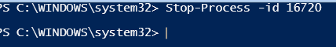

- Get-Service : Lists all the services running in the system.

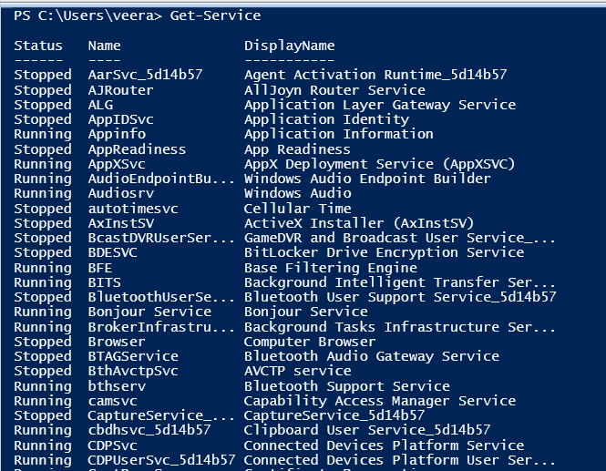

- Start-Service <service name> : Starts a service.

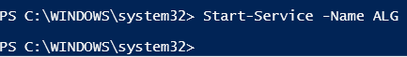

- Stop-Service <service name> : Stops a service.

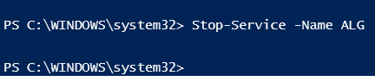

- Get-ChildItem : Lists files and directories (similar to dir or ls).
- New-Item -ItemType Directory -Path "C:\MyFolder1" ---- create a folder

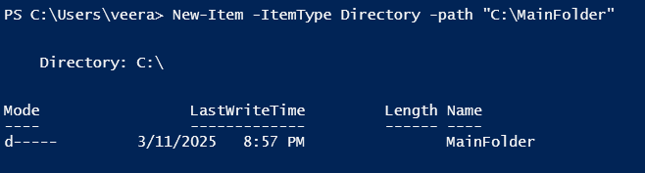

- New-Item -ItemType File -Path "C:\temp\test.txt" -- Creates a new file.

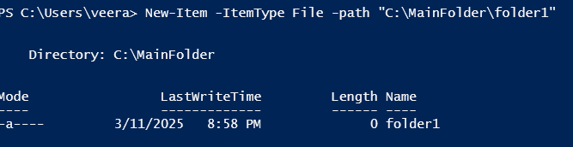

- Set-Content -Path "C:\temp\test.txt" -Value "Software Gurukulam!" : Writes content to a file.

- Get-Content -Path "C:\temp\test.txt" : Displays the content of a file.

- Copy-Item -Path " C:\temp\test1.txt " --Destination " C:\temp\test2.txt" –Force – copy file form one place other
- Remove-Item -Path "C:\temp\test.txt" -- Removes a file.
- Remove-Item -Path "C:\MyFolder" –Force -- Remove folder
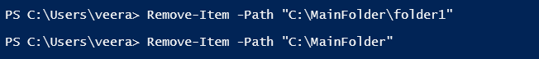

- $variable = "value" -- Assigns a value to a variable.
Write-Host $variable -- Displays the value of a variable.
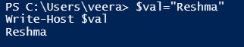

Write a shell script in If condition:

#If condition

$number=10
if($number -gt 5)
{
Write-Host "$number is greater than 5"
}
elseif($numner -eq 5)
{
Write-Host "$number is equal to 5"
}
else{
Write-Host "$number is lessthen 5"
}
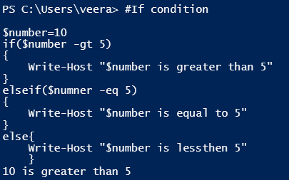

Write shell Script for creating the folder usinf for loop:

➢# Define the folder name and path
$folderName = "MyTestFolder"
$folderPath = Join-Path -Path "D:\AIWorkLoads" -ChildPath $folderName #Adjust C:\temp as needed

# Create the folder if it doesn't exist
if (-not (Test-Path -Path $folderPath)) {
New-Item -ItemType Directory -Path $folderPath | Out-Null
Write-Host "Created folder: $folderPath"
} else {
Write-Host "Folder already exists: $folderPath"
}

# Create 5 files within the folder with date and time in the filename and add content
for ($i = 1; $i -le 5; $i++) {
$dateTime = Get-Date -Format "yyyyMMdd"
$fileName = "file_$($dateTime)_$($i).txt"
$filePath = Join-Path -Path $folderPath -ChildPath $fileName

# Create the file
New-Item -ItemType File -Path $filePath -Force | Out-Null

# Set content for the file
$fileContent = "Softwaregurukulam_$fileName"
Set-Content -Path $filePath -Value $fileContent

Write-Host "Created file: $filePath with content: $fileContent"
}

