LINUX COMMANDS

1.What is linux?
Linux is an open-source operating system that powers everything from servers to computers, laptops, and more. It allows users to interact with computers, and its source code is freely available to view or modify. The Linux Kernel communicates directly with hardware and handles system processes. Linux Distributions are versions of Linux that include the kernel and additional software.
What is open-source software?
Software with source code that any user can view and change is open source. Nearly all open-source software is free to the public. Proprietary software (or closed-source software) is the inverse of open-source software because it is owned by a single entity and licensed to those who want to use it.

Key Features of Linux
- Open Source: The source code is freely available and can be modified and distributed by anyone.
- Multi-user System: Multiple users can access system resources like memory, storage, etc., simultaneously without interfering with each other.
- Security: Strong permission-based security, user authentication, and encryption.
- Portability: Can run on various hardware platforms, from mobile devices to supercomputers.
- Stability and Performance: Highly stable, with efficient memory management and high-performance capabilities.
- Customizability: Users can choose from various distributions and tailor the system to their needs.

Uses of Linux
- Servers: Most web servers use Linux (e.g., Apache, Nginx).
- Embedded Systems: Routers, smart TVs, IoT devices, etc.
- Desktop Computing: An alternative to Windows and macOS.
- Development: Preferred by developers due to powerful command-line tools and flexibility.
- Cloud Computing: Major platforms like AWS, Google Cloud, and Azure use Linux-based systems.

- Linux Commands:
File system Navigation
- pwd : Prints the present(current) working directory.
- ls : List contents of the current directory.
- cd <directory name> : Moves to current directory.
- cd .. : It moves one step back or it moves back to previous directory.
- mkdir <directory name> : It creates new directory.
- touch <file name> : It creates new file.
- vi <filename> : It edits the file with vi editor.In the editor we need to click insert to edit, and save file with ‘:wq!’
- cat <filename> : It displays the content of a file.
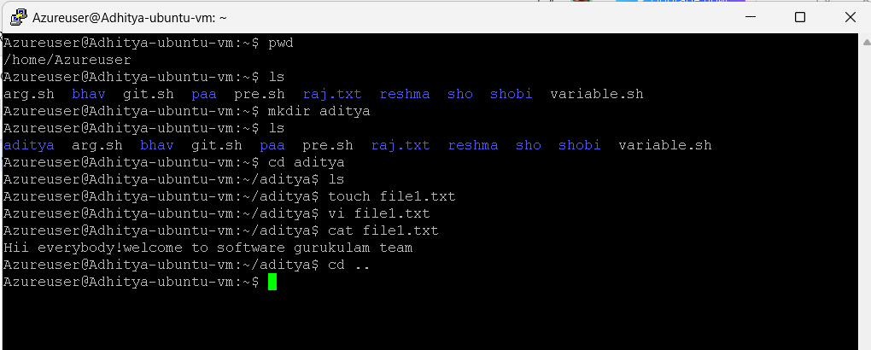

Directory and File Management:
- rm <filename>: Deletes a file.
- rmdir <foldername>: Deletes a empty directory.
- rm -rf <foldername>: Deletes a directory and its contents recursively.
- cp <filename> <path>: Copies a file to a specified location.
- mv <oldfilename> <newfilename>: Renames a file or move the file.
- mkdir -p <dir1/dir2/dir3>: Creates nested directories.
- rmdir -p <dir1/dir2/dir3>: Removes nested directories if they are empty.
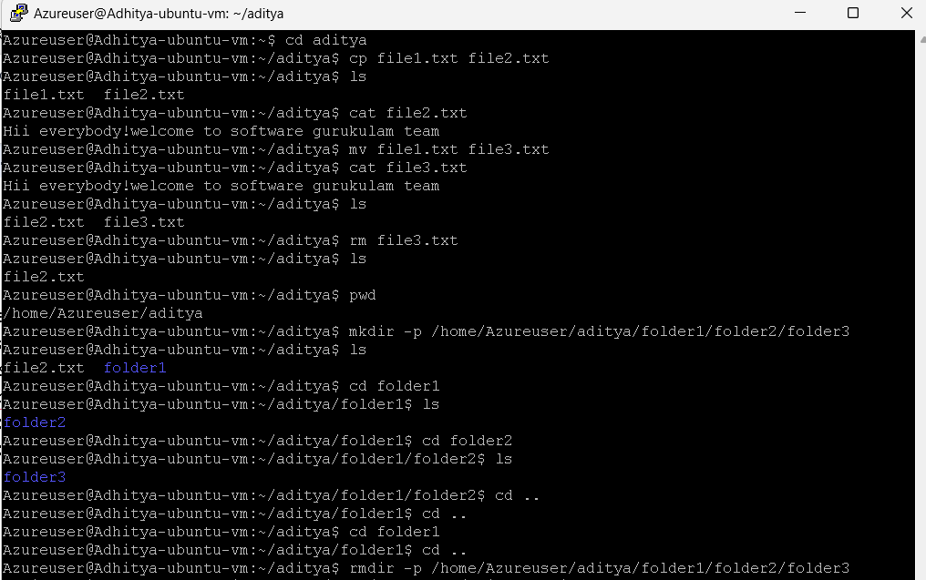

Creating multiple folders/files
- mkdir folder{1..10} : create multiple folder at a time.
- touch file{1..10}: create multiple files at a time.
- rm file{1..10}: Remove multiple files at a time.
- rmdir folder{1..10} : Remove multiple folder at a time.
- head -n 5 <filename>: Displays the first 5 lines of a file.
- tail -n 5 <filename> : Display the last 5 lines of a file.
- sed -n 5,10p <filename>:Displays lines 5 to 10 from a file.
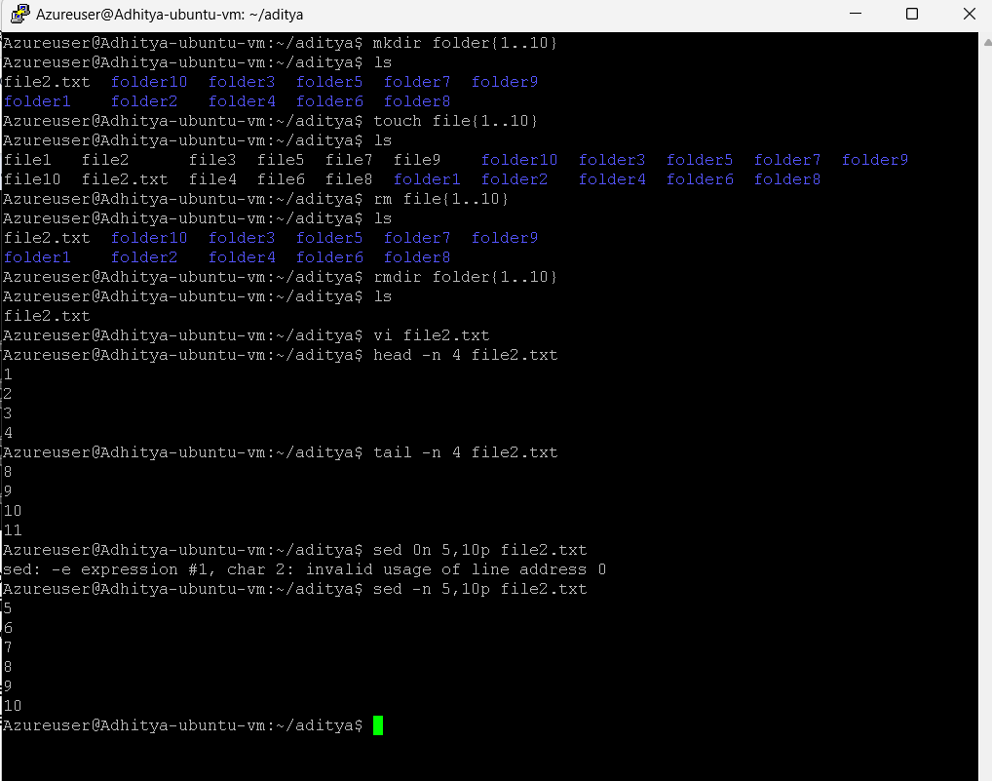

System information and management
- whoami: Displays the current user.
- uname -a: Displays detailed information about the system.
- Date: Shows the current date and time.
- cal <year>: Displays the calendar for a specified year (e.g., cal 2025).
- cal <month> <year>: Displays the calendar for a specific month and year (e.g., cal 01 5050).
- echo $RANDOM: Prints a random number.
- echo $(( RANDOM % 10 )): Generate a random number in a range (0–9).
- echo $(( RANDOM % 11 + 5 )): Generate a random number in a range (5–15).
- Top: Displays real-time information about system processes.
- df : Shows available disk space.
- Df -h :human readable language.
- du : Displays disk usage.
- ifconfig: Displays network configuration (used in Windows).
- ipconfig: Displays IP address and network configuration (used in Linux/macOS).
- man <command>: Displays the manual page for a command.
- find <directory> -type d: Searches for directories.
- find <directory> -type f: Searches for files.

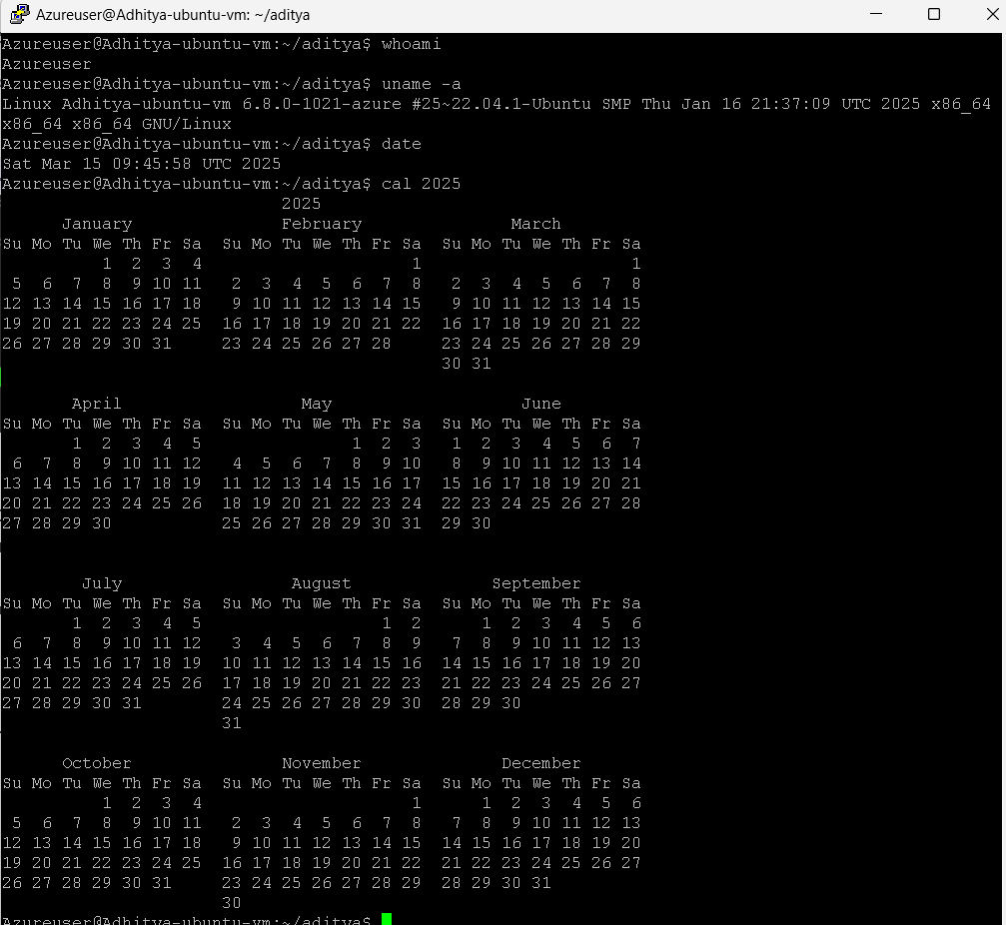
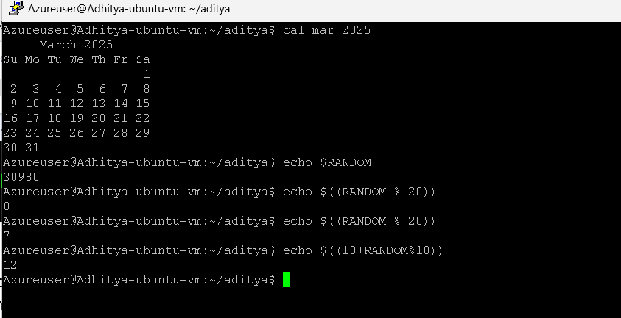

File permission:
- chmod 777 <filename>: Grants all permissions (read, write, execute) to a file.
- Chmod u-r <filename> : to remove read permission in user access.
- Chmod u+r <filename>: to add read permission in user access.
- Chmod g-w <filename>: to remove write permission in group access.
- ls -al: Checks file permissions.
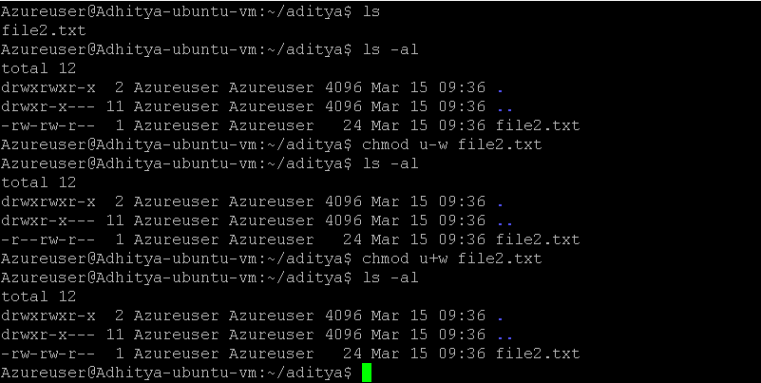

Shell Scripting:
Shell scripting is writing a series of commands in a plain text file (called a script) to be executed by a Unix/Linux shell
- In Shell Scripting, we need to save the file with ‘.sh’
- To create file --> touch file.sh
- To edit the file--> vi file.sh
- When we open the vi editor we need to give shebang --> #!
- To execute the file ---> bash file.sh.
- To print the file ---> cat file.sh.
Example:
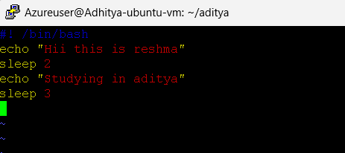
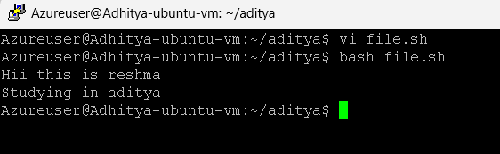
Argument & Parameter shell script:
In shell scripting, arguments are the inputs you provide to a script when you execute it. A parameter is a variable that stores the value of an argument.
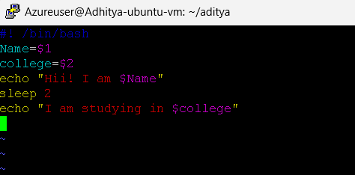
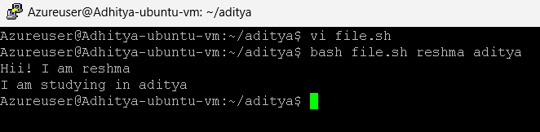
Predefined shell scripting:
Predefined shell scripting involves using built-in environment variables and commands that the shell provides by default. These are pre-configured variables and functions that help control how the shell operates and makes scripting easier.
