Solution:

2. How to create lock?
Test Query on SQL Assistant

BT;
update customer_service.employee set last_name='Patel' where employee_number=1014;
//ET; ----To release lock (other way is mentioned below in (3) )

- How to se locks ?
Goto start→ programs→Teradata Database→ database window
Type “start lok disp”
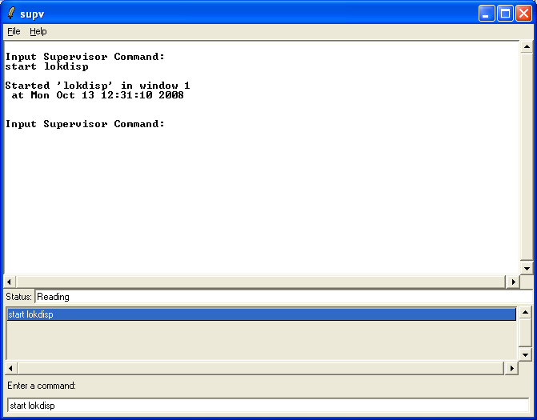

It will show you below screen.

Then type “table all” command

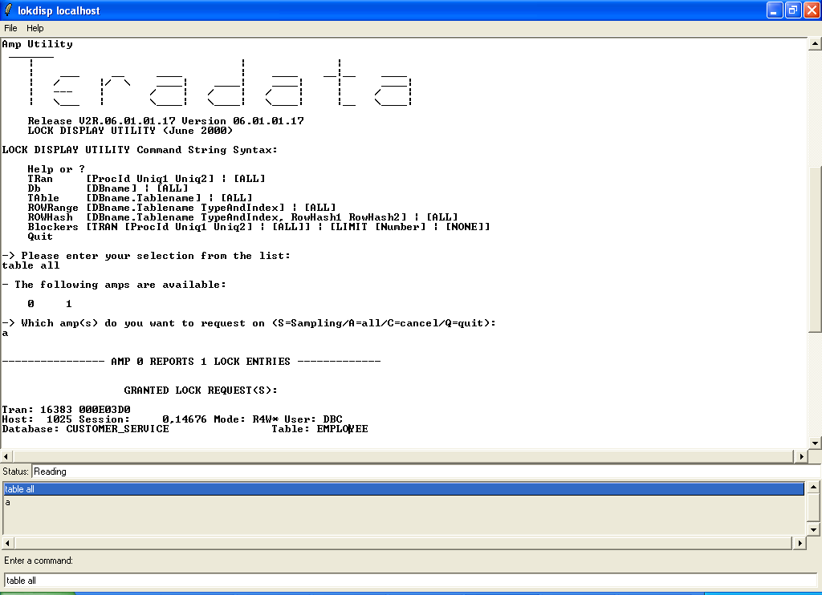

It will ask below input

Which amp(s) do you want to request on (S=Sampling/A=all/C=cancel/Q=quit):

Then press “a” means all from available options

It will show you below output…

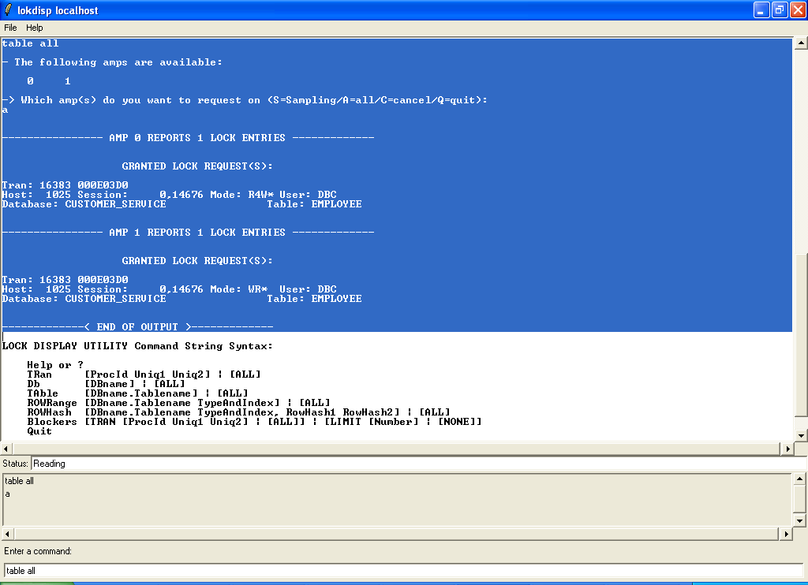

3. To release lock

Type below query on SQL assistant to release lock as below…

release lock customer_service.employee;

Again type same command “table all” on lok disp utility window…
Then press “a”

It will show you below output
