LINUX

1. LINUX

• Birth of LINUX

• What is LINUX

• Linux V/s Windows

• Why LINUX

• Linux Distribution

2. Linux installation on windows machine for Lab practices • Pre-requisites in windows operating system • Settings in windows operating system

• Downloading Linux packages for windows

• Installation process and creating users and group 3. LINUX Commands

Birth of LINUX

Ken Thompson and Dennis Ritchie (both of AT&T Bell Laboratories) in 1969 and first released in 1970. Later they rewrote it in a new programming language, C, to make it portable. The availability and portability

In 1983, Richard Stallman started the GNU project with the goal of creating a free UNIX-like operating system.

In 1986, Maurice J. Bach, of AT&T Bell Labs, published *The Design of the UNIX Operating System*.[11]This definitive description principally covered the System V Release 2 kernel, with some new features from Release 3 and BSD.

In 1987, MINIX, a Unix-like system intended for academic use, was released by Andrew S. Tanenbaum to exemplify the principles conveyed in his textbook, *Operating Systems: Design and Implementation*. While source code for the system was available, modification and redistribution were restricted.

**Linux** began in 1991 as a personal project by Finnish student Linus Torvalds: to create a new free operating system kernel. The resulting Linux kernel has been marked by constant growth throughout its history. Since the initial release of its source code in 1991, it has grown from a small number of C files under a license prohibiting commercial distribution to the 4.15 version in 2018 with more than 23.3 million lines of source code

What is LINUX

LINUX is an operating system or a kernel distributed under an open-source license. Its functionality list is quite like UNIX. The kernel is a program at the heart of the Linux operating system that takes care of fundamental stuff, 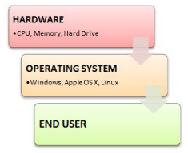

like letting hardware communicate with software.

**Windows Vs. Linux File System**

When we compare file system in Windows and Linux, in Microsoft Windows, files are stored in folders on different data drives like C: D: E:

But, in **Linux, files are ordered in a tree structure starting with the root**

**directory**.

This root directory can be considered as the start of the file system, and it further branches out various other subdirectories. The root is denoted with a forward

slash ʻ/ʼ.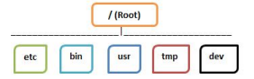

Why LINUX

**• Free and open-source.** 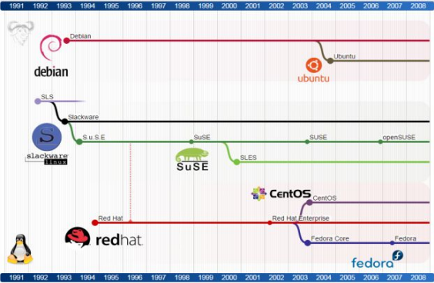

**• Security**

**• Developer Friendly**

**• Pre-installed Powerful Tools**

• Grep, wget, cron ie..

• Task automation

• Bash, SH, Korn, ZSH, Fish

• Personal for desktops and phones

• customization – free source code

• Performance

• Community (and business) driven.



Linux Distributions