**AIR QUALITY MONITORING SYSTEM DESIGN.**

In this Phase we are going to make an **IoT Based Air Pollution Monitoring System in** which we will**monitor the Air Quality over a webserver using internet**and will trigger a alarm when the air quality goes down beyond a certain level, means when there are sufficient amount of harmful gases are present in the air like CO2, smoke, alcohol, benzene and NH3. It will show the air quality in PPM on the LCD and as well as on webpage so that we can monitor it very easily. In this Iot Project, you can monitor the pollution level from anywhere using your computer or mobile. We can install this system anywhere and can also trigger some device when pollution goes beyond some level, like we can switch on the Exhaust fan or can send alert SMS/mail to the user.

REQUIRED COMPONENTS:

* MQ135 Gas sensor.
* Arduino Uno.
* Wi-Fi module ESP8266.
* 16X2 LCD.
* Breadboard.
* 10K potentiometer.
* 1K ohm resistors.
* 220 ohm resistor.
* Buzzer.

CIRCUIT DIAGRAM EXPLANATION:

First of all we will connect the ESP8266 with the Arduino. ESP8266 runs on 3.3V and if you will give it 5V from the Arduino then it won’t work properly and it may get damage. Connect the VCC and the CH_PD to the 3.3V pin of Arduino. The RX pin of ESP8266 works on 3.3V and it will not communicate with the Arduino when we will connect it directly to the Arduino. So, we will have to make a voltage divider for it which will convert the 5V into 3.3V. This can be done by connecting three resistors in series like we did in the circuit. Connect the TX pin of the ESP8266 to the pin 10 of the Arduino and the RX pin of the ESP8266 to the pin 9 of Arduino through the resistors.

ESP8266 Wi-Fi module gives your projects **access to Wi-Fi or internet**. It is a very cheap device and make your projects very powerful. It can communicate with any microcontroller and it is the most leading devices in the Iot Project.

Then we will connect the **MQ135 sensor with the Arduino**. Connect the VCC and the ground pin of the sensor to the 5V and ground of the Arduino and the Analog pin of sensor to the A0 of the Arduino. Connect a buzzer to the pin 8 of the Arduino which will start to beep when the condition becomes true. In last, we will connect LCD with the Arduino. The connections of the LCD are as follows,

* Connect pin 1 (VEE) to the ground.
* Connect pin 2 (VDD or VCC) to the 5V.
* Connect pin 3 (V0) to the middle pin of the 10K potentiometer.
* Connect the other two ends of the potentiometer to the VCC and the GND. The potentiometer is used to control the screen contrast of the LCD. Potentiometer of values other than 10K will work too.
* Connect pin 4 (RS) to the pin 12 of the Arduino.
* Connect pin 5 (Read/Write) to the ground of Arduino. This pin is not often used so we will connect it to the ground.
* Connect pin 6 € to the pin 11 of the Arduino. The RS and E pin are the control pins which are used to send data and characters.
* The following four pins are data pins which are used to communicate with the Arduino.

Connect pin 11 (D4) to pin 5 of Arduino.

Connect pin 12 (D5) to pin 4 of Arduino.

Connect pin 13 (D6) to pin 3 of Arduino.

Connect pin 14 (D7) to pin 2 of Arduino.

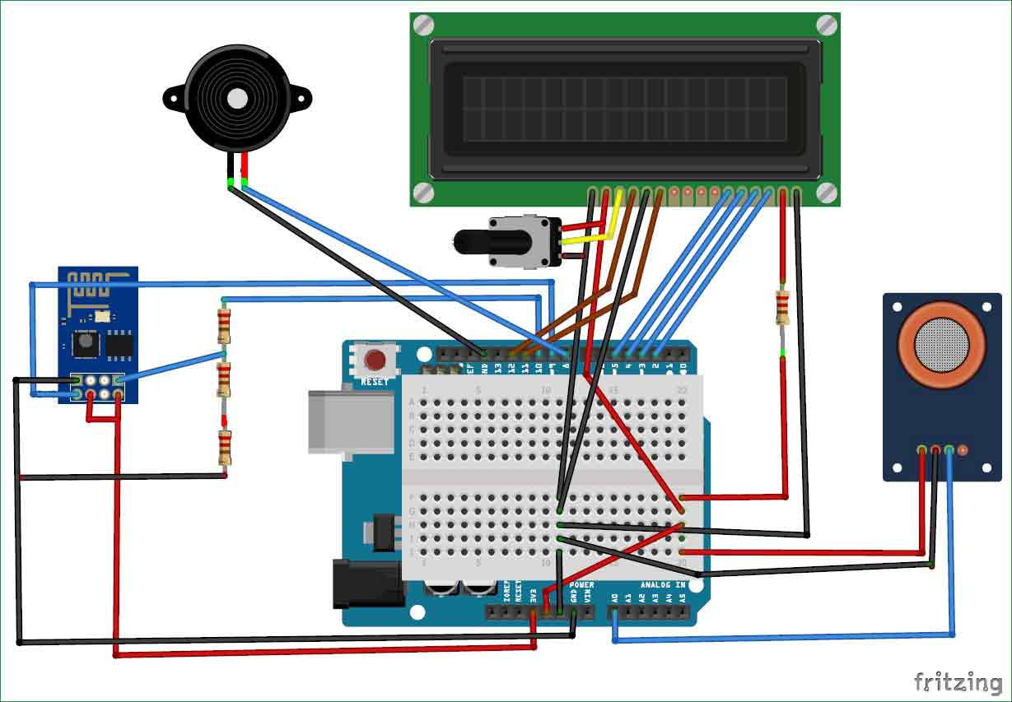

* Connect pin 15 to the VCC through the 220 ohm resistor. The resistor will be used to set the back light brightness. Larger values will make the back light much more darker.
* Connect pin 16 to the Ground.

***WORKING EXPLANATION:***

The MQ135 sensor can sense NH3, NOx, alcohol, Benzene, smoke, CO2 and some other gases, so it is perfect gas sensor for our **Air Quality Monitoring Project**. When we will connect it to Arduino then it will sense the gases, and we will get the Pollution level in PPM (parts per million). MQ135 gas sensor gives the output in form of voltage levels and we need to convert it into PPM. So for converting the output in PPM, here we have used a library for MQ135 sensor, it is explained in detail in “Code Explanation” section below.

Sensor was giving us value of 90 when there was no gas near it and the safe level of air quality is 350 PPM and it should not exceed 1000 PPM. When it exceeds the limit of 1000 PPM, then it starts cause Headaches, sleepiness and stagnant, stale, stuffy air and if exceeds beyond 2000 PPM then it can cause increased heart rate and many other diseases.

When the value will be less than 1000 PPM, then the LCD and webpage will display “Fresh Air”.  Whenever the value will increase 1000 PPM, then the buzzer will start beeping and the LCD and webpage will display “Poor Air, Open Windows”. If it will increase 2000 then the buzzer will keep beeping and the LCD and webpage will display “Danger! Move to fresh Air”.

**CODE EXPLANATION:**

Before beginning the coding for this project, we need to first Calibrate the MQ135 Gas sensor. There are lots of calculations involved in converting the output of sensor into PPM value. But here we are using the Library for MQ135. Using this library you can directly get the PPM values, by just using the below two lines:

*MQ135 gasSensor = MQ135(A0);*

*Float air_quality = gasSensor.getPPM();*

But before that we need to calibrate the MQ135 sensor, for calibrating the sensor upload the below given code and let it run for 12 to 24 hours and then get the RZERO value.

***#****include “MQ135.h”*

*Void setup ()*

*{*

*Serial.begin (9600);*

*}*

*Void loop()*

*{*

*MQ135 gasSensor = MQ135(A0);*

*// Attach sensor to pin A0*

*Float rzero = gasSensor.getRZero();*

*Serial.println (rzero);*

*Delay(1000);*

*}*

After getting the RZERO value. Put the RZERO value in the library file downloaded “MQ135.h”: #define RZERO 494.63.

Now we can begin the actual code for our Air quality monitoring project.

In the code, first of all we have defined the libraries and the variables for the Gas sensor and the LCD. By using the Software Serial Library, we can make any digital pin as TX and RX pin. In this code, we have made Pin 9 as the RX pin and the pin 10 as the TX pin for the ESP8266. Then we have included the library for the LCD and have defined the pins for the same.

We have also defined two more variables: one for the sensor analog pin and other for storing air_quality value.

*#include <SoftwareSerial.h>*

*#define DEBUG true*

*SoftwareSerial esp8266(9,10);*

*#include <LiquidCrystal.h>*

*LiquidCrystal lcd(12,11, 5, 4, 3, 2);*

*Const int sensorPin= 0;*

*Int air_quality;*

Then we will declare the pin 8 as the output pin where we have connected the buzzer. “Lcd.begin(16,2)**”** command will start the LCD to receive data

Now we will set the cursor to first line and will print the “Circuitdigest**”.** Then we will set the cursor on the second line and will print “SensorWarming**”.**

*pinMode(8, OUTPUT);*

*lcd.begin(16,2);*

*lcd.setCursor (0,0);*

*lcd.print (“circuitdigest “);*

*lcd.setCursor (0,1);*

*lcd.print (“Sensor Warming “);*

*delay(1000);*

Then we will set the baud rate for the serial communication. Different ESP’s have different baud rates so write it according to your ESP’s baud rate. Then we will send the commands to set the ESP to communicate with the Arduino and show the IP address on the serial monitor.

*Serial.begin(115200);*

*Esp8266.begin(115200);*

*sendData(“AT+RST\r\n”,2000,DEBUG);*

*sendData(“AT+CWMODE=2\r\n”,1000,DEBUG);*

*sendData(“AT+CIFSR\r\n”,1000,DEBUG);*

*sendData(“AT+CIPMUair_quality=1\r\n”,1000,DEBUG);*

*sendData(“AT+CIPSERVER=1,80\r\n”,1000,DEBUG);*

*pinMode(sensorPin, INPUT);*

*lcd.clear();*

For printing the output on the webpage in web browser, we will have to use HTML programming. So, we have created a string named webpage and stored the output in it. We are subtracting 48 from the output because the read() function returns the ASCII decimal value and the first decimal number which is 0 starts at 48.

*If(esp8266.available())*

*{*

*If(esp8266.find(“+IPD,”))*

*{*

*Delay(1000);*

*Int connectionId = esp8266.read()-48;*

*String webpage = “<h1>IOT Air Pollution Monitoring System</h1>”;*

*Webpage += “<p><h2>”;*

*Webpage+= “ Air Quality is “;*

*Webpage+= air_quality;*

*Webpage+=” PPM”;*

*Webpage += “<p>”;*

The following code will call a function named sendData and will send the data & message strings to the webpage to show.

*sendData(cipSend,1000,DEBUG);*

*sendData(webpage,1000,DEBUG);*

*cipSend = “AT+CIPSEND=”;*

*cipSend += connectionId;*

*cipSend += “,”;*

*cipSend +=webpage.length();*

*cipSend +=”\r\n”;*

The following code will print the data on the LCD. We have applied various conditions for checking air quality, and LCD will print the messages according to conditions and buzzer will also beep if the pollution goes beyond 1000 PPM.

*Lcd.setCursor (0, 0);*

*Lcd.print (“Air Quality is “);*

*Lcd.print (air_quality);*

*Lcd.print (“ PPM “);*

*Lcd.setCursor (0,1);*

*If (air_quality<=1000)*

*{*

*Lcd.print(“Fresh Air”);*

*digitalWrite(8, LOW);*

Finally, the below function will send and show the data on the webpage. The data we stored in string named ‘webpage’ will be saved in string named ‘command’. The ESP will then read the character one by one from the ‘command’ and will print it on the webpage.

*String sendData(String command, const int timeout, boolean debug)*

*{*

*String response = “”;*

*Esp8266.print(command);*

*// send the read character to the esp8266*

*Long int time = millis();*

*While( (time+timeout) > millis())*

*{*

*While(esp8266.available())*

*{*

*// The esp has data so display its output to the serial window*

*Char c = esp8266.read(); // read the next character.*

*Response+=c;*

*}*

*}*

*If(debug)*

*{*

*Serial.print(response);*

*}*

*Return response;*

*}*

**CONCLUSION:**

The web platform was conceived in a manner that allows access to it from most modern devices and beyond, thus increasing step by step the portability of our system. Information is always displayed in an easy-to-read format, regardless of the host-screen resolution, encouraging the user to utilise this application. The project was conceived in a manner that allows the user to conﬁgure both the account and the device in the most accessible possible conditions, providing a low level of diﬃculty in use and a very user-friendly interface overall. The entire project will be continuing in next phase of Development Part-ll…..