**AIR QUALITY MONITORING.**

**Output design:**

“https://www.tinkercad.com/things/9qJI4XguMtx”

First of all, this project is describes how to interface Arduino with gas sensor. So, login to your Tinker cad account and go to designs, then circuits click on new circuits, after that the black page will appear in that page to select the components which is going to takes place. Here, select Arduino UNO, then bread board, LED, gas sensor, Resistor, potentiometer, piezo and LCD 16×2.

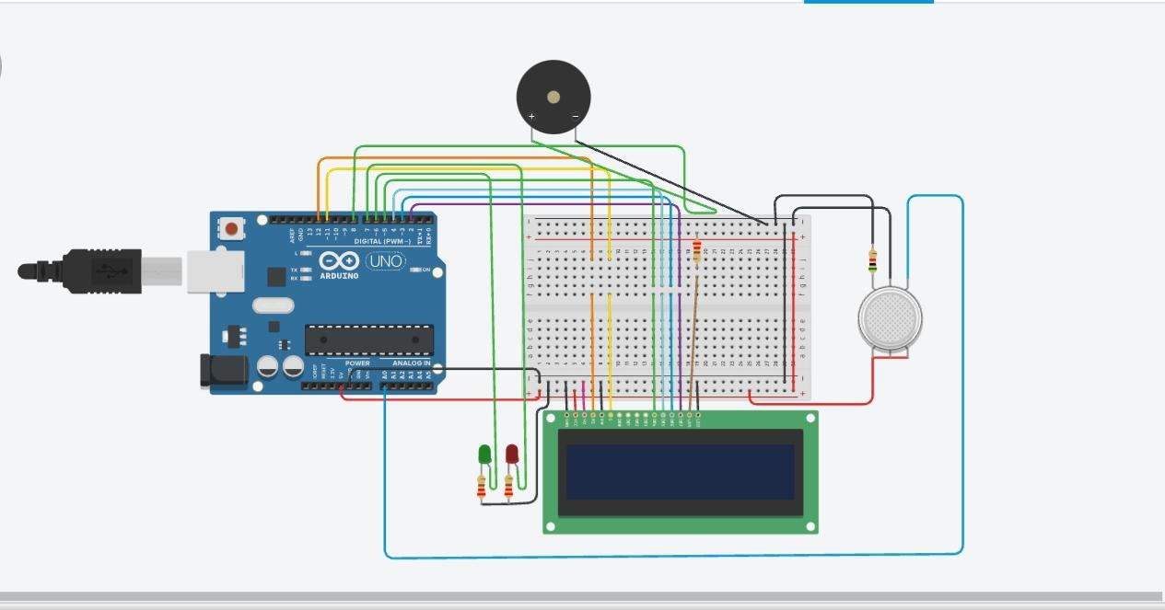

The Arduino board which is a microcontroller that controls everything basically and the bread board through which all the connections are made for external which is basically used for external connections and the LCD, which displays the amount of smoke and here, the LED light which describes the commander of sensor and there is a gas sensor that sense the amount of gas and the potentiometer which is used to make contrast to the LED. And as we can see we have made the particular connections.

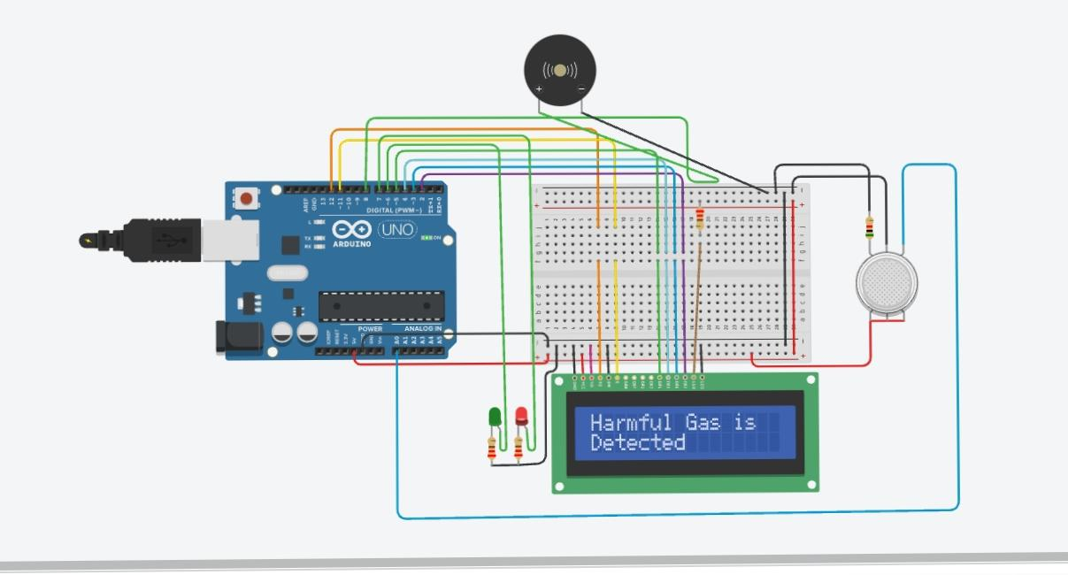

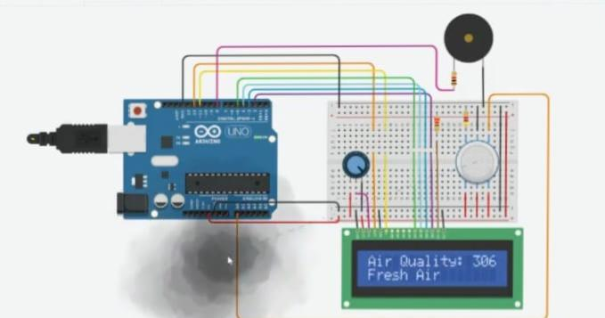This design represents the simulation of Air detecting sensor. When the gas is sensed through the gas sensor with the help of Arduino the piezo indicates through it’s buzzer alarm And it intimates to LCD board as “Harmful gas is detected”.

The design of simulation represents the air quality that simulates and describes the quality using the gas sensor with the help of Arduino Uno In the LCD board as “FRESH AIR” When the air quality is below 500.

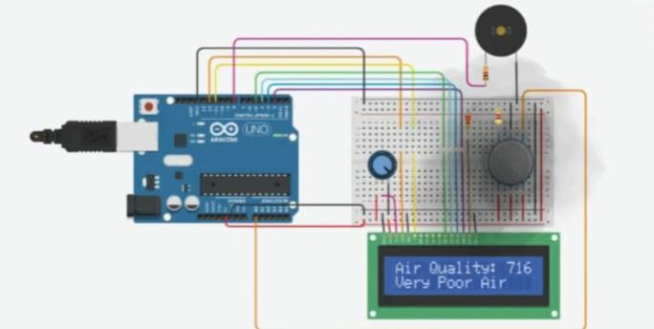

**The design of simulation represents the air quality that simulates and describes the quality using the gas sensor with the help of Arduino uno In the LCD board as “VERY POOR AIR ” When the air quality is Above 500.**