Zoho
Purchase Module: Purchase module consists of eight sections:
- Vendors
- Purchase order
- Bill
- Recurring Bill
- Vendor credit/Debit note
- Expenses
- Recurring Expenses
- Payment Made

1.Vendors

When clicking on vendor add button, it will redirect to vendor list out page, which lists all vendors in a table containing details of:

- Vendor Name
- Phone Number
- Mail ID
- GST Treatment
- GST Number
- Opening Balance
- Status
- Balance (based on the transactions)

• On top of the table, search option: search option based on both alphabets and numbers.
• On top of the page, export to excel option: For export the table to excel
• On top of the page, impot from excel option: For import data to the table from excel
•On top of the table, sort by option:
When clicking on the sort by option, a dropdown menu must appear with the below options and sorting must be done in these three ways:

- All
- Vendor Name
- Balance Amount

- On top of the table, filter by option: When clicking on the filter option, a dropdown menu must appear with the below options and filter must be done in these three ways:
- All
- Active
- Inactive

- On top of the table, Add Vendor button: When clicking on Add Vendor button it will redirect to ‘Add Vendor’ Page.
ADD VENDOR page consists of a form containing:

- Primary contact section, Containing:
- Title
- When clicking on the input field for 'Title’, a dropdown list must appear with the list containing:
- Mr
- Mrs
- Ms
- Dr
- First Name
- Input field for entering First Name.
- Last Name
- Input field for entering Last Name.
- Company Name
- Input field for entering Company Name
- Vendor Display Name
- When clicking on the input field for 'Vendor Display Name', a dropdown list must appear with options containing display names in three formats using title, first name, and last name
- Vendor Email
- Input field for entering Vendor Email.
- Vendor Phone (2 input fields)
- Land phone: Input field for entering land phone number
- Mobile: Input field for entering mobile phone number
- More Details: When clicking 'More Details', it will display an additional section with the following optional fields:
- Skype name/number: Input field for entering Skype name/number.
- Designation: Input field for entering designation.
- Department: Input field for entering department.
- Website: Input field for entering website.

- Other details: When clicking 'Other details', it will display an additional section with the following optional fields:
- GST Treatment: A dropdown list must appear with options for GST treatments.
- If the GST Type is registered, a new input field must appear to add GSTIN.
- GSTIN: Input field for entering the GST number. If the number is invalid, an error message will be displayed.
- PAN NO: Input field for entering the PAN number. If the number is invalid, an error message will be displayed.
- Source of Supply: A dropdown list must appear with options for the source of supply.
- Currency: A dropdown list must appear with options for Currency. (Default set to Indian currency)
- Opening Balance Type: dropdown for selecting debit/credit.
- Opening Balance: Input field for entering the opening balance. If the opening balance type is debit, the opening balance will be positive; if it is credit, it will be negative.
- Payment Terms: A dropdown list must appear with options for payment terms, including:
- Net 30
- NET 60
- Due on receipt
- Add Payment Term option: for adding custom payment terms.
- Credit Limit: Input field for entering credit limit. An input field for entering the credit limit. If the credit limit decreases, a notification will be sent to company.

- Address: when clicking address, it will display address portion with two sections containing following optional fields:

- Billing address
- Attention: Input field for entering attention
- Country: Input field for Selecting country
- Address: Input field for entering address
- City: Input field for entering city
- State: Input field for entering state
- Zip Code: Input field for entering zip code
- Phone: Input field for entering phone (if it is wrong it will show invalid message)
- Fax: Input field for entering fax (if it is wrong it will show invalid message)
- Same as billing address check box: If the billing address and shipping address are the same, clicking on the checkbox will display the shipping address the same as the billing address.
- Shipping address
- Attention: Input field for entering attention
- Country: Input field for Selecting country
- Address: Input field for entering address
- City: Input field for entering city
- State: Input field for entering state
- Zip Code: Input field for entering zip code
- Phone: Input field for entering phone (if it is wrong it will show invalid message)
- Fax: Input field for entering fax (if it is wrong it will show invalid message)
- Contact person: When clicking 'Contact person', it will display a section with a contact person table containing the following fields:
- Salutation: Dropdown with salutations
- First Name: Input field
- Last Name: Input field
- Email Address: Input field
- Work Phone: Input field
- Mobile: Input field
- Skype Name/No: Input field
- Designation: Input field
- Department: Input field
- Add contact person button: for adding new contact person to the table.
- Remarks: when clicking remarks, it will display remarks section containing:
- Remarks: text area for entering remarks (not mandatory)
- Save and cancel button
- When clicking save button it will redirect to the list out page, displaying the saved details
- When clicking on cancel button will reset the form
- When clicking on the table row in the list out page, it will redirect to respective vendor overview page.
- Vendor overview page contains:
- Side table with vendor names and their balances on the left side.
- On the top of the side table, there are search, sort, and add vendor options.
- When clicking on a vendor in the side table, the right side overview (like a template) and its statement and transaction table change according to the selected vendor in the side table.
- Overview page displays all the details from create page like a template (right side)
- Transaction button: when clicking transaction button, it will show the transaction details containing:
- Name
- Phone number
- Email
- Credit limit
- Balance
- GSTIN
(The above mentioned are highlighted contents)
- Transactions table: the table for list out all transactions of vendor it containing:

- Serial Number
- Type
- Number
- Date
- Total
- Balance

- The 'Type', 'Date', 'Total ', 'Balance', and 'Number' columns all have the filter option and search option.
- The vendor's balance dynamically updates based on each transaction.

- On the top of the overview page containing,
- Statement option: When clicking on this option, the transaction table statement will be displayed in the overview section
- Statement-From date and To date filtration option.
- Statement Print option
- Statement Pdf option
- Statement Share option –whatsapp and email
- Comment option- (add, view, edit, delete are available)

- Edit option
- Attach file option
- Active/inactive button: for activate/inactivate the vendor.
- Delete option
- Entered/Altered Details: This section displays information about who entered or altered the payment made at last(highlight).
- Entered/Altered Details History: History of who entered or altered.

2.Purchase order

When clicking on purchase order it will redirect to purchase order page, which lists all purchase order in a table containing details of:
- Date
- Purchase order number
- Vendor name
- Mail id
- Total Amount
- Balance
- Status(draft/save)
- Action
- When clicking the 'Convert' button in the action column, a dropdown menu will appear, allowing conversion to either 'Convert to Bill' or 'Convert to Recurring Bill,' with only one conversion possible. After conversion, the action column will change to either "Convert to Bill" with a number or "Convert to Recurring Bill" with a number, indicating the converted status.
• On top of the table, search option: search option based on both alphabets and numbers.
• On top of the page, export to excel option: For export the table to excel
• On top of the page, impot from excel option: For import data to the table from excel

• On top of the table, sort option:
- When clicking on the sort by option a drop menu must appear with the below options and sorting must be done in these three ways:
- All
- Purchase order Number
- Vendor Name
• On top of the table, filter by option:
- When clicking on the filter by option a dropdown menu must appear with the below options and sorting must be done in these three ways:
- All
- Draft
- Save

• On top of the table, Add Purchase Order button: When clicking on Add Purchase Order button it will redirect to Add Purchase Order Page:
• Add Purchase Order Page consists of a form
- Vendor details

- Vendor Name: Clicking on the input field for vendor name will display a dropdown menu displaying active vendor names.
- Add vendor button: Clicking this button allows to add a new vendor. The added vendors are displayed in the vendor name dropdown for future selection.
- Vendor Search: A search option is available to search for vendors from the dropdown.
- Vendor GST Treatment: This field is automatically displayed based on the selected vendor's GST treatment.
- Vendor GST IN: This field is automatically displayed based on the selected vendor's GST IN.
- Vendor Billing Address: This field is automatically displayed based on the selected vendor's billing address.
- Place of Supply: This field is automatically displayed based on the selected vendor's place of supply and is also selectable from a dropdown.

- The “Deliver to” section provides two options (radio buttons) to choose from
- Organization: When select “Organization”, it will display the following input fields,

- Name: input field for entering the name
- GST Number: input field for entering the GST Number
- Email: input field for entering the Email
- Address: input field for entering the Address
- Street: input field for entering the Street
- City: input field for entering the City
- State: input field for entering the State

- Customer: When select “Customer” it will display the following input fields,
- Customer name: Clicking on the input field for ‘customer name’ will display a dropdown menu displaying active customer names.
- Add customer button: Clicking this button allows to add a new customer. The added customers are displayed in the ‘customer name’ dropdown for future selection.
- Customer Search: A search option is available to search for customers from the dropdown.
- Email: Automatically get updated when customer name is selected.
- Billing Address: Automatically get updated when customer name is selected.
- GST Type: Automatically get updated according to selected customer’s GST type
- GST Number: Automatically get updated according to selected customer’s GST Number
- Place of supply: Automatically updates when the customer name is selected, and the user can change the customer’s place of supply.

- purchase Order Number: This is an input field for entering the purchase order number. For example, if the purchase order number starts with a number, the next entry for the purchase order number of that company must be the next number; otherwise, it will show an error.

- Reference Number: This field automatically generates numbers (continuous numbers).

- Order date: The date field is pre-filled with the current date as the default, and it also provides a calendar for selecting a different date.

- Expiry date: The date automatically displayed based on the order date and payment terms.

- Payment Terms :( A drop down list containing three options):

- Due on Receipt
- Net 30
- Net 60
- Add new payment term button (User can add a custom term)
- Payment type: When clicking on the 'Payment type' input field, a dropdown list should appear with options such as bank names, cash, cheque, and UPI.
- If 'bank name' is selected, the bank account number will automatically appear in an input field below.
- If 'cheque' is selected, an input field will be shown for entering the cheque number.
- If 'UPI' is selected, an input field will be shown for entering the UPI number

- Item details table consists of:
- Serial number
- Items: A dropdown list of all active items for adding items to the table. And a search option available for searching the items in the dropdown.
- Item add button: when clicking on the button, it will redirect to add item page for adding new item name to the dropdown.
- HSN: Automatically updated the field based on the HSN number entered in the item creation page.
- Quantity: Input field for entering Quantity.
- Rate: Automatically updated with the purchase price value entered in item creation page.
- Tax: Clicking on the 'Tax' input field should display a dropdown list of taxes based on the place of supply of vendor and company state. If the place of supply of vendor is equal to the company state, it will display the GST value entered from the item creation page otherwise, it will display the IGST value entered from the item creation page.
- Discount: An input field for entering any available discount, with a default value of 0 if no discount is applicable.
- Amount: Amount will be automatically displayed (Quantity*Rate-Discount)
- Clone option: Clone the above row.
- Delete row option: Delete the particular row.
- Add new row option: Add new row.

- Sub Total: It will automatically generate a value, which will be Amount in the item table. If there are multiple items, the subtotal will be the total amount of the values in the 'Amount' field in the table.
- GST, CGST, SGST: If the 'Tax' is GST, it will display two fields, CGST and SGST, each containing half the value of the GST. If the 'Tax' is IGST, it will display the same IGST value.
- Tax Amount: If the 'Tax' is GST, it will display tax amount as CGST+SGST else tax amount is IGST
- Shipping charge: An input field for entering the shipping charge, which can be zero or any amount.
- Adjustment: An input field for entering the adjustment value, which can be zero or any amount.
- Total: It will automatically generate a value. (Subtotal+ Tax amount+ Adjustment+ Shipping charge)
- Paid/Advance: An input field for entering the paid amount, which can be zero or any amount (if it exceeds the total, an error will be displayed).
- Balance: It will automatically generate a value. (Total-Paid)

- Customer Note: Input field for entering customer notes

- Terms and condition: Input field for entering Terms and conditions.

- Attach file: Field for attach file.

- Save: It will save the Form data and redirect to list out page (when saved as save, the status will be 'Save').

- Draft: It will draft the Form data and redirect to list out page (when saved as a draft, the status will be 'Draft')

- Cancel: It will reset the form.

- When clicking on the table row in list out page, it will redirect to respective Purchase order overview page.
- Purchase order overview page contains:
- Side table with Purchase orders details such as vendor name, amount, status, date, purchase order number.(left side)
- On the top of the side table, there are search, sort, and add purchase order options.
- When clicking on a purchase order details in the side table, the right side overview (like a template) will change according to the selected purchase order details in the side table.
- Overview page containing,
- All the details from create page. (right side)
- Edit button: Edit purchase order
- Delete button: Delete purchase order
- File attach button: Attach file and download attached file.
- Print (Template, slip)
- PDF (Template, slip)
- Share: share to email and Whatsapp
- Convert :(Draft purchase order convert to save)
- Slip: Slip with details same as template.
- Comment option- (add, view, edit, delete are available)
- Entered/Altered Details: This section displays information about who entered or altered the payment made at last(highlight).
- Entered/Altered Details History: History of who entered or altered.

- Template option: when clicking on template button it will display templates (three formats).
- Template page consists of following:
- Purchase order number
- Purchase order date
- From (company name, address)
- To (Customer name, address)
- Item details :(Item name, hsn, price, quantity, tax, discount, total) like table
- Subtotal
- Tax value
- GST/IGST
- Tax amount
- Shipping charge
- Adjustment
- Total

3.Bill

When clicking on bill add button, it will redirect to bill list out page, which lists all bills in a table containing details of:

- Date
- Bill No
- Vendor Name
- Mail ID
- Amount
- Status
- Balance (based on the transactions)

• On top of the table, search option: search option based on both alphabets and numbers.
• On top of the page, export to excel option: For export the table to excel
• On top of the page, impot from excel option: For import data to the table from excel

• On top of the table, sort by option:

When clicking on the sort by option, a dropdown menu must appear with the below options and sorting must be done in these three ways:
- All
- Vendor Name
- Bill No

On top of the table filter by option: When clicking on the filter option, a dropdown menu must appear with the below options and filter must be done in these three ways:

- All
- Draft
- Save
• On top of the table, Add Bill button: When clicking on Add Bill button it will redirect to Add Bill Page:
• Add Bill Page consists of a form
- Vendor details

- Vendor Name: Clicking on the input field for vendor name will display a dropdown menu displaying active vendor names.
- Add vendor button: Clicking this button allows to add a new vendor. The added vendors are displayed in the vendor name dropdown for future selection.
- Vendor Search: A search option is available to search for vendors from the dropdown.
- Vendor GST Treatment: This field is automatically displayed based on the selected vendor's GST treatment.
- Vendor GST IN: This field is automatically displayed based on the selected vendor's GST IN.
- Vendor Billing Address: This field is automatically displayed based on the selected vendor's billing address.
- Place of Supply: This field is automatically displayed based on the selected vendor's place of supply and is also selectable from a dropdown.

- Bill Number: This is an input field for entering the bill number. For example, if the bill number starts with a number, the next entry for the bill number of that company must be the next number; otherwise, it will show an error.

- Reference Number: This field automatically generates numbers (continuous numbers).

- Purchase order number: The number is automatically generated based on the converted purchase order to the bill.

- Bill date: The date field is pre-filled with the current date as the default, and it also provides a calendar for selecting a different date.

- Due date: The date automatically displayed based on the bill date and payment terms.

- Payment Terms :( A drop down list containing three options):

- Due on Receipt
- Net 30
- Net 60
- Add Customer name:
- Clicking on the input field for ‘customer name’ will display a dropdown menu displaying active customer names.
- Add customer button: Clicking this button allows to add a new customer. The added customers are displayed in the ‘customer name’ dropdown for future selection.
- Customer Search: A search option is available to search for customers from the dropdown.
- Email: Automatically get updated when customer name is selected.
- GST Type: Automatically get updated according to selected customer’s GST type
- GST Number: Automatically get updated according to selected customer’s GST Number
- Place of Supply: This field is automatically displayed based on the selected customer's place of supply and is also selectable from a dropdown.

- Payment type: When clicking on the 'Payment type' input field, a dropdown list should appear with options such as bank names, cash, cheque, and UPI.
- If 'bank name' is selected, the bank account number will automatically appear in an input field below.
- If 'cheque' is selected, an input field will be shown for entering the cheque number.
- If 'UPI' is selected, an input field will be shown for entering the UPI number

- Item details table consists of:

- Serial number
- Items: A dropdown list of all active items for adding items to the table. And a search option available for searching the items in the dropdown.
- Item add button: when clicking on the button, it will redirect to add item page for adding new item name to the dropdown.
- HSN: Automatically updated the field based on the HSN number entered in the item creation page.
- Quantity: Input field for entering Quantity.
- Available quantity: Available quantity will be automatically displayed (item’s stock in hand + Quantity).
- Rate: Automatically updated with the purchase price value entered in item creation page.
- Tax: Clicking on the 'Tax' input field should display a dropdown list of taxes based on the place of supply of vendor and company state. If the place of supply of vendor is equal to the company state, it will display the GST value entered from the item creation page otherwise, it will display the IGST value entered from the item creation page.
- Discount: An input field for entering any available discount, with a default value of 0 if no discount is applicable.
- Amount: Amount will be automatically displayed (Quantity*Rate-Discount)
- Clone option: Clone the above row.
- Delete row option: Delete the particular row.
- Add new row option: Add new row.

- Sub Total: It will automatically generate a value, which will be Amount in the item table. If there are multiple items, the subtotal will be the total amount of the values in the 'Amount' field in the table.
- GST, CGST, SGST: If the 'Tax' is GST, it will display two fields, CGST and SGST, each containing half the value of the GST. If the 'Tax' is IGST, it will display the same IGST value.
- Tax Amount: If the 'Tax' is GST, it will display tax amount as CGST+SGST else tax amount is IGST
- Shipping charge: An input field for entering the shipping charge, which can be zero or any amount
- Adjustment: An input field for entering the adjustment value, which can be zero or any amount.
- Total: It will automatically generate a value. (Subtotal+ Tax amount+ Adjustment+ Shipping charge)
- Paid/Advance: An input field for entering the paid amount, which can be zero or any amount (if it exceeds the total, an error will be displayed).
- Balance: It will automatically generate a value. (Total-Paid)

- Description: Input field for entering description.
- Attach file: Field for attach file.

- Save: It will save the Form data and redirect to list out page (when saved as save, the status will be 'Save').

- Draft: It will draft the Form data and redirect to list out page (when saved as a draft, the status will be 'Draft')

- Cancel: It will reset the form.

- When clicking on the table row in list out page, it will redirect to respective bill overview page.
- Bill overview page contains:
- Side table with bill details such as vendor name, amount, status, date, bill number on the left side.
- On the top of the side table, there are search, sort, and add bill options.
- When clicking on a bill details in the side table, the right side overview (like a template) will change according to the selected bill details in the side table.
- Overview page containing,
- All the details from create page. (right side)
- Edit button: Edit bill
- Delete button: Delete bill
- File attach button: Attach file and download attached file.
- Print (Template, slip)
- PDF (Template, slip)
- Share: share to email and Whatsapp
- Convert :(Draft bill convert to save)
- Slip: Slip with item details.
- Comment option- (add, view, edit, delete are available)
- Entered/Altered Details: This section displays information about who entered or altered the payment made at last(highlight).
- Entered/Altered Details History: History of who entered or altered.

- Template option: when clicking on template button it will display templates (three formats).
- Template page consists of following:
- Bill number
- Date
- Company details
- Bill to (Vendor details)
- Deliver To (Customer details)
- Item details :(Item name, HSN, rate, quantity, tax, discount, total) like table
- Subtotal
- Tax value
- GST/IGST
- Tax amount
- Shipping charge
- Adjustment
- Total

4.Recurring Bill

When clicking on bill add button, it will redirect to bill list out page, which lists all bills in a table containing details of:

- Date
- Recurring Bill No
- Vendor Name
- Mail ID
- Amount
- Status
- Balance (based on the transactions)

• On top of the table, search option: search option based on both alphabets and numbers.
• On top of the page, export to excel option: For export the table to excel
• On top of the page, impot from excel option: For import data to the table from excel

• Life cycle chart
• On top of the table sort by option:

When clicking on the sort by option, a dropdown menu must appear with the below options and sorting must be done in these three ways:
- All
- Vendor Name
- Bill No

On top of the table filter by option: When clicking on the filter option, a dropdown menu must appear with the below options and filter must be done in these three ways:

- All
- Draft
- Save

• On top of the table, Add Recurring Bill button: When clicking on Add Recurring Bill button it will redirect to Add Recurring Bill Page:
• Add Recurring Bill Page consists of a form
- Vendor details

- Vendor Name: Clicking on the input field for vendor name will display a dropdown menu displaying active vendor names.
- Add vendor button: Clicking this button allows to add a new vendor. The added vendors are displayed in the vendor name dropdown for future selection.
- Vendor Search: A search option is available to search for vendors from the dropdown.
- Vendor GST Treatment: This field is automatically displayed based on the selected vendor's GST treatment.
- Vendor GST IN: This field is automatically displayed based on the selected vendor's GST IN.
- Vendor Billing Address: This field is automatically displayed based on the selected vendor's billing address.
- Place of Supply: This field is automatically displayed based on the selected vendor's place of supply and is also selectable from a dropdown.

- Recurring Bill Number: This is an input field for entering the recurring bill number. For example, if the recurring bill number starts with a number, the next entry for the recurring bill number of that company must be the next number; otherwise, it will show an error.
- Profile Name: Input field for entering profile name.
- Date: The date field is pre-filled with the current date as the default, and it also provides a calendar for selecting a different date.
- Reference Number: This field automatically generates numbers (continuous numbers).
- Repeat every: Clicking on the input field for 'repeat every' will display a dropdown menu with the options week, month and 6 months.
- Add repeat every: Clicking this button allows to add a new ‘repeat every’. The added ‘repeat every’ are displayed in the repeat every dropdown for future selection.
- Credit period:( A drop down list containing three options):

- Due on Receipt
- Net 30
- Net 60
- Add new credit button (User can add a custom period)
- Expiry date: The date automatically displayed based on the date and credit period.
- Purchase order number: The number is automatically generated based on the converted purchase order to the recurring bill.
- Add Customer name:
- Clicking on the input field for ‘customer name’ will display a dropdown menu displaying active customer names.
- Add customer button: Clicking this button allows to add a new customer. The added customers are displayed in the ‘customer name’ dropdown for future selection.
- Customer Search: A search option is available to search for customers from the dropdown.
- Email: Automatically get updated when customer name is selected.
- GST Type: Automatically get updated according to selected customer’s GST type
- GST Number: Automatically get updated according to selected customer’s GST Number
- Billing Address: Automatically get updated when customer name is selected.
- Place of Supply: This field is automatically displayed based on the selected customer's place of supply and is also selectable from a dropdown.

- Payment type: When clicking on the 'Payment type' input field, a dropdown list should appear with options such as bank names, cash, cheque, and UPI.
- If 'bank name' is selected, the bank account number will automatically appear in an input field below.
- If 'cheque' is selected, an input field will be shown for entering the cheque number.
- If 'UPI' is selected, an input field will be shown for entering the UPI number

- Item details table consists of:

- Serial number
- Items: A dropdown list of all active items for adding items to the table. And a search option available for searching the items in the dropdown.
- Item add button: when clicking on the button, it will redirect to add item page for adding new item name to the dropdown.
- HSN: Automatically updated the field based on the HSN number entered in the item creation page.
- Quantity: Input field for entering Quantity.
- Available quantity: Available quantity will be automatically displayed (item’s stock in hand + Quantity).
- Rate: Automatically updated with the purchase price value entered in item creation page.
- Tax: Clicking on the 'Tax' input field should display a dropdown list of taxes based on the place of supply of vendor and company state. If the place of supply of vendor is equal to the company state, it will display the GST value entered from the item creation page otherwise, it will display the IGST value entered from the item creation page.
- Discount: An input field for entering any available discount, with a default value of 0 if no discount is applicable.
- Amount: Amount will be automatically displayed (Quantity*Rate-Discount)
- Clone option: Clone the above row.
- Delete row option: Delete the particular row.
- Add new row option: Add new row.

- Sub Total: It will automatically generate a value, which will be Amount in the item table. If there are multiple items, the subtotal will be the total amount of the values in the 'Amount' field in the table.
- GST, CGST, SGST: If the 'Tax' is GST, it will display two fields, CGST and SGST, each containing half the value of the GST. If the 'Tax' is IGST, it will display the same IGST value.
- Tax Amount: If the 'Tax' is GST, it will display tax amount as CGST+SGST else tax amount is IGST
- Shipping charge: An input field for entering the shipping charge, which can be zero or any amount
- Adjustment: An input field for entering the adjustment value, which can be zero or any amount.
- Total: It will automatically generate a value. (Subtotal+ Tax amount+ Adjustment+ Shipping charge)
- Paid/Advance: An input field for entering the paid amount, which can be zero or any amount (if it exceeds the total, an error will be displayed).
- Balance: It will automatically generate a value. (Total-Paid)

- Description: Input field for entering description.
- Attach file: Field for attach file.

- Save: It will save the Form data and redirect to list out page (when saved as save, the status will be 'Save').

- Draft: It will draft the Form data and redirect to list out page (when saved as a draft, the status will be 'Draft')

- Cancel: It will reset the form.

- When clicking on the table row in list out page, it will redirect to respective recurring bill overview page.
- Recurring bill overview page contains:
- Side table with bill details such as profile name, amount, status, date, bill number on the left side.
- On the top of the side table, there are search, sort, and add bill options.
- When clicking on a recurring bill details in the side table, the right side overview (like a template) will change according to the selected bill details in the side table.
- Overview page containing,
- All the details from create page. (right side)
- Edit button: Edit Recurring Bill
- Delete button: Delete Recurring Bill
- File attach button: Attach file and download attached file.
- Print (Template, slip)
- PDF (Template, slip)
- Share: share to email and Whatsapp
- Convert :(Draft recurring bill convert to save)
- Slip: Slip with item details.
- Comment option- (add, view, edit, delete are available)
- Entered/Altered Details: This section displays information about who entered or altered the payment made at last(highlight).
- Entered/Altered Details History: History of who entered or altered.

- Template option: when clicking on template button it will display templates (three formats).
- Template page consists of following:
- Recurring Bill number
- Date
- Company details
- Bill to (Vendor details)
- Deliver To (Customer details)
- Order number
- Item details :(Item name, HSN, rate, quantity, tax, discount, total) like table
- Subtotal
- Tax value
- GST/IGST
- Tax amount
- Shipping charge
- Adjustment
- Total

5.Vendor Credit/Debit Note

When clicking on vendor credit/debit note add button, it will redirect to vendor credit/debit note list out page, which lists all vendor credit/debit note in a table containing details of:

- Date
- Debit Note No
- Vendor Name
- Mail ID
- Amount
- Status
- Balance (based on the transactions)

• On top of the table, search option: search option based on both alphabets and numbers.
• On top of the page, export to excel option: For export the table to excel
• On top of the page, impot from excel option: For import data to the table from excel

• Life cycle chart
• On top of the table sort by option:

When clicking on the sort by option, a dropdown menu must appear with the below options and sorting must be done in these three ways:
- All
- Vendor Name
- debit note No

On top of the table filter by option: When clicking on the filter option, a dropdown menu must appear with the below options and filter must be done in these three ways:

- All
- Draft
- Save

• On top of the table, Add Vendor Credit/Debit Note button: When clicking on Add Vendor Credit/Debit Note button it will redirect to add vendor credit/debit note Page:

• Add Recurring Bill Page consists of a form
- Vendor details

- Vendor Name: Clicking on the input field for vendor name will display a dropdown menu displaying active vendor names.
- Add vendor button: Clicking this button allows to add a new vendor. The added vendors are displayed in the vendor name dropdown for future selection.
- Vendor Search: A search option is available to search for vendors from the dropdown.
- Vendor GST Treatment: This field is automatically displayed based on the selected vendor's GST treatment.
- Vendor GST IN: This field is automatically displayed based on the selected vendor's GST IN.
- Vendor Billing Address: This field is automatically displayed based on the selected vendor's billing address.
- Place of Supply: This field is automatically displayed based on the selected vendor's place of supply and is also selectable from a dropdown.

- Debit Note Number: This is an input field for entering the debit note number. For example, if the debit note number starts with a number, the next entry for the debit note number of that company must be the next number; otherwise, it will show an error.

- Reference Number: This field automatically generates numbers (continuous numbers).

- Date: The date field is pre-filled with the current date as the default, and it also provides a calendar for selecting a different date.

- Bill number: The number is automatically generated based on the selected vendor's bill number and recurring bill number, and it is displayed in a dropdown. If there is no bill or recurring bill number, it won't be displayed.

- Payment type: When clicking on the 'Payment type' input field, a dropdown list should appear with options such as bank names, cash, cheque, and UPI.
- If 'bank name' is selected, the bank account number will automatically appear in an input field below.
- If 'cheque' is selected, an input field will be shown for entering the cheque number.
- If 'UPI' is selected, an input field will be shown for entering the UPI number

- Item details table consists of:

- Serial number
- Items: A dropdown list of all active items for adding items to the table. And a search option available for searching the items in the dropdown.
- If the selected item from dropdown not based on the bill number or recurring bill number, it will show an error.
- Item add button: when clicking on the button, it will redirect to add item page for adding new item name to the dropdown.
- HSN: Automatically updated the field based on the HSN number entered in the item creation page.
- Quantity: Input field for entering quantity based on the bill number or recurring bill number. If the quantity not based on the bill number or recurring bill number, it will show an error
- Available quantity: Available quantity will be automatically displayed (item’s stock in hand - Quantity).
- Rate: Automatically updated with the purchase price value entered in item creation page.
- Tax: Clicking on the 'Tax' input field should display a dropdown list of taxes based on the place of supply of vendor and company state. If the place of supply of vendor is equal to the company state, it will display the GST value entered from the item creation page otherwise, it will display the IGST value entered from the item creation page. If the selected tax from dropdown not based on the bill number or recurring bill number, it will show an error.
- Discount: An input field for entering any available discount, with a default value of 0 if no discount is applicable.
- Amount: Amount will be automatically displayed (Quantity*Rate-Discount)
- Clone option: Clone the above row.
- Delete row option: Delete the particular row.
- Add new row option: Add new row.

- Sub Total: It will automatically generate a value, which will be Amount in the item table. If there are multiple items, the subtotal will be the total amount of the values in the 'Amount' field in the table.
- GST, CGST, SGST: If the 'Tax' is GST, it will display two fields, CGST and SGST, each containing half the value of the GST. If the 'Tax' is IGST, it will display the same IGST value.
- Tax Amount: If the 'Tax' is GST, it will display tax amount as CGST+SGST else tax amount is IGST
- Shipping charge: An input field for entering the shipping charge, which can be zero or any amount
- Adjustment: An input field for entering the adjustment value, which can be zero or any amount.
- Total: It will automatically generate a value. (Subtotal+ Tax amount+ Adjustment+ Shipping charge)
- Paid/Advance: An input field for entering the paid amount, which can be zero or any amount (if it exceeds the total, an error will be displayed).
- Balance: It will automatically generate a value. (Total-Paid)

- Vendor credit note: Input field for entering Vendor credit note.
- Attach file: Field for attach file.

- Save: It will save the Form data and redirect to list out page (when saved as save, the status will be 'Save').

- Draft: It will draft the Form data and redirect to list out page (when saved as a draft, the status will be 'Draft')

- Cancel: It will reset the form.

- When clicking on the table row in list out page, it will redirect to respective debit note overview page.
- Debit note overview page contains:
- Side table with bill details such as vendor name, amount, status, date, bill number on the left side.
- On the top of the side table, there are search, sort, and add bill options.
- When clicking on a debit note details in the side table, the right side overview (like a template) will change according to the selected bill details in the side table.
- Overview page containing,
- All the details from create page. (right side)
- Edit button: Edit debit note
- Delete button: Delete debit note
- File attach button: Attach file and download attached file.
- Print (Template, slip)
- PDF (Template, slip)
- Share: share to email and Whatsapp
- Convert :(Draft debit note convert to save)
- Slip: Slip with item details.
- Comment option- (add, view, edit, delete are available)
- Entered/Altered Details: This section displays information about who entered or altered the payment made at last(highlight).
- Entered/Altered Details History: History of who entered or altered.

- Template option: when clicking on template button it will display templates (three formats).
- Template page consists of following:
- Debit note number
- Date
- Company details
- Bill to (Vendor details)
- Deliver To (Customer details)
- Order number
- Item details :(Item name, HSN, rate, quantity, tax, discount, total) like table
- Subtotal
- Tax value
- GST/IGST
- Tax amount
- Shipping charge
- Adjustment
- Total

6.Expense

When clicking on expense add button, it will redirect to expense list out page, which lists all expense in a table containing details of:

- Date
- Expense Account
- Expense Type
- Payment Method
- Amount
- Status
• On top of the table, search option: search option based on both alphabets and numbers.
• On top of the page, export to excel option: For export the table to excel
• On top of the page, impot from excel option: For import data to the table from excel

• Life cycle chart
• On top of the table sort by option:

When clicking on the sort by option, a dropdown menu must appear with the below options and sorting must be done in these three ways:
- All
- Amount
- Expense Account

On top of the table filter by option: When clicking on the filter option, a dropdown menu must appear with the below options and filter must be done in these three ways:

- All
- Draft
- Save

• On top of the table, add expense button: When clicking on add expense button it will redirect to add expense page:

• Add Expense Page consists of a form
- Date: The date field is pre-filled with the current date as the default, and it also provides a calendar for selecting a different date
- Expense Account: Clicking on the input field for Expense account will display a dropdown menu displaying accounts and other account names created from chart of accounts.
- Add expense account button: Clicking this button allows to add a new expense account. The added accounts are displayed in the expense account dropdown for future selection.
- Expense account search: A search option is available to search for accounts from the dropdown
- Goods/Service: Check box for selecting Good/Service
- SAC/HSN:
- If ‘Goods’ is selected, it will display the HSN Number field for entering the HSN number.
- if ‘Service’ is selected, it will display the SAC Number field for entering the SAC number.

- Amount: Input field for entering the amount
- Payment method: When clicking on the 'Payment method' input field, a dropdown list should appear with options such as bank names, cash, cheque, and UPI.
- If 'bank name' is selected, the bank account number will automatically appear in an input field below.
- If 'cheque' is selected, an input field will be shown for entering the cheque number.
- If 'UPI' is selected, an input field will be shown for entering the UPI number
- Vendor details

- Vendor Name: Clicking on the input field for vendor name will display a dropdown menu displaying active vendor names.
- Add vendor button: Clicking this button allows to add a new vendor. The added vendors are displayed in the vendor name dropdown for future selection.
- Vendor Search: A search option is available to search for vendors from the dropdown.
- Vendor GST Treatment: This field is automatically displayed based on the selected vendor's GST treatment.
- Vendor GST IN: This field is automatically displayed based on the selected vendor's GST IN.
- Vendor Billing Address: This field is automatically displayed based on the selected vendor's billing address.
- Place of Supply: This field is automatically displayed based on the selected vendor's place of supply and is also selectable from a dropdown.
- Expense number: This is an input field for entering the expense number. For example, if the expense number starts with a number, the next entry for the expense number of that company must be the next number; otherwise, it will show an error.
- Reference Number: This field automatically generates numbers (continuous numbers).
- Add Customer name: Clicking on the input field for ‘customer name’ will display a dropdown menu displaying active customer names.
- Add customer button: Clicking this button allows to add a new customer. The added customers are displayed in the ‘customer name’ dropdown for future selection.
- Customer Search: A search option is available to search for customers from the dropdown.
- Email: Automatically get updated when customer name is selected.
- GST Type: Automatically get updated according to selected customer’s GST type
- GST Number: Automatically get updated according to selected customer’s GST Number
- Billing Address: Automatically get updated when customer name is selected.
- Place of Supply: This field is automatically displayed based on the selected customer's place of supply and is also selectable from a dropdown.

- GST Treatment: If customer’s place of supply and vendor’s place of supply are equal, it will display GST dropdown with values GST 0%, GST 3%, GST 5%, GST 12%, GST 18%, GST 28%. If not equal, it will display IGST dropdown with values IGST 0%, IGST 3%, IGST 5%, IGST 12%, IGST 18%, IGST 28%.
- note: Input field for entering note.
- Attach file: Field for attach file.

- Save: It will save the Form data and redirect to list out page (when saved as save, the status will be 'Save').

- Draft: It will draft the Form data and redirect to list out page (when saved as a draft, the status will be 'Draft')

- Cancel: It will reset the form.

- When clicking on the table row in list out page, it will redirect to respective expense overview page.
- Expense overview page contains:
- Side table with expense details such as amount, status, date, expense account on the left side.
- On the top of the side table, there are search, sort, and add expense options.
- When clicking on an expense details in the side table, the right side overview (like a template) will change according to the selected expense details in the side table.
- Overview page containing,
- All the details from create page. (right side)
- Edit button: Edit Expense
- Delete button: Delete Expense
- File attach button: Attach file and download attached file.
- Print (Template)
- PDF (Template)
- Share: share to email and Whatsapp
- Convert :(Draft Expense convert to save)
- Comment option- (add, view, edit, delete are available)
- Entered/Altered Details: This section displays information about who entered or altered the payment made at last(highlight).
- Entered/Altered Details History: History of who entered or altered.

- Template option: when clicking on template button it will display templates (three formats).
- Template page consists of following:

- Company details
- Bill to (Vendor details)
- Deliver To (Customer details)
- Date
- Particulars-Expense account
- Amount

7.Recurring Expense

When clicking on recurring expense add button, it will redirect to expense list out page, which lists all recurring expense in a table containing details of:

- Date
- Expense Account
- Expense Type
- Payment Number
- Amount
- Status
• On top of the table, search option: search option based on both alphabets and numbers.
• On top of the page, export to excel option: For export the table to excel
• On top of the page, impot from excel option: For import data to the table from excel
• Life cycle chart
• On top of the table sort by option:

When clicking on the sort by option, a dropdown menu must appear with the below options and sorting must be done in these three ways:
- All
- Amount
- Expense Account

On top of the table filter by option: When clicking on the filter option, a dropdown menu must appear with the below options and filter must be done in these three ways:

- All
- Draft
- Save

• On top of the table, add recurring expense button: When clicking on add recurring expense button it will redirect to add recurring expense page:

• Add Recurring Expense Page consists of a form
- Date: The date field is pre-filled with the current date as the default, and it also provides a calendar for selecting a different date
- Profile Name: Input field for entering profile name.
- Expense Account: Clicking on the input field for Expense account will display a dropdown menu displaying accounts and other account names created from chart of accounts.
- Add expense account button: Clicking this button allows to add a new expense account. The added accounts are displayed in the expense account dropdown for future selection.
- Expense account search: A search option is available to search for accounts from the dropdown
- Goods/Service: Check box for selecting Good/Service
- SAC/HSN:
- If ‘Goods’ is selected, it will display the HSN Number field for entering the HSN number.
- if ‘Service’ is selected, it will display the SAC Number field for entering the SAC number.

- Amount: Input field for entering the amount
- Payment through: When clicking on the 'Payment through' input field, a dropdown list should appear with options such as bank names, cash, cheque, and UPI.
- If 'bank name' is selected, the bank account number will automatically appear in an input field below.
- If 'cheque' is selected, an input field will be shown for entering the cheque number.
- If 'UPI' is selected, an input field will be shown for entering the UPI number
- Vendor details

- Vendor Name: Clicking on the input field for vendor name will display a dropdown menu displaying active vendor names.
- Add vendor button: Clicking this button allows to add a new vendor. The added vendors are displayed in the vendor name dropdown for future selection.
- Vendor Search: A search option is available to search for vendors from the dropdown.
- Vendor GST Treatment: This field is automatically displayed based on the selected vendor's GST treatment.
- Vendor GST IN: This field is automatically displayed based on the selected vendor's GST IN.
- Vendor Billing Address: This field is automatically displayed based on the selected vendor's billing address.
- Place of Supply: This field is automatically displayed based on the selected vendor's place of supply and is also selectable from a dropdown.

- Add Customer name: Clicking on the input field for ‘customer name’ will display a dropdown menu displaying active customer names.
- Add customer button: Clicking this button allows to add a new customer. The added customers are displayed in the ‘customer name’ dropdown for future selection.
- Customer Search: A search option is available to search for customers from the dropdown.
- Email: Automatically get updated when customer name is selected.
- GST Type: Automatically get updated according to selected customer’s GST type
- GST Number: Automatically get updated according to selected customer’s GST Number
- Billing Address: Automatically get updated when customer name is selected.
- Place of Supply: This field is automatically displayed based on the selected customer's place of supply and is also selectable from a dropdown.

- GST Treatment: If customer’s place of supply and vendor’s place of supply are equal, it will display GST dropdown with values GST 0%, GST 3%, GST 5%, GST 12%, GST 18%, GST 28%. If not equal, it will display IGST dropdown with values IGST 0%, IGST 3%, IGST 5%, IGST 12%, IGST 18%, IGST 28%.
- note: Input field for entering note.
- Attach file: Field for attach file.

- Save: It will save the Form data and redirect to list out page (when saved as save, the status will be 'Save').

- Draft: It will draft the Form data and redirect to list out page (when saved as a draft, the status will be 'Draft')

- Cancel: It will reset the form.

- When clicking on the table row in list out page, it will redirect to respective recurring expense overview page.
- Recurring Expense overview page contains:
- Side table with expense details such as amount, status, date, profile name on the left side.
- On the top of the side table, there are search, sort, and add recurring expense option.
- When clicking on a recurring expense details in the side table, the right side overview (like a template) will change according to the selected recurring expense details in the side table.
- Overview page containing,
- All the details from create page. (right side)
- Edit button: Edit Expense
- Delete button: Delete Expense
- File attach button: Attach file and download attached file.
- Print (Template)
- PDF (Template)
- Share: share to email and Whatsapp
- Convert :(Draft Recurring Expense convert to save)
- Comment option- (add, view, edit, delete are available)
- Entered/Altered Details: This section displays information about who entered or altered the payment made at last(highlight).
- Entered/Altered Details History: History of who entered or altered.

- Template option: when clicking on template button it will display templates (three formats).
- Template page consists of following:

- Company details
- Reference no
- Bill to (Vendor details)
- Deliver To (Customer details)
- Date
- Particulars-Expense account
- Amount

8.Payment made

When clicking on payment made add button, it will redirect to payment made list out page, which lists all payment made in a table containing details of:

- Date
- Payment Number
- Vendor Name
- Mail ID
- Amount
- Status
• On top of the table, search option: search option based on both alphabets and numbers.
• On top of the page, export to excel option: For export the table to excel
• On top of the page, impot from excel option: For import data to the table from excel
• On top of the table sort by option:

When clicking on the sort by option, a dropdown menu must appear with the below options and sorting must be done in these three ways:
- All
- Payment number
- Vendor name

On top of the table filter by option: When clicking on the filter option, a dropdown menu must appear with the below options and filter must be done in these three ways:

- All
- Draft
- Save

• On top of the table, add payment made button: When clicking on add payment made button it will redirect to add payment made page:

• Add payment made consists of a form
- Vendor details
- Vendor Name: Clicking on the input field for vendor name will display a dropdown menu displaying active vendor names.
- Add vendor button: Clicking this button allows to add a new vendor. The added vendors are displayed in the vendor name dropdown for future selection.
- Vendor Search: A search option is available to search for vendors from the dropdown.
- Vendor GST Treatment: This field is automatically displayed based on the selected vendor's GST treatment.
- Vendor GST IN: This field is automatically displayed based on the selected vendor's GST IN.
- Vendor Billing Address: This field is automatically displayed based on the selected vendor's billing address.
- Place of Supply: This field is automatically displayed based on the selected vendor's place of supply and is also selectable from a dropdown.

- Payment Number: This is an input field for entering the payment number. For example, if the payment number starts with a number, the next entry for the payment number of that company must be the next number; otherwise, it will show an error.
- Reference Number: This field automatically generates numbers (continuous numbers).
- Date: The date field is pre-filled with the current date as the default, and it also provides a calendar for selecting a different date
- Payment Method: When clicking on the 'Payment Method' input field, a dropdown list should appear with options such as bank names, cash, cheque, and UPI.
- If 'bank name' is selected, the bank account number will automatically appear in an input field below.
- If 'cheque' is selected, an input field will be shown for entering the cheque number.
- If 'UPI' is selected, an input field will be shown for entering the UPI number

- Bill Section
- This section automatically displays the selected vendor’s data, including opening balance, recurring bills, debit notes, and bills in a table format.
- The table containing:
- Type
- Date
- Bill Number
- Total Amount
- Payment
- Balance (To display the vendor’s current balance)
- Payment: Input field for entering the payment amount
- Total Balance: Automatically displays the total balance.
- Highlight Payment and Total balance

- Save: It will save the Form data and redirect to list out page (when saved as save, the status will be 'Save').

- Draft: It will draft the Form data and redirect to list out page (when saved as a draft, the status will be 'Draft')

- Cancel: It will reset the form.

- When clicking on the table row in list out page, it will redirect to respective payment made overview page.
- Payment made overview page contains:
- Side table with payment made details such as vendor name, amount, status, date on the left side.
- On the top of the side table, there are search, sort, and add payment made option.
- When clicking on a payment made details in the side table, the right side overview (like a template) will change according to the selected details in the side table.
- Overview page containing,
- All the details from create page. (right side)
- Edit button: Edit payment made
- Delete button: Delete payment made
- File attach button: Attach file and download attached file.
- Print (Template)
- PDF (Template)
- Share: share to email and Whatsapp
- Convert :(Draft payment made convert to save)
- Comment option- (add, view, edit, delete are available)
- Entered/Altered Details: This section displays information about who entered or altered the payment made at last(highlight).
- Entered/Altered Details History: History of who entered or altered.

- Template option: when clicking on template button it will display templates (three formats).
- Template page consists of following:
- Name of the firm
- details of registered company
- Vendor details
- Date
- Particulars-Payment paid
- Payment Amount

Accountant Module: Purchase module consists of two sections:
- Chart of accounts
- Manual Journal

1.Chart of accounts

When clicking on chart of account add button, it will redirect to chart of account list out page, which lists all chart of accounts in a table containing details of:

- Account Name
- Account code
- Account type
- Status
- (80+ ledgers automatically displayed in this table)

• On top of the table, search option: search option based on both alphabets and numbers.

On top of the table filter by option: When clicking on the filter option, a dropdown menu must appear with the below options and filter must be done in these ways:
- Assets
- Liability
- Equity
- Income
- Expense

• On top of the table, add chart of accounts button: When clicking on add chart of accounts, it will redirect to add chart of accounts page:

• Add chart of accounts consists of a form
- Account type: Clicking on the input field for account type will display a dropdown menu displaying account types such as
- Assets
- Other Assets
- Other Current Assets
- Cash
- Bank
- Fixed Asset
- Stock
- Payment Clearing
- Liability
- Other Liability
- Other Current Liability
- Credit Card
- Long Term Liability
- Overseas Tax Payable
- Equity
- Equity
- Income
- Income
- Other Income
- Expense
- Expense
- Cost Of Goods Sold
- Other Expense

- Account Search: A search option is available to search for accounts from the dropdown.
- If any optgroup is selected, the description of the optgroup will be displayed.
- Add account option: Clicking this button allows the addition of a new account. The newly added accounts will be listed under the ‘Other Account’ optgroup in the dropdown menu for future selection. If the account already exists, an error message will be displayed.
- Account Name: Input field for entering account name.
- Account Code: Input field for entering account code.
- Description: Input field for entering account description.
- Save: It will save the form data and redirect to list out page (when saved as save, the status will be 'Save').
- Cancel: It will reset the form.

- When clicking on the table row in list out page, it will redirect to respective chart of accounts overview page.
- Chart of accounts overview page contains:
- Side table with chart of accounts details such as account name and it’s account type and status in left side.
- On the top of the side table, there are search, filter and add chart of accounts option.
- When clicking on a chart of accounts details in the side table, the right side overview (like a template) will change according to the selected details in the side table.
- Overview page containing,
- All the details from create page. (right side)
- Display all transactions under the account.
- Closing Balance: The closing balance remains zero in the absence of transactions. When transactions exist, the closing balance is determined by these transactions. (Highlight)
- Edit button: Edit chart of accounts
- Delete button: Delete chart of accounts
- File attach button: Attach file and download attached file.
- Print overview
- PDF overview
- Share: share to email and Whatsapp
- Convert: Active/Inactive
- Comment option- (add, view, edit, delete are available)
- Entered/Altered Details: This section displays information about who entered or altered the payment made at last(highlight).
- Entered/Altered Details History: History of who entered or altered.

2.Manual Journal
When clicking on manual journal add button, it will redirect to manual journal list out page, which lists all manual journal in a table containing details of:
- Date
- Journal No
- Contact Name
- Notes (When hovering over the note icons, small popups display the notes.)
- Amount
- Status

• On top of the table, search option: search option based on both alphabets and numbers.
• On top of the page, export to excel option: For export the table to excel
• On top of the page, impot from excel option: For import data to the table from excel
• On top of the table sort by option:

When clicking on the sort by option, a dropdown menu must appear with the below options and sorting must be done in these three ways:

- All
- Journal No
- Contact Name

On top of the table filter by option: When clicking on the filter option, a dropdown menu must appear with the below options and filter must be done in these three ways:

- All
- Draft
- Save

• On top of the table, add manual journal button: When clicking on add manual journal button it will redirect to add manual journal page:

• Add manual journal consists of a form

- Date: The date field is pre-filled with the current date as the default, and it also provides a calendar for selecting a different date
- Journal Number: This is an input field for entering the journal number. For example, if the journal number starts with a number, the next entry for the journal number of that company must be the next number; otherwise, it will show an error.
- Reference Number: This field automatically generates numbers (continuous numbers).
- Currency: The field is set with the value ‘Indian Rupee’(dropdown).

- table consists of:
- Number: serial numbers
- Accounts: A dropdown list of all account names from chart of accounts for adding accounts to the table. And a search option available for searching the account names in the dropdown.
- account add button: when clicking on the button, it will redirect to chart of account add page for adding new account name to the dropdown.
- Description: Input field for entering description.
- Contact: A dropdown list of active vendors, customers and employees for adding contact to the table. And a search option available for searching the contacts in the dropdown.
- Debit: Input field for entering debit amount.
- Credit: Input field for entering credit amount.
- Clone option: Clone the above row.
- Delete row option: Delete the particular row.
- Add new row option: Add new row.

- Total:
- Debit: It will automatically generate a value. (Subtotal of the debit amounts)
- Credit: It will automatically generate a value. (Subtotal of the credit amounts)
- Difference: It will automatically generate a value. (Credit total - Debit total)
- Note: Input field for entering notes
- Attach file: Field for attach file.

- Save: It will save the Form data and redirect to list out page (when saved as save, the status will be 'Save').

- Draft: It will draft the Form data and redirect to list out page (when saved as a draft, the status will be 'Draft')

- Cancel: It will reset the form.

- When clicking on the table row in list out page, it will redirect to respective manual journal overview page.
- Manual journal overview page contains:
- Side table with manual journal details such as manual journal number, total, status, date on the left side.
- On the top of the side table, there are search, sort, and add manual journal option.
- When clicking on a manual journal details in the side table, the right side overview (like a template) will change according to the selected details in the side table.
- Overview page containing,
- All the details from create page. (right side)
- Edit button: Edit manual journal
- Delete button: Delete manual journal
- File attach button: Attach file and download attached file.
- Print (Template)
- PDF (Template)
- Share: share to email and Whatsapp
- Convert :(Draft manual journal convert to save)
- Comment option- (add, view, edit, delete are available)
- Entered/Altered Details: This section displays information about who entered or altered the payment made at last(highlight).
- Entered/Altered Details History: History of who entered or altered.

- Template option: when clicking on template button it will display templates (three formats).
- Template page consists of following:
- Company details
- Journal number
- Date
- Reference number
- Particulars-Account name
- Note
- Debit amount
- Credit amount

Reports Module: The Reports Module includes a Business Overview consisting of six sections.
- Trail Balance
- Profit and Loss Account
- Horizontal Profit and Loss Account
- Cash Flow Statement
- Balance Sheet
- Horizontal Balance Sheet

1.Trail Balance

When clicking on trail balance in the business overview section, it will redirect to trail balance transaction page, which lists all expenses in a table containing details of:
- Particulars
- It displays all ledgers under the groups in the ‘chart of accounts’ account type section
- Debit
- Ledger’s Debit amount
- Credit
- Ledger’s Credit amount
- Grand Total: This fields are automatically displayed based on the total credit amount and debit amount.
- If the credit balance is greater than the debit balance, specify the difference in the debit balance side (always specify the lesser side).
- On the top of the table, display of company details are available.
- On the top of the table, display of from-date and to-date are available.
- On the top of the table, filter option: for filtering the table using from-date and to-date.
- Print trail balance
- Share-Whatsapp and Email
- Back option: for redirect to the reports page.
Format of trail balance:

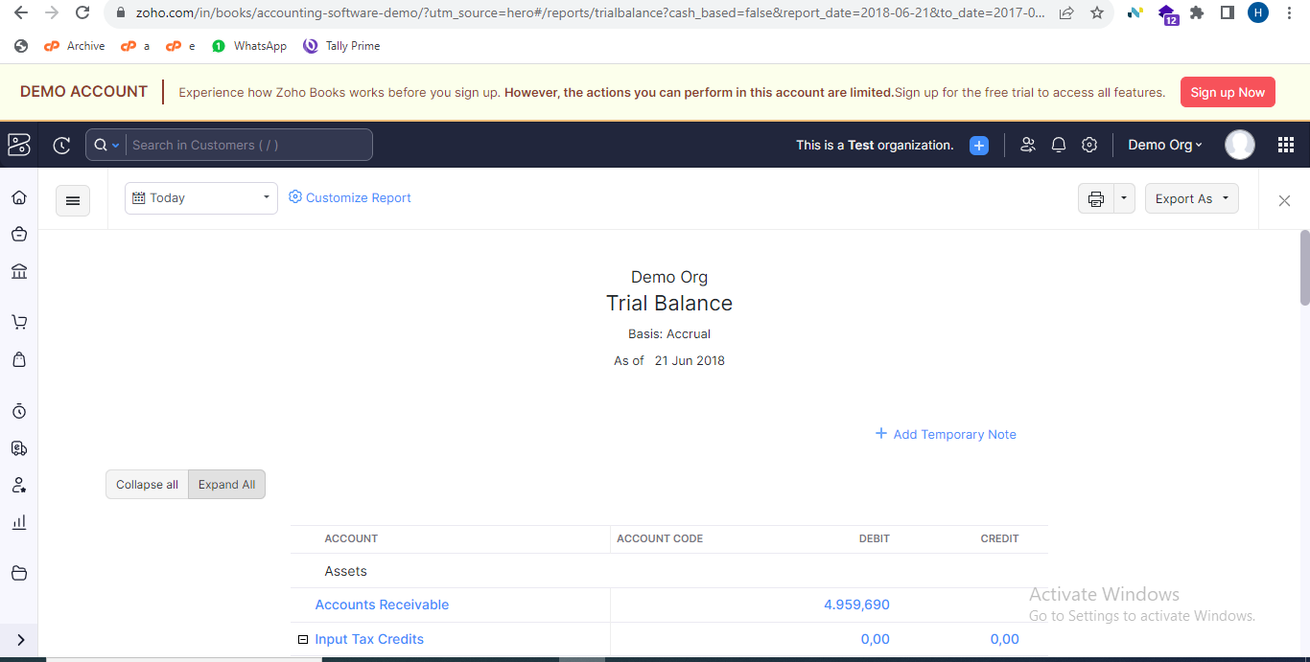

2. Profit and Loss Account
- “Profit and loss account” is used for analysing the profit and loss.
When clicking on profit and loss account in the business overview section, it will redirect to profit and loss account page, which lists all profit and loss account in the page containing details of:

- Trading account:
- Debit side:
- Opening balance
- Closing balance
- Purchase amount (purchase-purchase return)
- Direct expense
- Credit side:
- Sales (sales amount-sales return)
- Direct income
- If there is a profit, it will be a debit balance. Then trading account completely moves to the income and expenditure account.
- Profit and Loss Account Section:
- Lists out all indirect income and indirect expenses
- Displays the difference between indirect income and indirect expenses to check for profit or loss.
- Displays net profit in debit side and net loss in credit side.
- Tallies the debit side, credit side to analyse profit and loss.
- On the top of the table, display of company details are available.
- On the top of the table, display of from-date and to-date are available.
- On the top of the table, filter option: for filtering the table using from-date and to-date.
- Print profit and loss account
- Share-Whatsapp and Email
- Back option: for redirect to the reports page.

Format of profit and loss account:

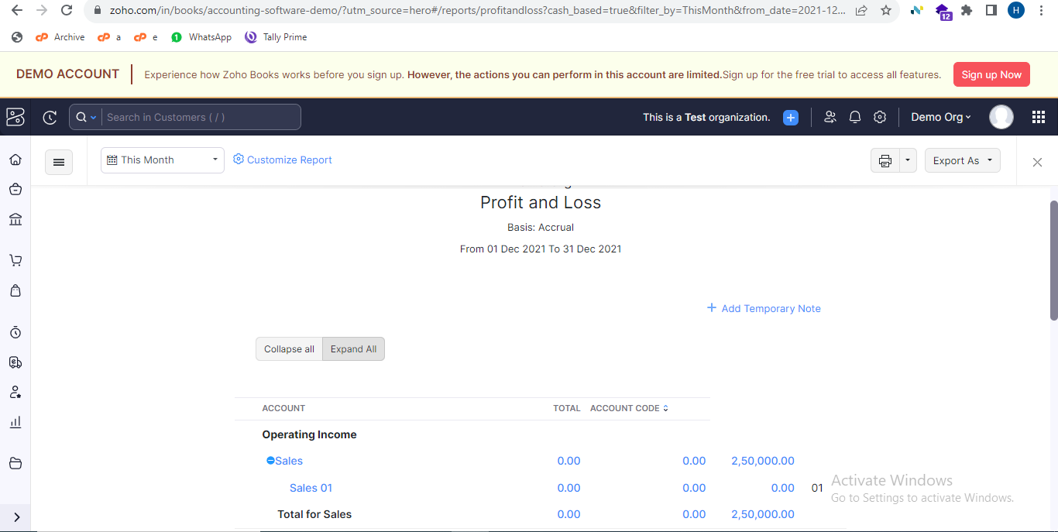

3. Horizontal Profit and Loss Account
- “Horizontal Profit and loss account” is used for analysing the profit and loss.
When clicking on horizontal profit and loss account in the business overview section, it will redirect to horizontal profit and loss account page, which lists all horizontal profit and loss account in the page containing details of:
- Trading account:
- Debit side:
- Opening balance
- Closing balance
- Purchase amount (purchase-purchase return)
- Direct expense
- Credit side:
- Sales (sales amount-sales return)
- Direct income
- If there is a profit, it will be a debit balance. Then trading account completely moves to the income and expenditure account.
- Profit and Loss Account Section:
- Lists out all indirect income and indirect expenses
- Displays the difference between indirect income and indirect expenses to check for profit or loss.
- Displays net profit in debit side and net loss in credit side.
- Tallies the debit side, credit side to analyse profit and loss.

- On the top of the table, display of company details are available.
- On the top of the table, display of from-date and to-date are available.
- On the top of the table, filter option: for filtering the table using from-date and to-date.
- Print horizontal profit and loss account.
- Share-Whatsapp and Email
- Back option: for redirect to the reports page.

Format of horizontal profit and loss account:

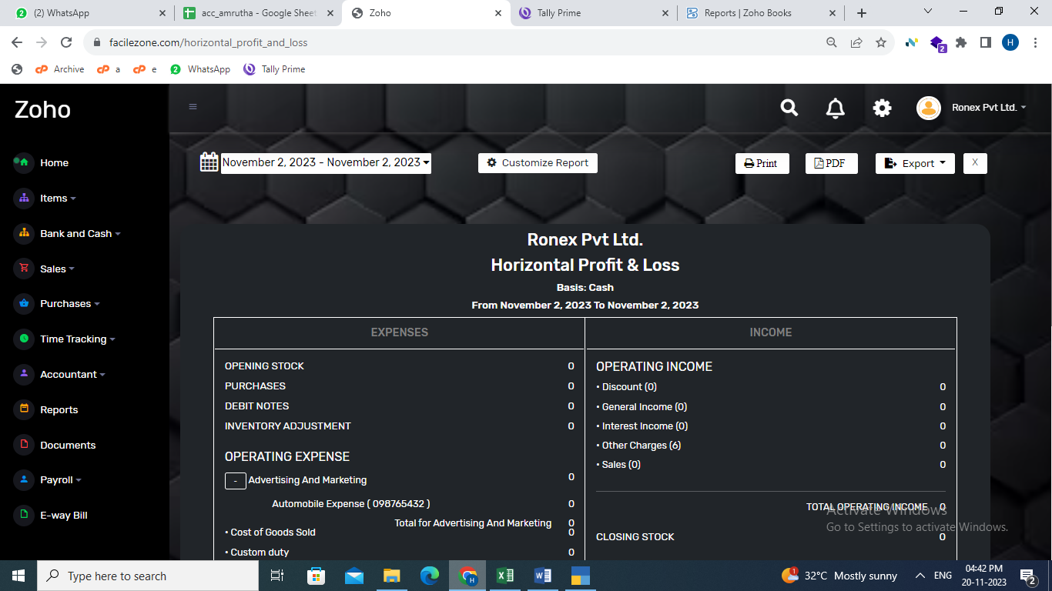

4.Cash flow statement
When clicking on cash flow statement in the business overview section, it will redirect to cash flow statement page, which lists all cash flow entries in the table containing details of:

- Date
- Reference number
- Name
- Type
- Cash In
- Cash out
- Balance
- Total cash in hand, Total cash out and cash in (highlight)
- Cash In containing details of:
- Sales-Invoice, Recurring invoice, Retainer invoice
- Purchase-Vendor credit/Debit note
- Cash and Bank-Banking, Loan account
- Cash Out containing details of:
- Purchase-Bills, Recurring bills
- Sales-Credit note
- Payroll-Employees loan, salary
- Cash and Bank-Banking, Loan account

- On the top of the table, display of company details are available.
- On the top of the table, display of from-date and to-date are available.
- On the top of the table, filter option: for filtering the table using from-date and to-date.
- Print cash flow statement
- Share-Whatsapp and Email
- Back option: for redirect to the reports page.

5.Balance sheet
- “Balance sheet is used for analysing financial statement”
When clicking on balance sheet in the business overview section, it will redirect to balance sheet page, which lists all balance sheets in page containing details of:
- Liabilities:
- Current liabilities
- Other current liabilities
- Debtors
- Profit and loss account:
- Opening balance
- Loss/Profit
- Assets
- Capital account (In case of profit, it will be added to the capital, whereas in the case of a loss, it will be deducted from the capital.)
- Fixed asset
- Bank
- Cash
- Sundry debtors
- Current asset
- Creditors
- Tallies the liabilities and assets.
- On the top of the table, display of company details are available.
- On the top of the table, display of from-date and to-date are available.
- On the top of the table, filter option: for filtering the table using from-date and to-date.
- Print balance sheet
- Share-Whatsapp and Email
- Back option: for redirect to the reports page.
Format of balance sheet: 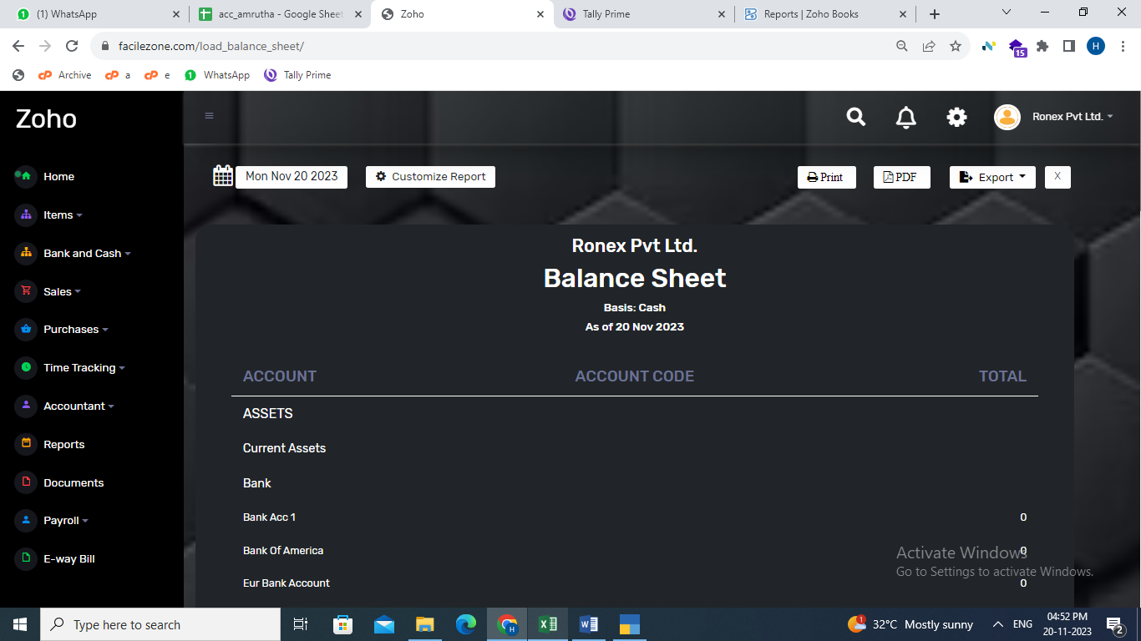

6.Horizontal balance sheet
When clicking on horizontal balance sheet in the business overview section, it will redirect to horizontal balance sheet page, which lists all horizontal balance sheets in page containing details of:
- Liabilities:
- Current liabilities
- Other current liabilities
- Debtors
- Profit and loss account:
- Opening balance
- Loss/Profit
- Assets
- Capital account (In case of profit, it will be added to the capital, whereas in the case of a loss, it will be deducted from the capital.)
- Fixed asset
- Bank
- Cash
- Sundry debtors
- Current asset
- Creditors

- Tallies the liabilities and assets.
- On the top of the table, display of company details are available.
- On the top of the table, display of from-date and to-date are available.
- On the top of the table, filter option: for filtering the table using from-date and to-date.
- Print horizontal balance sheet
- Share-Whatsapp and Email
- Back option: for redirect to the reports page.
Format of horizontal balance sheet: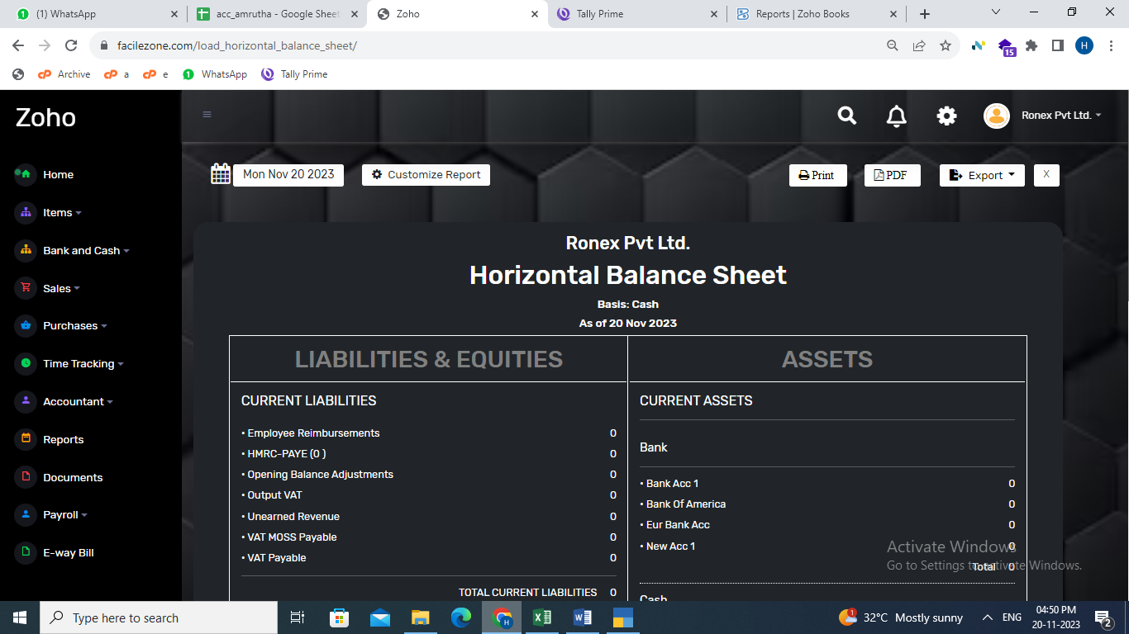

Cash &Bank Module: Record All Cash and bank transactions. Cash& Bank module consists of six sections:

  - Banking
  - Bank Holders
  - Cash in Hand
  - Cheques
  - UPI
  - Loan Amount

- Banking

When clicking on Banking it will redirect to List out page, which lists all items in a table containing details of Date, Bank Name, Account Number, IFSC Code, Opening Balance, Balance, Status.

- On top of the table, Search option: search option based on both alphabets and numbers.
- On top of the table, Sort by option: When clicking on the Sort by option a dropdown menu must appear with the below options and sorting must be done in these three ways:
  - All
  - Name
  - Opening Balance

- On top of the table, Filter by option: When clicking on the filter option a dropdown menu must appear with the below options and sorting must be done in these three ways:

  - All
  - Active
  - Inactive

- On top of the table, Add Bank button: When clicking on Add Bank button it will redirect to CREATE PAGE.
- CREATE PAGE consists of a form containing:
- BANK NAME: Name of the Bank
- ACCOUNT NUMBER: Account Number of the bank.
- BANK IFSC CODE: IFSC code of the bank
- BRANCH NAME: Name of the bank branch
- OPENING BALANCE: Opening Balance of Account Holder.
- DEBIT/CREDIT: If the opening balance is 'Debit' the amount is saved as positive; if it's 'Credit' it is saved as negative.
- DATE: The date field is pre-filled with the current date as the default, and it also provides a calendar for selecting a different date
- Save Bank Account & Close Button

- When trying to add existing account number it shows an error message
- When Clicking any row of banking table in list out page, it will Redirect to overview page.
- Overview page which lists all items in a table containing details of Serial number, Date, Type, Name, Amount, Action :(EDIT & DELETE)
- On top of the table displays BANK NAME and TOTAL Amount
- On the top of the table Search Option: Search option based on both alphabets and numbers.
- On the top of the table EDIT BANK Option Available. When clicking the button, it redirects to EDIT PAGE
- On the top of the table Delete Button Available: To delete Bank
- On the top of the table Bank Transaction are available. It consists of the following:

- Bank to Cash Transfer: When clicking this option, it redirects to bank_ to _cash page it consists a form:
- FROM: Dropdown with bank names
- TO: Input field with the default value set to 'Cash’.
- Amount: Input field for entering the amount
- ADJUSTMENT DATE: Input field for entering date
- DESCRIPTION: Input field for entering description
- SAVE & CANCEL Button
- When these details are saved, they will be displayed in the transaction table.
- After this transaction, the bank balance will decrease and the cash balance of ‘from bank’ will also decrease
- Cash to Bank Transfer: When clicking this option, it redirects to cash _to _bank page it consists a form:
- FROM: Input field with the default value set to 'Cash’.
- TO: Dropdown with bank names
- Amount: Input field for entering the amount
- ADJUSTMENT DATE: Input field for entering date
- DESCRIPTION: Input field for entering description
- SAVE & CANCEL Button
- When these details are saved, they will be displayed in the transaction table
- After this transaction increase the cash balance of ‘to bank’ and increase the bank balance
- Bank to Bank Transfer: When clicking this option, it redirects to bank _to _bank page it consists a form:
- FROM: Dropdown with bank names
- TO: Dropdown with bank names
- Amount: Input field for entering the amount
- ADJUSTMENT DATE: Input field for entering date
- DESCRIPTION: Input field for entering description
- SAVE & CANCEL Button
- When these details are saved, they will be displayed in the transaction table
- After this transaction increase the cash balance of ‘to bank’ and increase the bank balance of ‘to bank’ and decrease the cash balance of ‘from bank’ and decrease the bank balance of ‘to bank’
- Adjust Bank Balance: When clicking this option, it redirects to adjust bank balance page it consists a form:
- Account Name: It contains Bank Name
- TYPE: It Consist of Two types:
- Increase Balance
- Reduce Balance
- Increase Balance
- Amount: Amount to be Increase
- ADJUSTMENT DATE: It contains date
- DESCRIPTION: It contains the description about transactions
- SAVE & CANCEL Button
- When these details are saved, they will be displayed in the transaction table and the bank balance will increased
- Decrease Balance
- Amount
- Adjustment
- Description
- Save & cancel Button
- When these details are saved, they will be displayed in the transaction table and the bank balance will decreased

- On the Top of the Table STATEMENT Button is Available
- STATEMENT contain table details of Serial Number, Date, Type, Name, Amount,Balance
- On the top of statement table include details of transaction table
- All module bank entries should be shown on the transaction page
- Statement should be include:
- PRINT
- PDF
- Share
- Attach File

- Cash in Hand Module:

When clicking on Cash in hand it will redirect to cash _in _hand
page, which lists all items in a table containing details of Date,
Type, Name, Amount, Action
- On top of the table Search option: search option based on both alphabets and numbers.
- On top of the table Filter by Date option- it works as filter the data using date and also user can choose ‘form’ date & ‘To’ date
- On the top of the table shows cash balance
- On the top of the table Add Cash button
- When Clicking Add Cash Button it redirects to add _cash _adjust page: it contains a form of following fields
- ADJUSTMENT: It consist of 2 options
- Add Cash
- Reduce Cash
- AMOUNT: Contain Amount
- ADD DATE: To adjust date
- DESCRIPTION: To add description
- CLOSE & SAVE Payment
On the Top of the table Statement Button Available. When
clicking statement, it redirects to cash statement page.
- The balance increases when transactions involve actions like adding cash, credit notes, invoices, recurring invoices, or retainer invoices, specifically when the payment method selected is cash. Conversely, the balance decreases when transactions involve reducing cash, paying bills, recurring bills, or employee salaries, again specifically when the payment method chosen is cash.
- Statement contains table of details such that Date, Type, Name, Amount, Balance
- On the top of the statement table displays the login customer details and company name, balance
- Edit, Delete, Print, Pdf, Attach file, Download Attached file and share through WhatsApp or mail options

- Bank Holders
- When clicking Bank Holders option it redirects to bank_account_holder list out page. bank_account_holder page consists of table containing SERIAL NUMBER, HOLDER NAME, BANK NAME, IFSC CODE and BRANCH NAME
- On the top of the table Search option: Working on alphabetical and numerical order.
- On the top of the table Export to Excel option
- On top of the table Sort by option: sorting must be done in these three ways:
1.All
2.Holder Name
3.Bank Name
- On top of the table Filter by option: When clicking on the Filter option a dropdown menu must appear with the below options and filtering must be done in these three ways:
1.All
2.Active
3.Inactive

- On top of the table New button: When clicking on New button it will redirect to CREATE PAGE.CREATE PAGE consists of a form containing:
- Bank Account Holder Form
- NAME: Name of the bank holder
- ALIAS: Contain alternative name of bank holder
- PHONE NUMBER: Number of the bank holder
- EMAIL: Email of the holder
- ACCOUNT TYPE: Contain the type of account(Bank)
- Bank Account Form
- BANK NAME: It list out all added bank names and customer can choose one of them
- Add bank account option
- ACCOUNT NUMBER: This field Automatically updated when customer choose bank name
- IFSC CODE: This field Automatically updated when customer choose bank name
- SWIFT CODE: To contain swift code
- BRANCH NAME: Contain branch name
- Bank Configuration Form
- SET CHEQUE BOOK RANGE: Consist of two options
- YES
- NO
- ENABLE CHEQUE PRINTING: Consist of two options
- YES
- NO
- SET CHEQUE PRINTING CONFIGURATION: Consist of two options
- YES
- NO
- Mailing Address Form
- MAILING NAME: Mail name
- ADDRESS: Contain the address
- COUNTRY: Contain list of country
- STATE: Contain the list of state
- PIN: Contain the pin number
- Tax registration form
- PAN IT NUMBER: Contain Pan number
- REGISTRATION TYPE: It contain 4 options
- REGULAR
- COMPOSITION
- CONSUMER
- UNREGISTER
- GST IN: This field is only Available for Regular and compositions
- SET ALTER GST DETAILS: It contains 2 options
- YES
- NO
- Opening Balance Form
- DATE: It contain date
- AMOUNT: It contains amount (Debit and credit balance)
- On the bottom of the form check box which is to agree all terms and conditions and a SAVE button
- Clicking any items in the table it redirects to OVERVIEW page
- Overview page list out all information about Bank holder
- Edit, Active & inactive and Delete options

4)Loan Account

When clicking Loan Account option, it redirects to list out page
- bank_account_holder page consists of table containing DATE, HOLDER NAME, ACCOUNT NUMBER, LOAN AMOUNT, BALANCE, STATUS, ACTION(EDIT&DELETE)
- Edit & delete perform based on the id
- On the top of the table Search option: Working on alphabets order.
- On top of the table Filter by option: When clicking on the Filter by option a dropdown menu must appear with the below options and filtering must be done in these three ways:
    - All
    - Active
    - Inactive
- On top of the table Sort by option: When clicking on the Sort by option a dropdown menu must appear with the below options and sorting must be done in these three ways:
- All
- Holder Name
- Amount
- On the top of the table Export to Excel option
- One account holder can have only one loan account at a time.
- On the top of the table Add Loan Account Button Available: it contains a form
- ACCOUNT NAME: This field list out holder’s name and also enable to add holder’s name
- ACCOUNT NUMBER: This field automatically updated by choosing account name
- LOAN AMOUNT: Input field for entering loan amount
- LENDER BANK: Input field for entering the bank
- DATE: This field shows the current date and also user can choose date
- LOAN RECEIVED IN: This field list out cash, bank name and UPI
- TERMS: It enable to type terms
- PROCESSING PAID FROM: This field list out cash, bank name and UPI
- INTEREST RATE: It contain the interest rate
- PROCESSING FEE: It contain the process fee
- On the bottom of the form Save Loan Account Button Available
- By clicking Any of items in table it Redirects to the OVERVIEW PAGE
- Overview page Contain The transaction table. Which includes the field of NAME, TYPE, DATE, AMOUNT, INTEREST, TOTAL AMOUNT, ACTION (EDIT&DELETE
- On the top of the transaction table Search option: Working on alphabetical order.
- On the top of the table date Filter option: filtration is based on the from date and to date
- On the top of the table Display the NAME, ACCOUNT NUMBER, RECEICVED BANK, BALANCE
- Balance calculated by loan amount-payment amount
- Make Payment button (List out page): When clicking on the Make Payment button It will redirect to Make Payment page.
- Make Payment page consists of a form containing:
- Principal amount: Input field for entering Principal amount
- Date: The date field is pre-filled with the current date as the default, and it also provides a calendar for selecting a different date.
- Interest amount: Input field for entering Interest amount
- Total amount: The amount must be automatically generated and displayed in the input field (Principal amount+ Interest amount)
- Paid From: When clicking on the 'Paid From' input field, a dropdown list should appear with options such as bank names, cash, cheque, and UPI.
- Save Button: It will save the form data and redirect to list out page. it will display in transaction table also.

- Additional Loan: When clicking on the Additional Loan button It will redirect to Additional Loan page.
- Additional Loan page consists of a form containing:
- Date: The date field is pre-filled with the current date as the default, and it also provides a calendar for selecting a different date.
- Additional Loan Amount: Input field for entering Additional Loan Amount
- Interest amount: Input field for entering Interest amount
- Received from: When clicking on the 'Received from' input field, a dropdown list should appear with options such as bank names, cash, cheque, and UPI.
- Total Loan Amount: Input field with value equal to
(Interest amount + Additional Loan Amount)
- Save Button: It will save the form data and redirect to list out page.
- principle amount and interest, and total amount updated automatically.
- On the bottom of the form close and save button
- After adding payment, it shows in the transaction table
- On the top of overview page STATEMENT button available
- STATEMENT contain table details of DATE, TYPE, NAME, AMOUNT, INTEREST, TOTAL, BALANCE
- On the top of statement table shows the all details of transaction table
- On the top of table filter by date option: which filter name and holder’s name according to the date
- On the top of the table SHARE, PRINT, PDF and ACTIVE and INACTIVE are available

5) Cheque:

When we click ‘Cheque’ it shows all the cheque transaction details through
- the Cheque payment type in the different transaction tables will be displayed.
- If any cheque transactions done, the created or altered date and name of created or altered person should be displayed in the transaction history.
VIEW CHEQUE:
- If data present in different table with the payment type Cheque will be listed in the Cheque Details page.
- Date Range field, to show the selected start and end date.
- Import – to import data
- Export to Excel – export the transaction details to excel
- Print – print transactions
- PDF – can take pdf pf all transactions
- Share (WhatsApp, Email)
- Templates /statement
- Company details
- Party Details
- Type of Transactions
- Date
- Total Amount
- Search button to search transaction by filtering done while typing on it.
- Transaction table to display all the cheque transactions. And each have filter to type exact match and filter records. Table includes,
- TYPE – Type of transactions
- NAME – Party Name
- REF NO.
- CHEQUE NUMBER
- DATE – transaction date
- AMOUNT – Total Amount

6) UPI:

- When we click ‘UPI’ it shows all the UPI transaction details through the UPI
- payment type in the different transaction tables will be displayed.
- If any UPI transactions done, the created or altered date and name of created or
- altered person should be displayed in the transaction history.
- VIEW UPI:
- If data present in different table with the payment type UPI will be
- listed in the UPI Details page.
- Date Range field, to show the selected start and end date.
- Import – to import data
- Export to Excel – export the transaction details to excel
- Print – print transactions
- PDF – can take pdf pf all transactions
- Share (WhatsApp, email)
- Templates /statement
- Company details
- Party Details
- Type of Transactions
- Date
- Cheque Number
- Total Amount
- Search button to search transaction by filtering done while typing on it.
- Transaction table to display all the UPI transactions. And each have
- filter to type exact match and filter records. Table includes,
- TYPE – Type of transactions
- NAME – Party Name
- REF NO.
- UPI ID
- DATE – transaction date
- AMOUNT – Total Amount
s

