Student Management System
DBMS Mini Project
Team Members:
M.Ganesh Haricharan– RA1911030010091
S.Pranai Govind - RA1911030010106
P.Reshvanth- RA1911030010099

Abstract
- This project is a web based Student Management system.
- Student Management System is software which is helpful for students as well as the school authorities. In the current system all the activities are done manually. Its time saving and scalable.
- Our Student Management System deals with the various activities related to the students In the software we can register as a user and user has two types student and administrator.
- Administrator has the power to add new user and can edit the students details entered. A admin can add students record ,attendance status with department wise. All students can search his/her basics details.
Objectives:
- The main objective of the project is to design and develop a user friendly-system
- Easy to use and an efficient computerized system.
- Develop an accurate and flexible system, it will eliminate data redundancy.
- To study the functioning of Students management System.
- To make a software fast in processing, with good user interface.
- To make software with good user interface so that user can change it and it should be used for a long time without error and maintenance.
- To provide synchronized and centralized farmer and seller database.
- Computerization can be helpful as a means of saving time and money
Project Overview
- In the software we can register as a user and user has two types student and administrator.
- Administrator has the power to add new user and can edit the students details entered.
- An admin can add students record with department wise.
- All students can search his/her basics details and can edit them.
Software Requirements:
- Frontend- HTML, CSS, Java Script, Bootstrap
Backend-Python flask (Python 3.7) , SQLAlchemy,
- Operating System: Windows 10
- Google Chrome/Internet Explorer
- XAMPP (Version-3.7)
- Python main editor (user interface): VS code
- workspace editor: Sublime text 3
Hardware Requirements:
- Computer with a 1.1 GHz or faster processor
- Minimum 2GB of RAM or more
- 2.5 GB of available hard-disk space
- 5400 RPM hard drive
- 1366 × 768 or higher-resolution display
- DVD-ROM drive
Schema Diagram:
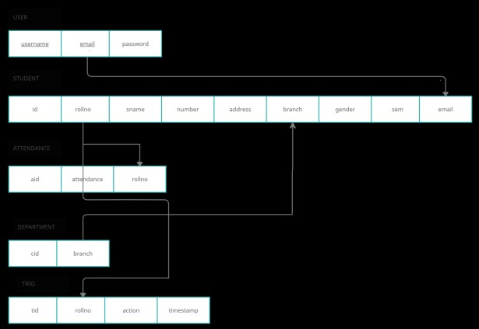
ER – Diagram:
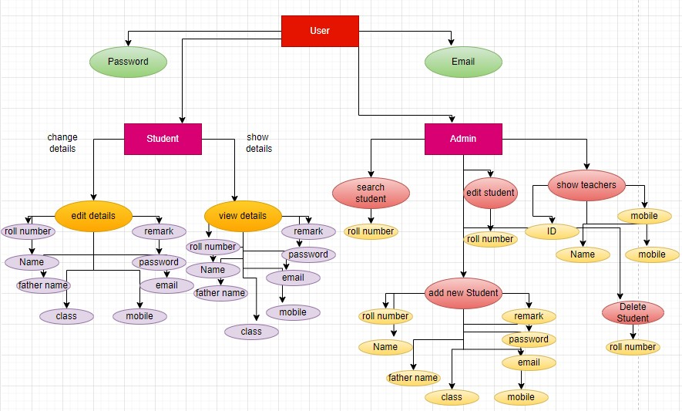
Non Functional Requirements
i] EFFICIENCY REQUIREMENT:
When a student management system is implemented can view or edit or delete details in an efficient manner. ii] RELIABILITY REQUIREMENT:
The system should provide a reliable environment to both student and admin. All changes should be reaching at the admin without any errors. iii] IMPLEMENTATION REQUIREMENT:
Implementation of the system using css and php in front end and database part is developed by mysql. Responsive web designing is used for making the website compatible for any type of screen. iv] DELIVERY REQUIREMENT:
The whole system is expected to be delivered in four months of time with a weekly evaluation by the project guide.
Functional Requirements
USER:
USER LOGIN:
- This feature used by the user to login into system. A user must login with his user name and password to the system after registration. If they are invalid, the user not allowed to enter the system.
- Username and password will be provided after user registration is confirmed.
- Password should be hidden from others while typing it in the field.
System Tools
The various system tools that have been used in developing both the front end and the back end of the project.
FRONT END: CSS are utilized to implement the frontend.
CSS (Cascading Style Sheets): CSS is a style sheet language used for describing the look and formatting of a document written in a markup language.

BACK END: MySQL
MySQL: MySQL is the world's second most widely used open-source relational database management system (RDBMS). The SQL phrase stands for Structured Query Language.
An application software called Navicat was used to design the tables in
MySQL.
Tables
Admin:
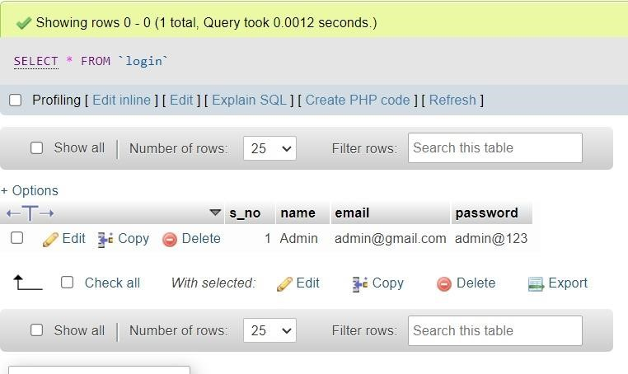
Tables
Teachers:
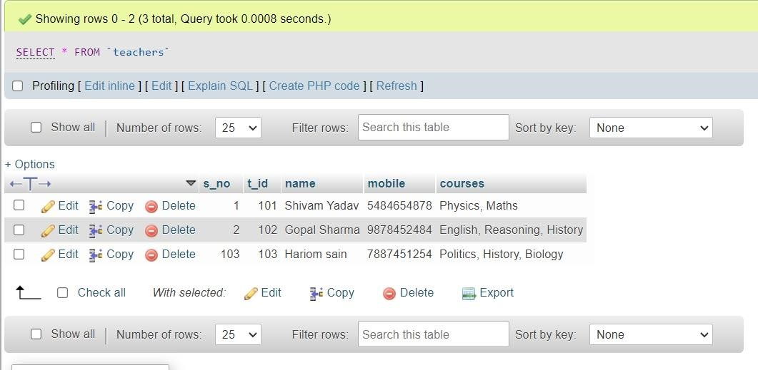
Tables
Students:
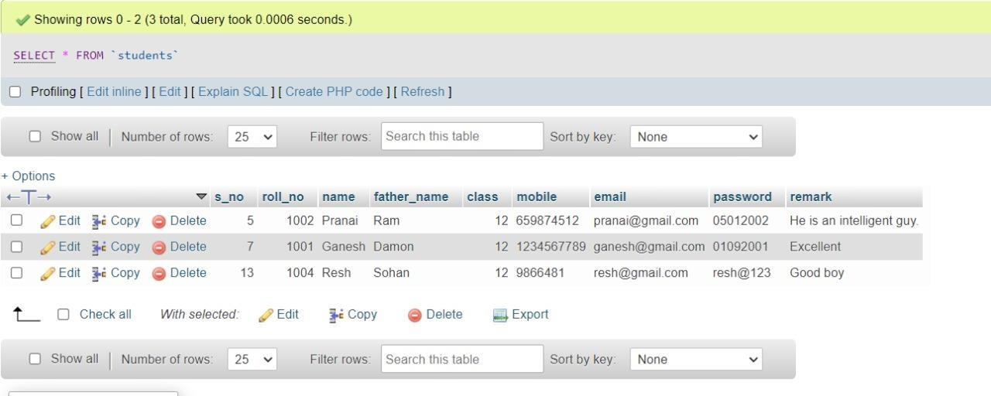
LOGIN Data Flow Diagram:
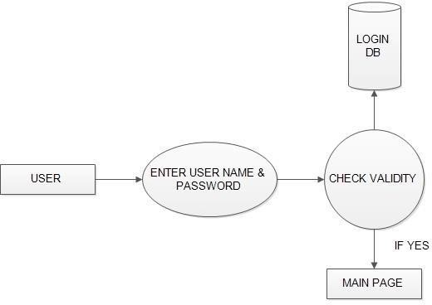
OUTPUTS
Front End
ScreenShots
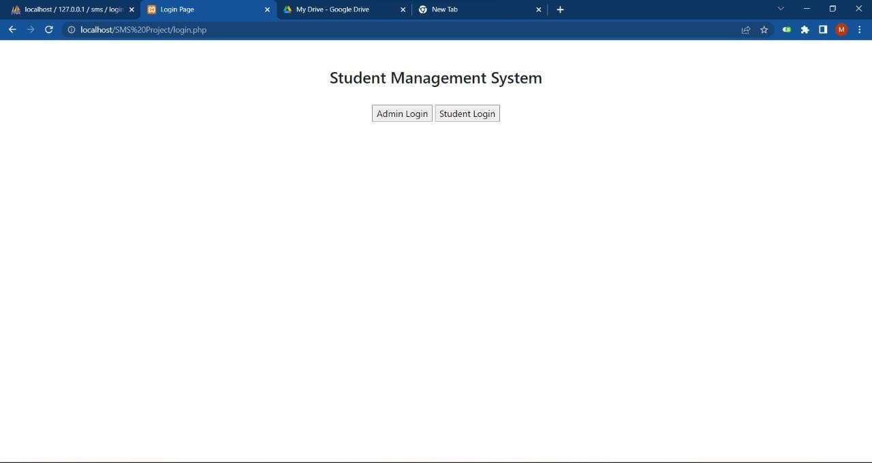
Front End ScreenShots
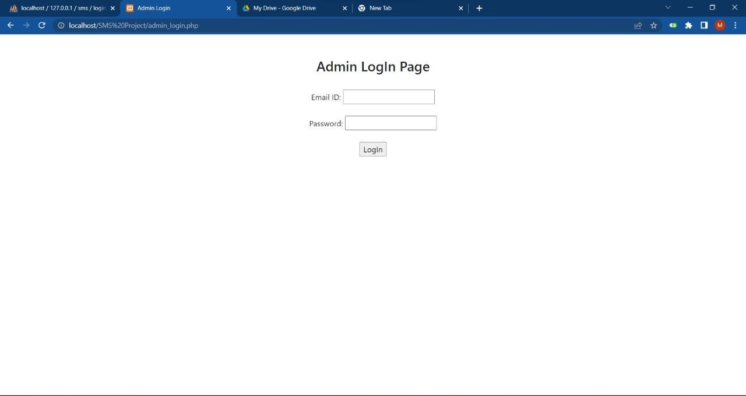
Front End ScreenShots
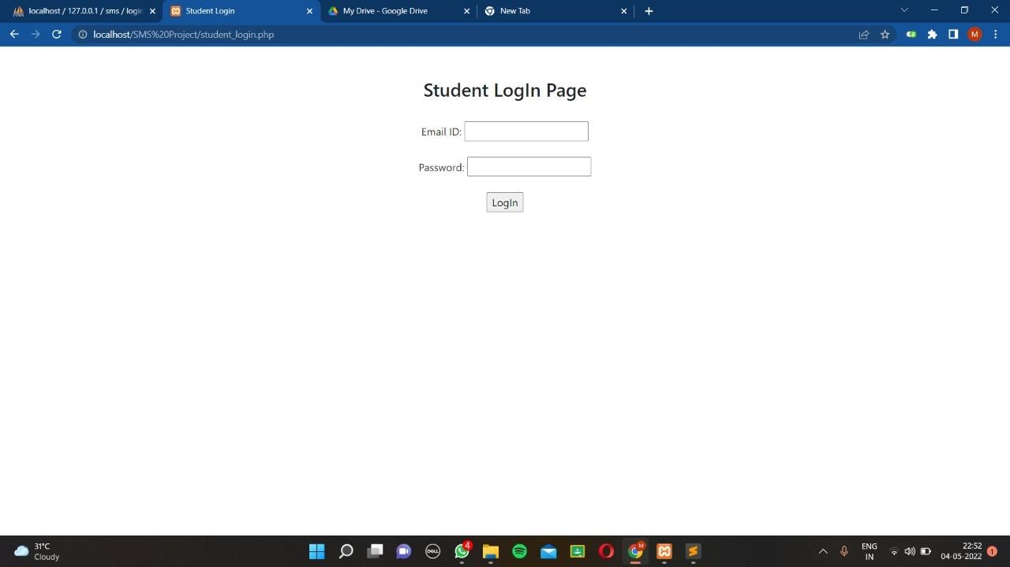
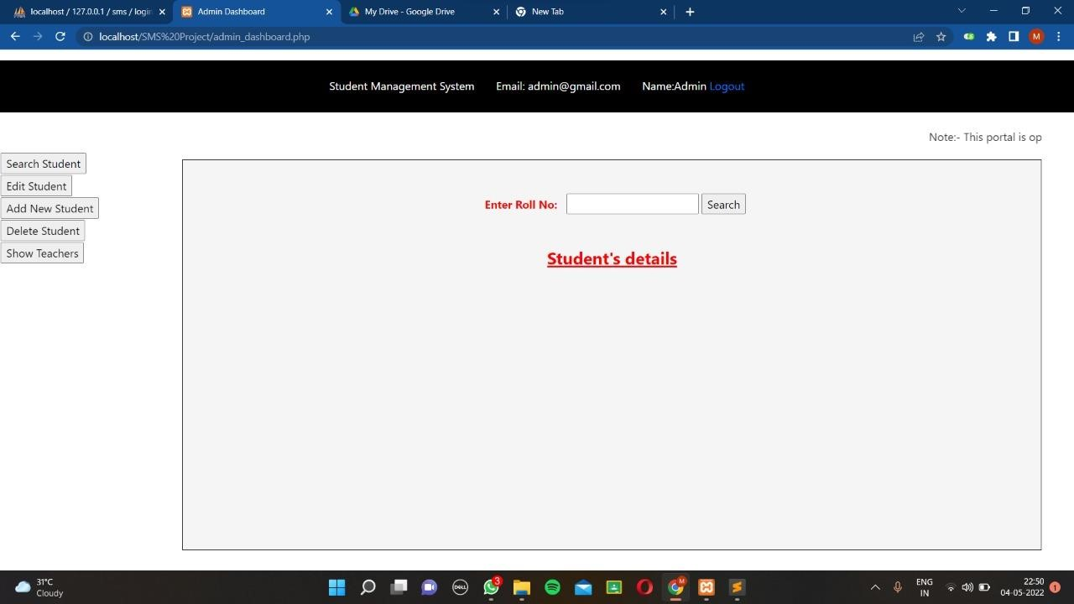
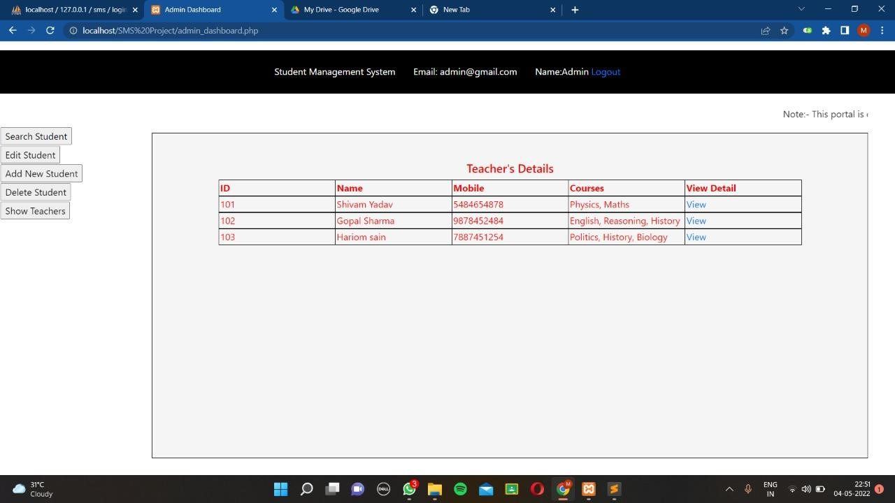
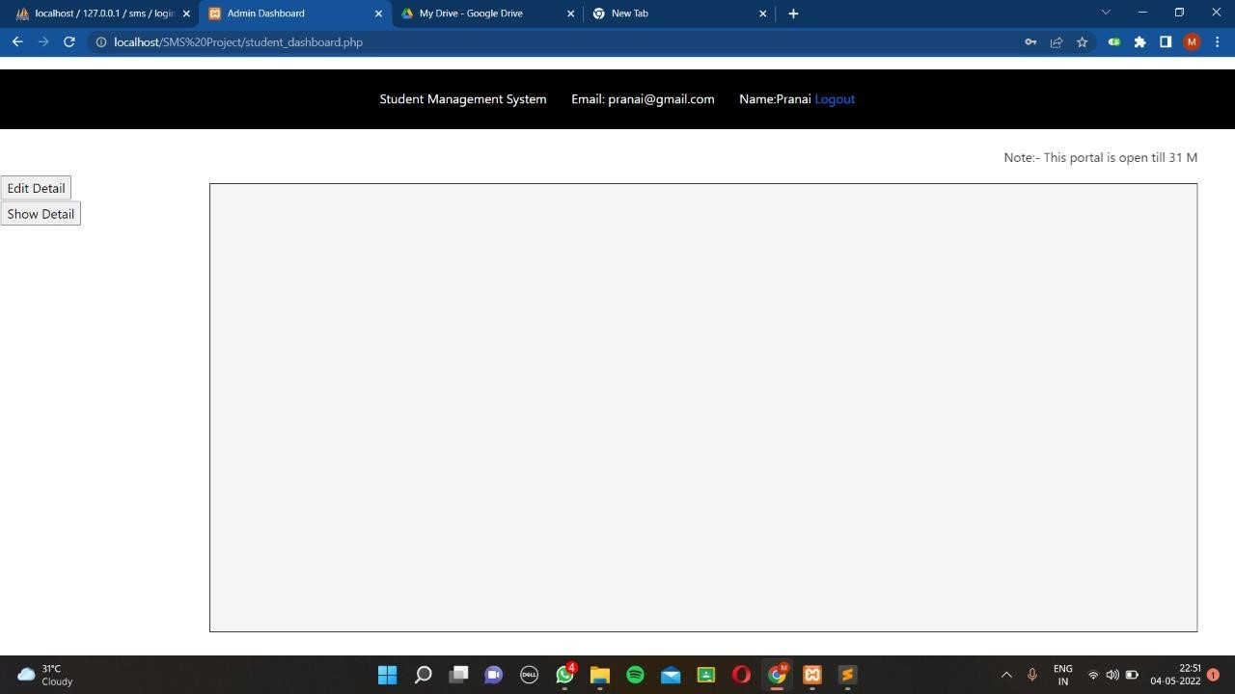
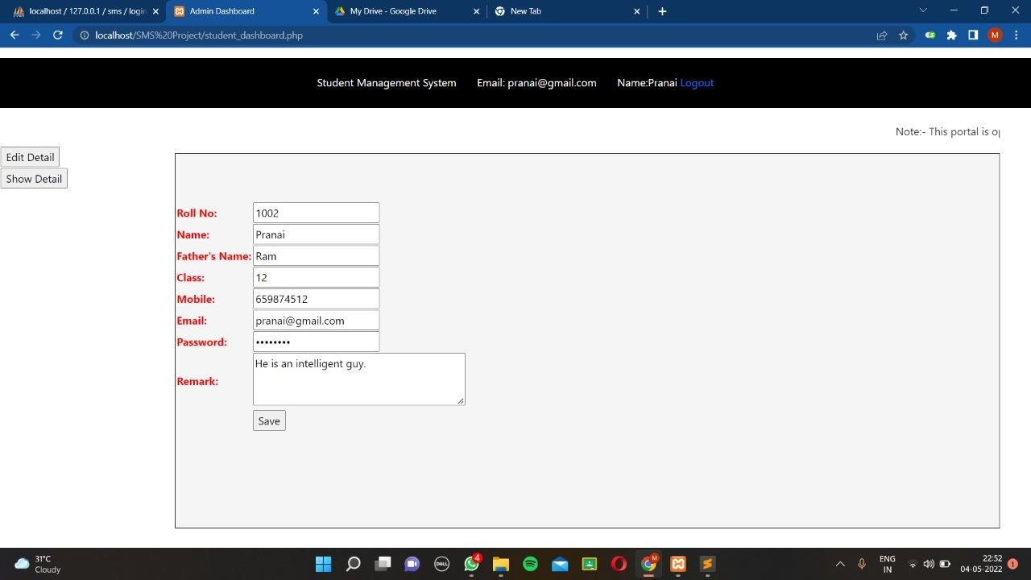
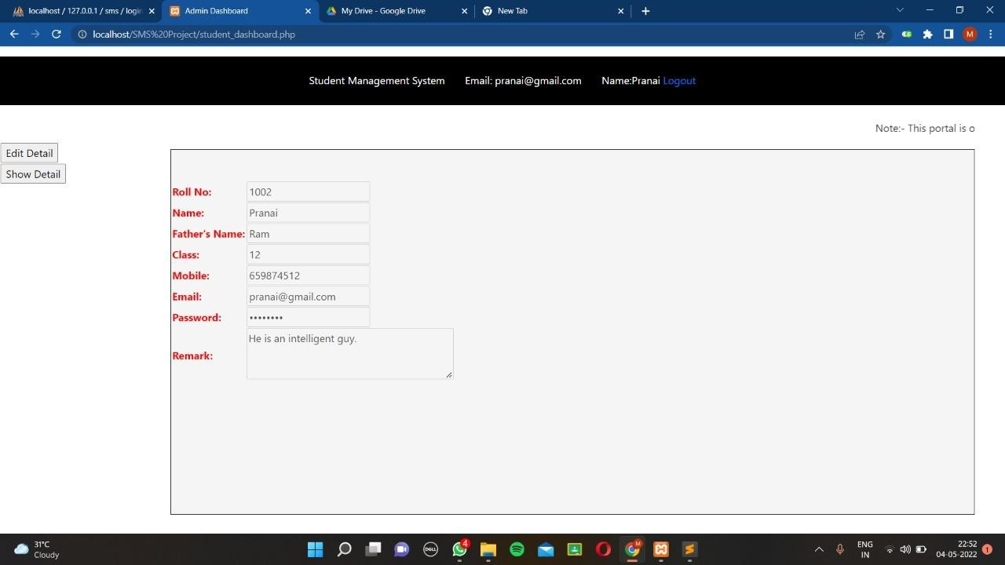

Back End ScreenShots
Back End ScreenShots:
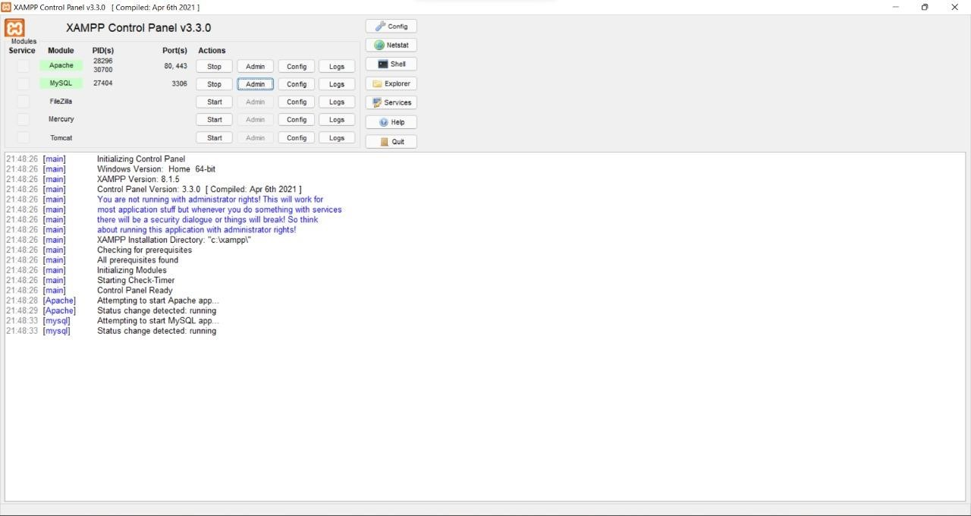

Thank You

