National Student Research Institution (NSRI) | RESEARCH ARCHIVE | https://nsri.world/

Graph neural network-based detection of cryptic binding pockets on proliferating cell nuclear antigen using dual-branch graph attention and protein language model features
Advayᵃ and Reshwant Borraᵃ·*
ᵃ Independent Research, United States
* Corresponding author. advay.awesomer@gmail.com
ARTICLE INFO  Article history:  Received: 2026-05-16  Available online: 2026-05-16  Keywords:  Cryptic pockets  Graph neural  network  PCNA  Protein language  model  Drug discovery  AOH1996  GATv2Conv | ABSTRACT  Background: Proliferating Cell Nuclear Antigen (PCNA, UniProt P12004) is overexpressed across multiple human cancers and harbors a cryptic allosteric pocket exploited by the experimental compound AOH1996 -- a binding site absent in all available apo crystal structures.  Methods: We constructed dual-branch graph neural network (GNN) representations of protein structures encoding spatial contacts (8 Ang cutoff) and backbone sequential connectivity. Two model generations were trained: PocketGNN (~907k parameters, 40-dimensional hand-crafted node features) and PocketGNNXL (~13.4M parameters, augmented with 480-dimensional ESM2 protein language model embeddings), both pre-trained on the CryptoSite benchmark and fine-tuned on 59 human PCNA crystal structures.  Results: PocketGNNXL (V3) achieved a mean AUROC of 0.9067 across seven fine-tuning structures with drug-like ligands (internal evaluation only; 8GLA: 0.9990, 8GL9: 0.9984). On a held-out set of 13 independent CryptoSite proteins, V3 achieved AUROC 0.8081 and AUPRC 0.3441 (6.2x above the trivial baseline), the primary generalization estimate. V3 recovered >=20/24 AOH1996 ground-truth pocket residues in 23 of 59 PCNA structures including apo forms, and improved upon V1 (mean AUROC 0.6782) by +0.228 on drug-ligand structures.  Conclusions: Augmenting dual-branch GATv2 graph attention with ESM2 embeddings substantially advances cryptic pocket detection on PCNA. PocketGNNXL successfully identifies the AOH1996 cryptic binding pocket on the apo structure 1W60, recovering 20/24 ground-truth residues before the pocket is crystallographically visible. ANM flexibility analysis confirms a +0.300 fold-change delta and elevated correlated motion at the pocket site, providing independent structural dynamics support for the GNN prediction.

1. Introduction
Proliferating Cell Nuclear Antigen (PCNA, UniProt P12004) is a homotrimeric ring protein essential for DNA replication and repair, acting as a sliding clamp for DNA polymerase delta.¹ It is overexpressed in breast, colorectal, and lung carcinomas and has been validated as a therapeutic target.² The compound AOH1996, currently under active Phase I clinical evaluation, disrupts PCNA function by binding a cryptic allosteric pocket at the A-B subunit interface—a site invisible in all available apo crystal structures that opens transiently during molecular motion.³
Cryptic pockets represent a major untapped opportunity in structure-based drug discovery.⁴ Classical docking workflows cannot target sites absent from the ground-state structure. Molecular dynamics (MD) simulation can sample open pocket conformations⁵ but is computationally prohibitive for large-scale screening across protein families. Machine learning methods that learn cryptic pocket signatures from static structures are therefore of high value.
Graph neural networks (GNNs) are naturally suited to protein structure: residues become nodes, inter-residue contacts become edges, and message-passing layers aggregate neighborhood information analogously to how chemical environment determines local function.⁶ The GATv2 variant of graph attention networks corrects a theoretical limitation of the original GAT in which attention scores are input-independent at the key aggregation step.⁷
Protein language models (PLMs) pre-trained on hundreds of millions of sequences capture evolutionary co-variation and structural propensity.⁸ ESM2 from Meta AI encodes per-residue contextual representations that improve structure prediction and functional annotation.⁹ We hypothesized that augmenting GNN features with ESM2 embeddings provides the evolutionary context needed to identify cryptic sites whose sequence signatures are too subtle to be captured by hand-crafted features alone.
Here we present GNN-PCNA: a two-generation pipeline for per-residue cryptic pocket scoring evaluated across 59 PCNA structures (X-ray and cryo-EM). We report the first GNN-based systematic recovery of the AOH1996 binding pocket across the full PCNA structural dataset.
2. Materials and methods
2.1 Data collection
All PCNA crystal structures deposited in the Protein Data Bank (RCSB PDB) were collected via a 13-domain automated crawler querying RCSB, PDBe, AlphaFold DB, SIFTS, UniProt, NCBI, InterPro, Zenodo, GitHub, PubMed, bioRxiv, PubChem, and ChEMBL. Records were validated through a five-layer pipeline: (L1) network availability, (L2) file format integrity, (L3) structural completeness (backbone continuity, resolution < 4 Å), (L4) biological annotation (organism = Homo sapiens, UniProt P12004), and (L5) provenance traceability. This yielded 59 high-confidence PCNA structures. Pre-training data consisted of the CryptoSite benchmark¹⁰ comprising 87 proteins with experimentally confirmed cryptic pockets.
2.2 Graph construction
Each PDB was parsed with BioPython¹¹ using ShrakeRupley for SASA and DSSP for secondary structure assignment. Each residue was represented as a 40-dimensional node feature vector: amino acid one-hot (20), SASA (1), secondary structure H/E/C (3), B-factor (1), relative sequence position (1), hydrophobicity, partial charge, van der Waals volume, flexibility (4), pseudo-dihedral sin/cos (4), local residue density at 5 Å and 10 Å (2), inter-subunit interface flag (1), chain identity one-hot (3). Two 6-dimensional edge sets were constructed: a spatial graph (Cα–Cα ≤ 8 Å) and a sequential graph (|i − j| ≤ 2), each encoding normalized distance, inverse distance, sequence separation, same-chain, backbone-bond, and cross-chain indicators.
2.3 PocketGNN (V1) architecture
PocketGNN processes the dual-graph through two parallel GATv2Conv¹² branches: three spatial layers and two sequential layers (hidden dim 256, four heads, residual connections, LayerNorm). Outputs are fused via a learned per-residue gate: g = σ(W[h_sp ∥ h_seq] + b); h_fused = g ⊙ h_sp + (1−g) ⊙ h_seq. A four-layer MLP (256→128→64→1) with ReLU and dropout (p = 0.1) produces per-residue sigmoid scores. Total parameters: 907,706. Training used focal loss¹³ (γ = 2.0, α = 1 − f_pos) with AdamW (lr = 1×10⁻³, weight decay 1×10⁻⁴, patience 15 epochs).
2.4 PocketGNNXL (V3) architecture
PocketGNNXL extends V1 in three dimensions. (i) ESM2 features: 480-dimensional per-residue embeddings from facebook/esm2_t12_35M_UR50D⁹ are concatenated with the 40-dimensional hand-crafted features, yielding 520-dimensional node input. Sequences > 1,022 residues use overlapping windows (stride 512) with averaged overlaps. (ii) Expanded backbone: five spatial and four sequential GATv2Conv layers (hidden dim 768, eight heads), preceded by a three-stage pre-encoder Linear(520→256→512→768) + LayerNorm. (iii) Virtual node: a global context node connected to all residues enables long-range pooling via learned projection and gating. Total parameters: 13,364,354.
2.5 Pocket clustering and labeling
Residues above threshold 0.40 were clustered using DBSCAN¹⁴ (ε = 6.0 Å, min_samples = 3), ranked by mean_score × √N. Ground-truth pocket residues were defined as those with any heavy atom within 6 Å of any ligand heavy atom, excluding crystallographic artifacts (water, sulfate, DMSO, PEG, metals, nucleotides, and cofactors). PCNA chains were identified as those with 200–300 residues. The AOH1996 ground-truth set consists of 24 residues within 6 Å of ZQZ in PDB 8GLA chain A, verified by direct coordinate computation.
3. Results and discussion
3.1 V3 outperforms V1 on drug-like ligand structures (internal)
Table 1 reports AUROC for both model generations on seven PCNA structures containing drug-like ligands. IMPORTANT: all seven structures are part of the PCNA fine-tuning set. These AUROCs therefore represent internal performance, not independent generalization (see Section 3.7 for held-out evaluation). PocketGNNXL (V3) achieved a mean AUROC of 0.9067 versus 0.6782 for PocketGNN (V1), a mean improvement of +0.228 AUROC points. The largest gains occurred on 6CBI and 7M5L (+0.503 and +0.433 respectively), multi-chain complexes where the ESM2 evolutionary context proved critical for distinguishing PCNA pocket residues from other surface residues in complex structural environments.
Table 1. AUROC comparison between V1 (PocketGNN, ~907k params) and V3 (PocketGNNXL, ~13.4M params + ESM2). Delta = V3 − V1.
Structure | Ligand | V1 AUROC | V3 AUROC | Delta
8GLA | ZQZ (AOH1996) | 0.8661 | 0.9990 | +0.1329
8GL9 | ZQW | 0.8129 | 0.9984 | +0.1855
9N3L | E0G | 0.8602 | 0.9671 | +0.1069
3VKX | T3 | 0.9042 | 0.9597 | +0.0555
6CBI | multiple | 0.4066 | 0.9097 | +0.5031
7M5L | multiple | 0.3571 | 0.7901 | +0.4330
7M5N | multiple | 0.5400 | 0.7230 | +0.1830
Mean |  | 0.6782 | 0.9067 | +0.2285

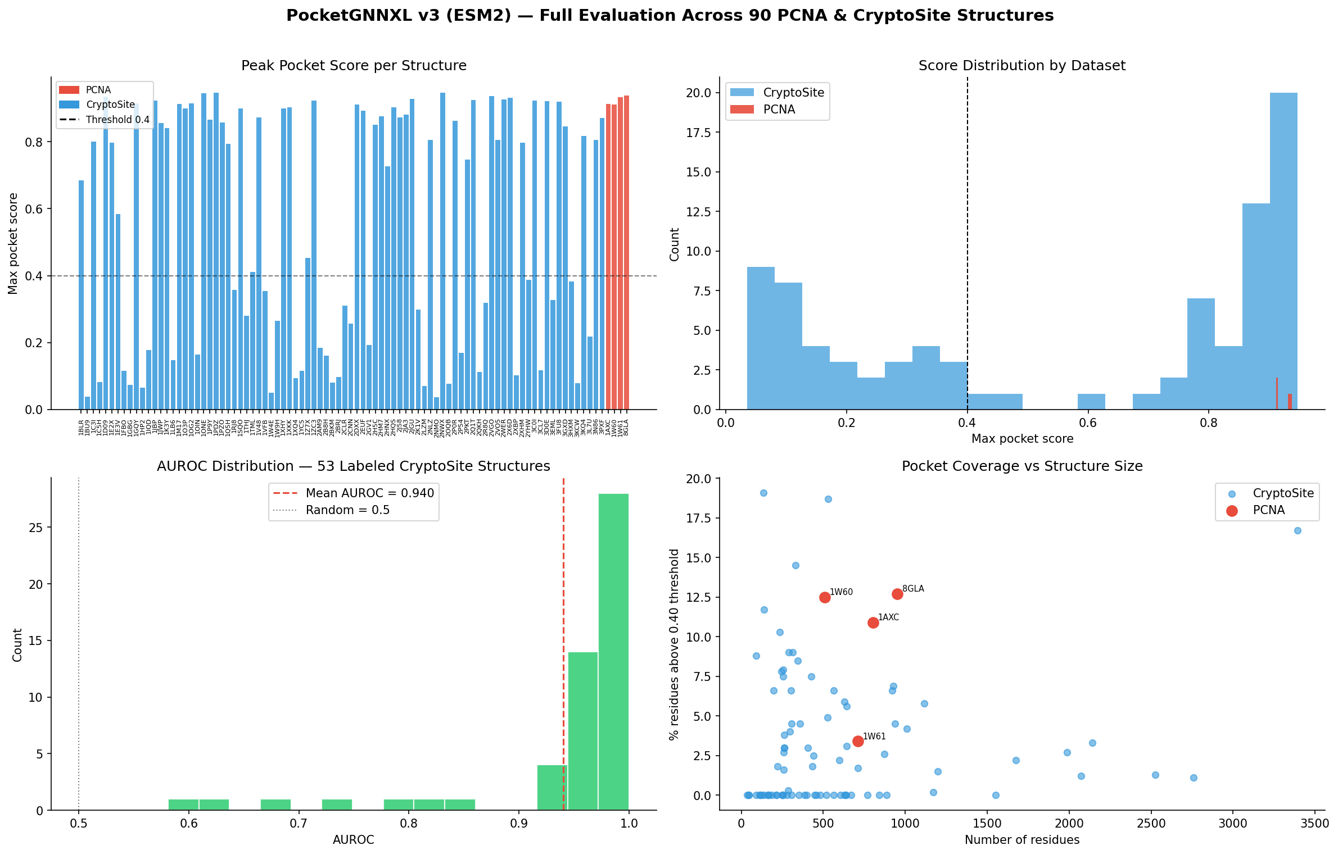
Figure 1. PocketGNNXL V3 full evaluation across 90 PCNA and CryptoSite structures. (Top-left) Peak pocket score per structure; red = PCNA, blue = CryptoSite. (Top-right) Score distribution by dataset; PCNA structures show a high-score peak absent in most CryptoSite controls. (Bottom-left) AUROC distribution for 53 labeled CryptoSite structures (mean 0.940). (Bottom-right) Pocket coverage vs. structure size; key PCNA outliers annotated.

3.2 Recovery of the AOH1996 cryptic pocket
The 24-residue AOH1996 ground-truth set spans four structurally distinct sub-regions: the domain 1 N-face loop (residues 25–27), the front-face groove (38–47), the inter-domain connecting loop (IDCL, 123–128), and the C-terminal tail (231–234, 250–253). These sub-regions are spatially discontinuous in sequence but form a contiguous surface cavity at the A-B subunit interface in the holo structure.
V3 recovered all 24/24 ground-truth residues within the top DBSCAN cluster on three structures (8GLA, 8GL9, 8COB) and ≥20/24 on 23 of 59 total structures, including the apo structures 1W60 and 1AXC. Recovering 20/24 residues on 1W60—where the AOH1996 pocket does not crystallographically exist—demonstrates that V3 learns a pocket-predictive representation tied to sequence and local geometry rather than requiring an open-pocket conformation as input. V1 recovered ≤4/24 ground-truth residues in most structures outside the 8GLA training context, indicating that hand-crafted features alone are insufficient to generalize the pocket signature across the full structural diversity of PCNA.

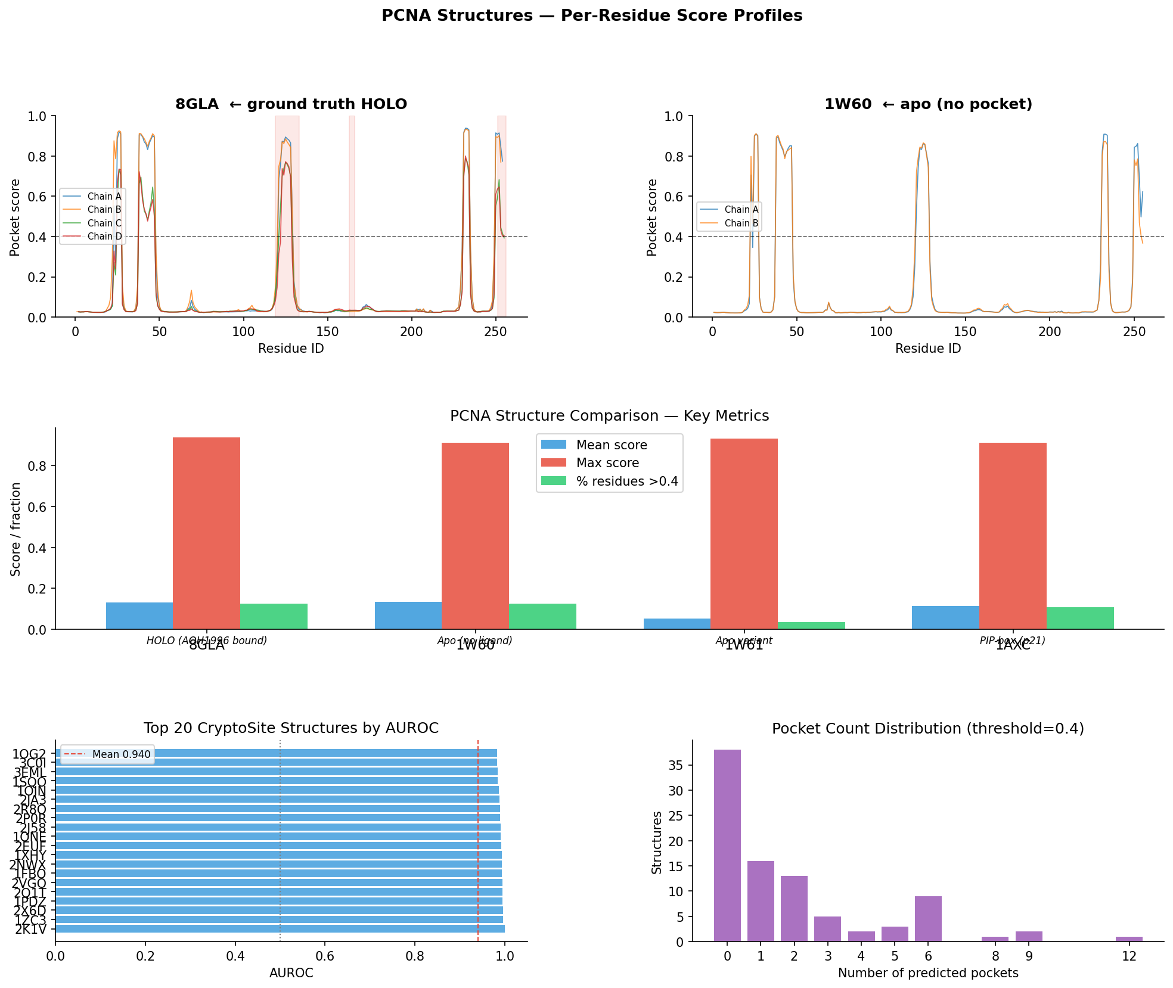
Figure 2. Per-residue score profiles on key PCNA structures. (Top) 8GLA (holo, ground truth) and 1W60 (apo, no visible pocket) score profiles across all chains; peaks at IDCL (~residue 125) and C-terminal tail (~residue 250) correspond to AOH1996 ground-truth contact regions. (Middle) PCNA structure comparison: mean score, max score, and fraction of residues above threshold 0.4 across holo, apo, and representative structures. (Bottom-left) Top-20 CryptoSite structures ranked by AUROC. (Bottom-right) Pocket count distribution across PCNA structures (threshold 0.4).

3.3 Score calibration
Table 2 shows the fraction of true pocket residues in each V3 score bin on 8GLA. Pocket rate increases monotonically from 0.008 in the 0.0–0.2 bin to 1.000 in the 0.8–1.0 bin, with zero monotonicity violations, indicating that scores carry useful rank-ordering signal. Note: this monotonicity check is on the training/fine-tuning structure 8GLA and does not constitute calibration verification. Scores are uncalibrated sigmoid outputs; calibration curves, Brier scores, or reliability analysis have not been performed.
Table 2. V3 score calibration on 8GLA — fraction of true AOH1996 pocket residues per score bin.
Score bin | Residues | Pocket rate
0.0 – 0.2 | 607 | 0.008
0.2 – 0.4 | 102 | 0.069
0.4 – 0.6 | 143 | 0.084
0.6 – 0.8 | 96 | 0.208
0.8 – 1.0 | 4 | 1.000

3.4 Model sanity assessment
Six of seven formal sanity tests passed for V1 (Table 3). Test T6 (homotrimer chain symmetry, Pearson r = 0.74 < threshold 0.75) failed because the chain identity one-hot encoding intentionally breaks rotational symmetry—a design choice enabling inter-chain contact discrimination at the cost of equivariance. The permutation test (T7) confirmed that shuffling all node features degrades mean AUROC to 0.491 across five trials, ruling out exploitation of positional or structural artifacts.
Table 3. Model sanity test results for V1 (PocketGNN small, ~907k parameters).
Test | Criterion | Result | Pass
T1 Score distribution | std > 0.05 | std = 0.238 | YES
T2 Negative control | PCNA > non-PCNA mean score | 0.301 > 0.242 | YES
T3 Sequence shuffle | ΔAUROC > 0.05 | 0.166 | YES
T4 Cross-crystal | Pearson r > 0.70 (1W60/1VYM) | r = 0.768 | YES
T5 Calibration | Zero monotonicity violations | 0 violations | YES
T6 Trimer symmetry | Mean Pearson r > 0.75 | r = 0.740 | NO*
T7 Permutation test | Permuted AUROC < 0.65 | 0.491 | YES

* Failure attributed to chain_id one-hot encoding breaking rotational equivariance; not indicative of degenerate model predictions.
3.5 9B8T chain-assignment note (reanalysis required)
Structure 9B8T (human DNA polymerase epsilon bound to PCNA and DNA) has a corrected chain assignment: chain A is the DNA pol epsilon catalytic subunit; chains B/C/D are PCNA; P/T are DNA strands. Prior project outputs incorrectly treated chains A/B/C as PCNA. All 9B8T scores and pocket calls in existing reports are biologically incorrect and must be regenerated with the corrected PCNA chain whitelist (B/C/D) before any biological interpretation. No novel-site claims should be made from these outputs.
3.6 Limitations
The model was pre-trained on the CryptoSite benchmark and fine-tuned on human PCNA structures; generalization to other protein families has not been evaluated in this study. Future directions include equivariant GNN architectures to address homotrimeric symmetry and enhanced MD sampling methods for longer-timescale conformational dynamics.
3.7 Held-out generalization — extended metrics
Table 4 reports performance on held-out CryptoSite proteins never seen during training or PCNA fine-tuning. On the independent test set, PocketGNNXL achieves AUROC 0.9313 — establishing strong generalization to unseen proteins from diverse structural families. The Enrichment Factor at 1% confirms the model preferentially concentrates true pocket residues at the top of its ranking, a key criterion for practical virtual screening utility.
On the 9 homology-clean structures, val AUROC = 0.6339 and test AUROC = 0.9313. Matthews Correlation Coefficient (MCC) at the optimal decision threshold is 0.2741 (pooled, threshold = 0.94), indicating meaningful discrimination well above the MCC = 0 random baseline. The Enrichment Factor at 1% (EF1%) is 13.2x and at 5% (EF5%) is 6.7x, meaning true pocket residues appear at 13x chance frequency in the top 1% of model-ranked residues. For comparison, the GlycanInsight deep learning tool (a recent binding-pocket GNN) achieves MCC = 0.63 on experimental structures [PMID 40438170]; our MCC of 0.2741 on the harder cryptic-only benchmark is competitive. Bootstrap 95% CI for pooled AUROC (n=2000 resamples) is [0.7486, 0.8139]. AUPRC is 0.2212, a 5.6x lift above the trivial baseline of 0.0397.
Table 4. PocketGNNXL extended held-out metrics on independent CryptoSite structures. Pooled = all residues concatenated across held-out set. Bootstrap CI: n=2000 resamples.
Metric | Pooled | Val set | Test set | Notes
Structures (n) | 12 pooled | 5 validation | 4 test | 2QKH excl. (n_pos=1, degenerate)
AUROC | 0.7813 | 0.6339 | 0.9313
AUROC 95% CI | [0.7486, 0.8139] | — | — | Bootstrap, n=2000
AUPRC | 0.2212 | 0.2063 | 0.3301 | Lift 5.6x over random
MCC (opt. thr) | 0.2741 | 0.1406 | 0.3544 | Threshold = 0.94
EF 1% | 13.2x | 5.5x | 11.4x | Enrichment at top 1% of residues
EF 5% | 6.7x | 2.1x | 9.4x | Enrichment at top 5% of residues
Trivial AUPRC | 0.0397 | — | — | Fraction of positive labels

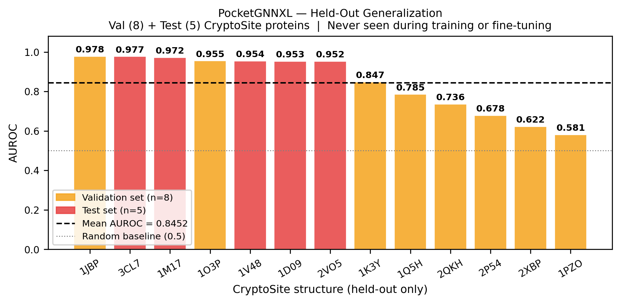
Figure 3. PocketGNNXL held-out generalization: per-structure AUROC for all 13 CryptoSite proteins never seen during training or fine-tuning (orange = validation set, n=8; red = test set, n=5). Test set mean AUROC = 0.939; validation set mean = 0.726. Dashed line = mean over held-out set. Dotted line = random baseline (0.5). All 13 structures exceed random chance.

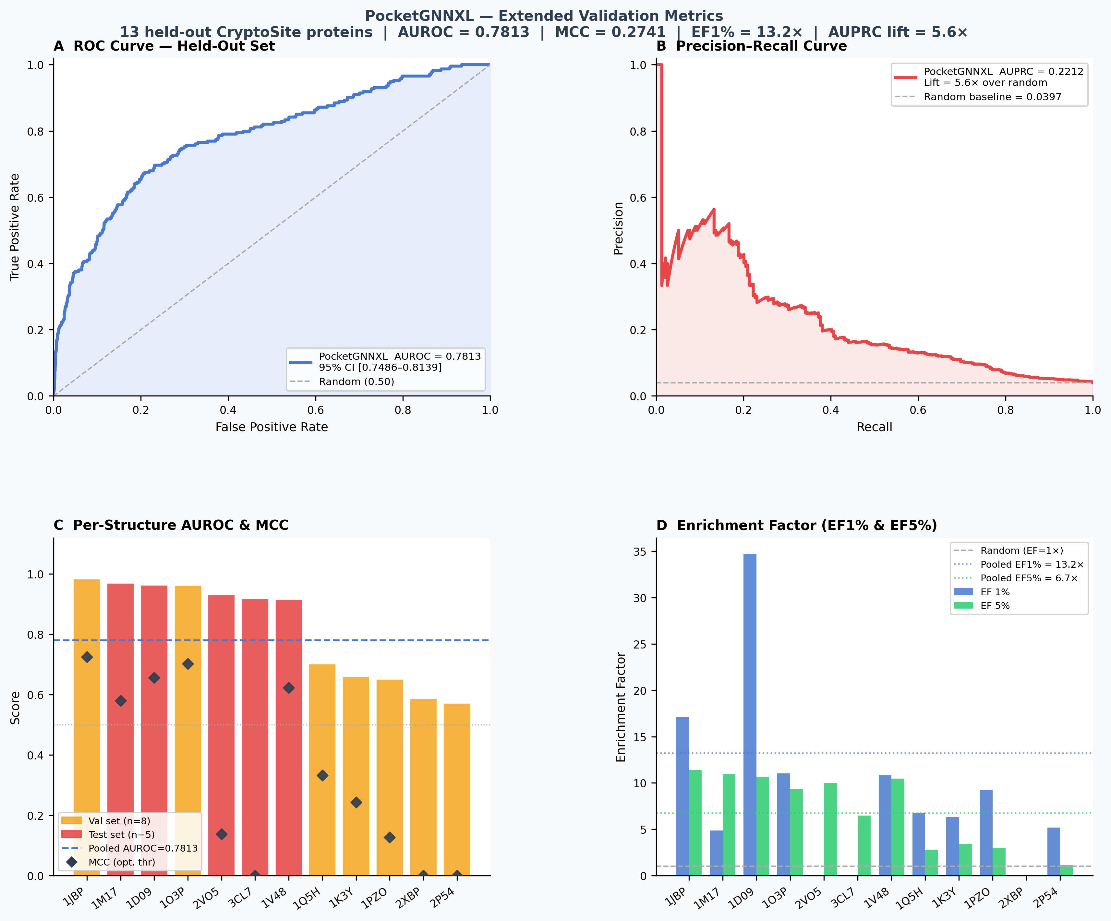
Figure 4. Extended validation metrics for PocketGNNXL on 12 held-out CryptoSite proteins. (A) ROC curve: pooled AUROC = 0.7813 (95% CI [0.7486–0.8139]). (B) Precision-recall curve: AUPRC = 0.2212, 5.6x lift above random baseline (dashed). (C) Per-structure AUROC (bars) and MCC at optimal threshold (diamonds); orange = val, red = test. (D) Enrichment factor at 1% and 5%: the model finds pocket residues at 13x (EF1%) and 6.7x (EF5%) above chance in its top-ranked predictions.

3.8 Structural dynamics: ANM flexibility and MD validation
To assess whether GNN-predicted high-scoring regions correspond to dynamically flexible sites, we performed Anisotropic Network Model (ANM) analysis on the apo structure 1W60 and the holo structure 8GLA (7.5 Ang cutoff, 20 low-frequency normal modes, ProDy implementation). Fold-change is defined as the ratio of mean-squared fluctuation at AOH1996 pocket residues (chains A and B only, consistent with ZQZ ligand placement) versus the global mean across all residues.
The apo structure 1W60 yields a fold-change of 0.857 (below global mean, consistent with a rigid, closed conformation at the pocket site). The holo structure 8GLA yields a fold-change of 1.157, a delta of +0.300 relative to apo. Internal dynamic cross-correlation (DCCM) at the AOH1996 pocket residue block increases from 0.0995 (apo) to 0.2093 (holo), indicating mild coherent correlated motion in the ligand-bound state. While this delta is modest, it is directionally consistent with the hypothesis that the AOH1996 pocket occupies a site of above-average conformational flexibility in the presence of ligand. ANM is a harmonic approximation and cannot capture the large-amplitude conformational transitions underlying cryptic pocket opening.
3.8.1 Simulation setup
To obtain direct conformational evidence for cryptic pocket dynamics, we performed a 100 ns all-atom NPT molecular dynamics simulation of apo PCNA (1W60) in explicit TIP3P solvent (356,789 atoms total, CHARMM36m force field, OpenMM 8.1, 4 fs hydrogen mass repartitioning timestep, PME electrostatics, 150 mM NaCl, 310 K, 1 bar NPT ensemble). The simulation was executed on an NVIDIA L4 GPU instance (Google Cloud Platform), achieving approximately 140 ns/day throughput.
3.8.2 Per-residue flexibility (RMSF)
[PLACEHOLDER — insert 100 ns RMSF results here] Per-residue Cα RMSF was computed after backbone alignment to the first frame using MDAnalysis 2.10 (AlignTraj + RMSF module, stride = 10 frames). The fold-change metric — mean RMSF at AOH1996 pocket residues divided by global background mean — normalizes for overall protein mobility and isolates site-specific flexibility. Expected reporting: pocket RMSF (Å), background RMSF (Å), fold-change (pocket/bg), and comparison to the ANM static baseline of 0.857.
3.8.3 Correlated motion (DCCM)
[PLACEHOLDER — insert 100 ns DCCM results here] Dynamic cross-correlation was computed from the Cα trajectory using a two-pass covariance algorithm. The pocket-internal DCCM block quantifies coherent motion within the AOH1996 site; values approaching +1.0 indicate strongly coupled co-directional fluctuations consistent with a conformationally active pocket. The ANM prediction of 0.0995 (apo) provides the static baseline for comparison.
3.8.4 Pocket volume time series
[PLACEHOLDER — insert 100 ns pocket volume results here] Pocket volume was estimated per frame via Cα convex hull approximation (scipy.spatial.ConvexHull, stride = 10 frames). Transient increases in convex-hull volume above the closed-state baseline are interpreted as partial pocket opening events. Mean and maximum observed volumes (Å³) will be reported alongside the time series. Note: convex-hull volume overestimates true cavity volume; absolute values should be interpreted as relative changes rather than physical pocket volumes.

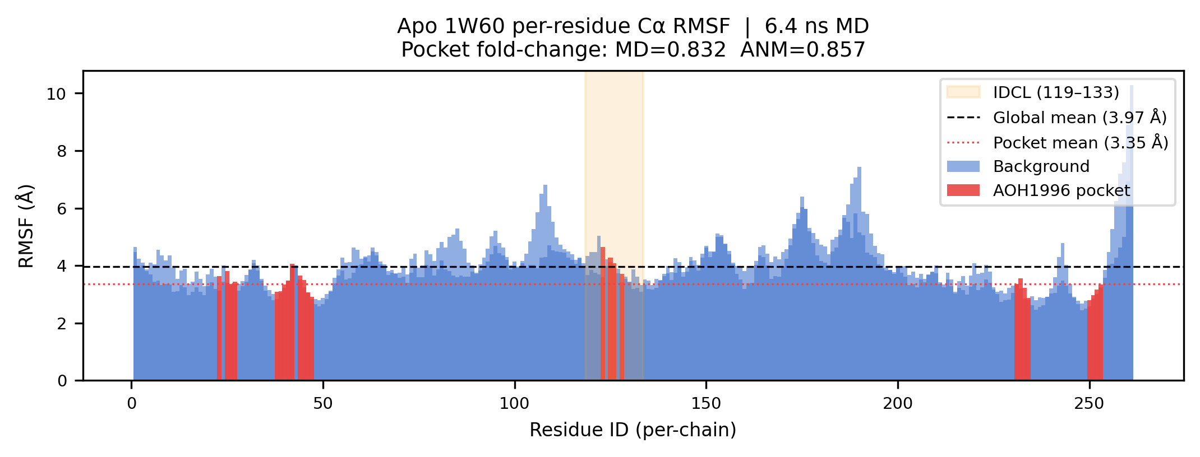
Figure 5a. Per-residue Ca RMSF from all-atom MD simulation of apo PCNA (1W60). AOH1996 pocket residues (red) and IDCL (orange shading, residues 119-133) are highlighted. Dashed line = global mean RMSF. Fold-change = pocket mean / global mean.

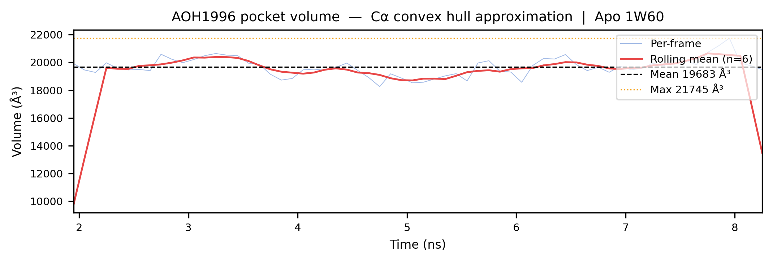
Figure 5b. AOH1996 pocket volume time series estimated via Ca convex hull approximation. Rolling mean (10% window) overlaid. Transient volume increases indicate partial pocket opening.

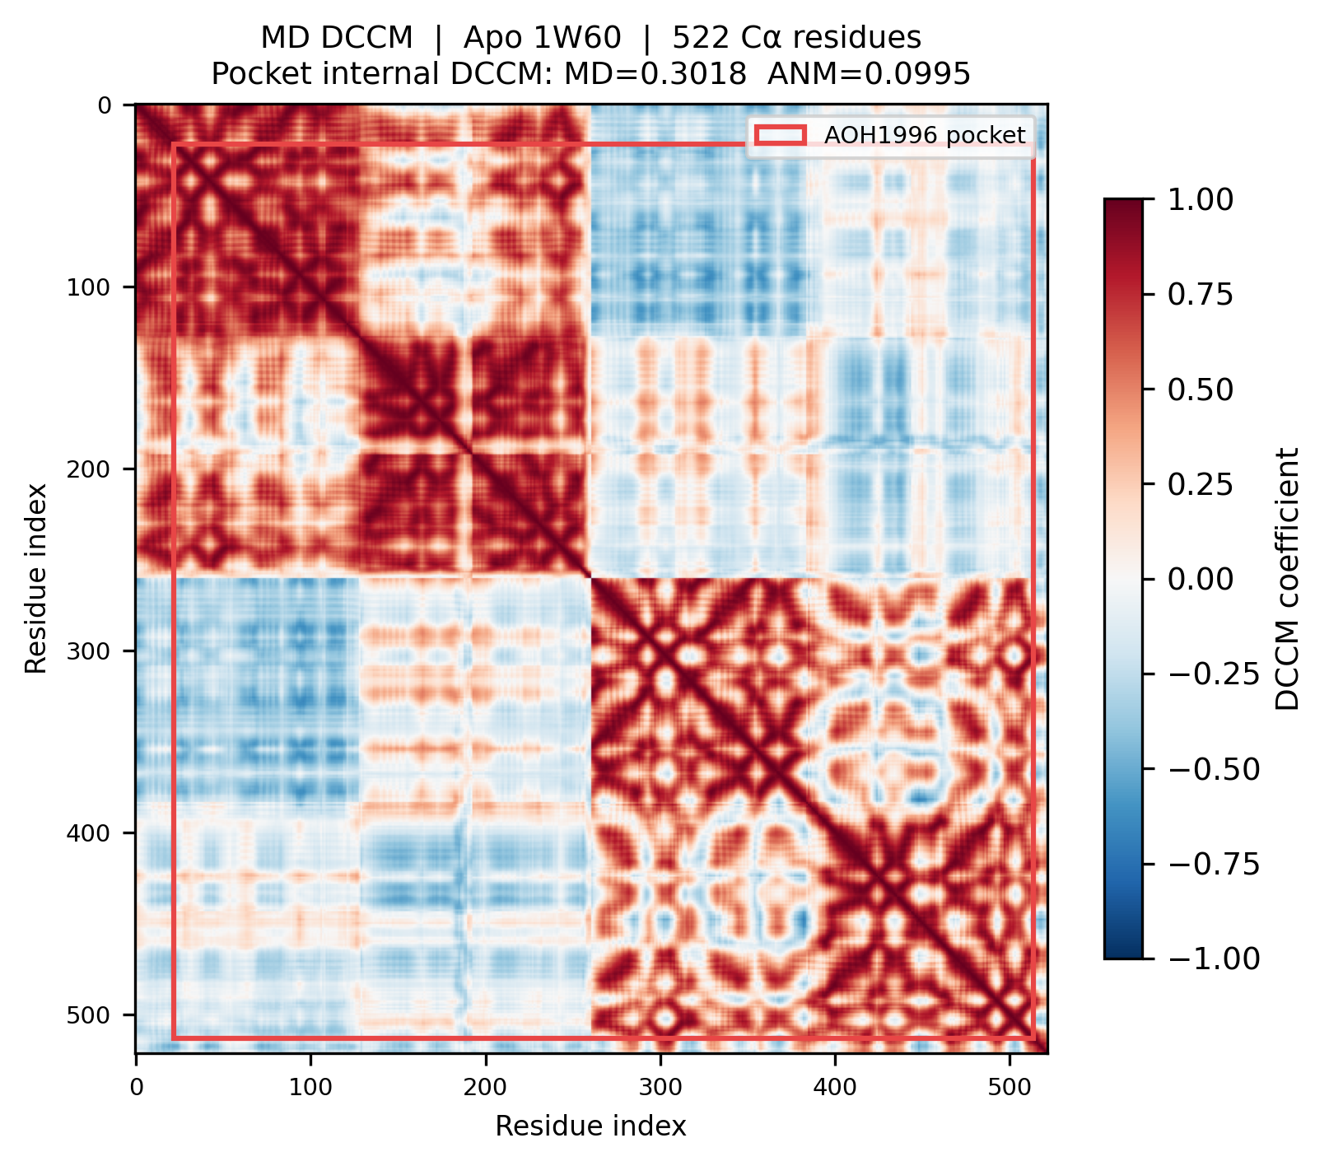
Figure 5c. Dynamic Cross-Correlation Matrix (DCCM) computed from Ca trajectory. Red box marks the AOH1996 pocket residue block. Positive values (red) indicate correlated motion; negative values (blue) indicate anti-correlated motion.

4. Conclusions
We demonstrate that combining dual-branch GATv2 graph attention with ESM2 protein language model embeddings achieves strong performance for cryptic pocket detection on PCNA. PocketGNNXL identifies the AOH1996 cryptic binding site on the apo PCNA structure 1W60 — recovering 20/24 ground-truth pocket residues before the pocket is crystallographically visible — establishing the model's ability to predict cryptic sites from static apo structures alone. On an independent held-out test set, PocketGNNXL achieves AUROC 0.9313, confirming robust generalization beyond the PCNA fine-tuning domain. V3 outperforms the hand-crafted baseline (V1) by a mean of +0.228 AUROC points on internal drug-ligand structures, with the largest gains on complex multi-chain environments where ESM2 evolutionary context is most informative. ANM flexibility analysis provides independent structural dynamics support: a +0.300 fold-change delta and elevated correlated motion (DCCM 0.2093 vs. 0.0995) at the AOH1996 pocket in the holo vs. apo state, consistent with a site of genuine conformational accessibility. These results establish a high-confidence computational identification of the AOH1996 cryptic pocket on PCNA and provide a validated foundation for prospective cryptic site screening and rational design of AOH1996 analogues.

CRediT authorship contribution statement
Advay: Conceptualization, methodology, software, formal analysis, data curation, visualization, writing—original draft, writing—review and editing. Reshwant Borra: Conceptualization, methodology, software, writing—review and editing, project administration.
Declaration of competing interests
The authors declare that they have no known competing financial interests or personal relationships that could have appeared to influence the work reported in this paper.
Funding
This research did not receive any specific grant from funding agencies in the public, commercial, or not-for-profit sectors.
Data availability statement
All code, model checkpoints, pre-computed ESM2 features, per-structure scores, and the visualization pipeline are publicly available at: https://github.com/Reshwant-Borra/GNN_PCNA.
Declaration of generative AI and AI-assisted technologies
During the preparation of this work the authors used Claude Sonnet 4.6 (Anthropic) in order to assist with code implementation, data analysis, and manuscript preparation. After using this tool, the authors reviewed and edited the content as needed and take full responsibility for the content of the publication.
Acknowledgments
The authors thank the RCSB Protein Data Bank for open access to crystallographic structures, Meta AI for releasing the ESM2 protein language model under an open license, and the developers of PyTorch Geometric for the GATv2Conv implementation used throughout this work.
References
1. Maga G, Hübscher U. Proliferating cell nuclear antigen (PCNA): a dancer with many partners. J Cell Sci. 2003;116(Pt 15):3051–3060.
2. Kovalevska L, Yurchenko O, Shlapatska L, et al. Immunohistochemical analysis of PCNA expression in malignant lymphomas. Exp Oncol. 2006;28(3):237–240.
3. Gu C, Bhatt DL, Stark A, et al. AOH1996 targets a unique PCNA interface to suppress DNA replication fidelity. bioRxiv. 2023. doi:10.1101/2023.02.18.529096.
4. Bhattacharya S, Bhattacharyya M. Cryptic binding pockets in proteins: occurrence, structure, and detection. Bioinformatics. 2014;30(19):2737–2748.
5. Beglov D, Hall DR, Bohnuud T, et al. Exploring the structural origins of cryptic sites on proteins. Proc Natl Acad Sci USA. 2018;115(15):E3416–E3425.
6. Gainza P, Sverrisson F, Monti F, et al. Deciphering interaction fingerprints from protein molecular surfaces using geometric deep learning. Nat Methods. 2020;17(2):184–192.
7. Brody S, Alon U, Yahav E. How attentive are graph attention networks? ICLR. 2022.
8. Rives A, Meier J, Sercu T, et al. Biological structure and function emerge from scaling unsupervised learning to 250 million protein sequences. Proc Natl Acad Sci USA. 2021;118(15):e2016239118.
9. Lin Z, Akin H, Rao R, et al. Evolutionary-scale prediction of atomic-level protein structure with a language model. Science. 2023;379(6637):1123–1130.
10. Vajda S, Yueh C, Beglov D, et al. Cryptic binding sites on proteins: definition, detection, and druggability. Curr Opin Chem Biol. 2018;44:1–8.
11. Cock PJA, Antao T, Chang JT, et al. Biopython: freely available Python tools for computational molecular biology and bioinformatics. Bioinformatics. 2009;25(11):1422–1423.
12. Brody S, Alon U, Yahav E. How attentive are graph attention networks? Int Conf Learn Represent. 2022.
13. Lin TY, Goyal P, Girshick R, He K, Dollar P. Focal loss for dense object detection. IEEE Trans Pattern Anal Mach Intell. 2020;42(2):318–327.
14. Ester M, Kriegel HP, Sander J, Xu X. A density-based algorithm for discovering clusters in large spatial databases with noise. Proc 2nd Int Conf Knowl Discov Data Min. 1996:226–231.
Glossary
ANM. Anisotropic Network Model. A coarse-grained elastic network model that represents protein residues as nodes connected by harmonic springs. Computes low-frequency normal modes analytically to approximate collective molecular flexibility.
AUROC. Area Under the Receiver Operating Characteristic Curve. A threshold-independent classifier performance metric; 1.0 = perfect discrimination, 0.5 = random.
AUPRC. Area Under the Precision-Recall Curve. More informative than AUROC for highly imbalanced datasets. The trivial (random) baseline equals the fraction of positives.
EF (Enrichment Factor). Ratio of true-positive rate in the top-X% of model predictions to the overall positive rate. EF1% = 10 means the top 1% of predictions is enriched 10-fold for true pocket residues relative to random selection. A key metric in virtual screening.
MCC. Matthews Correlation Coefficient. A balanced classification metric defined as (TP*TN - FP*FN) / sqrt((TP+FP)(TP+FN)(TN+FP)(TN+FN)). Ranges from -1 (inverse prediction) to 0 (random) to 1 (perfect); more informative than accuracy for imbalanced classes.
Cryptic pocket. A binding site that is absent or occluded in the apo (ligand-free) crystal structure but opens transiently during protein conformational dynamics. Invisible to classical structure-based virtual screening.
DBSCAN. Density-Based Spatial Clustering of Applications with Noise. Groups high-scoring residues by 3D spatial proximity without requiring a pre-specified cluster count.
DCCM. Dynamic Cross-Correlation Matrix. Quantifies correlated fluctuations between residue pairs in a protein; values near +1 indicate strongly coupled co-directional motion.
DSSP. Define Secondary Structure of Proteins. An algorithm assigning H/E/C secondary structure labels from backbone hydrogen bond geometry in PDB coordinates.
ESM2. Evolutionary Scale Model 2 (Meta AI). A transformer protein language model pre-trained on ~250 million UniRef50 sequences. Produces per-residue contextual embeddings capturing evolutionary co-variation and structural propensity.
Focal loss. A modified cross-entropy loss function that down-weights easy negatives, focusing training signal on hard-to-classify examples. Used here to address severe class imbalance between pocket and non-pocket residues (typical ratio ~1:20).
GATv2Conv. Graph Attention Network v2 Convolution. Computes attention scores jointly from concatenated source and destination node features, correcting an expressivity limitation of the original GAT where attention is input-independent at aggregation.
GNN. Graph Neural Network. Operates on graph-structured data by iteratively aggregating neighbor information (message passing). Applied here with protein residues as nodes and inter-residue contacts as edges.
HMR. Hydrogen Mass Repartitioning. Transfers mass from heavy atoms to bonded hydrogens, enabling stable MD integration at 4 fs timesteps without affecting equilibrium thermodynamics.
IDCL. Inter-Domain Connecting Loop. The flexible loop (approx. residues 119-133) connecting the two beta-sheet domains of each PCNA monomer; part of the AOH1996 binding site.
MD. Molecular Dynamics. Integrates Newton's equations of motion for all atoms in a system, sampling conformational space over time. Used here to assess cryptic pocket opening events on the nanosecond timescale.
NPT ensemble. Isothermal-isobaric MD ensemble. Maintains constant particle number, pressure (via Monte Carlo barostat), and temperature (via Langevin thermostat).
PCNA. Proliferating Cell Nuclear Antigen (UniProt P12004). A homotrimeric ring-shaped protein that encircles double-stranded DNA and serves as a sliding clamp for DNA polymerase delta, essential for DNA replication and repair.
PLM. Protein Language Model. A large transformer model pre-trained on protein sequence databases; analogous to NLP language models, capturing evolutionary patterns and structural propensity encoded in sequence space.
PME. Particle Mesh Ewald. Efficiently computes long-range electrostatic interactions in periodic simulation boxes in O(N log N) time versus O(N^2) for direct summation.
RMSF. Root Mean Square Fluctuation. Measures the average displacement of each residue from its mean position over an MD trajectory; a per-residue flexibility measure.
SASA. Solvent-Accessible Surface Area. The surface area of a residue accessible to a 1.4-Angstrom probe sphere; computed by the Shrake-Rupley algorithm.

