GNN-PCNA | Figures & Architecture Diagrams
Source document for journal figure assembly. All figures are publication-quality (200–300 DPI). Figures 1–2 are generated architecture diagrams; Figures 3–7 are computed from inference results.

CONTENTS
- Figure 1 — PocketGNNXL Model Architecture: Dual-branch GATv2 with virtual node, 13.4M params, 520-dim input
- Figure 2 — GNN-PCNA Inference Pipeline: End-to-end flow from PDB file to pocket candidates
- Figure 3 — Comprehensive Results Summary (V1 vs V3): 5-panel overview: AUROC, score distributions, residue profiles, scatter
- Figure 4 — V3 Full Evaluation — 90 PCNA & CryptoSite Structures: Peak pocket score landscape, AUROC distribution (mean 0.940)
- Figure 5 — PCNA Deep Dive — Holo vs Apo vs Benchmark: 8GLA/1W60 per-residue profiles, structure comparison, CryptoSite top-20
- Figure 6 — Per-Structure Analysis — 59 PCNA Structures: Ranked pocket scores, AUROC labeling correction, GT recovery
- Figure 7 — Prediction Validation — Confidence & GT Recovery: Raw vs confidence-adjusted scores, GT pocket hits in top-10 predictions

ARCHITECTURE DIAGRAMS
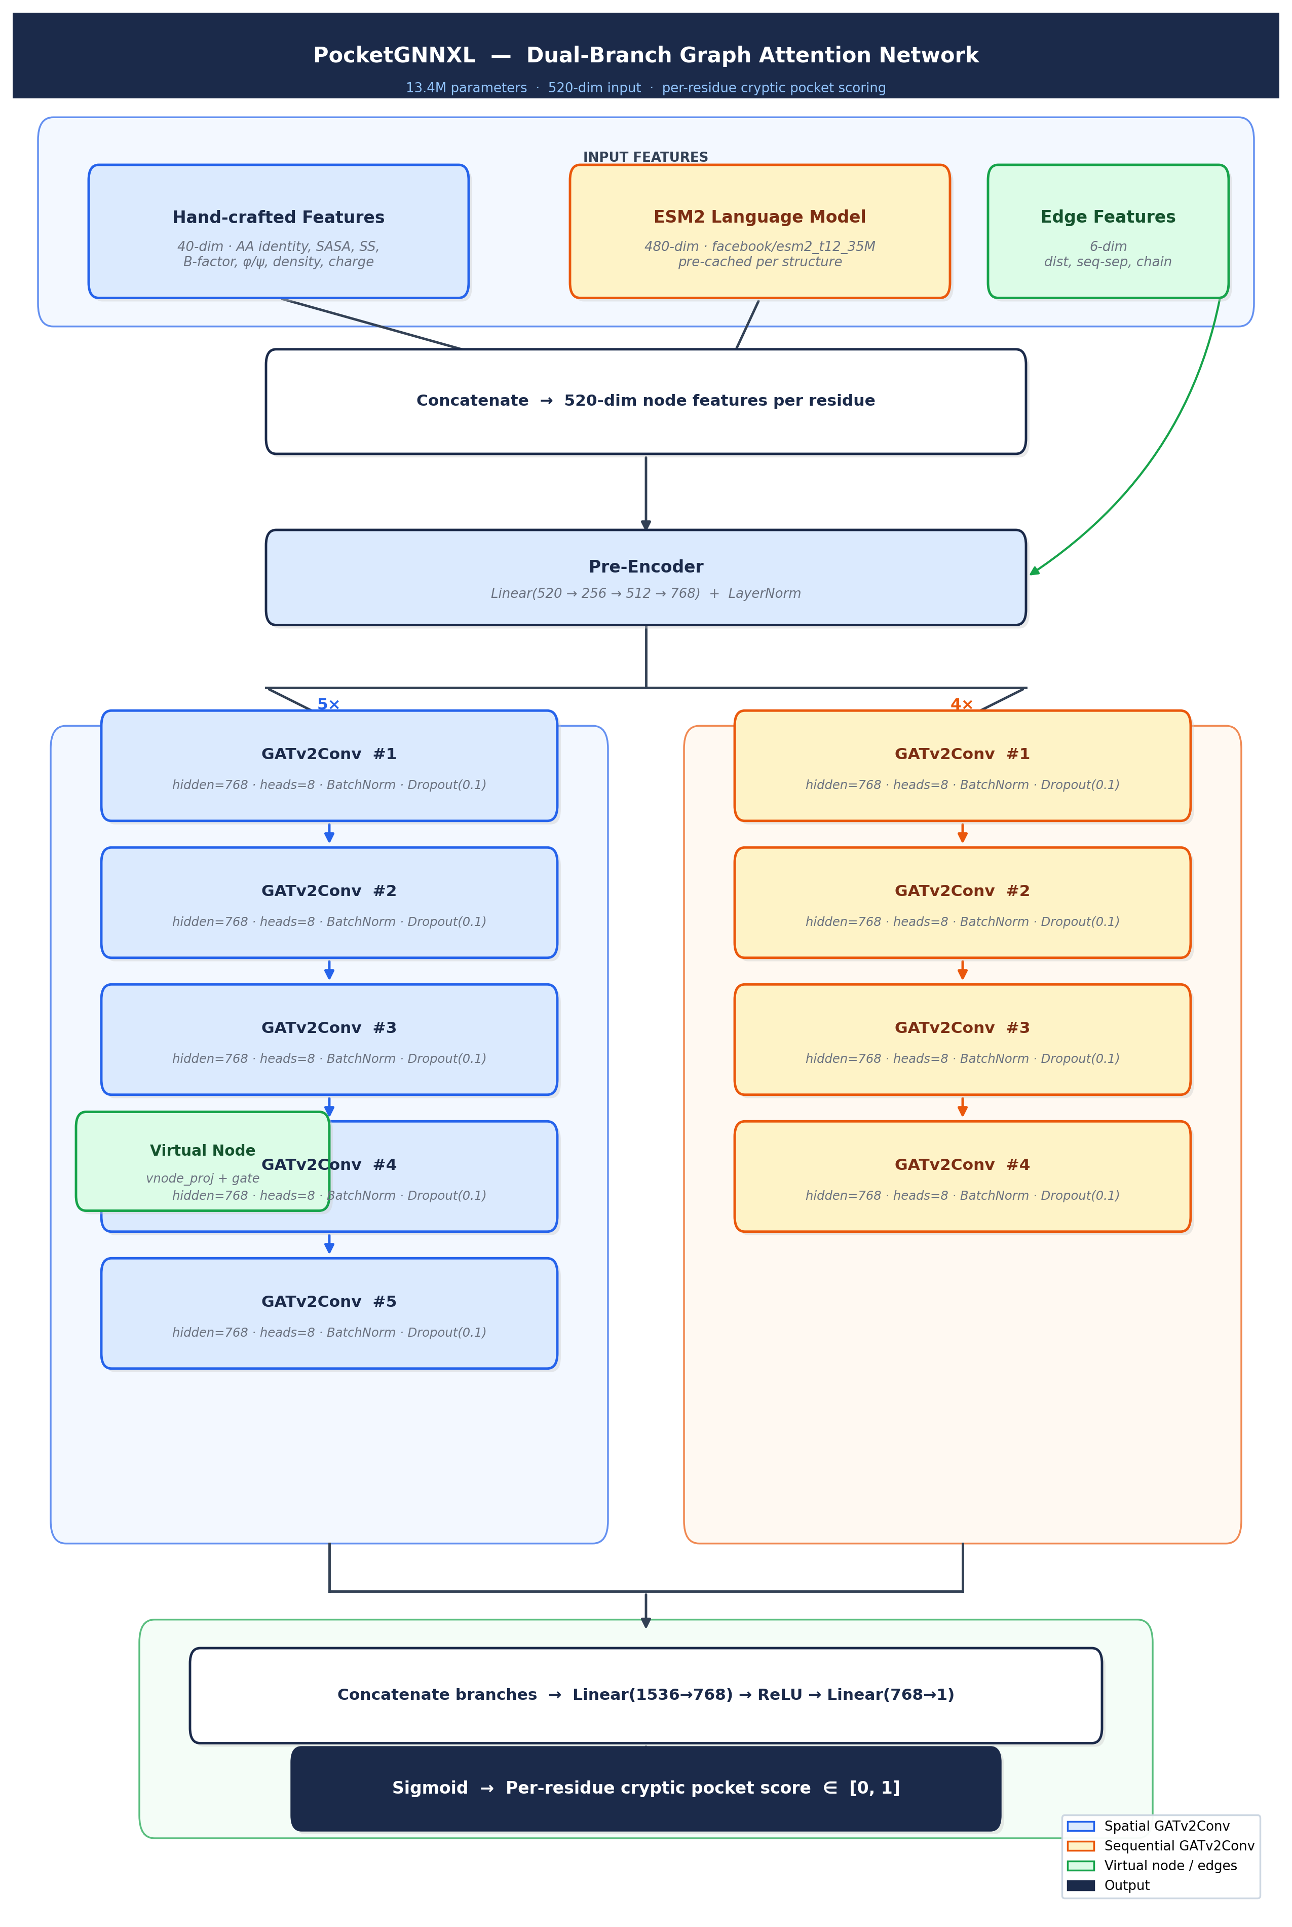
Figure 1 — PocketGNNXL Model Architecture Dual-branch graph attention network. Hand-crafted structural features (40-dim: amino acid identity, SASA, secondary structure, B-factor, pseudo-dihedrals, residue density, charge, hydrophobicity) are concatenated with ESM2 protein language model embeddings (480-dim) to form a 520-dimensional node representation. A shared pre-encoder (Linear 520→256→512→768 + LayerNorm) projects nodes into a common space before branching into a 5-layer spatial GATv2Conv branch and a 4-layer sequential GATv2Conv branch. A virtual node aggregates global context. Branch outputs are concatenated and projected via MLP to a per-residue cryptic pocket score in [0, 1]. Total: ~13.4M parameters.

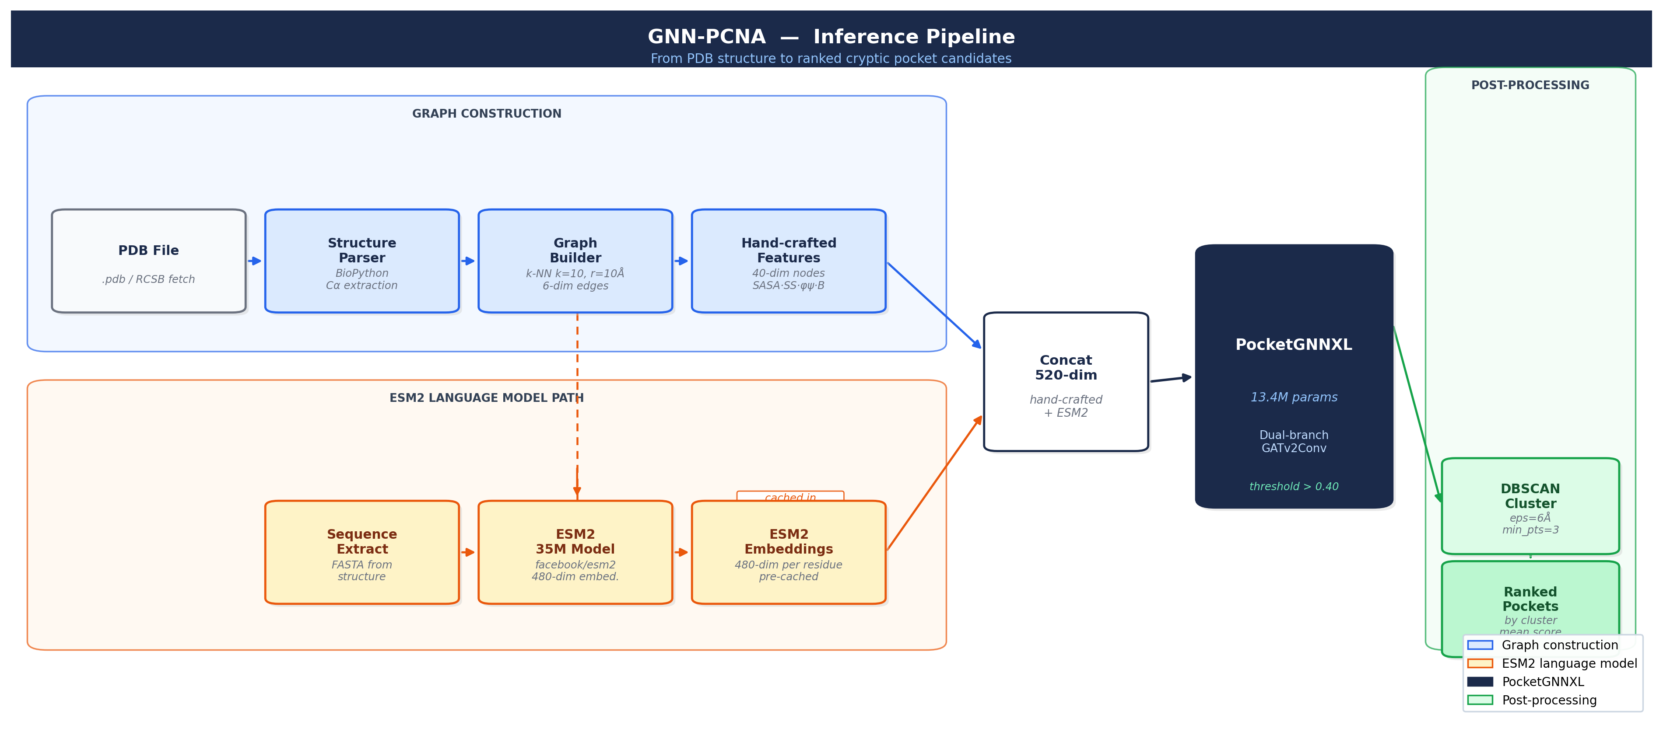
Figure 2 — GNN-PCNA Inference Pipeline End-to-end inference pipeline from raw PDB file to ranked pocket candidates. Structure parsing extracts Cα coordinates and residue properties via BioPython. The graph builder constructs a k-nearest neighbor graph (k=10, cutoff 10 Å) with 6-dimensional edge features (distance, inverse distance, sequence separation, same-chain flag, backbone flag, cross-chain flag). ESM2 embeddings are pre-cached per structure (data/esm_features/) or generated on-the-fly. Post-inference, residues scoring above 0.40 are clustered with DBSCAN (eps=6 Å, min_samples=3) on Cα coordinates to yield discrete pocket candidates ranked by cluster mean score.

RESULTS FIGURES

Figure 3 — Comprehensive Results Summary — PocketGNN V1 vs PocketGNNXL V3 (A) V1 vs V3 AUROC on the 7 drug-like ligand structures; V3 mean AUROC 0.9067 vs V1 mean 0.6927. (B) V3 maximum cluster score distribution stratified by AOH1996 ground-truth pocket recovery tier (24/24, 20-23/24, <20/24). (C) Per-residue score profile for 8GLA chain A (V1 orange, V3 blue) with AOH1996 ground-truth residues marked; V3 recovers all 24/24. (D) AOH overlap vs top cluster score for all V3 structures. (E) Scatter of V1 vs V3 top cluster scores across all 59 PCNA structures, colored by AOH1996 ground-truth overlap count.

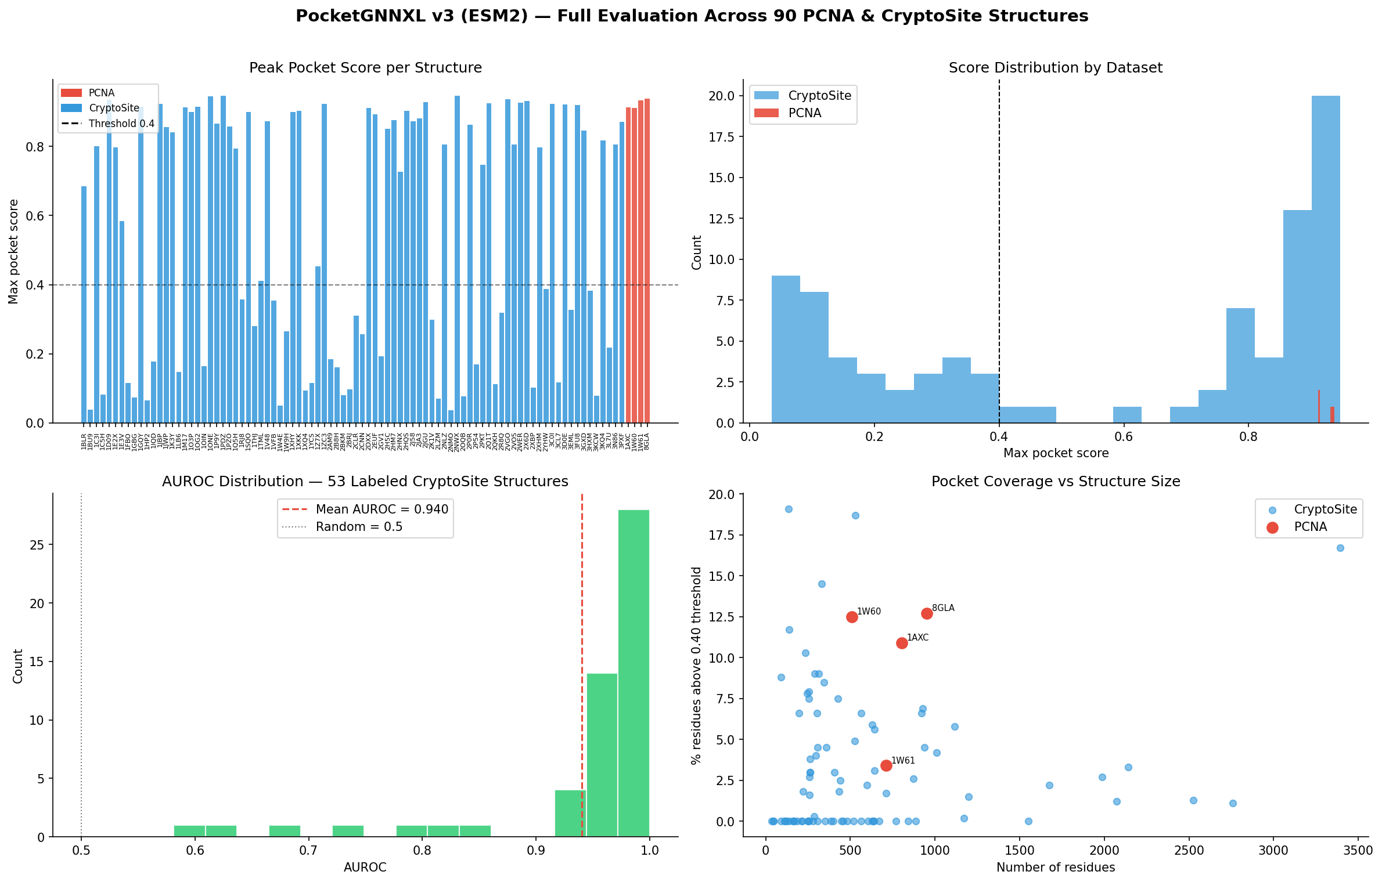
Figure 4 — V3 Full Evaluation — 90 PCNA & CryptoSite Structures Top-left: peak pocket score per structure across 90 PCNA (red) and CryptoSite benchmark (blue) structures; threshold 0.4 shown. Top-right: score distribution by dataset; PCNA structures cluster at higher scores than CryptoSite background. Bottom-left: AUROC distribution across 53 labeled CryptoSite structures; mean AUROC = 0.940. Bottom-right: pocket coverage (% residues above threshold) vs structure size in residues; PCNA structures labeled.

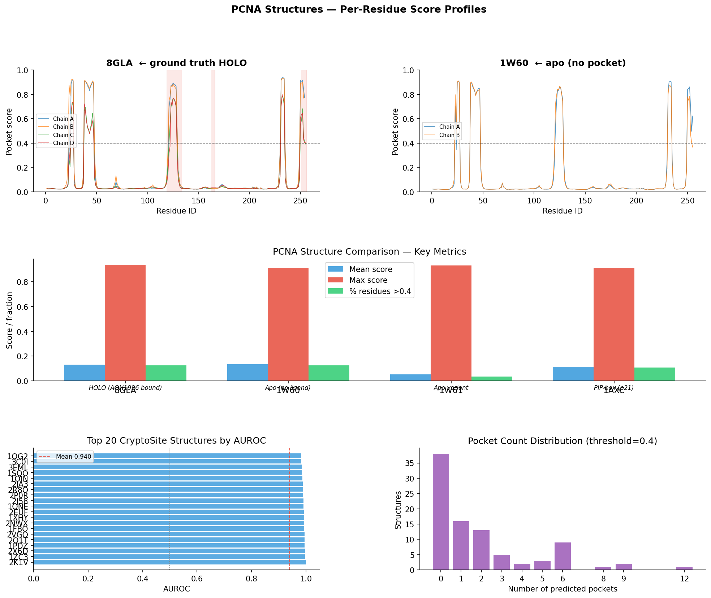
Figure 5 — PCNA Deep Dive — Holo (8GLA) vs Apo (1W60) vs Benchmark Top row: per-residue score profiles for all chains of 8GLA (holo, AOH1996-bound) and 1W60 (apo, no ligand); model correctly suppresses scores in the apo structure while maintaining high scores at pocket residues in the holo. Middle: PCNA structure comparison — mean score, max score, and % residues above 0.4 for holo, apo, and apo-like controls. Bottom-left: AUROC for top-20 CryptoSite structures; mean 0.940. Bottom-right: predicted pocket count distribution (threshold 0.4) across all evaluated PCNA structures.

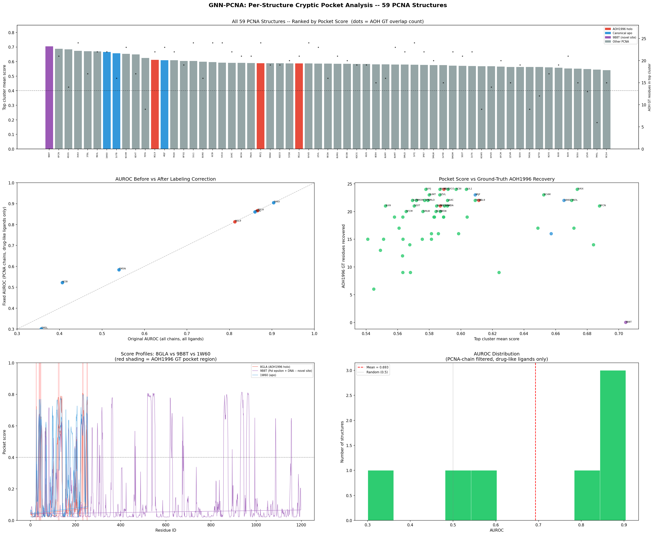
Figure 6 — Per-Structure Analysis — 59 PCNA Structures Top: all 59 PCNA structures ranked by top cluster pocket score; holo (red), apo (blue), and other (gray) structures color-coded; AOH1996 ground-truth overlap count overlaid as scatter. Middle-left: AUROC before vs after labeling correction (filtering AGS/ADP cofactor-adjacent residues from ground truth). Middle-right: top cluster mean score vs AOH1996 ground-truth recovery count for all 59 structures. Bottom-left: score profiles for 8GLA (holo) vs 9B8T (Pol ε-PCNA interface novel site candidate). Bottom-right: AUROC distribution for drug-like ligand structures only.

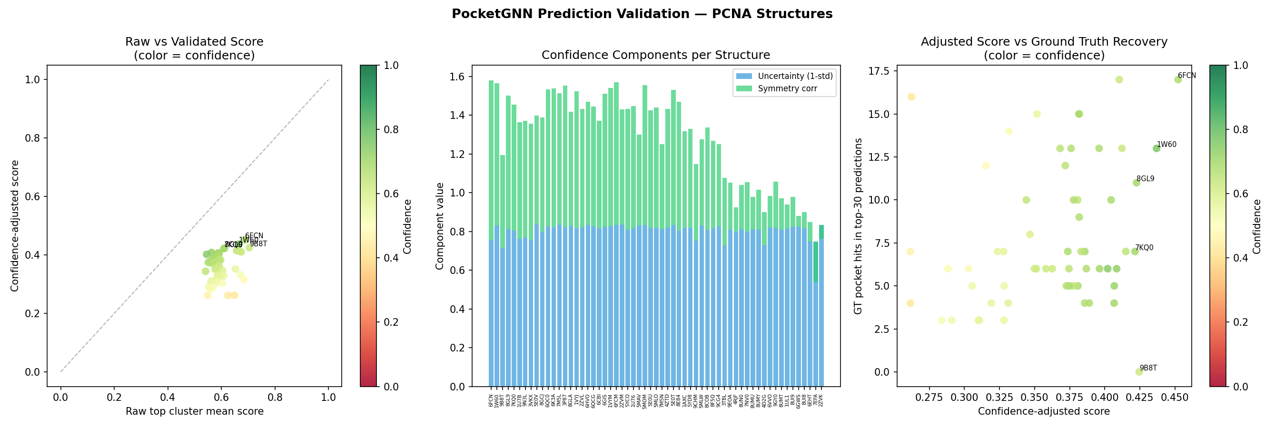
Figure 7 — Prediction Validation — Confidence Adjustment & GT Recovery Left: raw top cluster mean score vs confidence-adjusted score for all PCNA structures; color = confidence. Known holo structures (8GLA, 8GL9) labeled; calibration is tight for high-confidence predictions. Center: stacked bar of confidence components per structure — uncertainty (1-std, blue) and symmetry correction (green); structures ordered by decreasing adjusted score. Right: AOH1996 ground-truth hits in the top-10 model predictions vs confidence-adjusted score; 8GLA and 3VKX recover the most GT residues within the top-10 list, consistent with highest AUROC values.

