

Smart Healthcare Resource Allocation and Appointment Scheduling System
A CAPSTONE PROJECT REPORT
A Capstone Project Report submitted in partial fulfilment of the requirements
for the Course of
CSA4305 - Internet Programming
to the award of the degree of
BACHELOR OF TECHNOLOGY
IN
COMPUTER SCIENCE AND ENGINEERING
Submitted by
G.Pradeep Reddy (192311289)
B.Vishnuvardhan (192311267)
M.Reshwanth (192411235)
B.Maheshwar (192411195)
Module: Hospital Resource Management
Under the Supervision of
DR.D.Sudhagar

SIMATS ENGINEERING
Saveetha Institute of Medical and Technical Sciences
Chennai-602105

SEPTEMBER 2026



BONAFIDE CERTIFICATE

This is to certify that the Capstone Project entitled “Smart Healthcare Resource Allocation and Appointment Scheduling System” has been carried out by G.Pradeep Reddy (192311289), B.Vishnuvardhan (192311267), M.Reshwanth (192411235), B.Maheshwar (192411195) under the supervision of the project guide and is submitted in partial fulfilment of the requirements for the current semester of the B.Tech Computer Science and Engineering program at Saveetha Institute of Medical and Technical Sciences, Chennai.

COURSE COORDINATOR | COURSE FACULTY
Dr Marie Claude .N  Professor | Dr Sudhagar .D  Professor



DECLARATION

We, G.Pradeep Reddy (192311289), B.Vishnuvardhan (192311267), M.Reshwanth (192411235), B.Maheshwar (192411195), of the CSE, SIMATS Engineering, Saveetha Institute of Medical and Technical Sciences, Chennai, hereby declare that the Capstone Project Work entitled “Smart Healthcare Resource Allocation and Appointment Scheduling System” is the result of our own bona fide efforts. The work presented herein is original to the best of our knowledge and has been carried out in accordance with engineering ethics and academic integrity. Sources, references, data, software resources and AI-assisted resources used during the project have been appropriately acknowledged. We further declare that results and findings have not been fabricated or manipulated and that applicable institutional and professional requirements have been followed.

Place: Chennai
Date: ____________________

Signature of the Students with Names

INDIVIDUAL CONTRIBUTION STATEMENT

Student / Register No. | Specific Responsibilities | Design & Development | Testing & Analysis | Report Contribution | Approx. Contribution
G.Pradeep Reddy (192311289) | Appointment scheduling, authentication and integration | Login, appointment booking, role workflows | Booking and authentication tests | Ch. 1, Ch. 4 | 25%
B.Vishnuvardhan (192311267) | Resource and bed/room allocation | Resource database and allocation logic | Allocation and conflict tests | Ch. 2, Ch. 3 | 25%
M.Reshwanth (192411235) | Doctor availability and queue management | Doctor schedules, queues and availability | Scheduling and workload tests | Ch. 3, Ch. 4 | 25%
B.Maheshwar (192411195) | Dashboard, reports and documentation | Responsive UI, reports and monitoring | UI and report verification | Ch. 4, Ch. 5, Appendices | 25%
TOTAL |  |  |  |  | 100%

ABSTRACT
Smart Healthcare Resource Allocation and Appointment Scheduling System is a web-based hospital management application designed to improve the utilization of healthcare resources while reducing appointment delays and scheduling conflicts. Hospitals must coordinate doctors, consultation rooms, beds, diagnostic resources and patient appointments while dealing with changing availability and demand. Manual scheduling can lead to resource underutilization, double booking, long waiting times and inefficient allocation.
The proposed system combines patient appointment scheduling, doctor availability management, hospital resource tracking, allocation rules, conflict detection and administrative monitoring into a single platform. Patients or authorized staff can request appointments based on available time slots, while administrators can manage doctors, rooms and other resources. The system validates availability before confirming an appointment and records allocation information for later review.
The system is organized around major functions: User Authentication and Role Management; Doctor and Resource Management; Appointment Scheduling; Resource Allocation and Conflict Prevention; and Dashboard, Reports and Monitoring. A MySQL database stores users, doctors, resources, schedules, appointments and allocation records, while PHP provides server-side application logic. HTML, CSS, Bootstrap and JavaScript provide the responsive interface.
The engineering design emphasizes efficient resource utilization, prevention of schedule conflicts, role-based access, validation, traceability and usability. The prototype demonstrates how Internet Programming concepts can be applied to a practical healthcare resource management problem in a controlled academic environment.
Keywords: Healthcare Resource Management, Appointment Scheduling, Hospital Resources, Doctor Availability, Conflict Detection, PHP, MySQL

TABLE OF CONTENTS
Sl. No. | Title | Page No.
1 | Chapter 1: Introduction and Engineering Problem | 1
2 | Chapter 2: Literature Review and Existing Solutions | 5
3 | Chapter 3: Engineering Design, Trade-offs, Sustainability, Ethics, Safety & Risk | 9
4 | Chapter 4: Implementation, Testing & Results, Project Management | 15
5 | Chapter 5: Conclusion, Future Work and Reflection | 22
 | References | 25
 | Appendices | 27

LIST OF FIGURES
Figure No. | Figure Name | Page No.
Fig. 3.1 | Overall Hospital Resource Management Architecture | 10
Fig. 3.2 | Appointment Booking and Availability | 11
Fig. 4.1 | User Login Interface | 15
Fig. 4.2 | Hospital Resource Dashboard | 16
Fig. 4.3 | Appointment Scheduling Interface | 16

LIST OF TABLES
Table No. | Table Name | Page No.
Table 3.1 | Stakeholder / User Requirements | 9
Table 3.2 | Functional and Non-Functional Requirements | 9
Table 3.3 | Applicable Standards and Practices | 10
Table 3.4 | Design Specifications | 10
Table 3.5 | Alternative Solution Evaluation | 11
Table 3.6 | Trade-off Analysis | 13
Table 3.7 | Sustainability, Ethics, Safety and Security | 14
Table 3.8 | Risk Register | 14
Table 4.1 | Tools and Resources Used | 15
Table 4.2 | Test Plan and Verification | 18
Table 4.3 | Objective Achievement | 20
Table 4.4 | Project Budget | 21

LIST OF ABBREVIATIONS / SYMBOLS
Abbreviation / Symbol | Description
API | Application Programming Interface
DB | Database
EHR | Electronic Health Record
HTTPS | Hypertext Transfer Protocol Secure
PHP | PHP: Hypertext Preprocessor
SQL | Structured Query Language
UI | User Interface
RBAC | Role-Based Access Control
OPD | Outpatient Department
ICU | Intensive Care Unit
MFA | Multi-Factor Authentication

CHAPTER 1
INTRODUCTION AND ENGINEERING PROBLEM
1.1 Background
Hospitals operate with limited and highly utilized resources such as doctors, consultation rooms, beds, diagnostic facilities and appointment slots. Efficient coordination of these resources is essential for maintaining service quality and reducing patient waiting time. When scheduling is performed manually or through separate systems, appointments may overlap, resources may remain unused, and staff may spend considerable time resolving conflicts.
This project proposes a Smart Healthcare Resource Allocation and Appointment Scheduling System. The system provides a centralized platform for managing hospital resources and scheduling appointments according to availability. It connects users, doctors, schedules and resources through a structured database and validates requests before confirming bookings.
1.2 Need for the Project
- Manual scheduling can result in duplicate appointments and resource conflicts.
- Doctors and rooms may be underutilized when availability is not centrally tracked.
- Patients may experience longer waiting times because appointment slots are not optimally coordinated.
- Hospital administrators need visibility into resource usage and pending appointments.
- A centralized system can improve traceability of appointments, allocations and cancellations.
- A practical academic implementation demonstrates how web technologies can solve a real operational problem.
1.3 Problem Statement
The engineering problem is to design and implement a web-based system that schedules healthcare appointments and allocates hospital resources while balancing availability, waiting time, usability, reliability, security and implementation cost. The system should prevent double booking, verify doctor and resource availability, support cancellations and updates, and maintain records that allow administrators to monitor utilization.
1.4 Project Aim
To develop a secure and user-friendly hospital resource management application that improves appointment scheduling, resource utilization and operational visibility.
1.5 Project Objectives
Design a centralized web platform for managing doctors, hospital resources and appointments.
Maintain doctor schedules and resource availability in a structured database.
Allow authorized users to create, modify and cancel appointments.
Prevent appointment overlap and resource double booking through availability validation.
Allocate suitable rooms, beds or other resources according to predefined rules.
Provide dashboards and reports for appointment status and resource utilization.
Evaluate the prototype using functional and conflict-oriented test cases.

1.6 Scope
The project includes user registration and login, role management, doctor availability, hospital resource records, appointment creation and cancellation, resource allocation, conflict checking, dashboard monitoring and reporting. The prototype is intended for a controlled web-server environment such as XAMPP.
The project does not claim to provide a complete hospital information system, clinical decision support, emergency triage, medical diagnosis, real-time medical device integration or enterprise-scale deployment. These capabilities may be considered as future extensions.
1.7 Expected Engineering Outcome
The expected outcome is a functional web prototype demonstrating the workflow: authentication → availability check → appointment request → resource allocation → confirmation → appointment completion/cancellation → resource release → reporting. The prototype should provide evidence through defined functional and scheduling tests.

CHAPTER 2
LITERATURE REVIEW AND EXISTING SOLUTIONS
2.1 Review Method
The review is structured around four areas relevant to the proposed system: healthcare appointment scheduling, resource allocation, availability management and secure web application development. Existing hospital and appointment-management approaches are considered to identify practical requirements for the prototype.
2.2 Review of Existing Work
Appointment systems commonly provide patient registration, provider schedules, appointment slots and reminders. Resource management systems extend this model by tracking rooms, beds, equipment and staff availability. Scheduling approaches can use rule-based allocation to ensure that a requested appointment does not conflict with an existing booking.
2.3 Comparative Analysis
Existing Approach | Advantages | Limitations | Relevance to Proposed Work
Manual appointment registers | Simple and inexpensive | High risk of overlap and poor visibility | Motivates centralized scheduling
Basic online appointment system | Convenient patient booking | May not manage rooms/resources | Provides booking reference
Separate resource tracking | Tracks resource availability | Scheduling may remain disconnected | Motivates integrated allocation
Large hospital information systems | Comprehensive functionality | Complex and costly for a student prototype | Provides conceptual reference
Proposed system | Appointments and resource allocation in one workflow | Requires careful availability rules | Direct project solution

2.4 Research / Engineering Gap
A simple appointment booking interface does not fully address the operational problem when hospital resources are limited. A booking may be possible in time but impossible because a required doctor or room is unavailable. The proposed work integrates appointment scheduling with resource availability and conflict prevention in a modular web application.
2.5 Proposed Contribution
The project contributes a modular prototype that connects user management, doctor schedules, resource records, appointment booking, allocation validation and monitoring. The design focuses on reducing avoidable scheduling conflicts and improving visibility of resource utilization.

CHAPTER 3
ENGINEERING DESIGN & TRADE-OFFS, SUSTAINABILITY, ETHICS, SAFETY, RISK & SECURITY
3.1 Requirements
Stakeholder | Requirement
Patient / User | View available appointment slots and request, modify or cancel appointments according to permissions.
Doctor | View assigned appointments and availability schedule.
Administrator | Manage doctors, rooms/resources, schedules, appointments and utilization records.
Hospital Staff | Allocate and release resources and monitor daily scheduling status.
System Operator | Maintain database, application configuration and secure access.

Functional & Non-Functional Requirements
Requirement | Type | Measurable Target
User registration and login | Functional | Valid users can authenticate successfully.
Doctor availability | Functional | Available time slots are displayed correctly.
Appointment booking | Functional | Valid appointment requests can be confirmed.
Conflict prevention | Functional | Overlapping bookings are rejected.
Resource allocation | Functional | Required resources are assigned only when available.
Cancellation / release | Functional | Cancelled appointments release allocated resources.
Role-based access | Non-Functional | Unauthorized functions are denied.
Responsive UI | Non-Functional | Core pages remain usable on desktop and mobile-sized screens.
Input validation | Non-Functional | Invalid form data is rejected.

3.2 Constraints & Applicable Standards / Practices
Standard / Practice | Requirement | Application
OWASP Web Security Practices | Address common web risks | Validation, sessions, authorization and secure coding
HTTPS / TLS | Protect data in transit | Recommended for deployment
SQL prepared statements | Reduce injection risk | Parameterized database queries
Password hashing | Protect stored credentials | Passwords stored as hashes
RBAC | Restrict functions by role | Separate patient/staff/admin capabilities

3.3 Design Specifications
Parameter | Target / Requirement | Priority
Database | MySQL | High
Backend | PHP | High
Appointment validation | Doctor + time + resource availability | High
Resource tracking | Room/bed/equipment status | High
Conflict handling | Reject overlapping allocation | High
Session management | Server-side authenticated sessions | High
Interface | Responsive Bootstrap UI | Medium
Reports | Appointment and resource utilization summaries | Medium

3.4 Alternative Solutions & Evaluation
Criterion | Manual / Paper | Basic Online Booking | Integrated Proposed System
Cost | High staff effort | Medium | Medium
Scheduling visibility | Low | Medium | High
Resource allocation | Low | Low/Medium | High
Conflict prevention | Low | Medium | High
Traceability | Low | Medium | High

3.5 Selected Design & Detailed Design
A PHP and MySQL architecture is selected because it is suitable for the course environment and can be deployed using XAMPP. The browser communicates with the PHP application layer. Authentication and role checks are performed before sensitive operations. Appointment requests are validated against doctor schedules and resource availability before confirmation. The database stores users, doctors, resources, schedules, appointments and allocation records.
System Architecture:
Browser / User Interface → PHP Application Layer → Authentication & Authorization → Scheduling & Allocation Logic → MySQL Database

3.6 Trade-off Analysis
Design Decision | Alternative | Benefit | Disadvantage | Final Decision
Rule-based allocation | Manual assignment | Consistent conflict checking | Needs clear rules | Selected
PHP + MySQL | Node.js + MongoDB | Fits course/XAMPP environment | Less flexible for some architectures | Selected
Server-side sessions | JWT-only authentication | Simple browser integration | Needs careful session configuration | Selected
Centralized database | Separate spreadsheets | Consistent data and queries | Requires database maintenance | Selected

3.7 Sustainability, Ethics, Safety & Security
Domain | Consideration | Impact on Final Decision
Sustainability | Avoid unnecessary duplicated records and manual processing. | Centralized digital workflow.
Ethics | Protect patient and staff information. | Role-based access and minimum necessary data exposure.
Safety | Avoid treating scheduling software as a clinical decision system. | No diagnosis or clinical decision support in scope.
Security | Protect accounts and operational records. | Hashing, sessions, validation, prepared statements and access checks.

Risk Register
Risk | Likelihood | Severity | Mitigation | Residual Risk
Double booking | Medium | High | Availability validation before confirmation | Low
Incorrect resource status | Medium | High | Controlled update and release workflow | Medium
Unauthorized access | Medium | High | Authentication and role checks | Low
SQL injection | Medium | High | Prepared statements | Low
Incorrect user input | Medium | Medium | Validation and constrained fields | Low
Server failure | Low | Medium | Backups and recovery procedu | Low
CHAPTER 4
IMPLEMENTATION, TESTING & RESULTS, PROJECT MANAGEMENT
4.1 Development Approach & Resources
The project follows an incremental development approach. User authentication and database connectivity are implemented first, followed by doctor/resource management. Appointment scheduling and conflict validation are then integrated, followed by dashboards, reporting and testing. Module-level and integration testing are performed before evaluating the complete workflow.
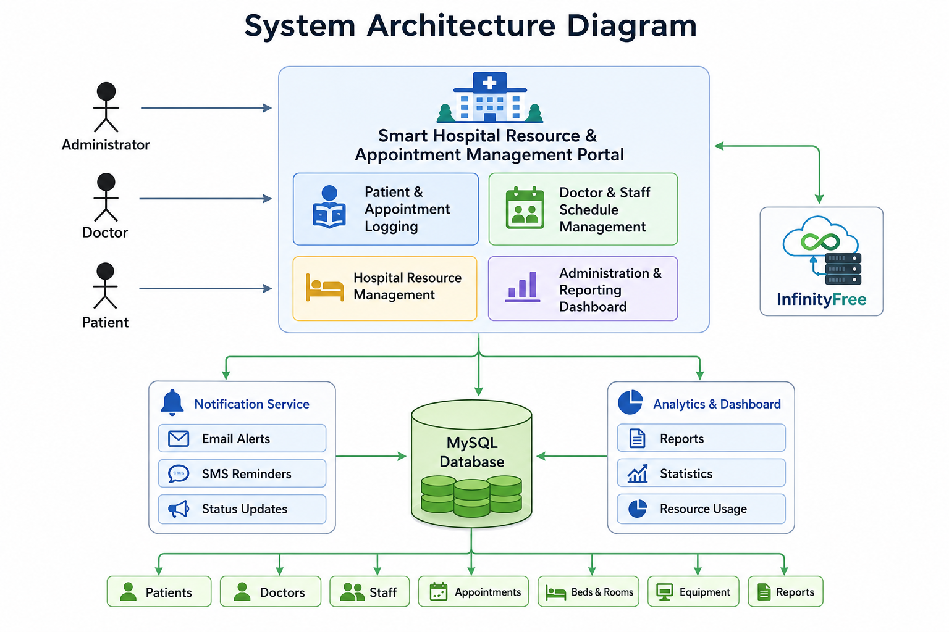
Fig 3.1
Resource | Purpose
XAMPP | Local Apache and MySQL development environment.
PHP | Server-side application logic.
MySQL | User, doctor, resource, appointment and allocation storage.
HTML/CSS/Bootstrap | Responsive web interface.
JavaScript/AJAX | Client-side interaction and asynchronous requests where needed.
Git | Source-code version control and collaboration.

4.2 Software Implementation & Modern Tools Used
Tool / Software | Purpose | Stage Used
PHP | Backend application logic | All implementation stages
MySQL | Persistent data storage | Database design and integration
Bootstrap 5 | Responsive UI | Frontend development
JavaScript | Client-side validation and interaction | Frontend development
XAMPP | Apache/PHP/MySQL local server | Development and testing
Git | Version control | Development and integration

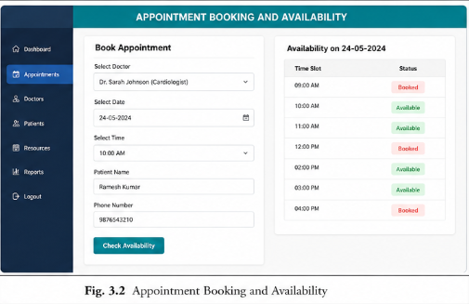
Fig.3.2
4.3 Module-wise Implementation
Module 1 – User Authentication & Role Management
- Registration validates required information and stores a password hash.
- Login verifies credentials and creates an authenticated session.
- Role checks restrict administrative and scheduling functions.
- Logout terminates the active session.
Module 2 – Doctor & Hospital Resource Management
- Administrators can register doctors and maintain their availability schedules.
- Rooms, beds and other hospital resources can be recorded with status information.
- Resource status is updated when resources are allocated, released or marked unavailable.
Module 3 – Appointment Scheduling
- Users select a suitable doctor and available time slot.
- The system checks for overlapping appointments before confirmation.
- Appointment status can be tracked as scheduled, completed or cancelled.
- Cancellation updates the corresponding resource availability.
Module 4 – Resource Allocation, Dashboard & Reports
- The system allocates an appropriate available resource for a confirmed appointment.
- Allocation conflicts are rejected rather than silently overwriting existing bookings.
- Dashboards summarize appointments, resource status and utilization.
- Administrators can review scheduling records for operational monitoring.

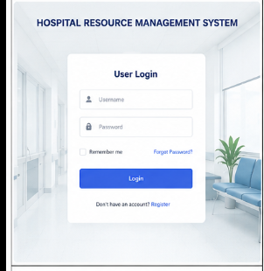
Fig.4.1
4.4 Test Plan & Verification
Requirement | Test Method | Acceptance Criterion
Registration | Submit valid and invalid forms | Valid user created; invalid data rejected
Login | Use correct and incorrect credentials | Correct credentials authenticate; incorrect credentials denied
Doctor availability | Create schedule and query slots | Only valid available slots are shown
Appointment | Book a free slot | Appointment is created successfully
Conflict prevention | Book an already occupied slot | Second conflicting booking is rejected
Resource allocation | Allocate occupied and free resources | Only available resources are assigned
Cancellation | Cancel a confirmed appointment | Appointment cancelled and resource released
Role security | Access restricted functions using wrong role | Unauthorized action denied
Dashboard | Perform sample transactions | Counts and status values update correctly

4.5 Results
The intended prototype results are evaluated against functional requirements and scheduling controls. The final implementation should demonstrate that appointment conflicts are detected, resources are allocated only when available, cancellations release resources, and role restrictions are enforced. Screenshots of login, dashboard, appointment booking, resource allocation and administrative monitoring should be included as implementation evidence.
Result Area | Expected Observation | Actual Result
Authentication | Valid users log in and invalid users are rejected. | To be recorded
Availability | Only available doctors/resources appear for booking. | To be recorded
Appointment | Valid appointments are created without overlap. | To be recorded
Conflict control | Overlapping appointment/resource requests are rejected. | To be recorded
Resource release | Cancelled/completed bookings release resources. | To be recorded
Dashboard | Operational status is reflected in summaries. | To be recorded

Note: Actual achieved values and Pass/Fail status should be filled after executing the final implementation test cycle. The tables above define verification criteria rather than claiming unperformed measurements.
4.6 Comparison with Existing Solutions & Achievement of Objectives
Objective | Evidence | Achievement
Develop healthcare scheduling system | Integrated PHP/MySQL web prototype | To be validated
Maintain doctor/resource availability | Doctor and resource modules | To be validated
Prevent scheduling conflicts | Availability and overlap checks | To be validated
Allocate hospital resources | Allocation workflow and resource status | To be validated
Provide monitoring | Dashboard and reports | To be validated

4.7 Strengths & Limitations
Strengths:
- Appointments and resource availability are managed in one workflow.
- Conflict detection reduces duplicate scheduling.
- Resource status can be monitored and updated.
- Role-based access separates administrative functions.
- The architecture is modular and suitable for an academic Internet Programming project.
Limitations:
- The prototype depends on correct resource and schedule data entered by authorized staff.
- Enterprise-scale hospital integration is outside the current scope.
- Real-time integration with medical devices and clinical systems is not implemented.
- Advanced optimization algorithms are not part of the initial prototype.
- Final performance values depend on the actual deployment environment and workload.

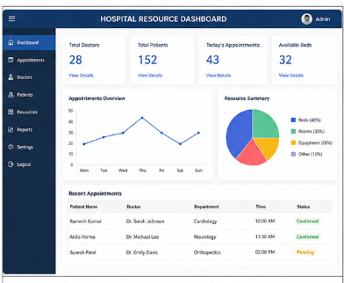
Fig.4.2
4.8 Project Planning, Roles & Budget
Phase | Activity | Planned Duration
1 | Requirement analysis and literature review | Week 1
2 | Database and system design | Week 2
3 | Authentication and role management | Week 3
4 | Doctor/resource management | Week 4
5 | Appointment scheduling and conflict checks | Week 5
6 | Allocation, dashboards and reports | Week 6
7 | Testing and verification | Week 7
8 | Documentation and final presentation | Week 8

Student | Assigned Responsibility | Actual Contribution
G.Pradeep Reddy | Appointment scheduling, authentication and integration | To be confirmed
B.Vishnuvardhan | Resource and bed/room allocation | To be confirmed
M.Reshwanth | Doctor availability and queue management | To be confirmed
B.Maheshwar | UI, reports and documentation | To be confirmed

Item | Estimated Cost | Actual Cost
Development software | ₹0 | ₹0 / To be confirmed
XAMPP / PHP / MySQL | ₹0 | ₹0
Domain / hosting (optional) | ₹0–2,000 | To be confirmed
Miscellaneous | ₹500 | To be confirmed
Total | ₹500–2,500 | To be confirmed

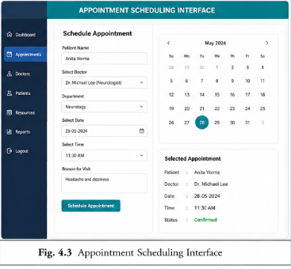
Fig.4.3

CHAPTER 5
CONCLUSION, FUTURE WORK AND REFLECTION

5.1 Conclusion
The Smart Healthcare Resource Allocation and Appointment Scheduling System is designed to address operational challenges associated with hospital appointment scheduling and limited healthcare resources. The proposed architecture combines authentication, doctor availability, resource tracking, appointment booking, conflict prevention, allocation and monitoring within a single web application.
T resources are allocated, and cancellations or completions release resources for subsequent use. The approach demonstrates how web development and database concepts can be applied to improve the coordination of healthcare operations.

5.2 Future Work
- Introduce optimization algorithms to improve resource utilization and reduce waiting time.
- Add SMS, email or mobile notifications for appointment reminders.
- Integrate calendar synchronization for doctors and departments.
- Add real-time dashboards for hospital administrators.
- Support multiple departments and more complex resource dependencies.
- Integrate with electronic health record systems through secure APIs where appropriate.
- Introduce multi-factor authentication and stronger audit controls.
- Develop a mobile application for patients and staff.

5.3 Professional Learning & Individual Reflection
New Knowledge Acquired:
- Practical application of appointment scheduling and resource allocation logic.
- Database relationships for users, doctors, resources, schedules and appointments.
- Role-based authentication and secure web application practices.
- Testing of scheduling conflicts and operational workflows.
- Integration of frontend, backend and database components.
Engineering & Professional Skills Developed:
- Requirements analysis and modular system design.
- Backend integration and database design.
- Software testing, debugging and documentation.
- Team coordination, version control and technical communication.

Individual Reflection – G.Pradeep Reddy: The main challenge was coordinating authentication with appointment operations. The work improved understanding of role-based access and the importance of validating scheduling requests before confirmation.
Individual Reflection – B.Vishnuvardhan: The main challenge was representing hospital resources and their availability. The work improved understanding of allocation rules, status tracking and conflict prevention.
Individual Reflection – M.Reshwanth: The main challenge was maintaining doctor schedules and appointment timing without overlaps. The work improved understanding of scheduling logic, availability queries and cancellation handling.
Individual Reflection – B.Maheshwar: The main challenge was integrating the dashboard, reports and documentation into a coherent workflow. The work improved skills in responsive UI development, testing and technical reporting.

REFERENCES

- National Institute of Standards and Technology (NIST), Digital Identity Guidelines and relevant security guidance.
- OWASP Foundation, OWASP Top 10: The Ten Most Critical Web Application Security Risks.
- OWASP Foundation, OWASP Cheat Sheet Series – Authentication, Session Management and Input Validation.
- PHP Documentation, PHP Manual – Password Hashing, Sessions, Database Access and Web Application Development.
- MySQL Documentation, MySQL Reference Manual – SQL Statements, Prepared Statements and Database Security.
- Mozilla Developer Network (MDN), Web security, HTTP, HTML, CSS and JavaScript documentation.
- General literature on healthcare appointment scheduling, resource allocation and hospital operations management.
- Note: The final submitted report should acknowledge the exact software versions, repositories, libraries, datasets (if any), and AI-assisted resources actually used during implementation.

APPENDICES
Appendix A – Appointment Scheduling Workflow
Authenticate the user and establish a secure session.
Load doctor schedules and hospital resource availability.
Select a valid appointment date and time.
Check doctor availability and existing appointments.
Check required resource availability.
Create the appointment and allocation records.
Update resource status where required.
Allow cancellation or completion and release the resource.
Record relevant operational activity.
Appendix B – Database Design
Table | Important Fields | Purpose
users | id, name, email, password_hash, role, created_at | User identity and authentication
doctors | id, name, department, specialization, status | Doctor information
resources | id, resource_name, type, location, status | Hospital resource records
doctor_schedule | id, doctor_id, date, start_time, end_time | Doctor availability
appointments | id, patient_id, doctor_id, date, start_time, end_time, status | Appointment records
allocations | id, appointment_id, resource_id, allocated_at, released_at | Resource allocation
audit_logs | id, user_id, action, timestamp, details | Operational auditing

Appendix C – Source Code / Code Repository Information
Repository URL: ________________________________________________
Version / Commit: ______________________________________________
Appendix D – Screenshots / Implementation Evidence
- Login and registration page.
- Hospital resource dashboard.
- Doctor availability page.
- Appointment scheduling page.
- Resource allocation page.
- Appointment status / cancellation result.
- Administrative monitoring dashboard.

Appendix E – Experimental / Raw Data
Record actual test results for appointment booking time, conflict detection, resource allocation, cancellation, dashboard updates and failure cases after the final prototype is executed. Do not insert estimated measurements as achieved results.
Appendix F – Ethics / Institutional Approval
The prototype should use synthetic or non-confidential data for demonstrations unless appropriate institutional approval and data-handling procedures are available. Real patient identifiers and confidential clinical information should not be included in screenshots or demonstration datasets.
Appendix G – Project Meeting / Progress Records
Date | Discussion / Task | Decision / Action | Member(s)
________ | Requirement discussion | Finalize module structure | ________
________ | Design review | Approve architecture | ________
________ | Implementation review | Integrate modules | ________
________ | Testing review | Resolve defects | ________

Appendix H – User / Industry Feedback
To be completed if feedback is collected from users, faculty, industry mentors or other evaluators.
Appendix I – Publications / Patents / Competitions / Product Outcomes
To be completed if the project produces a publication, patent, competition entry or product outcome.
Appendix J – Individual Contribution Evidence
Attach repository commits, module ownership records, screenshots of implementation work, testing records and report sections contributed by each team member.

