NYC OPENDATA: ACRIS DATASETS

ACRIS has two types of documents:
Real Property Records:- include documents in the Deeds and Other Conveyances, Mortgages & Instruments and Other Documents classes in ACRIS. These documents typically impact rights to real property and as such follow the real property rather than an individual.

Personal Property Records:- include documents in the UCC and Federal Liens class in ACRIS. These documents typically impact rights to personal property associated with real property and as such follow the individual party rather than the real property.

Each Real Property Record or Personal Property Record contains:
- A master record
- Zero or more lot(property) records
- Zero or more party records
- Zero or more cross-reference records
- Zero or more remarks records

The “Document ID” in the master record is used to link all other record types to a master record. To find all of the lot (property) records associated with a master record, simply retrieve all records in the property dataset with the same “Document ID” as the selected master record. The same process should be repeated for Party, Cross Reference and Remark records.

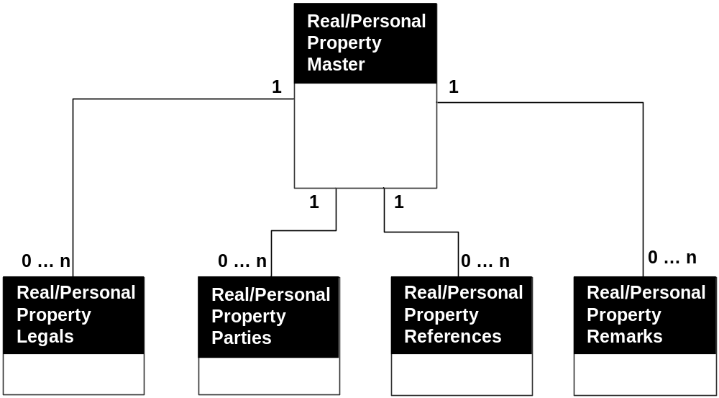

Real Property Records comprise of the following five datasets:
Record Type | Dataset Title | Dataset URL | Dataset Description
Master record | ACRIS - Real Property Master | http://data.cityofnewyork.us/City-Government/ACRIS-Real-Property-Master/bnx9-e6tj | Document Details for Real Property Related Documents Recorded in ACRIS
Lot(property) record | ACRIS - Real Property Legals | http://data.cityofnewyork.us/City-Government/ACRIS-Real-Property-Legals/8h5j-fqxa | Property Details for Real Property Related Documents Recorded in ACRIS
Party record | ACRIS - Real Property Parties | http://data.cityofnewyork.us/City-Government/ACRIS-Real-Property-Parties/636b-3b5g | Party Names for Real Property Related Documents Recorded in ACRIS
Cross-reference record | ACRIS - Real Property References | http://data.cityofnewyork.us/City-Government/ACRIS-Real-Property-References/pwkr-dpni | Document Cross References for Real Property Related Documents Recorded in ACRIS
Remarks record | ACRIS - Real Property Remarks | http://data.cityofnewyork.us/City-Government/ACRIS-Real-Property-Remarks/9p4w-7npp | Document Remarks for Real Property Related Documents Recorded in ACRIS

Personal Property Records comprise of the following five datasets:
Record Type | Dataset Title | Dataset URL | Dataset Description
Master record | ACRIS - Personal Property Master | http://data.cityofnewyork.us/City-Government/ACRIS-Personal-Property-Master/sv7x-dduq | Document Details for Personal Property Related Documents Recorded in ACRIS
Lot(property) record | ACRIS - Personal Property Legals | http://data.cityofnewyork.us/City-Government/ACRIS-Personal-Property-Legals/uqqa-hym2 | Property Details for Personal Property Related Documents Recorded in ACRIS
Party record | ACRIS - Personal Property Parties | http://data.cityofnewyork.us/City-Government/ACRIS-Personal-Property-Parties/nbbg-wtuz | Party Names for Personal Property Related Documents Recorded in ACRIS
Cross-reference record | ACRIS - Personal Property References | http://data.cityofnewyork.us/City-Government/ACRIS-Personal-Property-References/6y3e-jcrc | Document Cross References for Personal Property Related Documents Recorded in ACRIS
Remarks record | ACRIS - Personal Property Remarks | http://data.cityofnewyork.us/City-Government/ACRIS-Personal-Property-Remarks/fuzi-5ks9 | Document Remarks for Personal Property Related Documents Recorded in ACRIS

CODE MAPPINGS
In ACRIS, documents are stored with codes representing longer descriptions that are displayed on images generated by ACRIS and in Document Search. The translation from these codes is done via the following code datasets:

Dataset Title | Dataset URL | Dataset Description
ACRIS - Document Control Codes | http://data.cityofnewyork.us/City-Government/ACRIS-Document-Control-Codes/7isb-wh4c | ACRIS Document Type and Class Code mappings for Codes in the ACRIS Real and Personal Property Master Datasets
ACRIS - UCC Collateral Codes | http://data.cityofnewyork.us/City-Government/ACRIS-Country-Codes/j2iz-mwzu | ACRIS Collateral Type mapping for Codes in the ACRIS Personal Property Master Dataset
ACRIS - Property Types Codes | http://data.cityofnewyork.us/City-Government/ACRIS-Property-Types-Codes/94g4-w6xz | ACRIS State mapping for Codes in the ACRIS Real and Personal Property Legals Datasets
ACRIS - States Codes | http://data.cityofnewyork.us/City-Government/ACRIS-States-Codes/5c9e-33xj | ACRIS State mapping for Codes in the ACRIS Real and Personal Parties Property Datasets
ACRIS - Country Codes | http://data.cityofnewyork.us/City-Government/ACRIS-UCC-Collateral-Codes/q9kp-jvxv | ACRIS Countries mapping for Codes in the ACRIS Real and Personal Parties Property Datasets

