6SENG002W Concurrent Programming

FSP Process Analysis & Design Form

Name | K.K.Resindu Navoda
Student ID | 2016352/w1654203
Date | 2020/01/06

1. FSP Process Attributes

Attribute | Value
Name | STUDENT
Description | Money withdrawal process from a bank account by a student and buy a smart phone.
Alphabet | { readCurrentBalance, subtractMoney, buyPhone, calculateNewBalance, updateNewBalance, validateNewBalance}
Number of States | 6
Deadlocks (yes/no) | No
Deadlock Trace(s) | No

2. FSP Process Code

FSP Process:
STUDENT =(readCurrentBalance-> WITHDRAW),
WITHDRAW= (subtractMoney-> CALCULATE_BALANCE),
CALCULATE_BALANCE= (calculateNewBalance-> BUY_PHONE),
BUY_PHONE= (buyPhone -> updateNewBalance -> validateNewBalance-> STUDENT).

3. Actions Description
A description of what each of the FSP process' actions represents, i.e. is modelling. In addition, indicate if the action is intended to be synchronised (shared) with another process or asynchronous (not shared). (Add rows as necessary.)

Actions | Represents | Synchronous or Asynchronous
readCurrentBalance | Student reads the current bank account balance | Synchronized
subtractMoney | Reduce the withdrawal money amount from the bank account | Asynchronized
buyPhone | Student buying a smart phone | Synchronized
calculateNewBalance | Calculate the bank account balance after the withdrawal of money | Asynchronized
updateNewBalance | Update the bank account balance after the withdrawal of money | Synchronized
validateNewBalance | Validate the updated bank account balance | Synchronized

4. FSM/LTS Diagrams of FSP Process
Note that if there are too many states, more than 64, then the LTSA tool will not be able to draw the diagram. In this case draw small diagrams of the most important parts of the complete diagram.

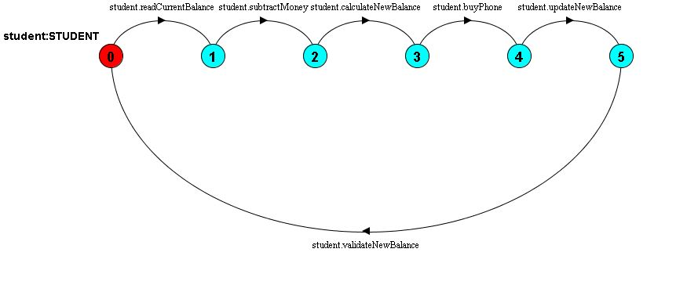

5. LTS States
A description of what each of the FSP process' states represents, i.e. is modelling. If there are a large number of states then you can group similar states together &/or only include the most important ones. For example, identify any states related to mutual exclusion (ME) & the associated critical section (CS), e.g. waiting to enter the CS state, in the CS state(s), left the CS state. (Add rows as necessary.)

States | Represents
0 | Student reads his/her own bank account balance
1 | withdrawal money amount from the bank account balance is subtracted from the balance
2 | The bank account balance after the withdrawal of money is calculated
3 | Student buying smart phone
4 | Bank account balance after the withdrawal of money is updated
5 | Updated bank account balance after the withdrawal is validated.

6. Trace Tree for FSP Process
The trace tree for the process. Use the conventions given in the lecture notes.

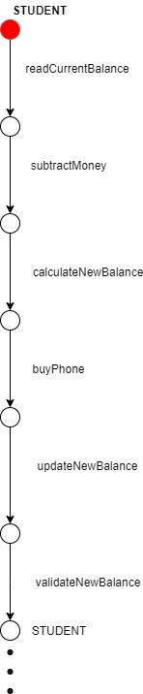

1. FSP Process Attributes

Attribute | Value
Name | GRANDMOTHER
Description | Money deposit process to the student’s bank account by a his/her grandmother as a birthday present and send e birthday card.
Alphabet | { readCurrentBalance, addCurrentBalance,calculateNewBalance, updateNewBalance, sendCard, validateNewBalance}
Number of States
Deadlocks (yes/no) | No
Deadlock Trace(s) | No

2. FSP Process Code

FSP Process:
GRANDMOTHER =(readCurrentBalance -> DEPOSIT),
DEPOSIT= (addCurrentBalance -> CALCULATE_BALANCE),
CALCULATE_BALANCE= (calculateNewBalance -> SEND_CARD),
SEND_CARD = (updateNewBalance -> sendCard -> validateNewBalance -> GRANDMOTHER).

3. Actions Description
A description of what each of the FSP process' actions represents, i.e. is modelling. In addition, indicate if the action is intended to be synchronised (shared) with another process or asynchronous (not shared). (Add rows as necessary.)

Actions | Represents | Synchronous or Asynchronous
readCurrentBalance | Grandmother reads the current bank account balance | Synchronized
addCurrentBalance | Add deposit money amount to the bank account | Asynchronized
calculateNewBalance | Calculate the bank account balance after depositing the money | Synchronized
updateNewBalance | Update the bank account balance after depositing the money | Synchronized
sendCard | Send a birthday card after grandmother deposit the money | Asynchronized
validateNewBalance | Validate the updated bank account balance | Synchronized

4. FSM/LTS Diagrams of FSP Process
Note that if there are too many states, more than 64, then the LTSA tool will not be able to draw the diagram. In this case draw small diagrams of the most important parts of the complete diagram.

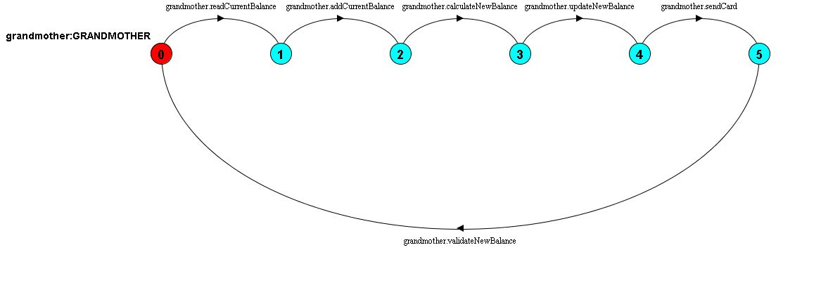

5. LTS States
A description of what each of the FSP process' states represents, i.e. is modelling. If there are a large number of states then you can group similar states together &/or only include the most important ones. For example, identify any states related to mutual exclusion (ME) & the associated critical section (CS), e.g. waiting to enter the CS state, in the CS state(s), left the CS state. (Add rows as necessary.)

States | Represents
0 | Grandmother reads student’s bank account balance
1 | Add the deposited amount of money to the bank account balance
2 | The bank account balance after depositing the money is calculated
3 | Bank account balance after depositing the money is updated
4 | Sends a card
5 | Updated bank account balance after the deposition is validated.

6. Trace Tree for FSP Process
The trace tree for the process. Use the conventions given in the lecture notes.

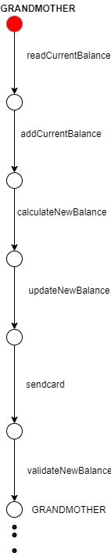

1. FSP Process Attributes

Attribute | Value
Name | UNIVERSITY
Description | Money withdrawal process from the bank account by the University
Alphabet | { readCurrentBalance, subtractMoney,calculateNewBalance, updateNewBalance, validateNewBalance}
Number of States
Deadlocks (yes/no) | No
Deadlock Trace(s) | No

2. FSP Process Code

FSP Process:
UNIVERSITY = (readCurrentBalance-> subtractMoney-> CALCULATE_BALANCE),
CALCULATE_BALANCE= (calculateNewBalance -> updateNewBalance -> validateNewBalance -> UNIVERSITY).

3. Actions Description
A description of what each of the FSP process' actions represents, i.e. is modelling. In addition, indicate if the action is intended to be synchronised (shared) with another process or asynchronous (not shared). (Add rows as necessary.)

Actions | Represents | Synchronous or Asynchronous
readCurrentBalance | University reads the current bank account balance | Synchronous
subtractMoney | Reduce the withdrawal money amount from the bank account | Asynchronous
calculateNewBalance | Calculate the bank account balance after the withdrawal of money | Synchronous
updateNewBalance | Update the bank account balance after the withdrawal of money | Synchronous
validateNewBalance | Validate the updated bank account balance | Synchronous

4. FSM/LTS Diagrams of FSP Process
Note that if there are too many states, more than 64, then the LTSA tool will not be able to draw the diagram. In this case draw small diagrams of the most important parts of the complete diagram.

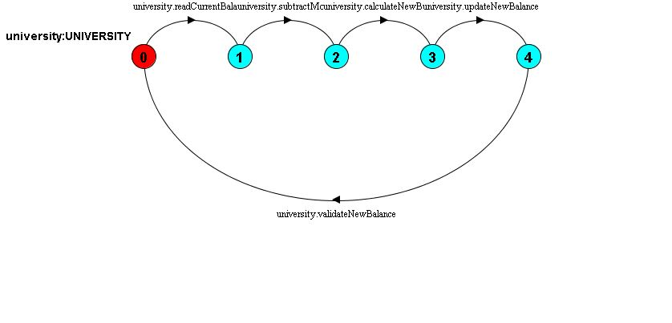

5. LTS States
A description of what each of the FSP process' states represents, i.e. is modelling. If there are a large number of states then you can group similar states together &/or only include the most important ones. For example, identify any states related to mutual exclusion (ME) & the associated critical section (CS), e.g. waiting to enter the CS state, in the CS state(s), left the CS state. (Add rows as necessary.)

States | Represents
0 | University reads the bank account balance
1 | withdrawal money amount from the bank account balance is subtracted from the balance
2 | The bank account balance after the withdrawal of money is calculated
3 | Bank account balance after the withdrawal of money is updated
4 | Updated bank account balance after the withdrawal is validated.

6. Trace Tree for FSP Process
The trace tree for the process. Use the conventions given in the lecture notes.

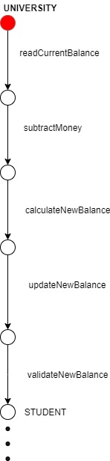

1. FSP Process Attributes

Attribute | Value
Name | LOAN_COMPANY
Description | Money deposit process to the bank account by a loan company
Alphabet | { readCurrentBalance, addCurrentBalance,calculateNewBalance, updateNewBalance, validateNewBalance}
Number of States
Deadlocks (yes/no) | No
Deadlock Trace(s) | No

2. FSP Process Code

FSP Process:
LOAN_COMPANY = (readCurrentBalance -> DEPOSIT),
DEPOSIT= (addCurrentBalance -> CALCULATE_BALANCE),
CALCULATE_BALANCE= (calculateNewBalance -> updateNewBalance -> validateNewBalance -> LOAN_COMPANY) .

3. Actions Description
A description of what each of the FSP process' actions represents, i.e. is modelling. In addition, indicate if the action is intended to be synchronised (shared) with another process or asynchronous (not shared). (Add rows as necessary.)

Actions | Represents | Synchronous or Asynchronous
readCurrentBalance | Student reads the current bank account balance | Synchronized
addCurrentBalance | Add the deposit money amount to the bank account balance | Asynchronous
calculateNewBalance | Calculate the bank account balance after depositing the money | Asynchronized
updateNewBalance | Update the bank account balance after depositing the money | Synchronized
validateNewBalance | Validate the updated bank account balance | Synchronized

4. FSM/LTS Diagrams of FSP Process
Note that if there are too many states, more than 64, then the LTSA tool will not be able to draw the diagram. In this case draw small diagrams of the most important parts of the complete diagram.

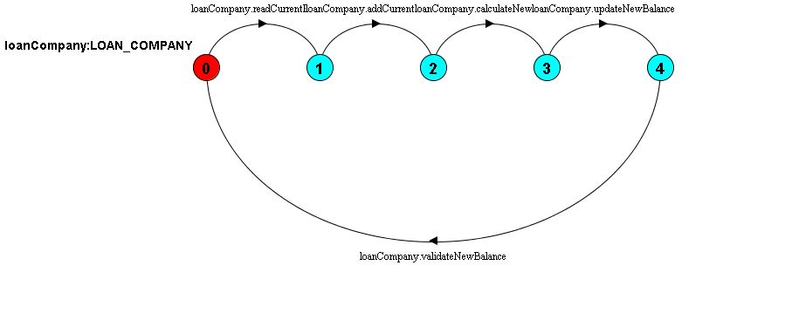

5. LTS States
A description of what each of the FSP process' states represents, i.e. is modelling. If there are a large number of states then you can group similar states together &/or only include the most important ones. For example, identify any states related to mutual exclusion (ME) & the associated critical section (CS), e.g. waiting to enter the CS state, in the CS state(s), left the CS state. (Add rows as necessary.)

States | Represents
0 | Loan company reads student’s bank account balance
1 | Deposit money amount to the bank account is added to the bank account balance
2 | The bank account balance after depositing the money is calculated
3 | Bank account balance after depositing the money is updated
4 | Updated bank account balance after the money deposit is validated.

6. Trace Tree for FSP Process
The trace tree for the process. Use the conventions given in the lecture notes.

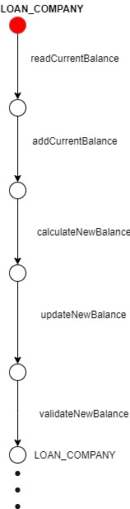

FSP Process Composition Analysis & Design Form

1. FSP Composition Process Attributes

Attribute | Value
Name | BANKING_SYSTEM
Description | Process of a banking system which allow multiple parties to interact with student’s bank account
Alphabet | { loanCompany.{ addCurrentBalance, calculateCurrentBalance, readCurrentBalance, {updateCurrentBalance, validateCurrentBalance}}, granny.{addCurrentBalance, calculateCurrentBalance, readCurrentBalance, sendCard, {updateCurrentBalance, validateCurrentBalance}}, student.{buyPhone, calculateCurrentBalance, readCurrentBalance, subtractMoney, {updateCurrentBalance, validateCurrentBalance}}, university.{calculateCurrentBalance, readCurrentBalance, subtractMoney, {updateCurrentBalance, validateCurrentBalance}}  }
Sub-processes | STUDENT,GRANDMOTHER,UNIVERSITY,LOAN_COMPANY
Number of States | 19
Number of Transitions | 16
Deadlocks (yes/no) | No
Deadlock Traces | No

2. FSP "main" Program Code

The code for the parallel composition of all of the sub-processes and the definitions of any process labelling sets used. (Do not include the code for the sub-processes.)

FSP Program:
|| BANKING_SYSTEM = (student : STUDENT
|| grandmother : GRANDMOTHER
|| loanCompany : LOAN_COMPANY
|| university : UNIVERSITY
|| {student, grandmother, loanCompany, university} :: BANK_ACCOUNT) .

3. Combined Sub-processes

Process | Description
STUDENT | Money withdrawal process from a bank account by a student and buy a smart phone.
GRANDMOTHER | Money deposit process to the student’s bank account by a his/her grandmother as a birthday present and send e birthday card.
LOANCOMPANY | Money deposit process to the bank account by a loan company
UNIVERSITY | Money withdrawal process from the bank account by the University

4. Analysis of Combined Process Actions

Asynchronous actions are done independently by a single sub-process & the synchronous actions are performed by at least two sub-process in the combination.

Blocked actions are ones that could be performed by at least one sub-process, but because it has been added to the alphabet of another that can not perform it, the action becomes synchronised, but it can not be performed.

Hidden actions are those that are internal to the combined process & do not form part of the visible interface.

Synchronous Actions | Synchronised by Sub-Processes
student. readCurrentBalance,  student.calculateCurrentBalance, student.updateCurrentBalance, student .validateCurrentBalance | STUDENT,BANK_ACCOUNT
granny. readCurrentBalance,  granny.calculateCurrentBalance, granny.updateCurrentBalance, granny.validateCurrentBalance | GRANDMOTHER,BANK_ACCOUNT
loanCompany. readCurrentBalance,  loanCompany.calculateCurrentBalance, loanCompany.updateCurrentBalance, loanCompany.validateCurrentBalance | LOANCOMPANY,BANK_ACCOUNT

Asynchronous Actions | Performed by Sub-Process
buyPhone | STUDENT
subtractMoney | STUDENT,UNIVERSITY
addCurrentBalance | GRANDMOTHER,LOAN-COMPANY
sendCard | GRANDMOTHER

5. Composition Structure Diagram

The structure diagram for the parallel composition.

