USE CASE DIAGRAMS

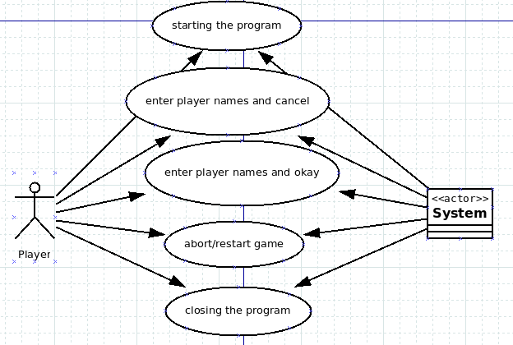
1.

Name: Starting the program
Description: Player double-clicks the program “Mancala” icon and application opens showing the empty gameboard.

Name: Enter the player names and cancel
Description: Player inserts ‘Alice’ as first player and ‘Bob’ as the second player into two fields inside the pop-up box. When button ‘Cancel’ is pressed, application again shows the empty gameboard.

Name: Enter the player names and okay
Description: Player inserts ‘Alice’ as first player and ‘Bob’ as the second player into two fields inside the pop-up box. When button ‘Start game’ is pressed, application shows filled gameboard with both players names and second player’s pits are highlighted to show it’s his/her turn.

Name: Abort/restart game
Description: When game is running, player clicks on Game menu and chooses ‘New game’. This action will pop up the player names inserting box and offer option to start a new game.

Name: Closing the program
Description: When game is running, player clicks on Game menu and chooses ‘Exit’. After clicking on it, program will be closed.

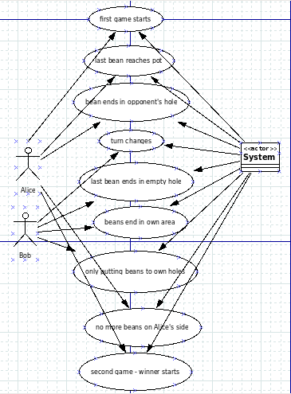
2.

3.
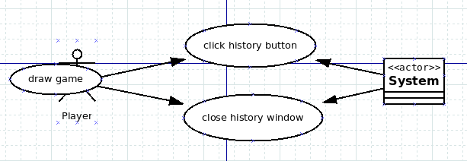
4.
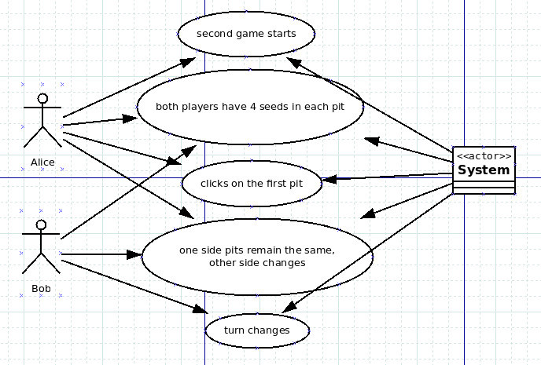

5.
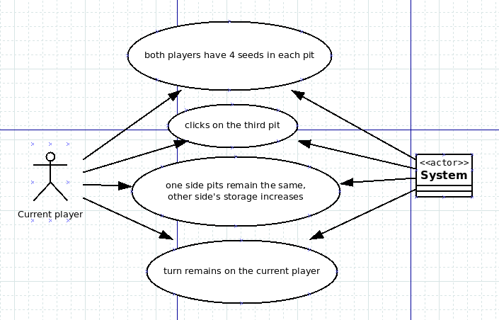
6.
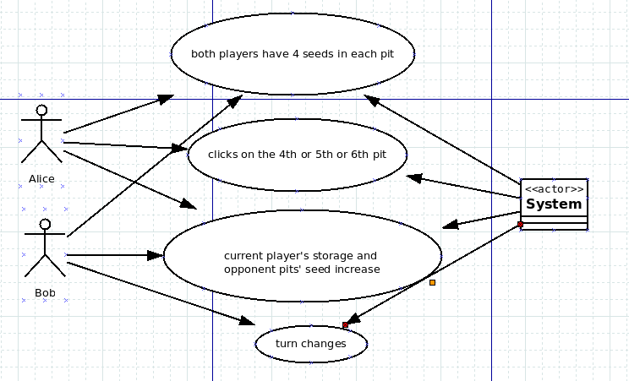

7.
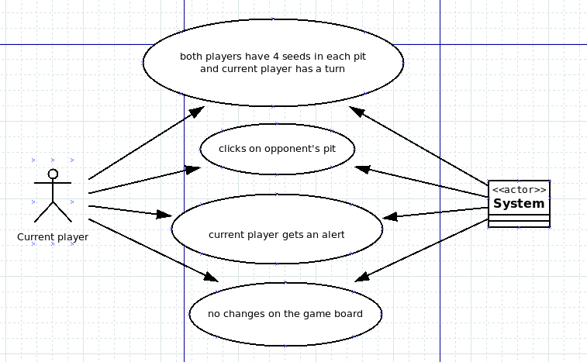
8.
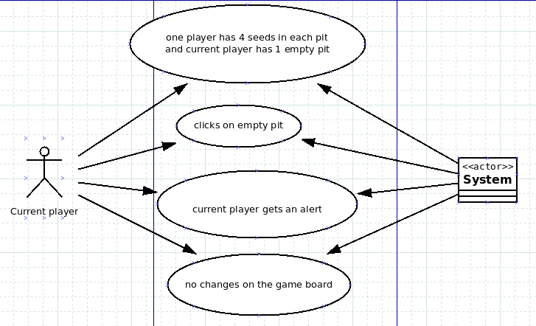

9.
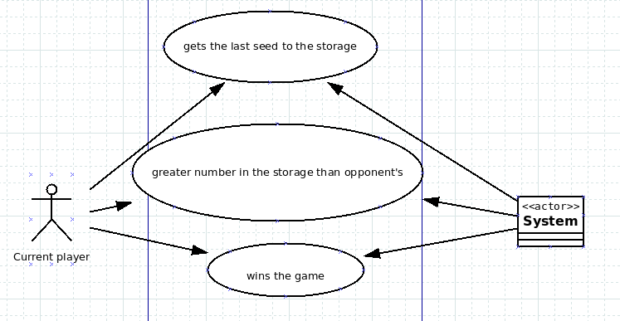
10.
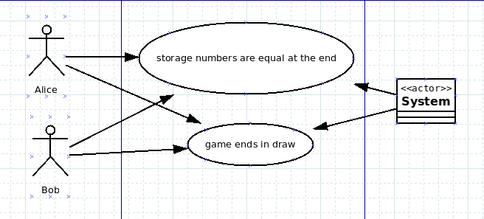
11.
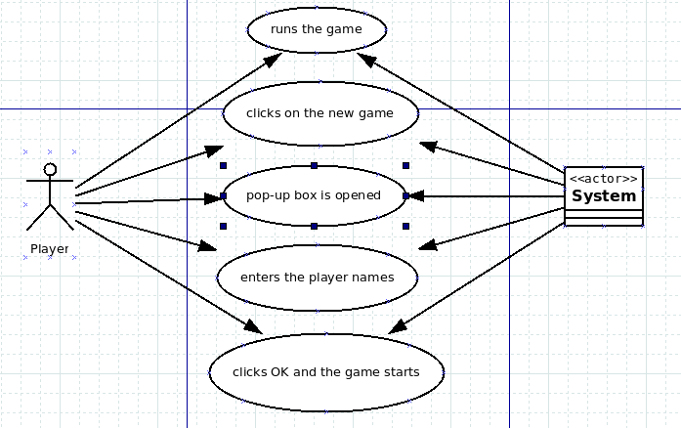
12.
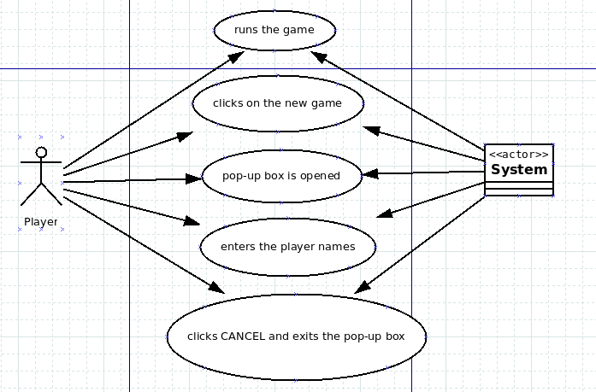
13.
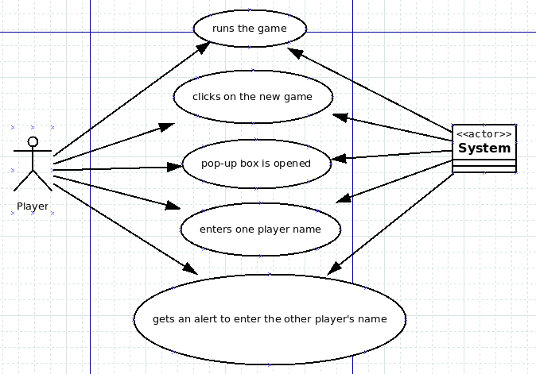
14.
