Game Setup:
Players sit opposite each other with the long sides of the gameboard facing them. 6 small pockets on your side of the gameboard belong to you,your large scoring pocket ( mancala ) is to your right.
How to Play
- Choose a player to go first and pick up all of the stones from one of your pockets.
- In a counter-clockwise direction,place one piece into each pocket,including your mancala,not your opponent’s mancala.
- If there are enough stones to go past your Mancala, continue placing them into your oppenent's pockets. However, skip his Mancala when placing stones.
- If your last stone ends up in your Mancala, you get to take another turn. In illustration 1, Player A has emptied his #3 pocket and the last stone ended up in his Mancala, allowing him to take another turn.
- If the last stone you place lands in an empty pocket on your side of the board, you get to take that stone -- plus all of your opponent's stones that are in the opposite pocket-- and place them in your own Mancala. As shown in illustration 2, Player B has moved the one stone from his pocket #2 into the empty pocket #3. He would now take that stone and the stones that are in A4 and place all those stones in his Mancala. His turn would then end and the next player goes.
- After you do this and capture,your turn is over.
Capturing your opponent’s stones
- If you place the last stone of your turn into an empty pocket on your side of the board,you capture all of the pieces in the pocket directly across from it on your opponent’s side of the board.
- Take the captured stones and the capturing stone, place them in your mancala.

How to win

As soon as all the small pockets on one side of the gameboard have been emptied,the game is over. The player with the most pieces in his or her mancala wins the game.
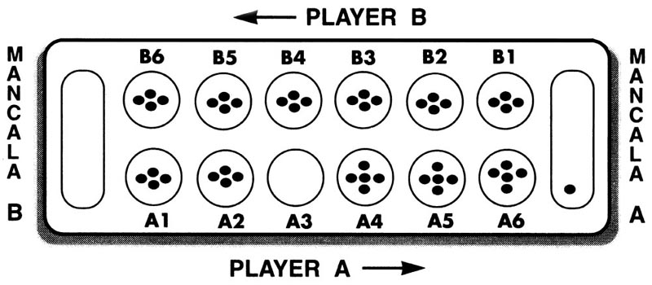

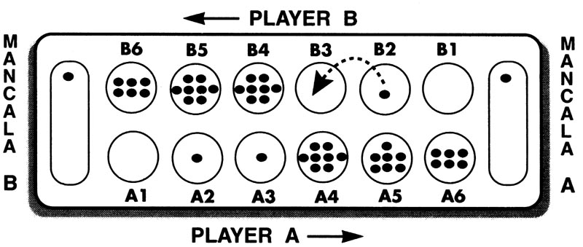
Illustration 1

Illustration 2

