Diagrams
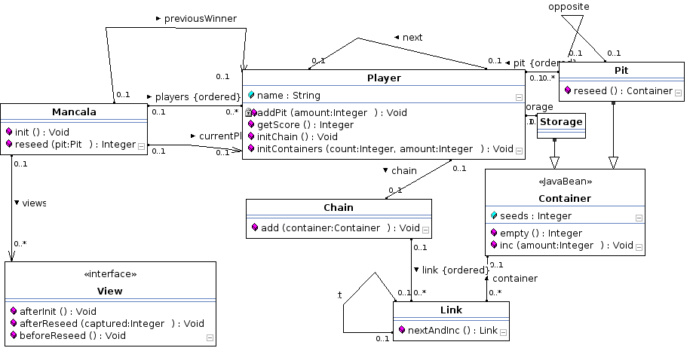
1.Class Diagram:

2. User Story 2
Pre-condition:
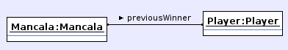
Post-condition:
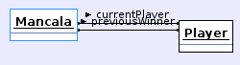

3. User Story 3
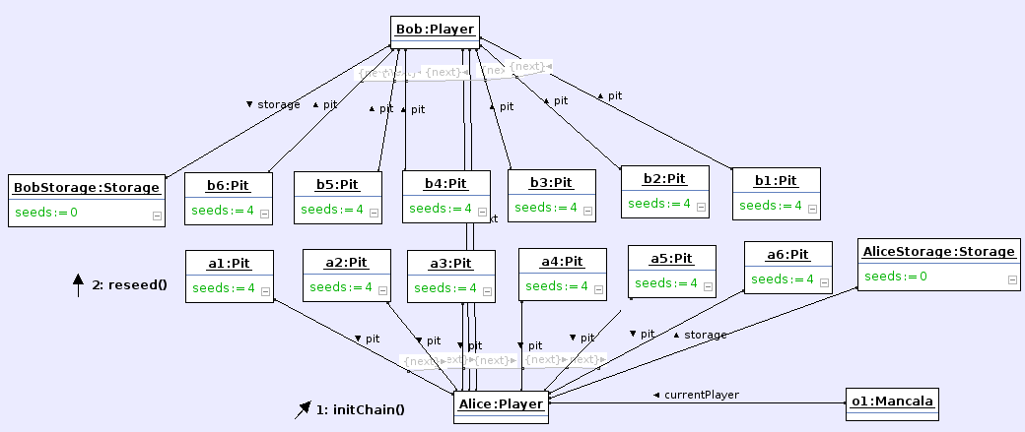
Pre-condition:

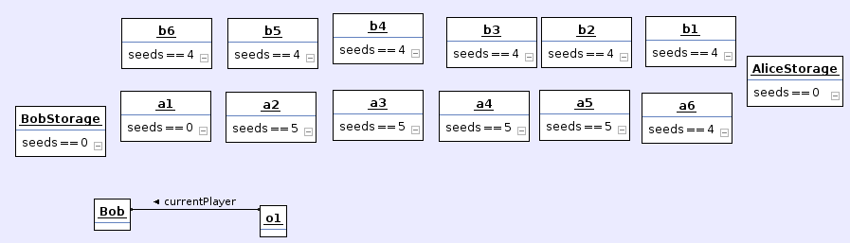
Post-condition:

4. User Story 4:
Pre-condition:
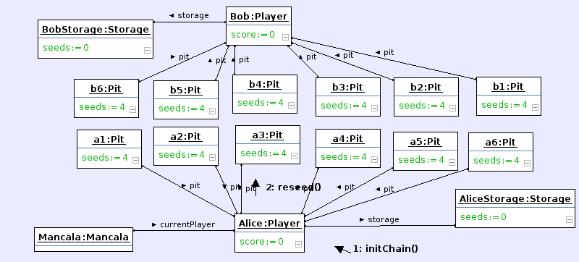

Post-condition:
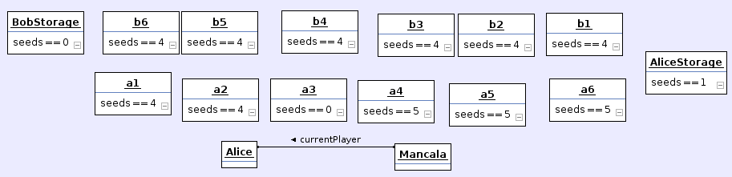

5.User Story 5
Pre-condition:
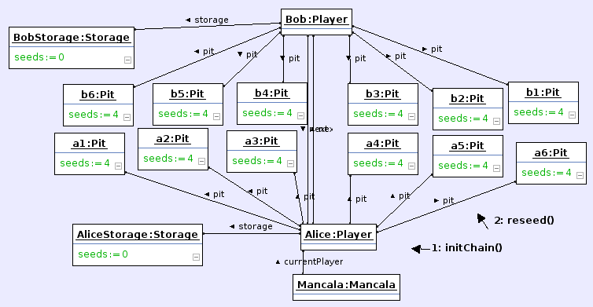
Post-condition:
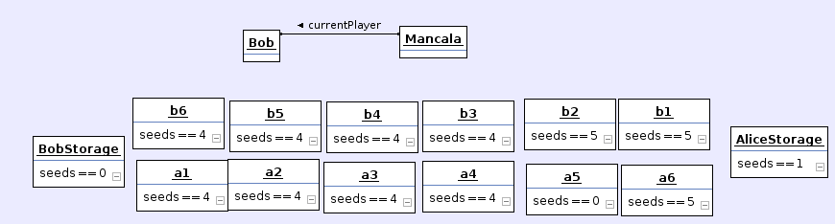

6. User Story 6
Pre-condition:
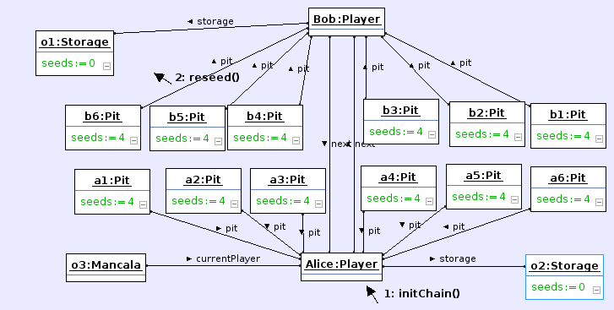
Post-condition:
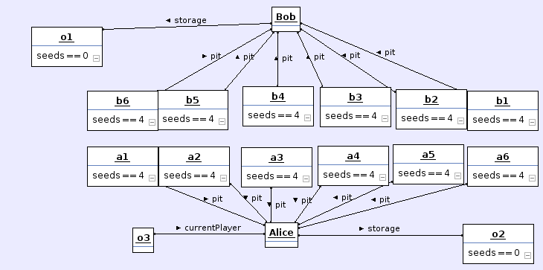

7.User Story 7
Pre-condition:
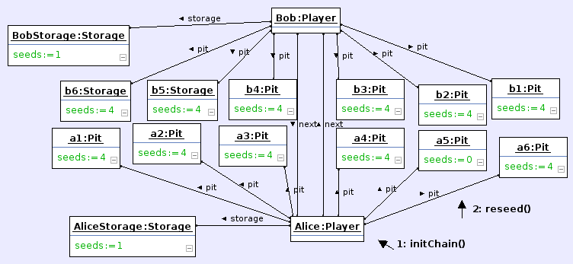
Post-condition:
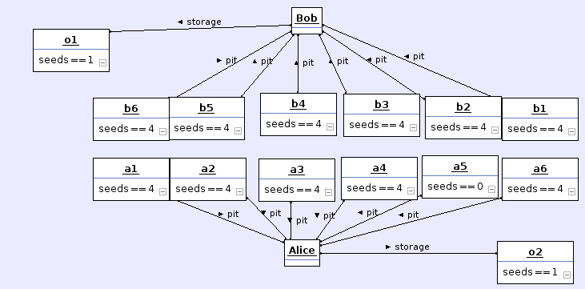

8. User Story 9:
Pre-condition:
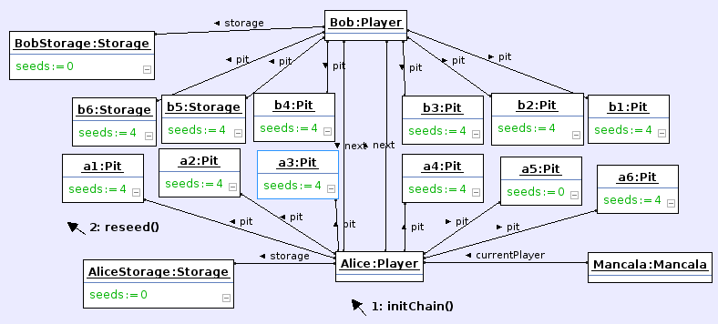
Post-condition:
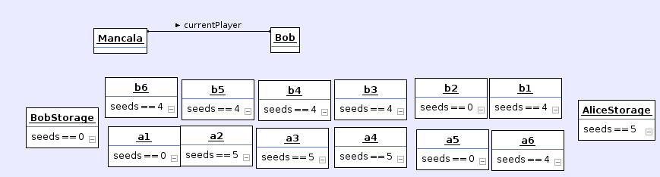
9. User Story 10
Pre-condition:
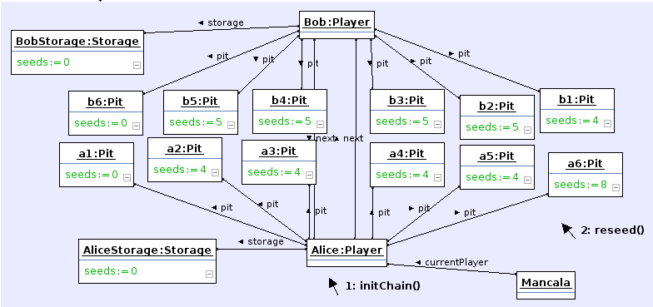
Post-condition:
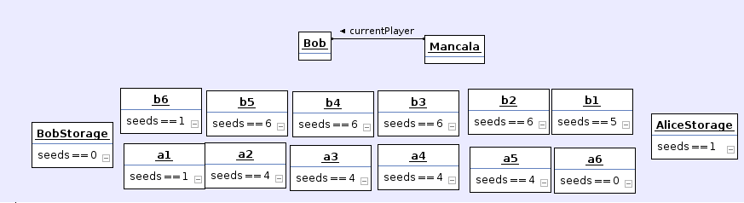
10. User Story 11
Pre-condition:
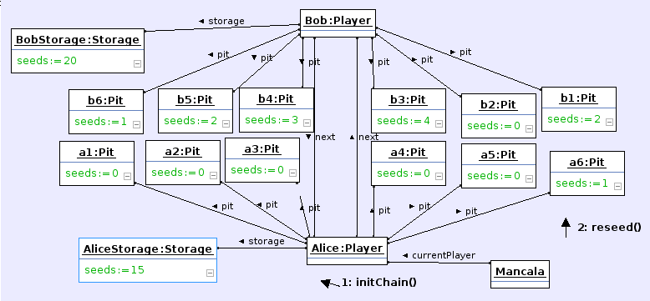
Post-condition:
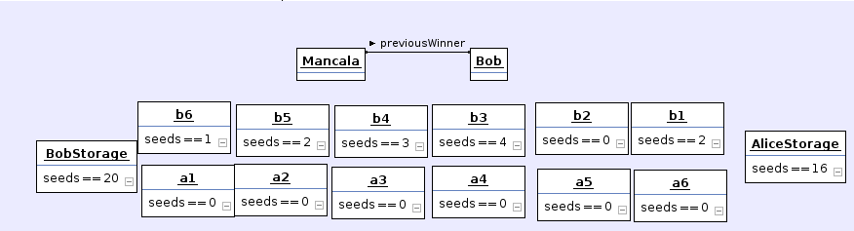

11. User Story 12
Pre-condition:
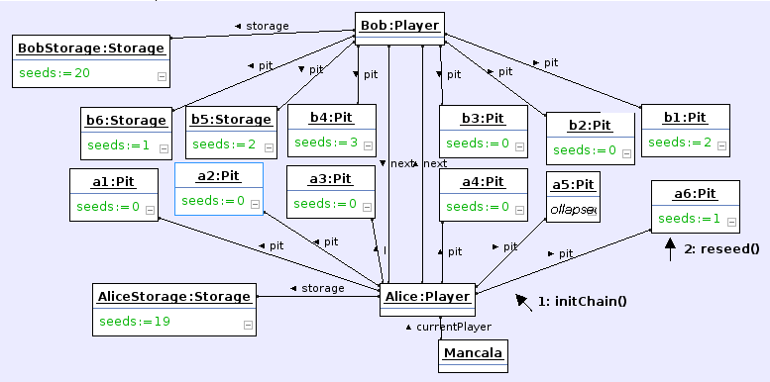
Post-condition:
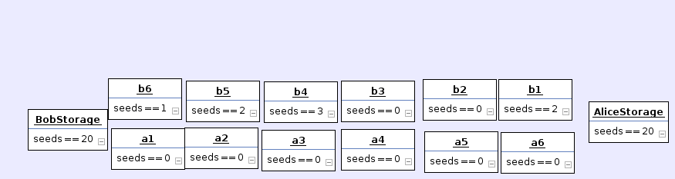

12. Chain
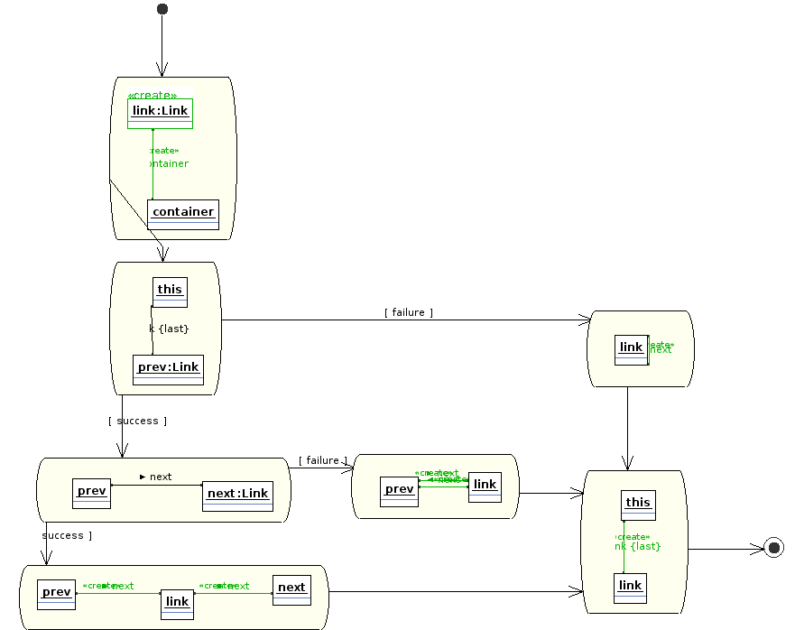

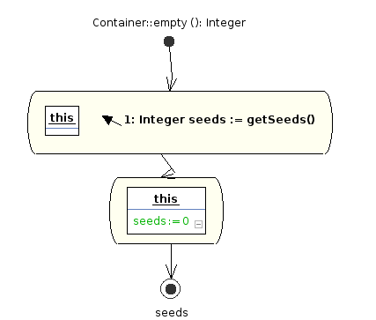
13.Container which is for empty

14. Container which is increased by seeds
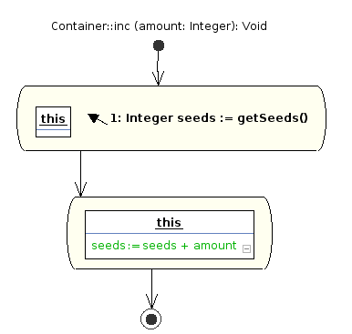
15.Link which is on the next position
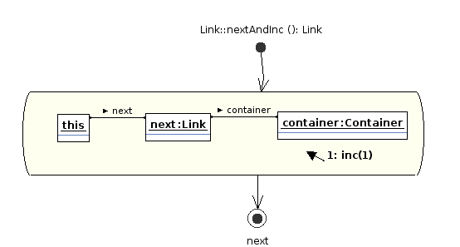

16. Reseeding from Mancala
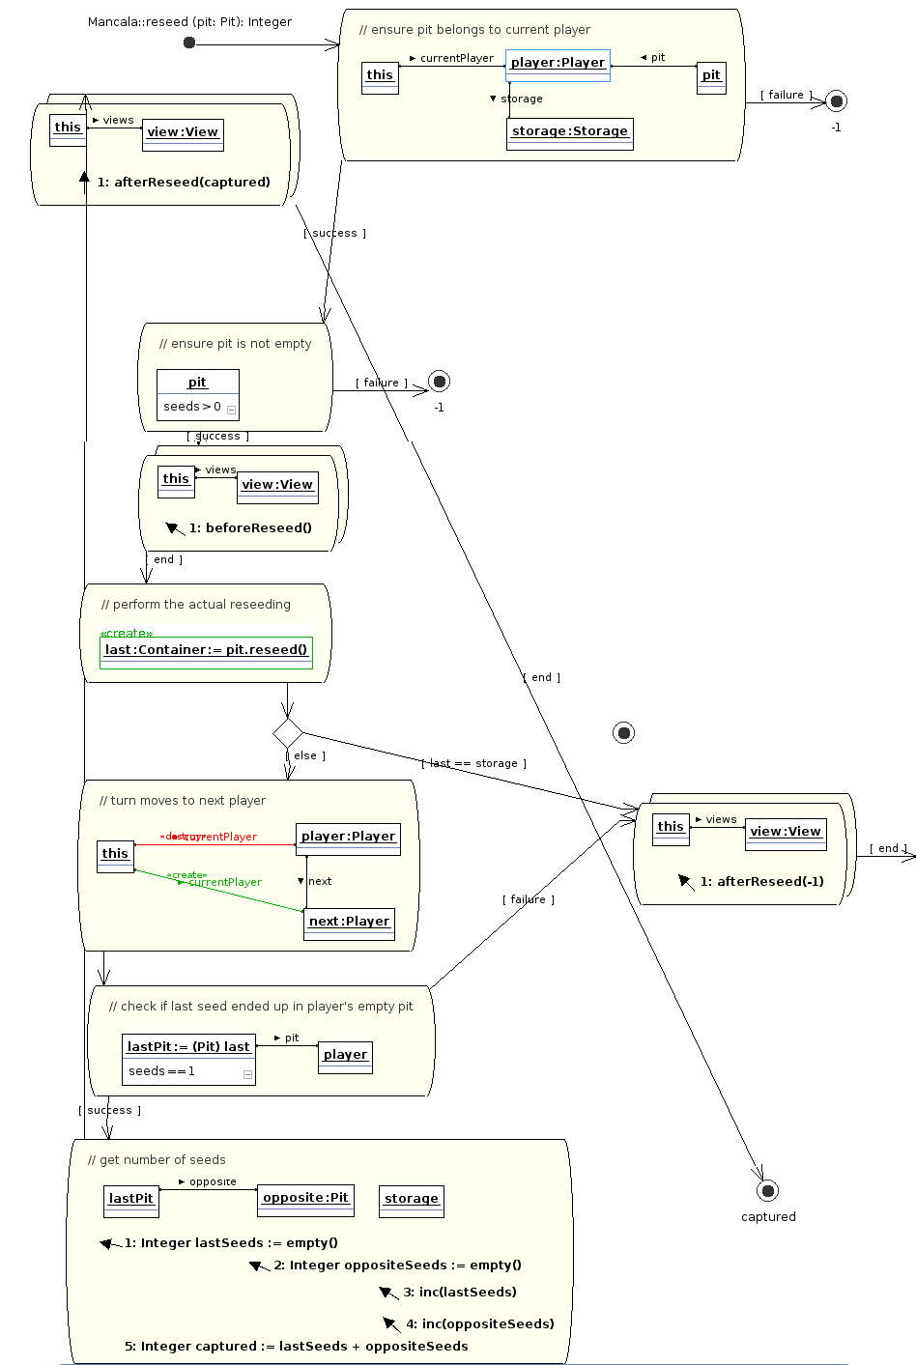

17. Initial for Mancala
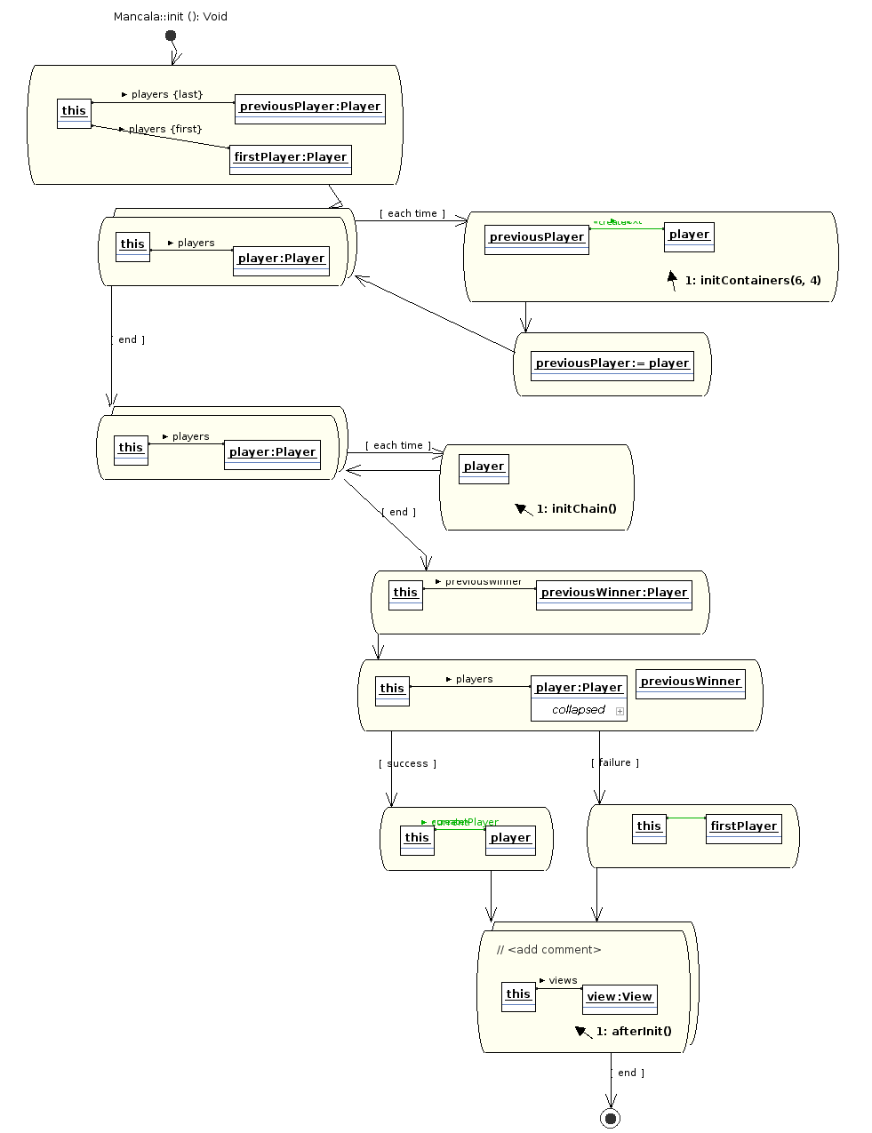

18.Reseeding from Pits
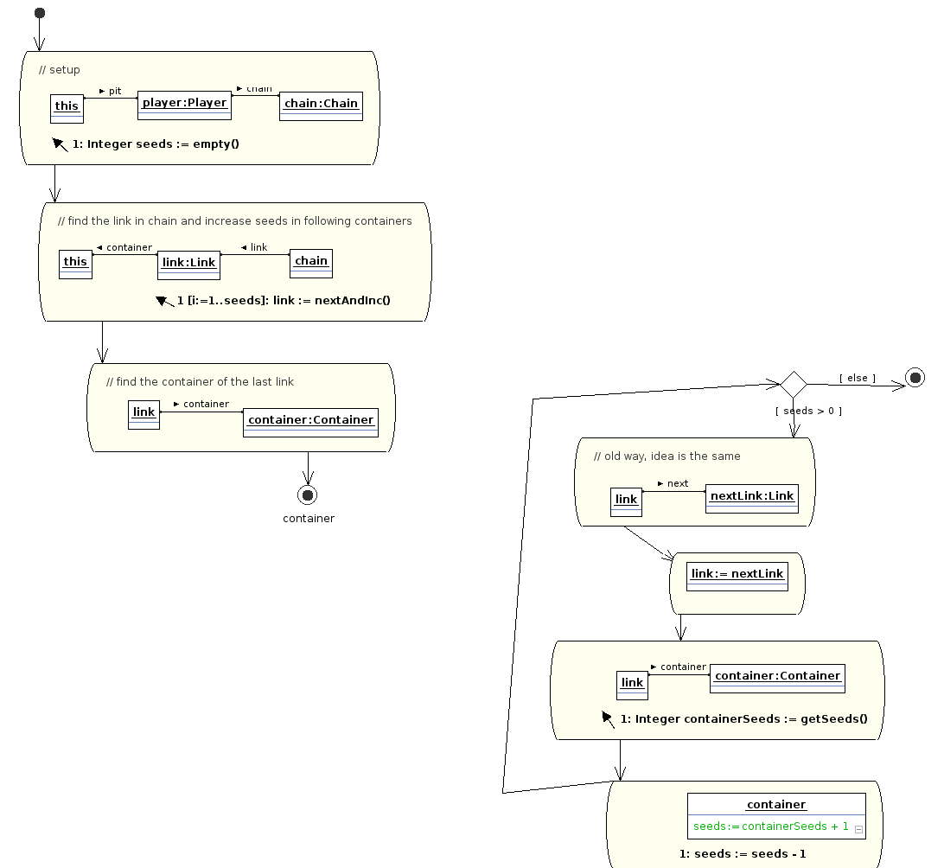
19.Adding pit for the player
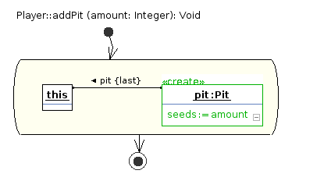

20. Getting score from the player
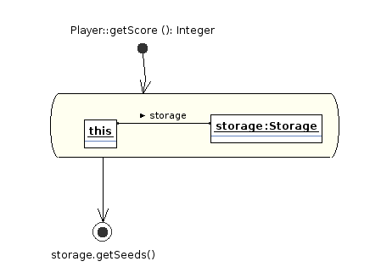
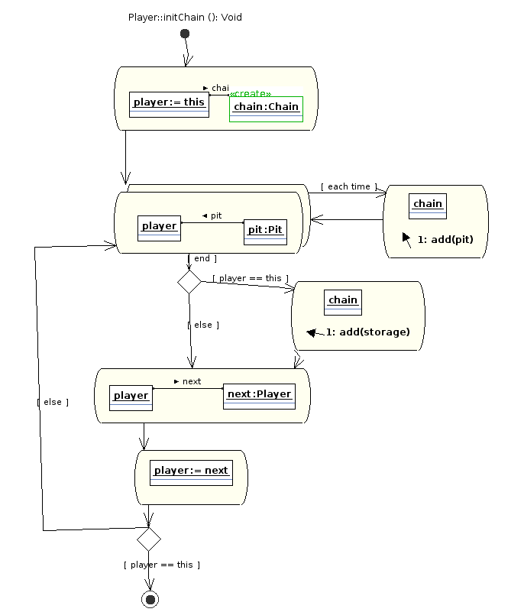
21. Initial chain for the player

22. Initial container for the player
