Task1

Create a simple FreeStyle Job To Install Nginx on your server (tools:jenkins, ubuntu vm)

Sudo visudo

sudo visudo safely edits the sudoers file to manage user sudo privileges.

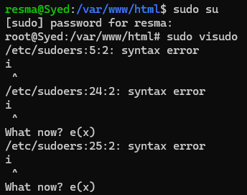

1. Update fetches the latest package lists, and upgrade installs the latest versions of packages.

2. Ensures Nginx is installed if not already present.

3. Starts the Nginx service and enables it to run at boot.

4. Restores the default Nginx page for serving.

5. Restarts Nginx to apply changes.

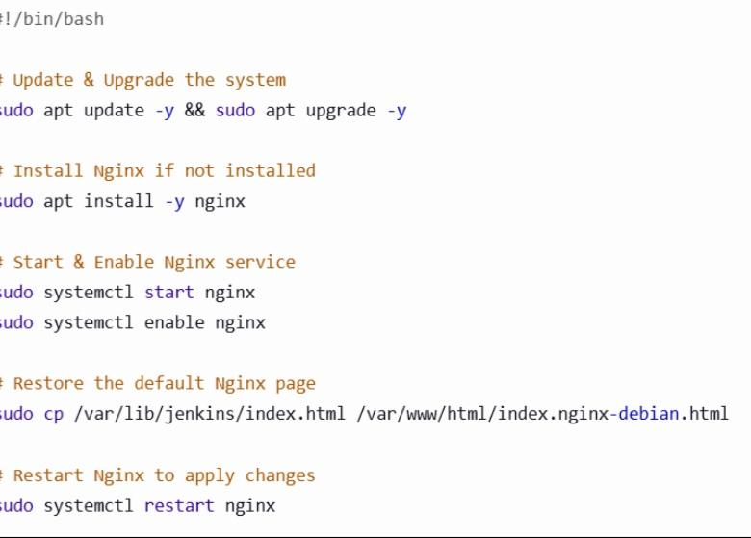

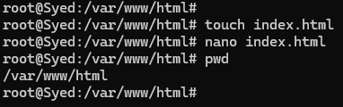

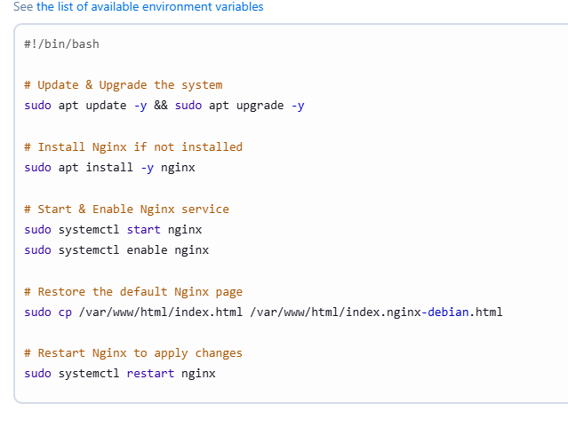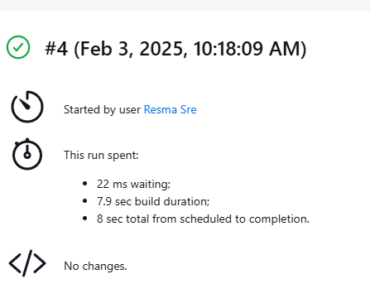

Output of nginx in chrome

