Classifying Flowers by Artificial Neural Networks using Back Propagation and
Genetic Algorithm

Stephen Marcel, 2327288
Fall 2019, CSCI 6522, Adv ML-II
Programming Assignment 2

Part A Results:
 | ANN01 |  |  | ANN03 |  |  | ANN07
 | Training MSE | Testing MSE | Accuracy | Training MSE | Testing MSE | Accuracy | Training MSE | Testing MSE | Accuracy
Fold 1 | 0.050881 | 0.17220 | 1.000 | 0.21706 | 0.67146 | 0.32593 | 0.22219 | 0.66656 | 0.34074
Fold 2 | 0.12726 | 0.30183 | 0.7333 | 0.17765 | 0.79472 | 0.31111 | 0.22175 | 0.66524 | 0.36296
Fold 3 | 0.058775 | 0.15037 | 1.000 | 0.21183 | 0.65760 | 0.32593 | 0.22219 | 0.66656 | 0.34074
Fold 4 | 0.11396 | 0.38030 | 0.66667 | 0.21175 | 0.69523 | 0.31852 | 0.22211 | 0.66634 | 0.40741
Fold 5 | 0.051165 | 0.27600 | 0.85761 | 0.17465 | 0.83850 | 0.30370 | 0.22164 | 0.66491 | 0.36296
Fold 6 | 0.059208 | 0.22648 | 0.933333 | 0.21904 | 0.67680 | 0.32593 | 0.22239 | 0.66656 | 0.34067
Fold 7 | 0.11601 | 0.38086 | 0.66667 | 0.18179 | 0.71343 | 0.31111 | 0.22219 | 0.66656 | 0.34074
Fold 8 | 0.11719 | 0.26312 | 0.86042 | 0.19552 | 0.76429 | 0.31111 | 0.22208 | 0.66554 | 0.33992
Fold 9 | 0.045523 | 0.11669 | 1.0000 | 0.21829 | 0.67429 | 0.32593 | 0.22219 | 0.66656 | 0.34074
Fold 10 | 0.058757 | 0.14853 | 1.0000 | 0.18181 | 0.80027 | 0.30370 | 0.22239 | 0.66666 | 0.40730

ANN1 10 Fold Cross Validation: Horizontal lines are the test MSE graphs
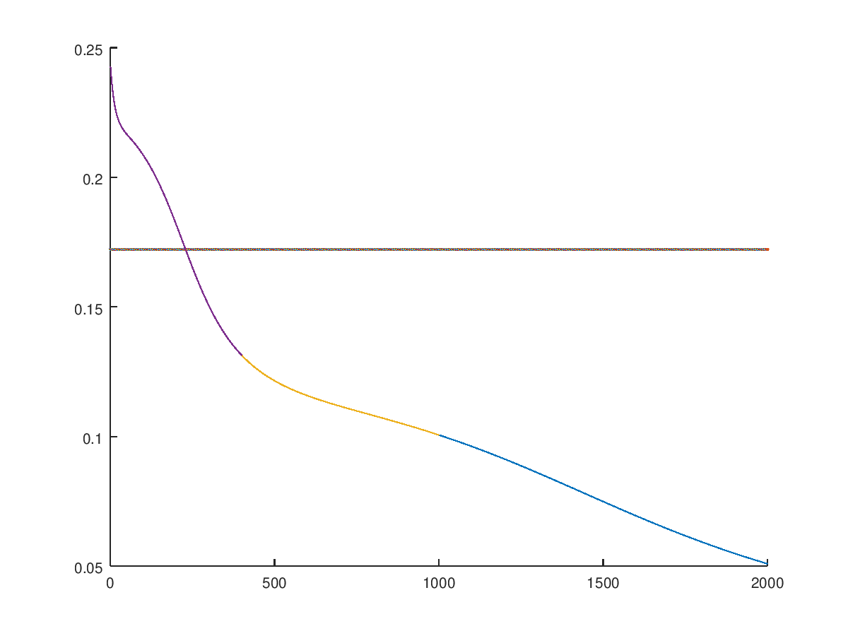
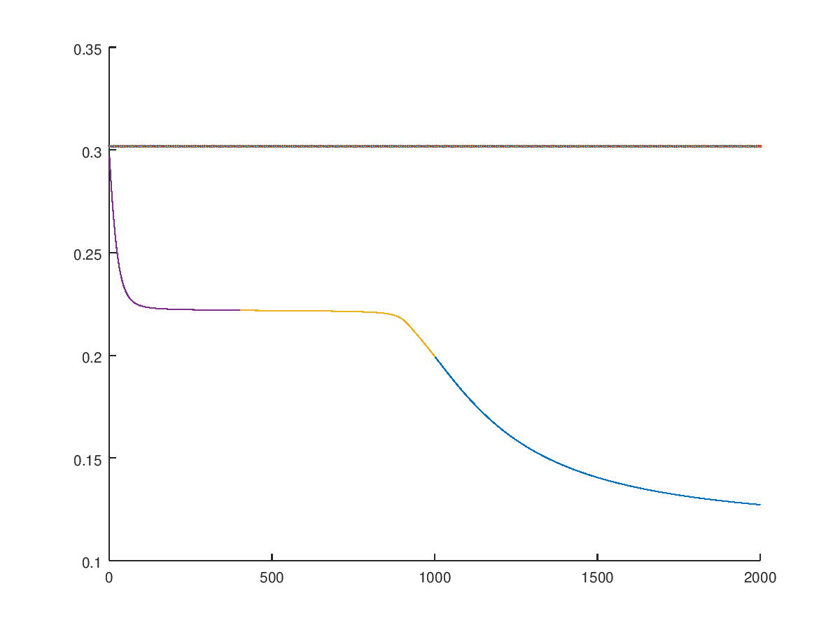
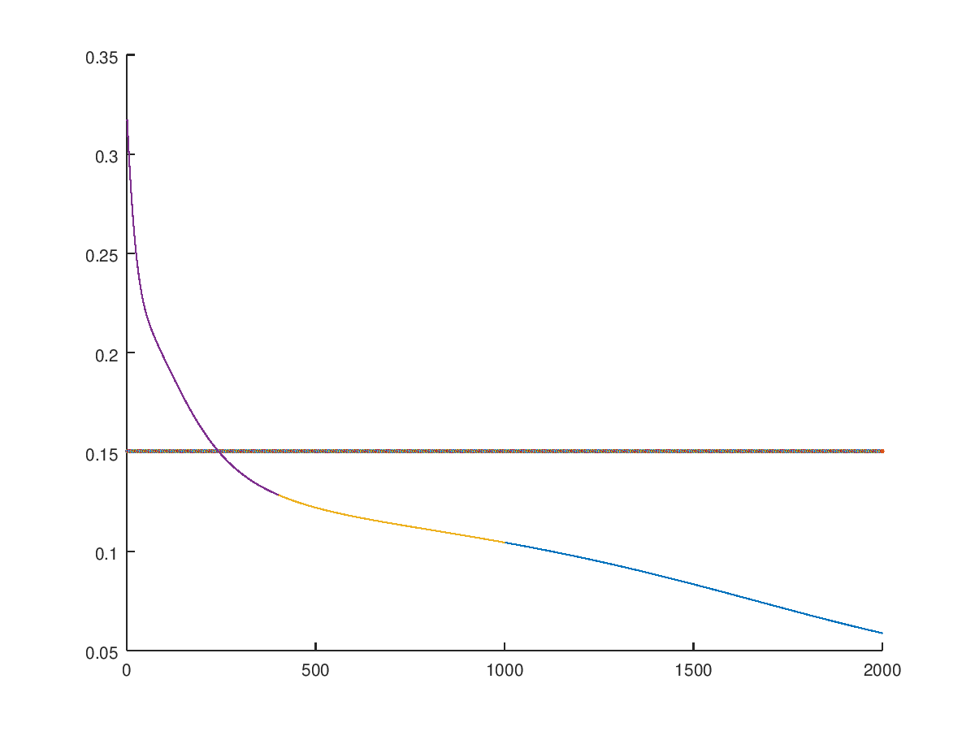
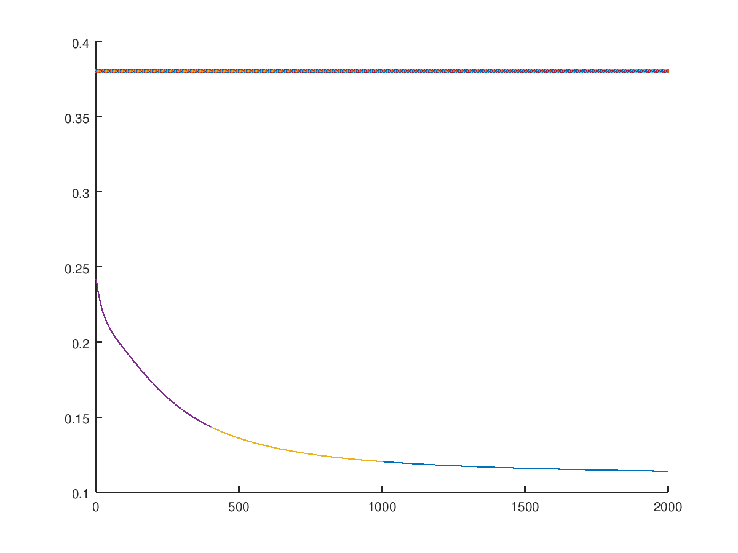
Fold 1 to 4:
Folds 5 to 8:
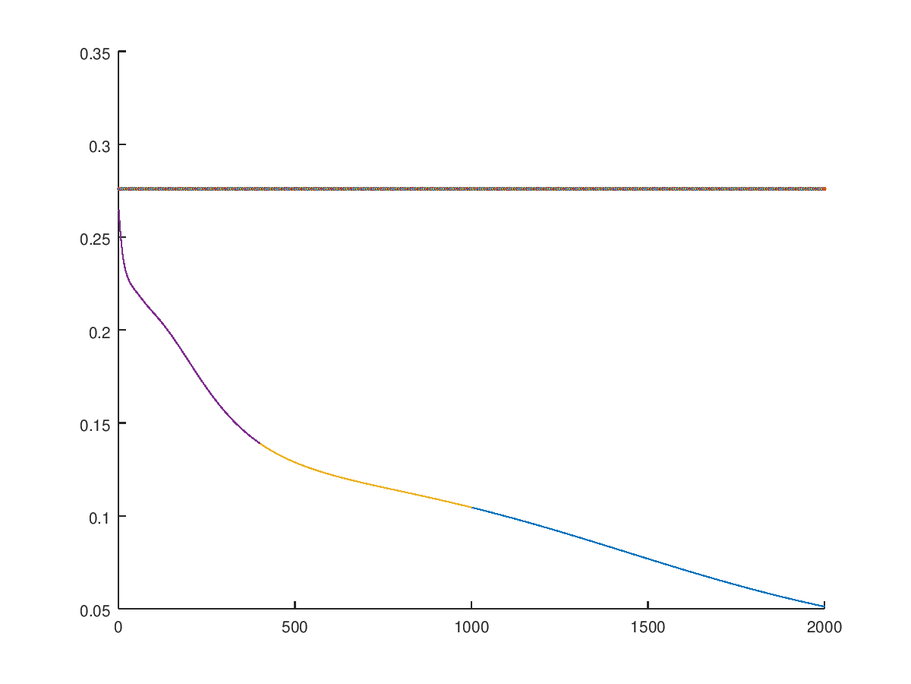
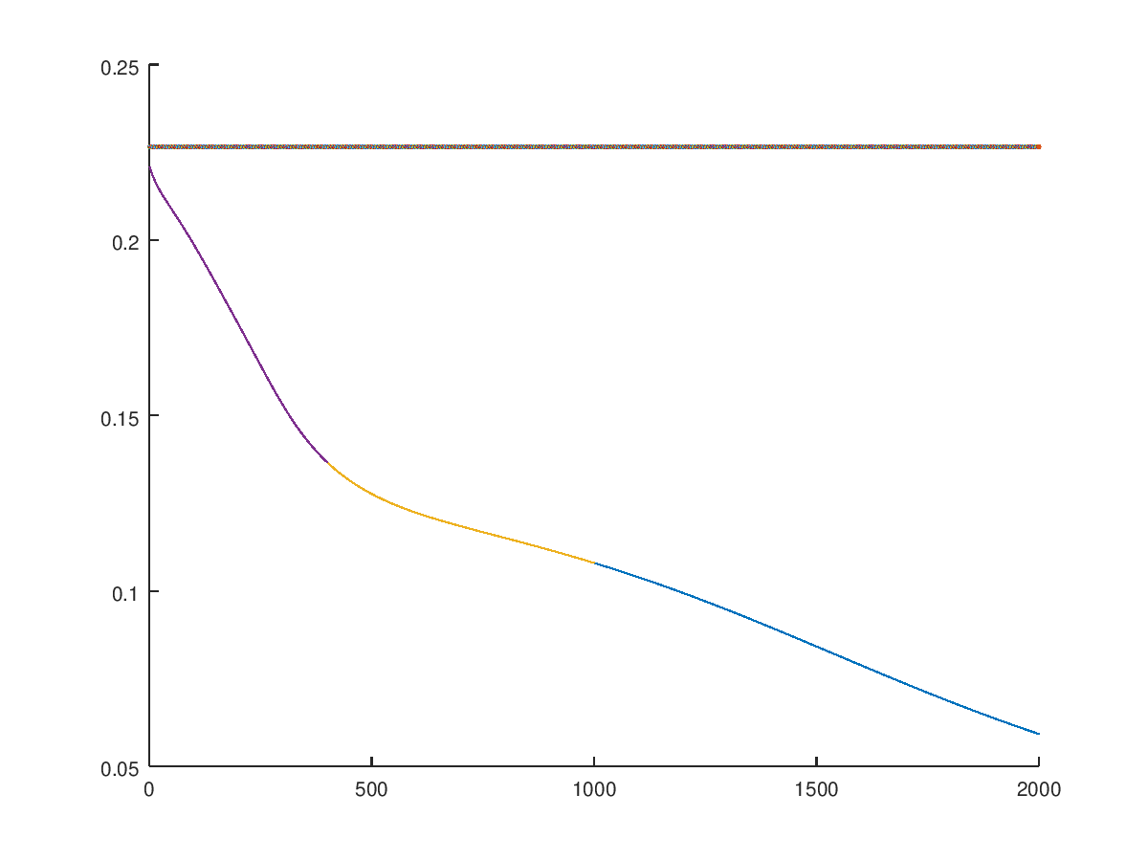
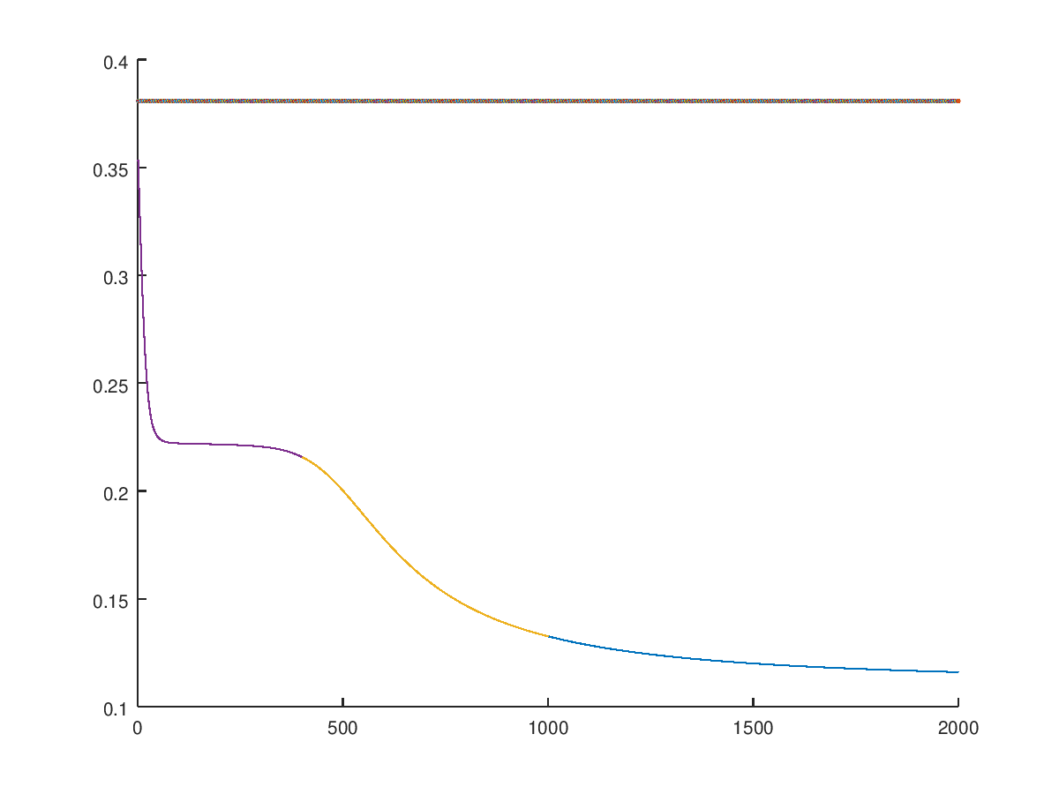
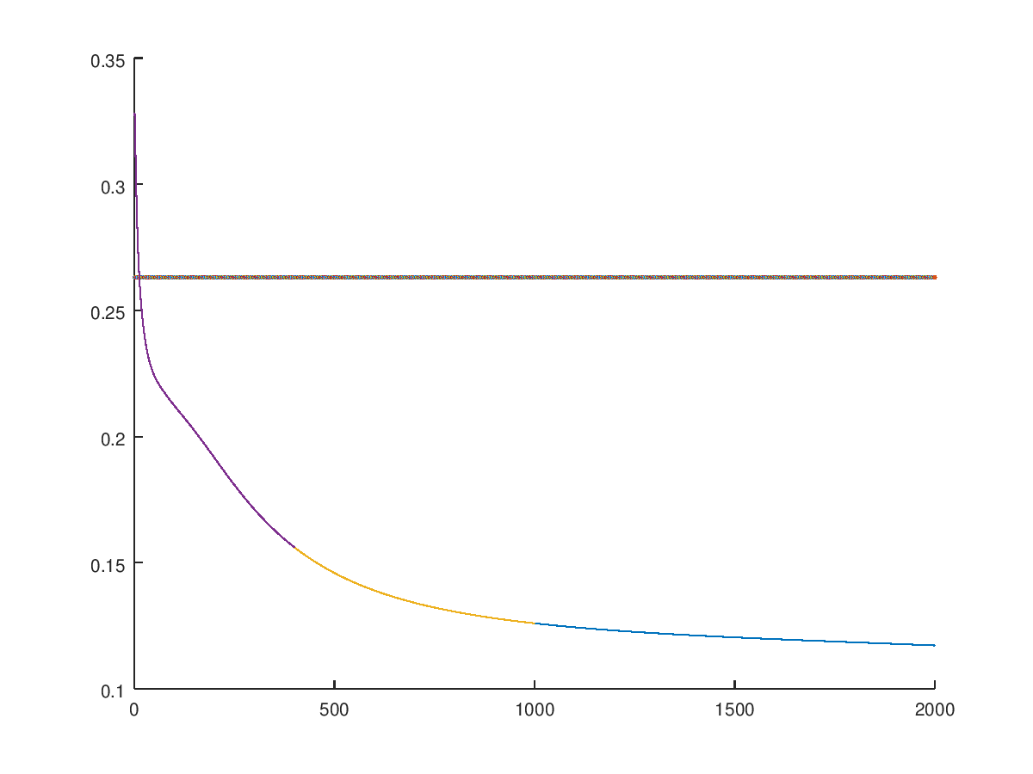
Fold 9 & 10:

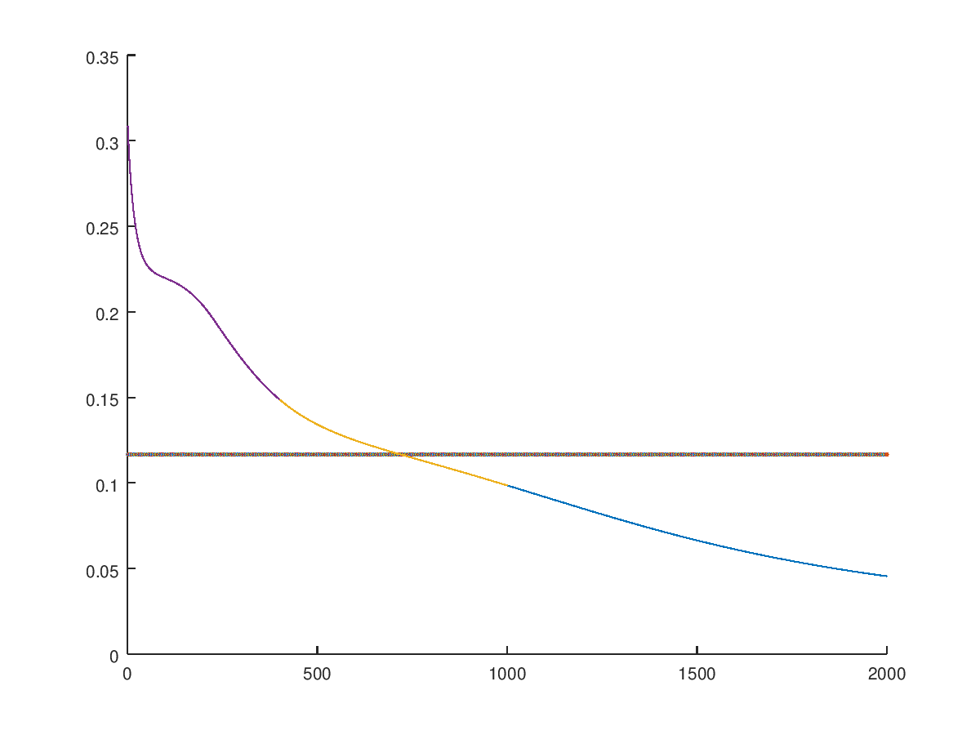
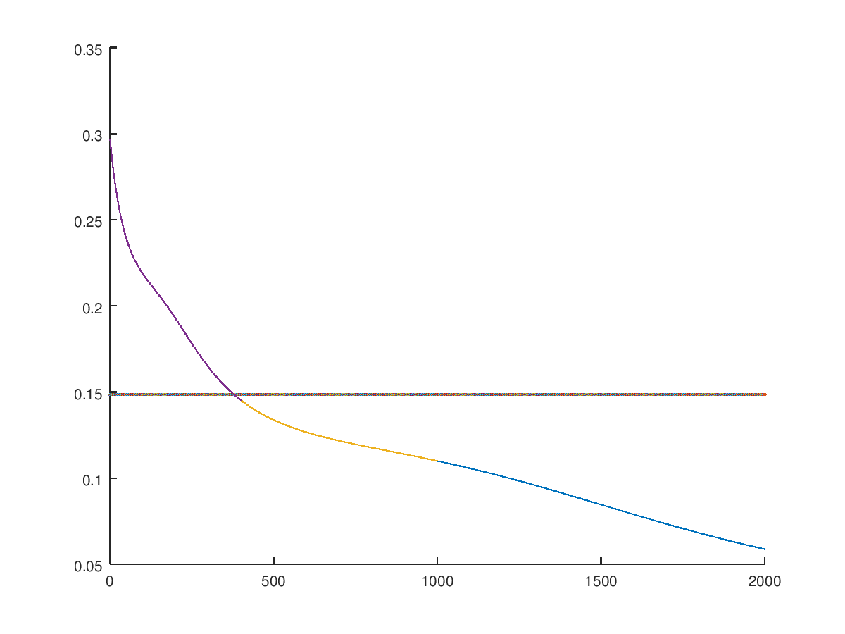

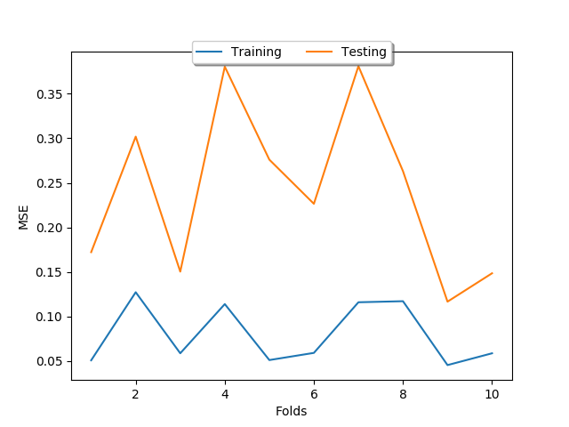
ANN3 10 Fold Cross Validation: Horizontal lines are the test MSE graphs
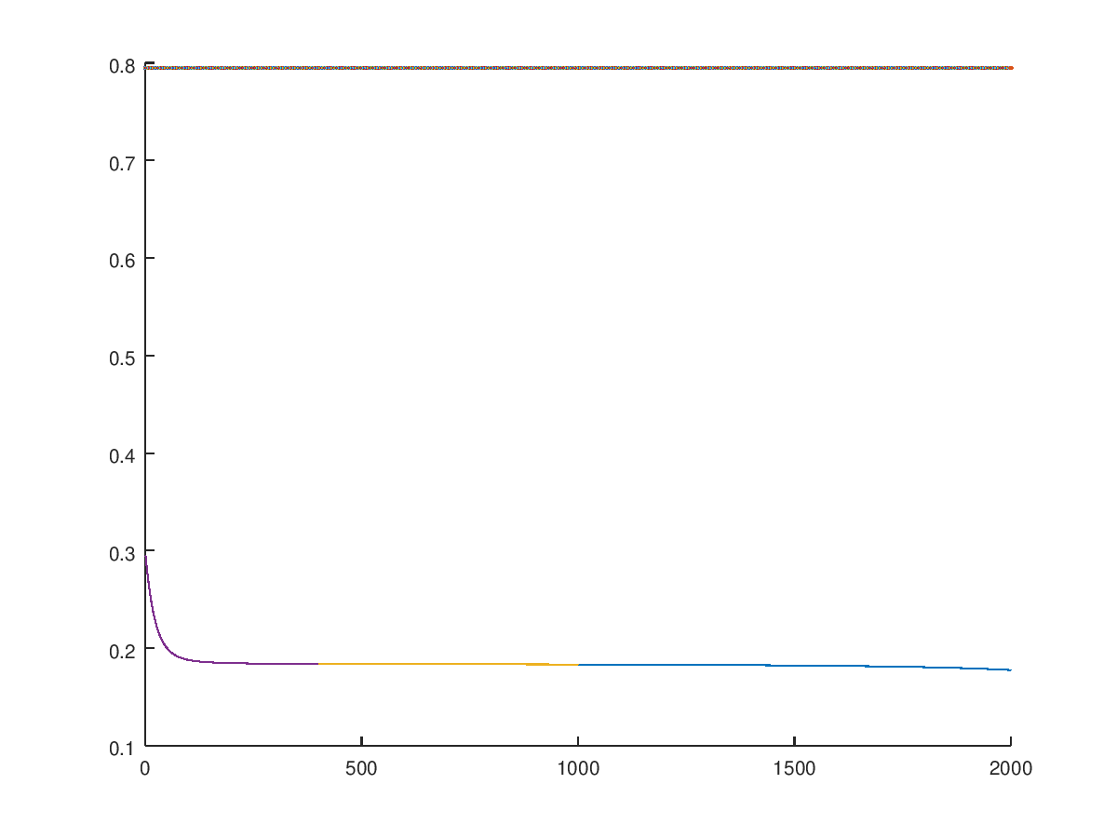
Fold 1to 4
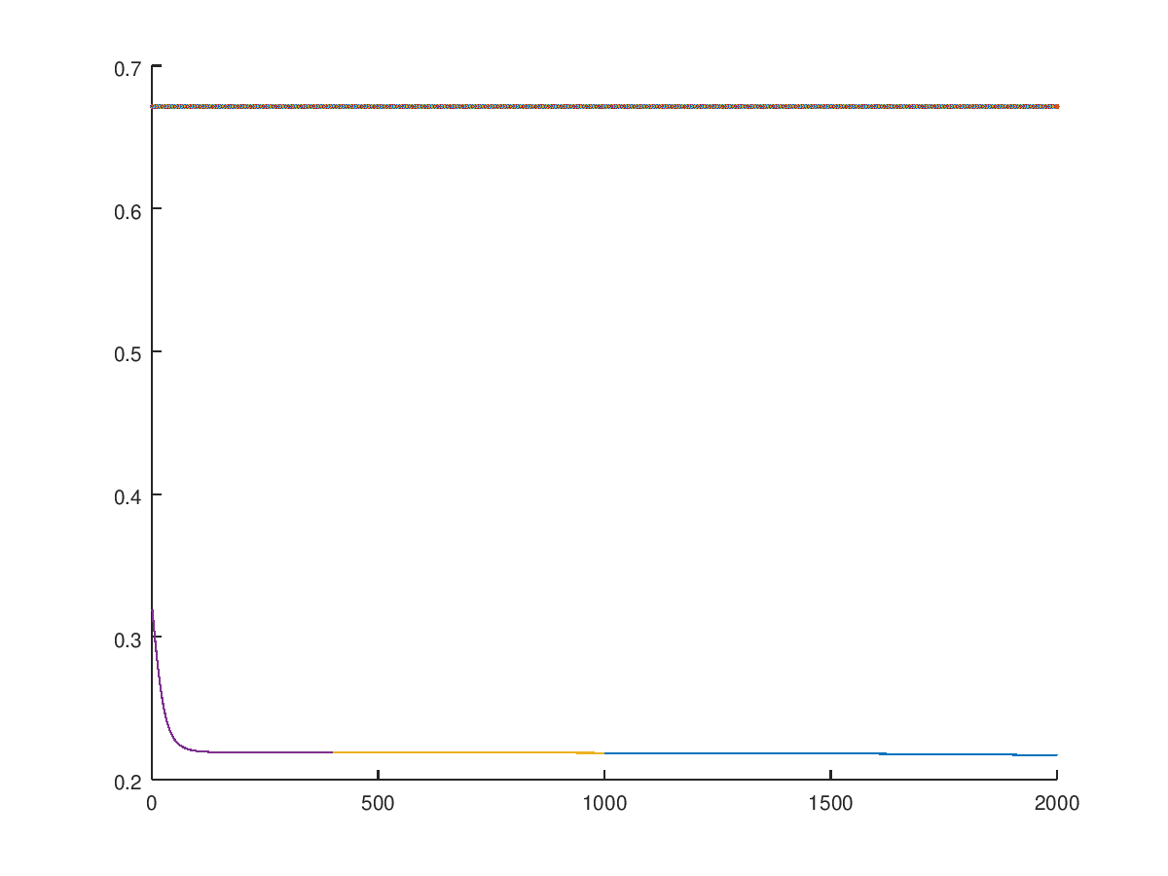
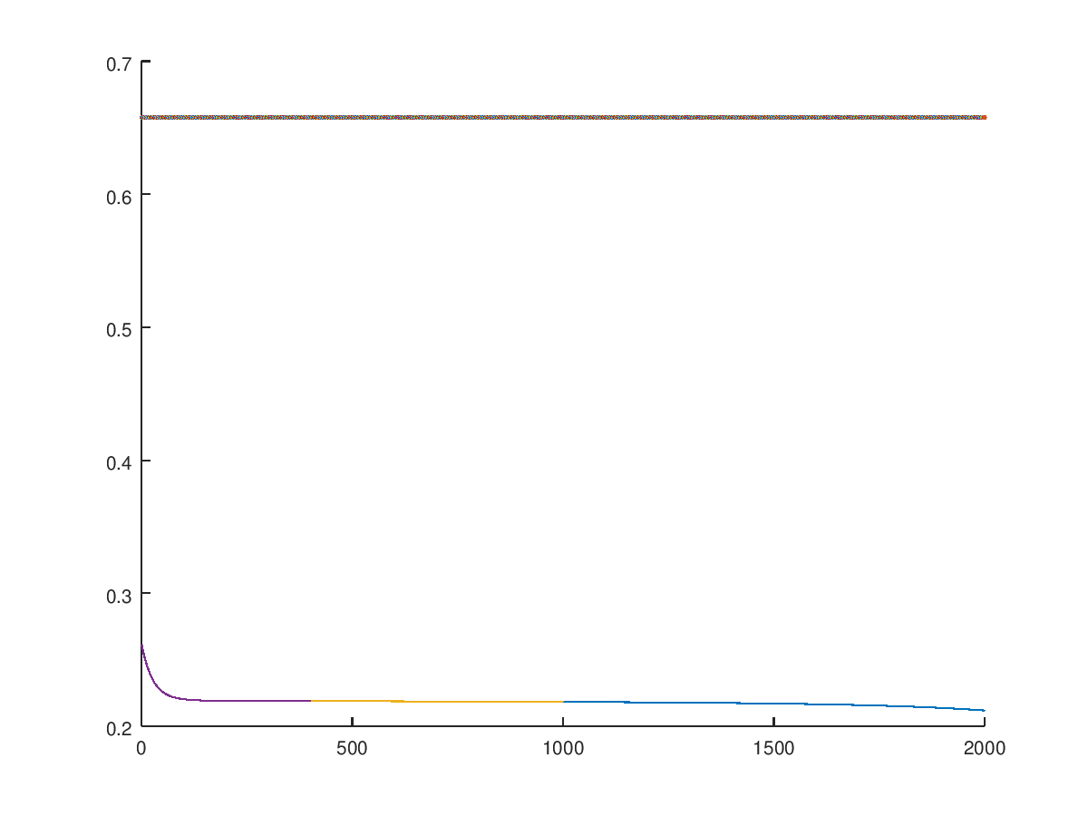
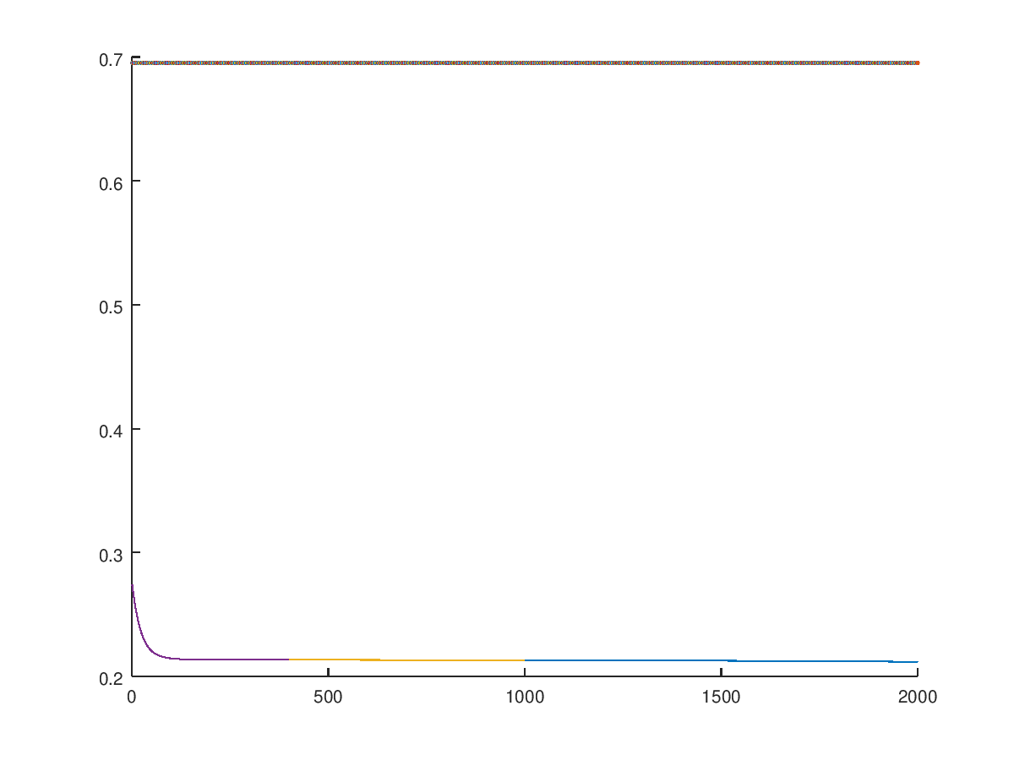
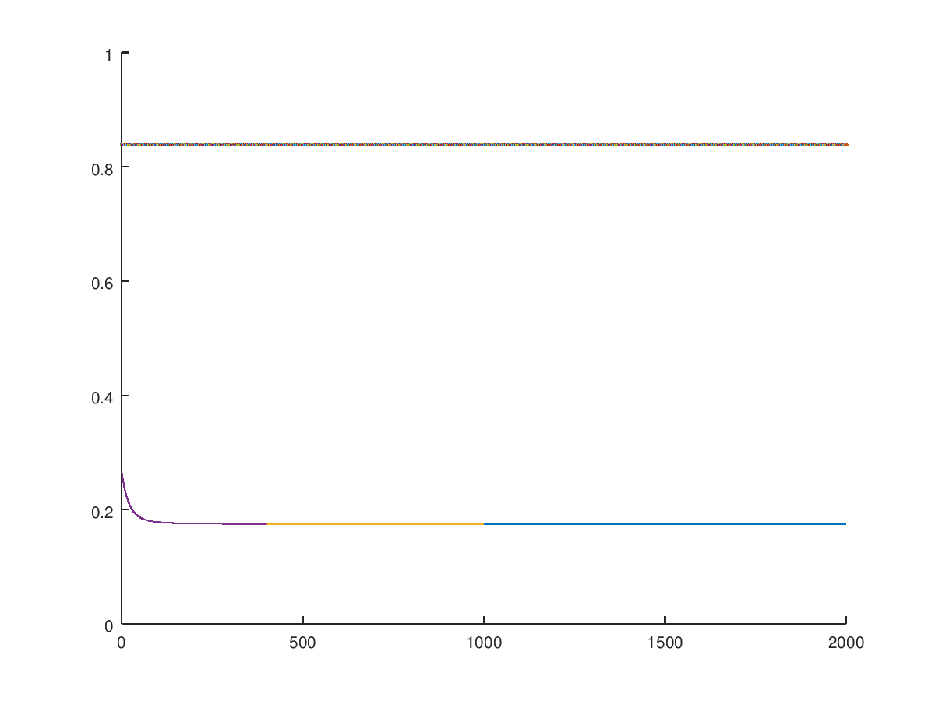
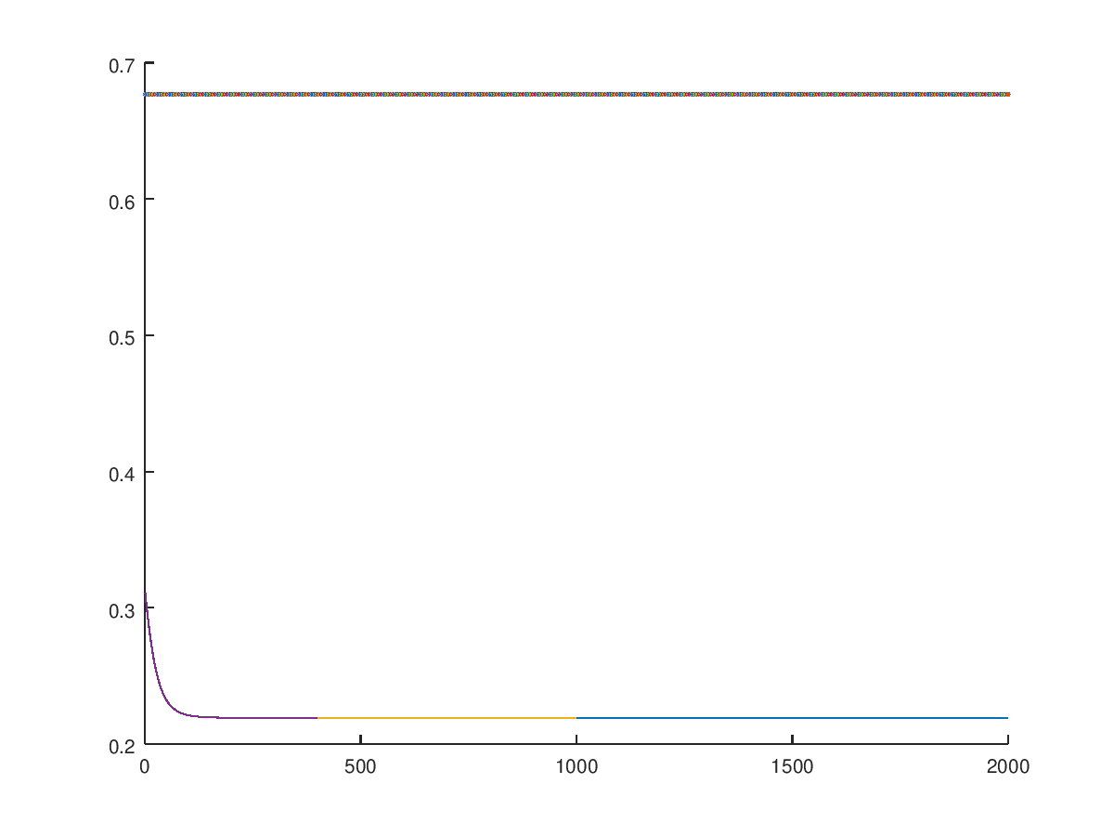
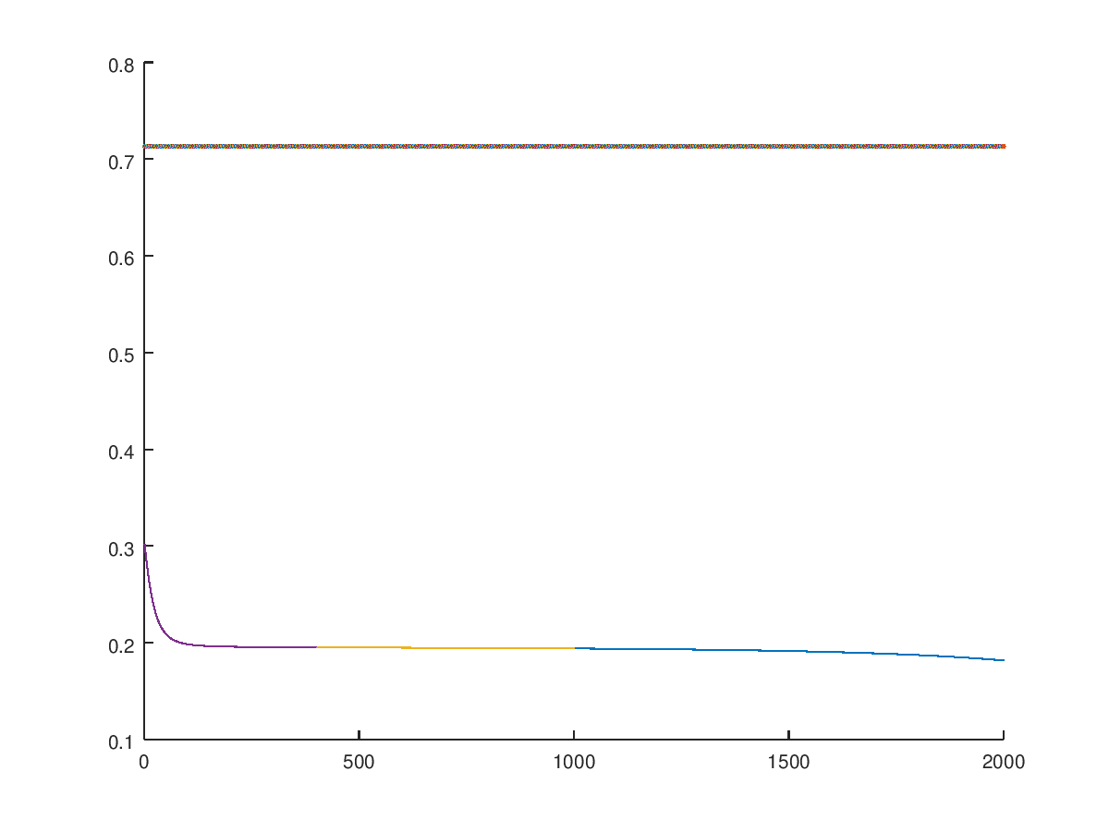
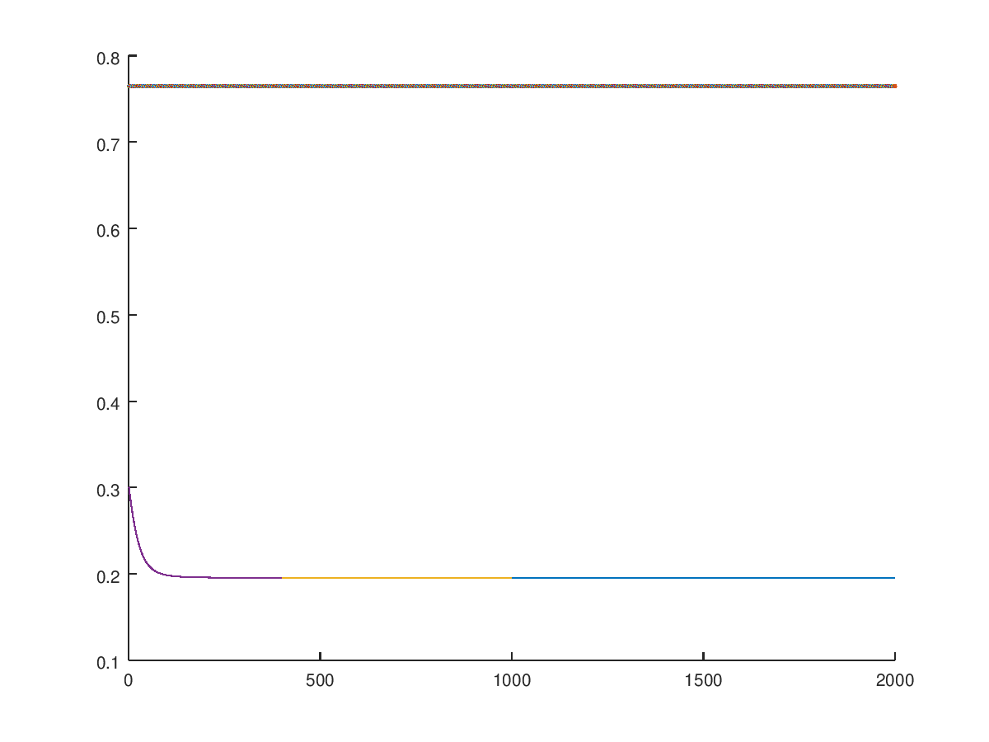
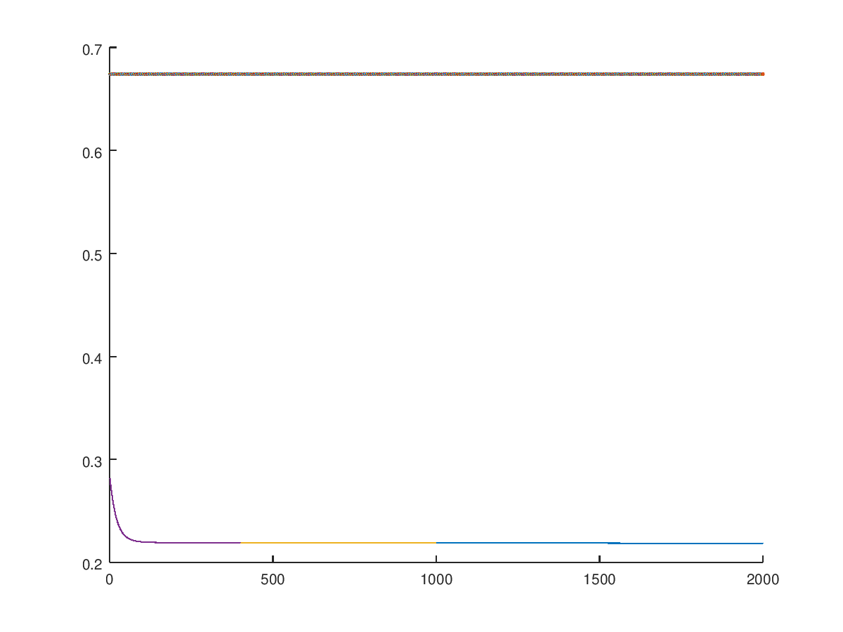
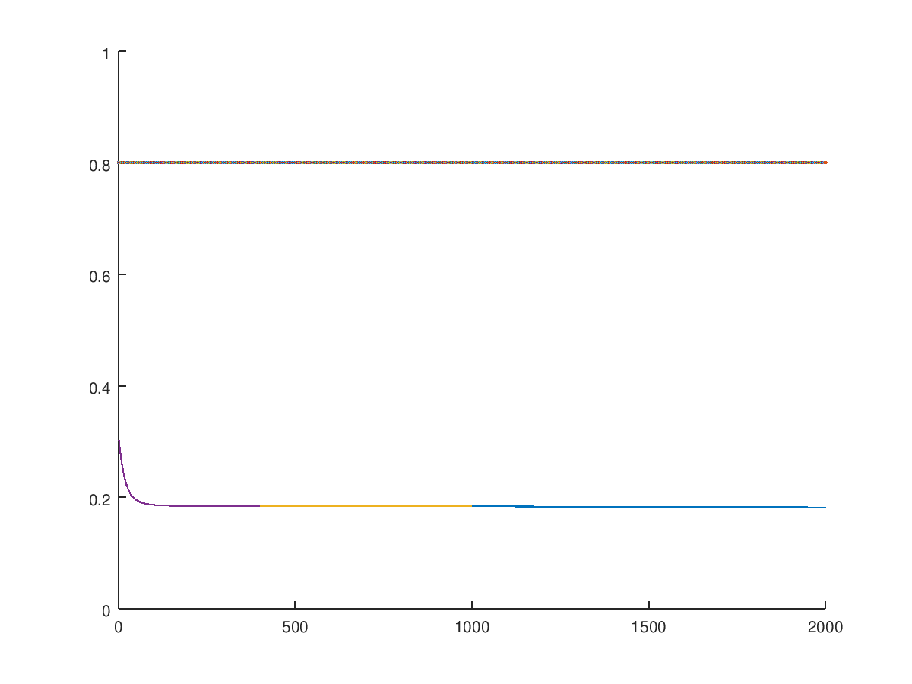
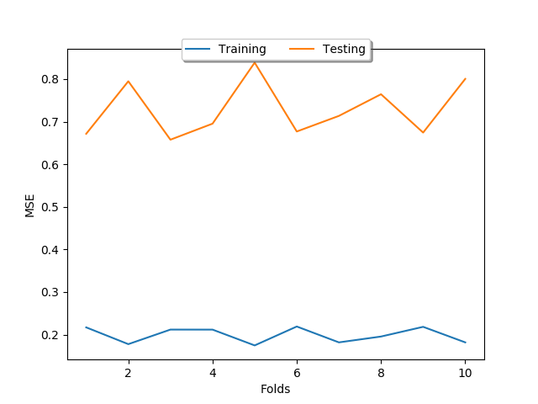
ANN7
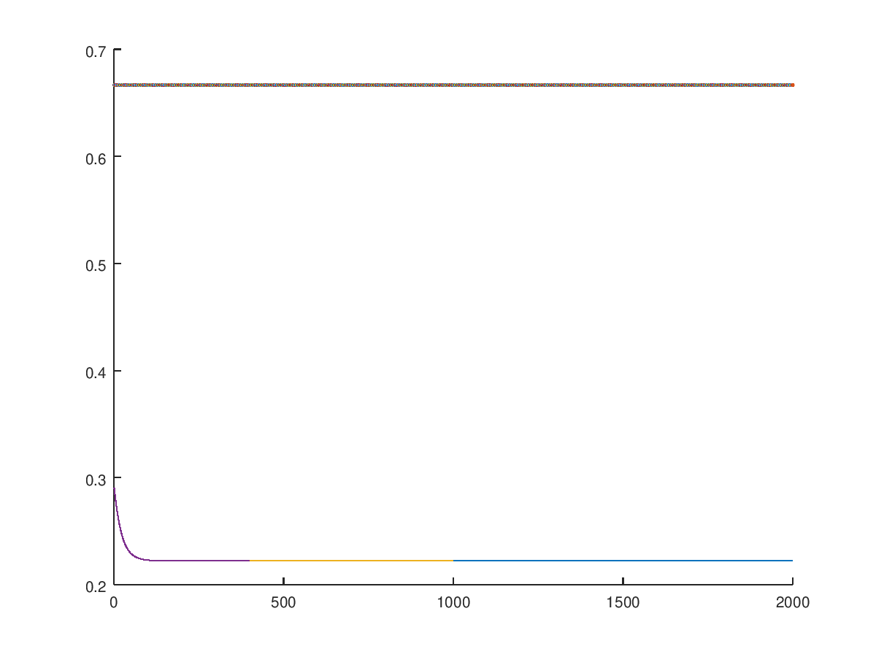
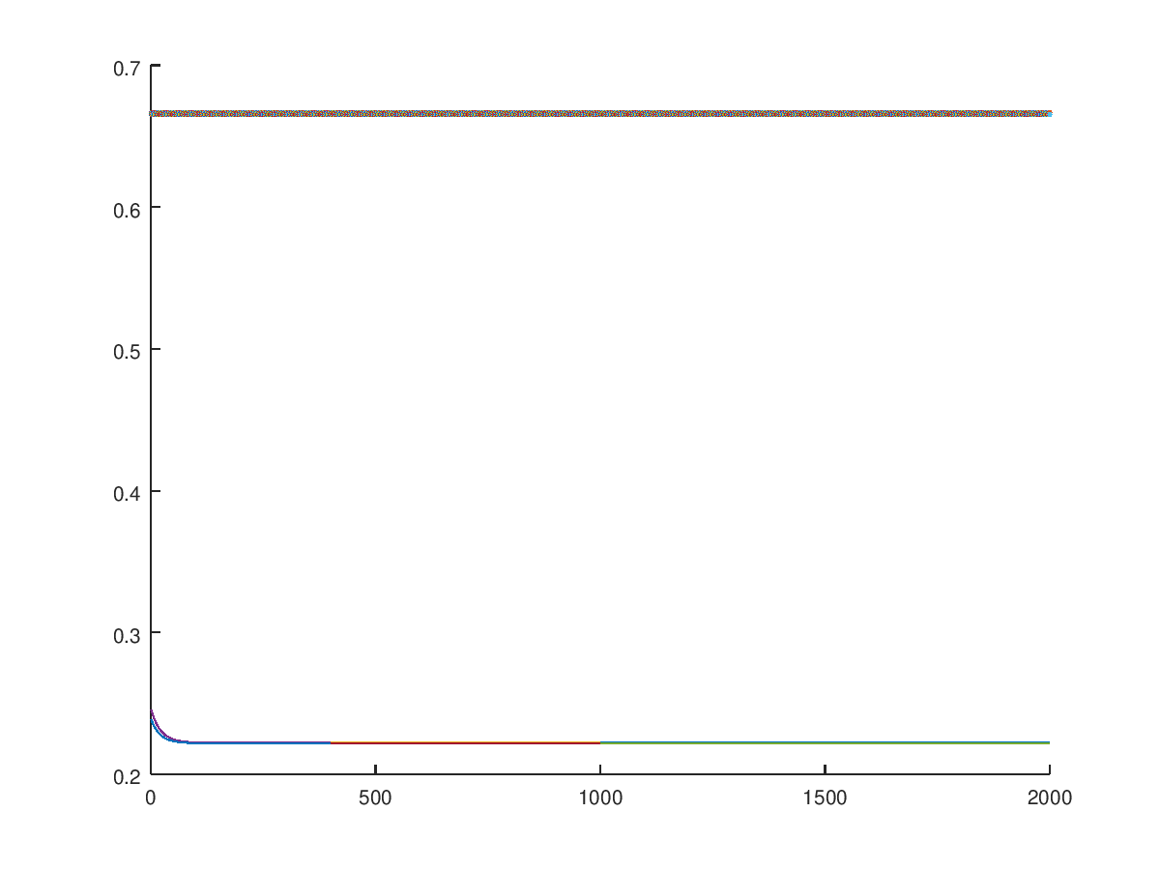
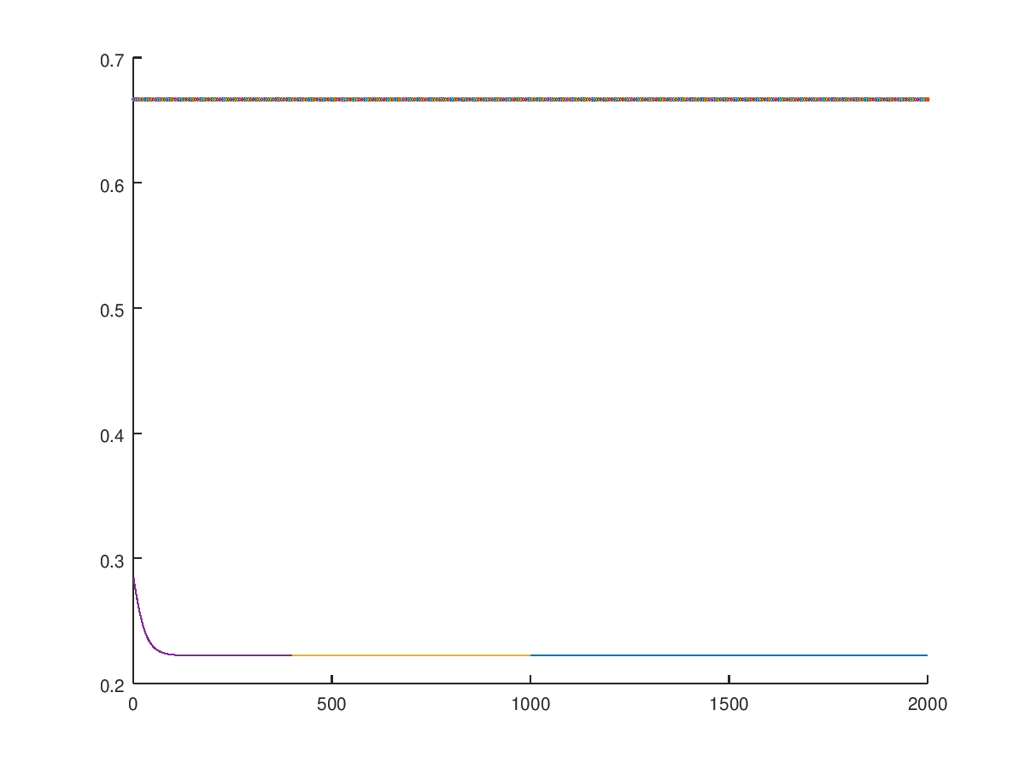
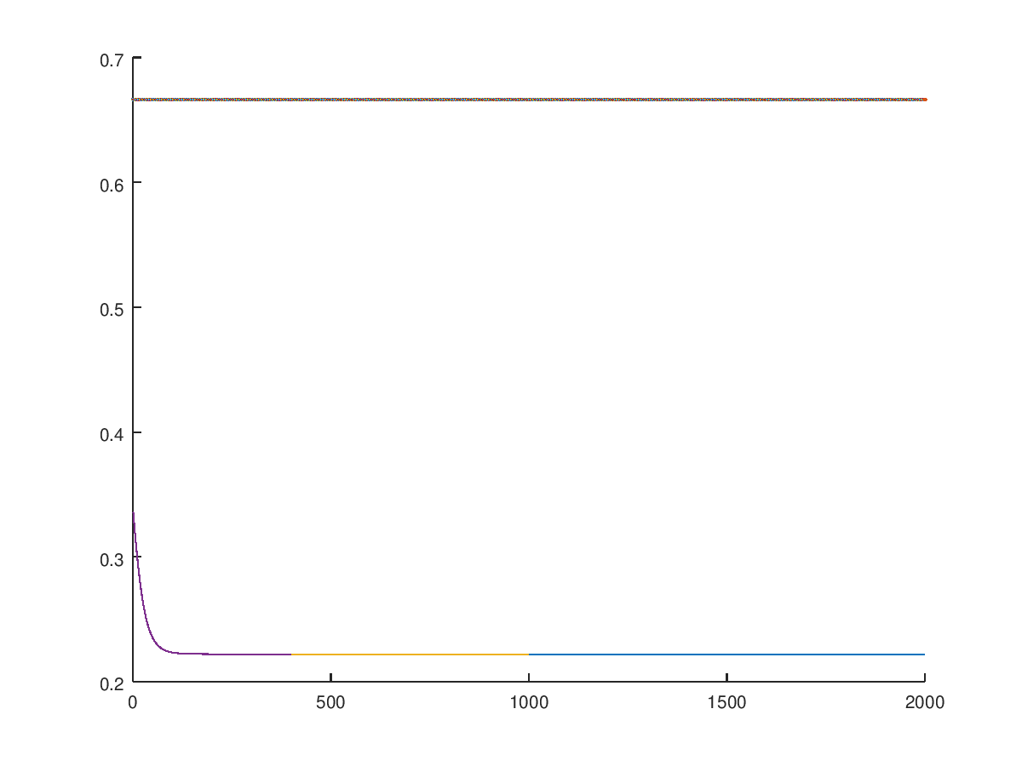
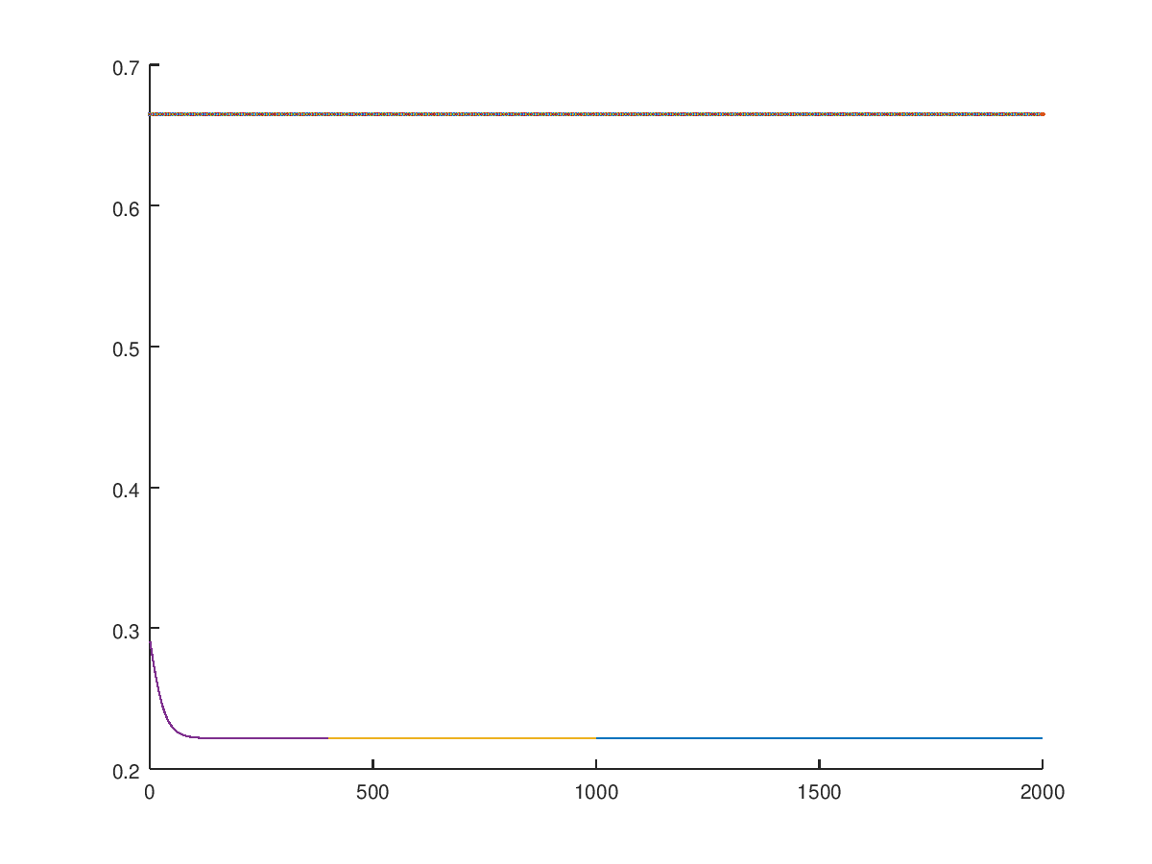
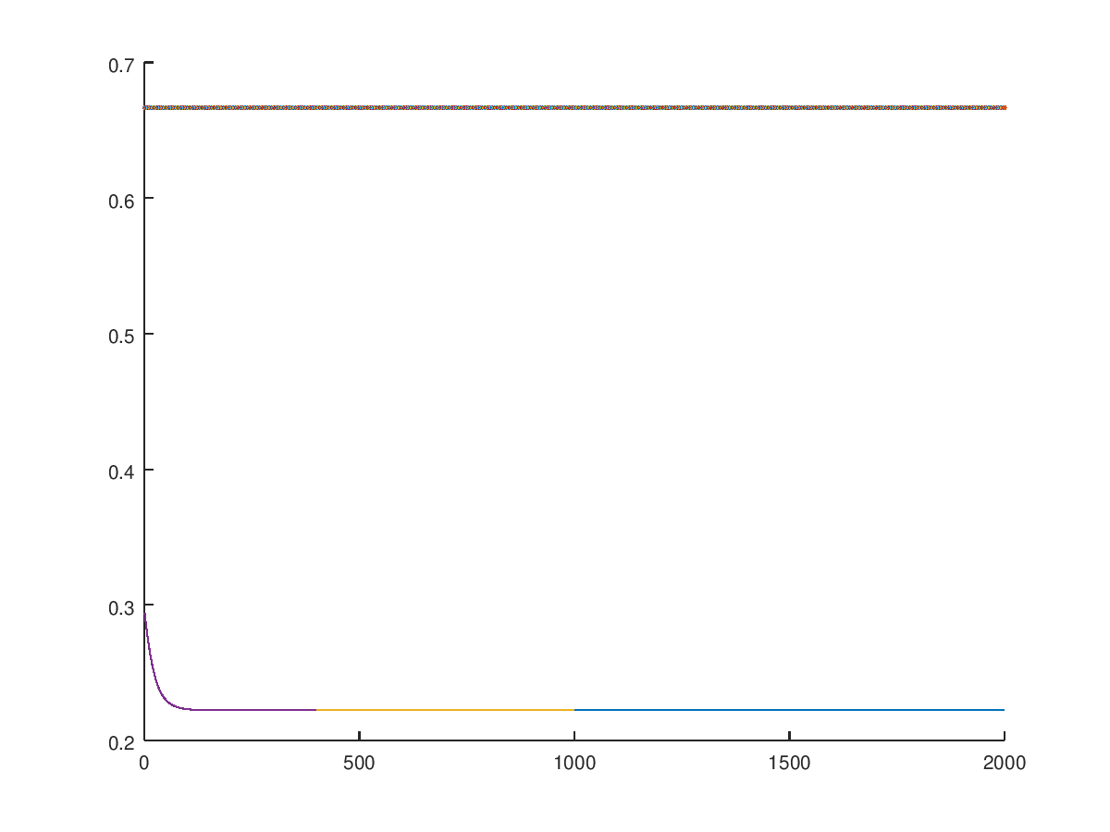
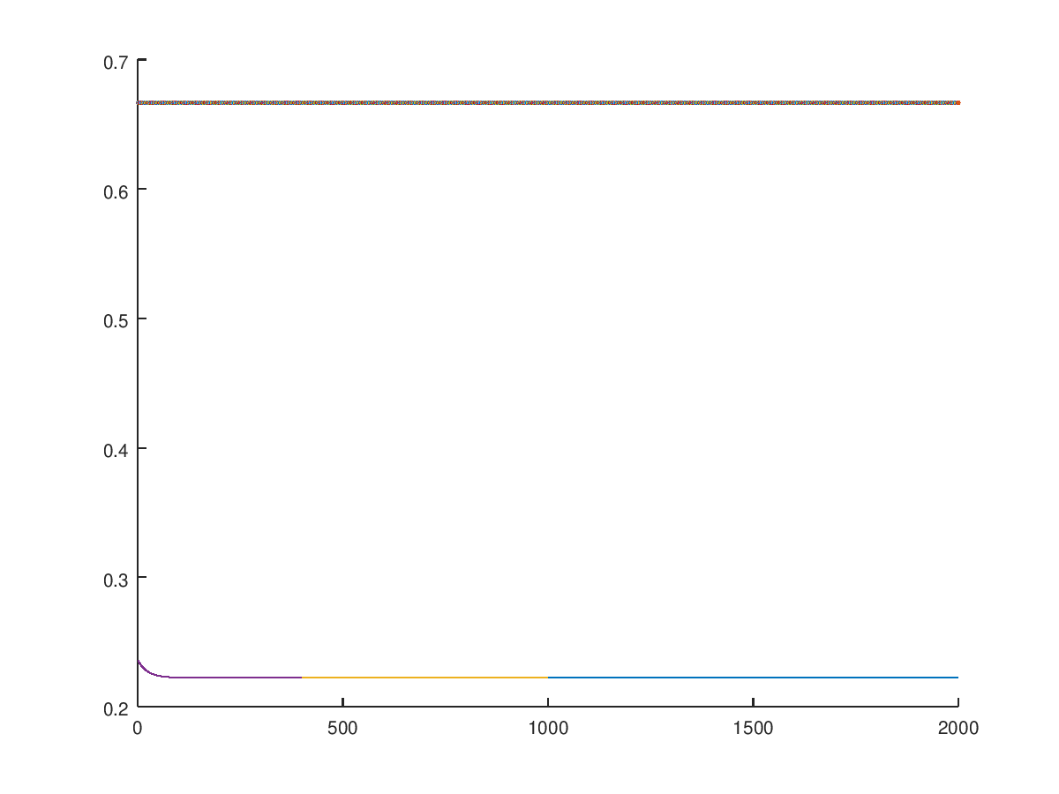
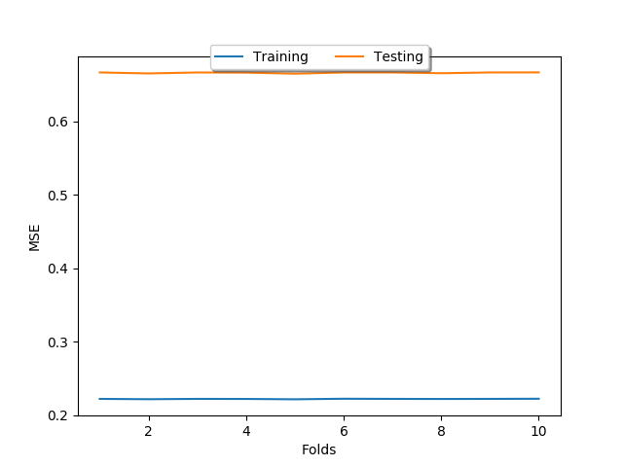
Part B Training with momentum, gamma = 0.33:

Fold 1- 4
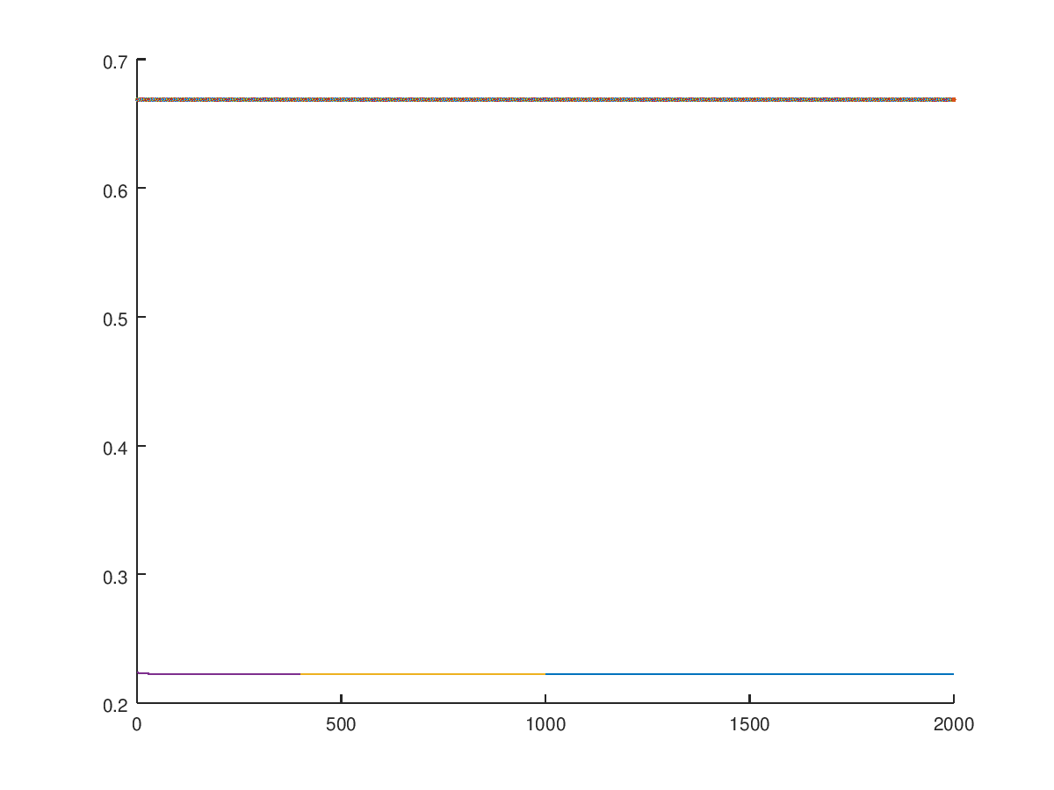
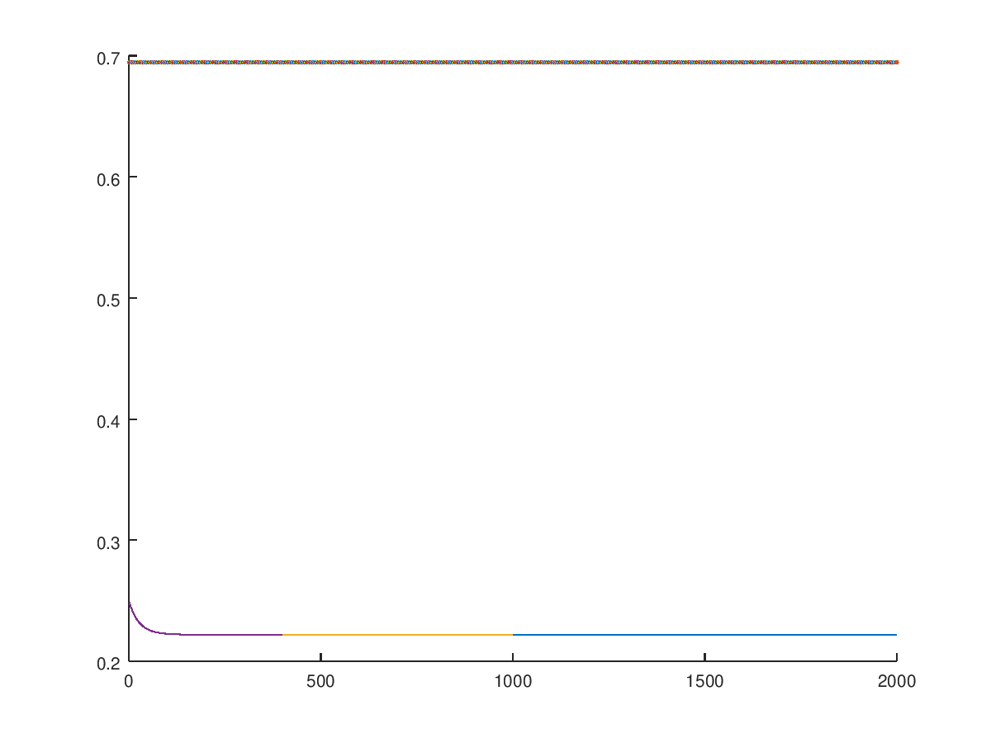
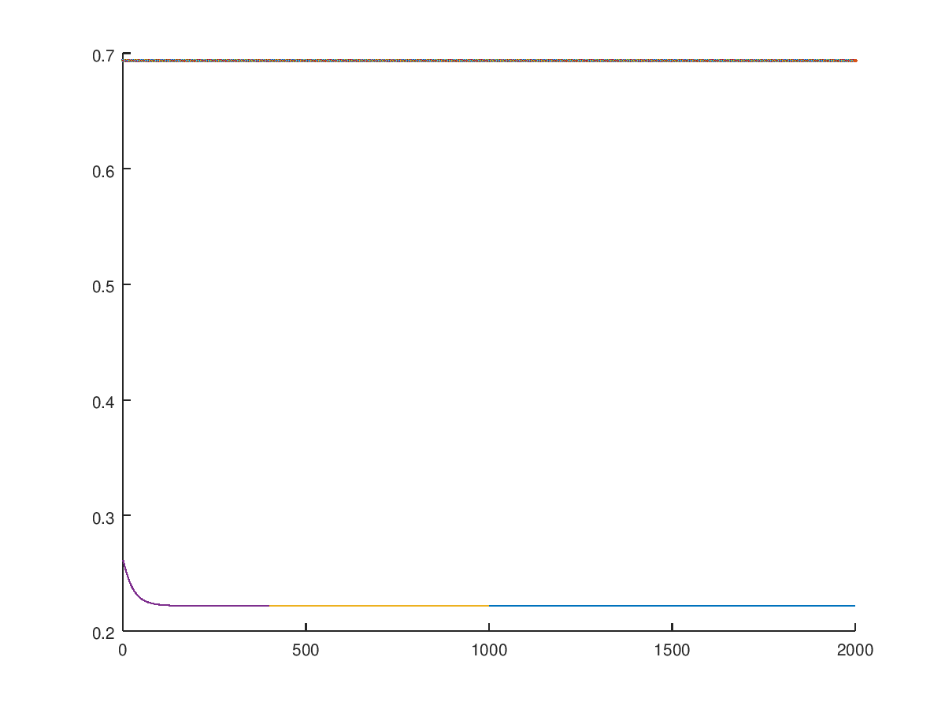
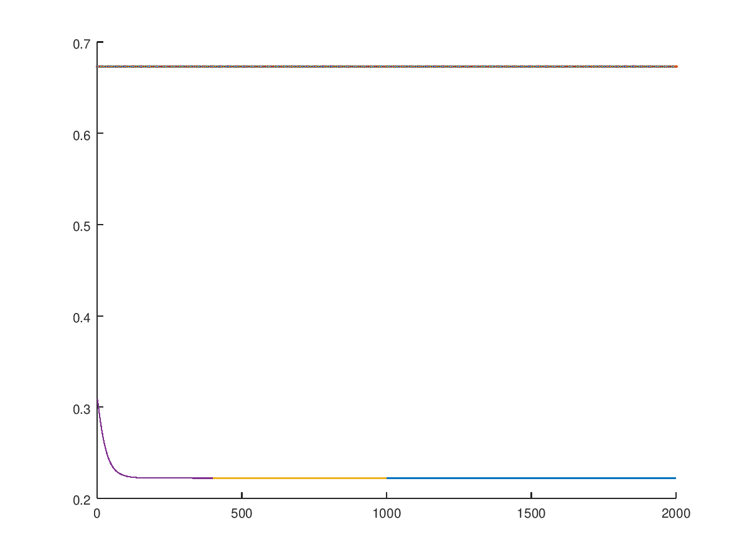
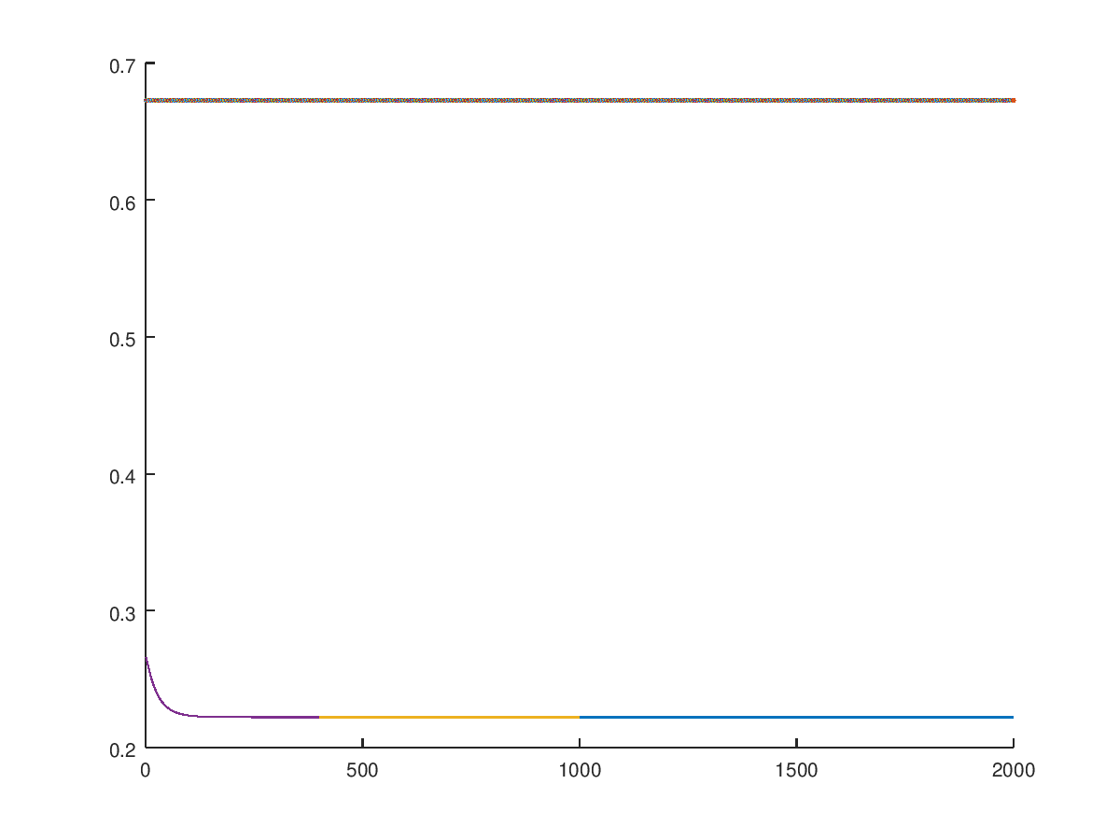
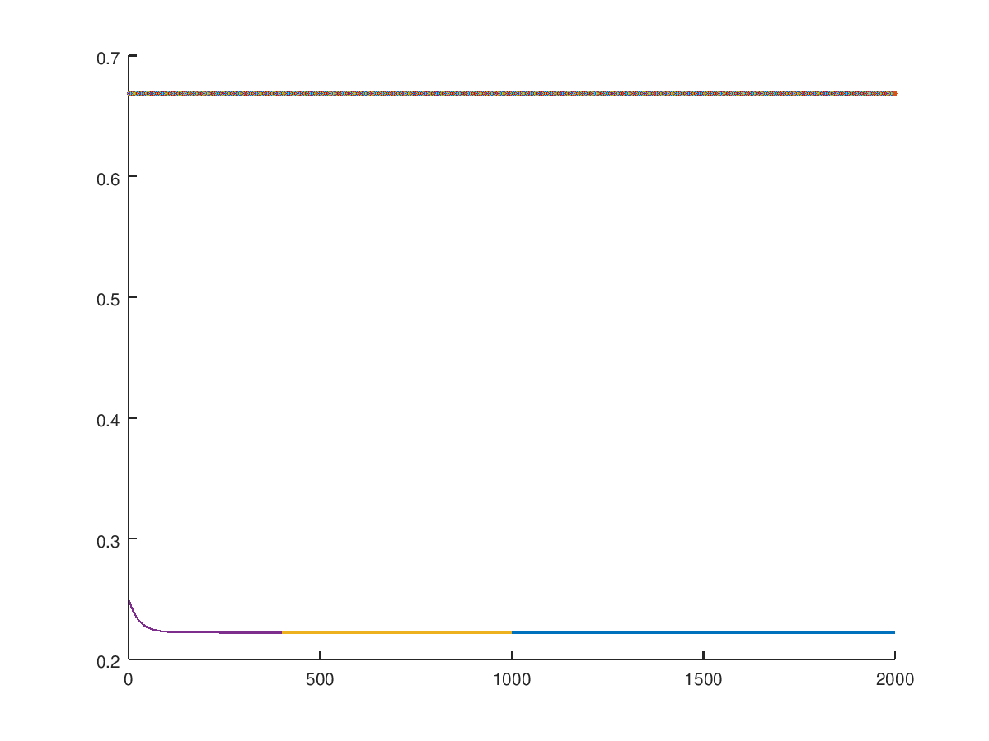
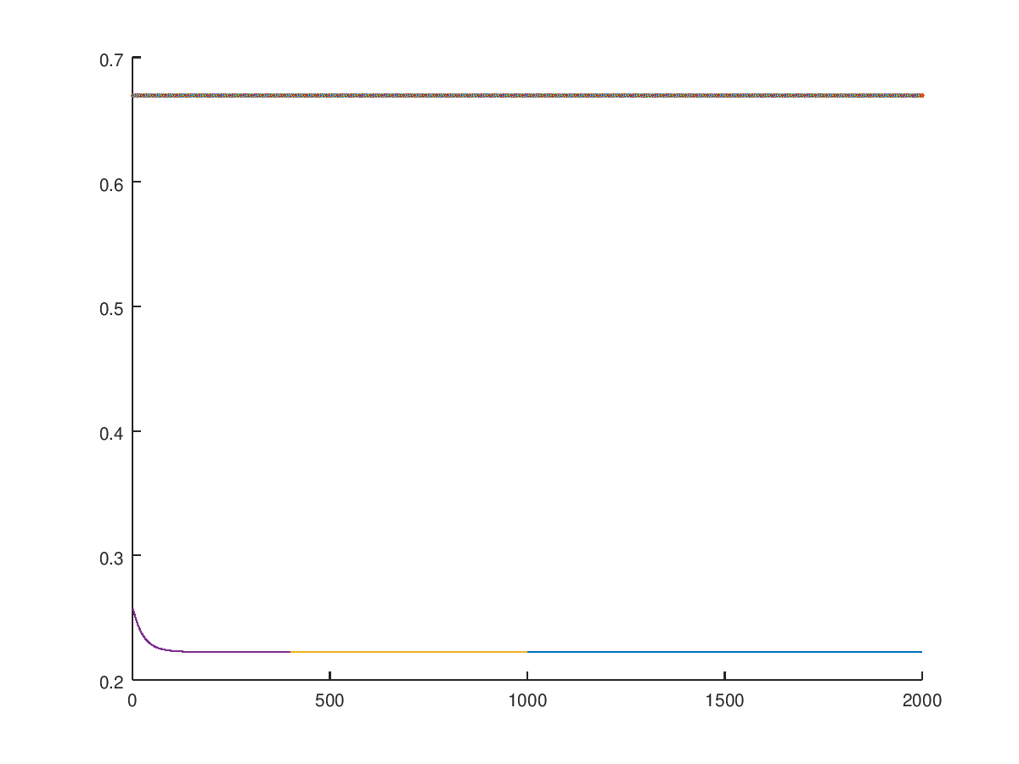
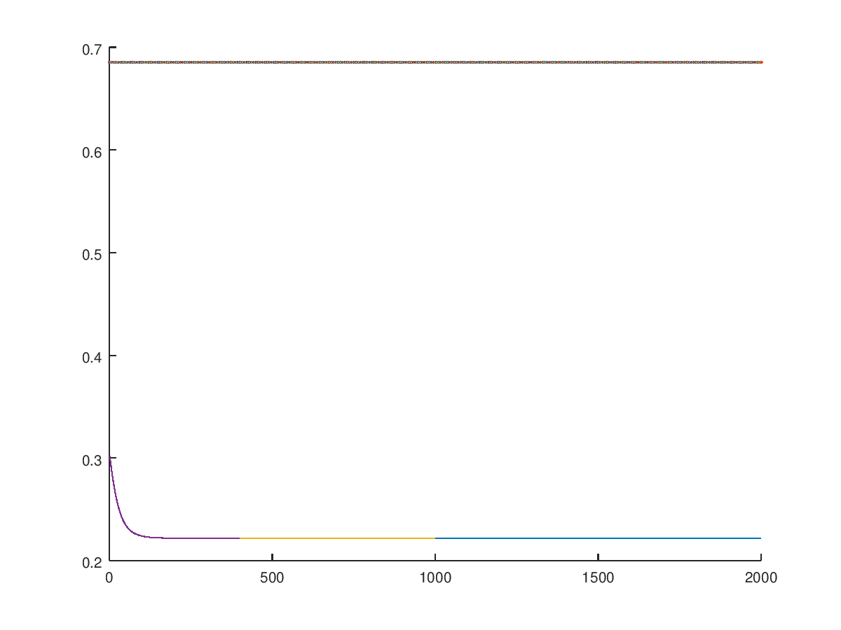
Fold 5 - 8:
Fold 9 & 10:
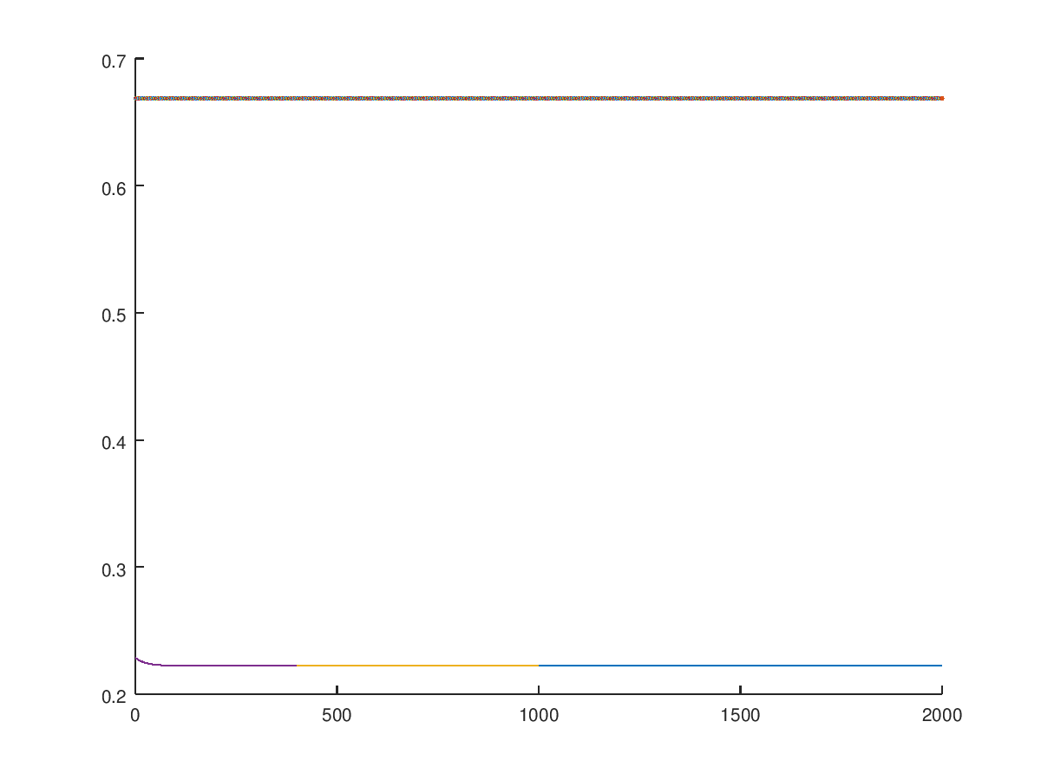
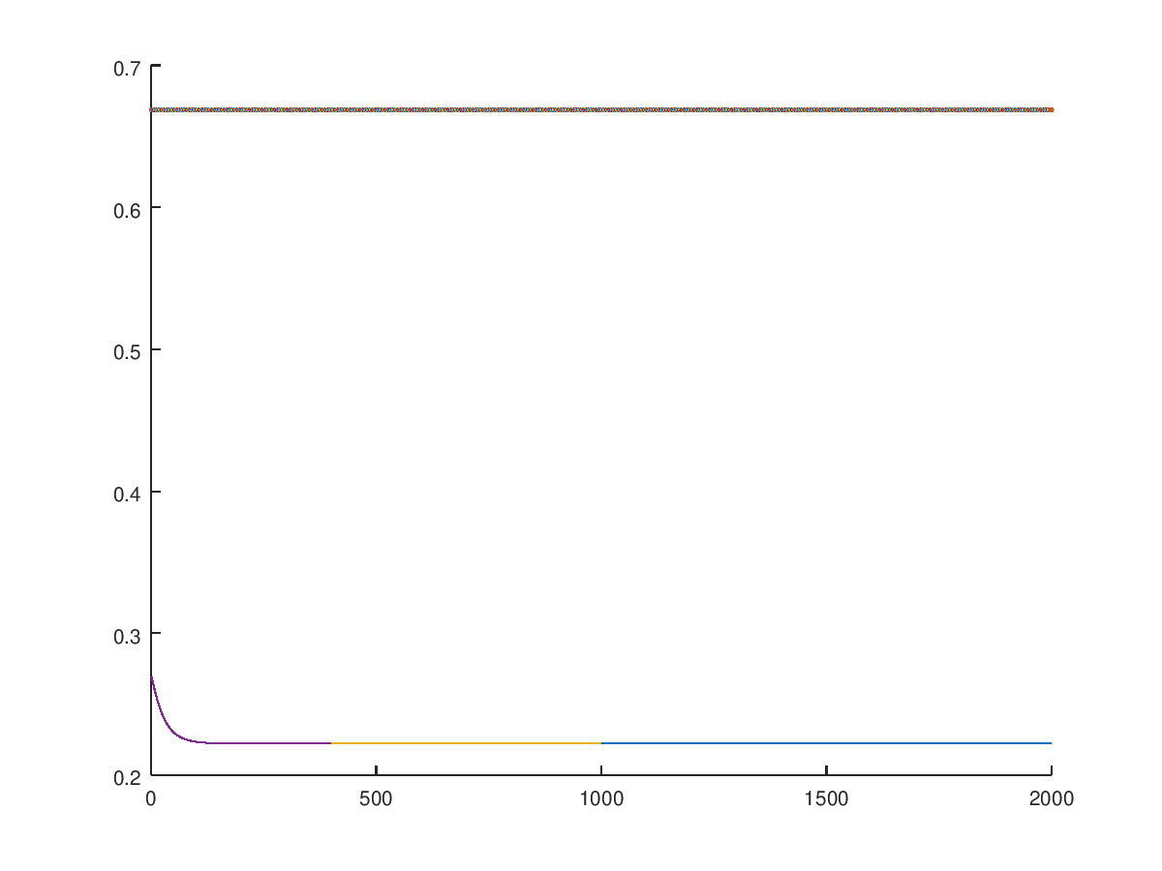

MSE output from 10 fold cross validation using backwards propagation
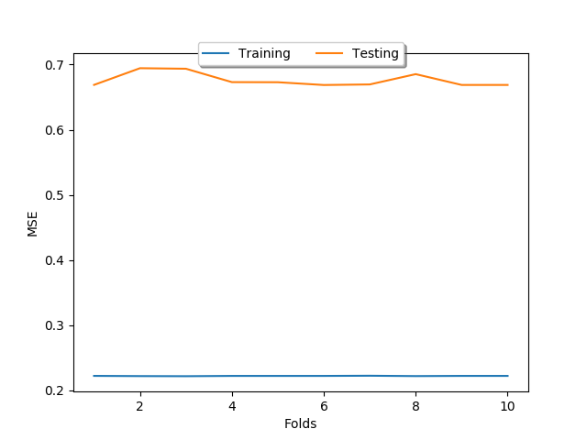
Fold 1:
Training MSE: 0.22221
Testing MSE: 0.66883
Accuracy: 0.31093
Fold 2:
Training MSE: 0.22187
Testing MSE: 0.69443
Accuracy: 0.29852
Fold 3:
Training MSE: 0.22171
Testing MSE: 0.69360
Accuracy: 0.31604
Fold 4:
Training MSE: 0.22216
Testing MSE: 0.67305
Accuracy: 0.32849
Fold 5:
Training MSE: 0.22215
Testing MSE: 0.67289
Accuracy: 0.32011
Fold 6:
Training MSE: 0.22216
Testing MSE: 0.66865
Accuracy: 0.31823
Fold 7:
Training MSE: 0.22244
Testing MSE: 0.66951
Accuracy: 0.32729
Fold 8:
Training MSE: 0.22188
Testing MSE: 0.68532
Accuracy: 0.31025
Fold 9:
Training MSE: 0.22218
Testing MSE: 0.66873
Accuracy: 0.31598
Fold 10:
Training MSE: 0.22218
Testing MSE: 0.66874
Accuracy: 0.30593

Genetic Algorithm:
Results of 10 Fold Cross Validation Using Genetic Algorithm Sample 1
Fold: 1  Training MSE: 0.222987  Testing MSE: 0.236  Average MSE: 0.2294935  Fold: 2  Training MSE: 0.226283  Testing MSE: 0.259077  Average MSE: 0.24268  Fold: 3  Training MSE: 0.223066  Testing MSE: 0.252824  Average MSE: 0.237945  Fold: 4  Training MSE: 0.224145  Testing MSE: 0.409144  Average MSE: 0.3166445  Fold: 5  Training MSE: 0.228754  Testing MSE: 0.264304  Average MSE: 0.246529  Fold: 6  Training MSE: 0.229247  Testing MSE: 0.238554  Average MSE: 0.2339005  Fold: 7  Training MSE: 0.220173  Testing MSE: 0.238342  Average MSE: 0.2292575  Fold: 8  Training MSE: 0.229997  Testing MSE: 0.254424  Average MSE: 0.2422105  Fold: 9  Training MSE: 0.222554  Testing MSE: 0.341481  Average MSE: 0.2820175  Fold: 10  Training MSE: 0.224823  Testing MSE: 0.244167  Average MSE: 0.234495 | Genetic Algorithm Stats  Population Size: 100  Generation Limit: 100  Mutation rate: 60  Crossover rate: 80  Elite Rollover rate: 10  Layers: [4, 3, 3, 3, 3]  Best Scoring Beta (mse avg: 0.2292575)  Beta[0] = [  [[0.9057 0.6893 2.6047]]  [[-0.2852 -0.6451 -0.9713]]  [[2.8691 1.152 2.6583]]  [[-3.9259 3.0515 0.9803]]  [[0.1225 2.1884 3.1583]]  ]  Beta[1] = [  [[-1.7405 -2.45 1.6556]]  [[-1.0161 -1.3146 1.0352]]  [[0.1242 2.0512 3.325 ]]  [[-0.7259 1.7291 -0.4459]]  ]  Beta[2] = [  [[-0.0949 1.9137 0.2576]]  [[-0.068 3.7838 0.6 ]]  [[ 0.8641 -0.8411 -0.749 ]]  [[0.2526 1.8331 1.5916]]  ]  Beta[3] = [  [[-0.3417 -0.5934 0.9358]]  [[ 0.8775 0.1862 -1.9265]]  [[-1.6977 1.2475 -0.9853]]  [[0.2411 0.8515 0.852 ]]  ]
Training Data using Genetic Algorithm for sample 1
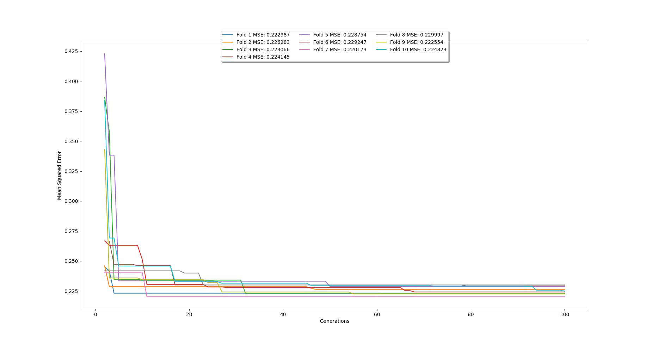
Results of 10 Fold Cross Validation Using Genetic Algorithm Sample 2
Fold: 1  Training MSE: 0.170444  Testing MSE: 0.229817  Average MSE: 0.2001305  Fold: 2  Training MSE: 0.207967  Testing MSE: 0.175004  Average MSE: 0.1914855  Fold: 3  Training MSE: 0.211898  Testing MSE: 0.260982  Average MSE: 0.23643999999999998  Fold: 4  Training MSE: 0.19975  Testing MSE: 0.230876  Average MSE: 0.215313  Fold: 5  Training MSE: 0.191935  Testing MSE: 0.310763  Average MSE: 0.251349  Fold: 6  Training MSE: 0.220011  Testing MSE: 0.271129  Average MSE: 0.24557  Fold: 7  Training MSE: 0.223615  Testing MSE: 0.230607  Average MSE: 0.227111  Fold: 8  Training MSE: 0.230747  Testing MSE: 0.261007  Average MSE: 0.245877  Fold: 9  Training MSE: 0.232049  Testing MSE: 0.296593  Average MSE: 0.26432100000000003  Fold: 10  Training MSE: 0.22047  Testing MSE: 0.265943  Average MSE: 0.2432065 | Genetic Algorithm Stats  Population Size: 500  Generation Limit: 25  Mutation rate: 300  Crossover rate: 400  Elite Rollover rate: 50  Layers: [4, 3, 3, 3, 3]  Best Scoring Beta (mse avg: 0.1914855)  Beta[0] = [  [[ 0. 0.8388 -2.0487]]  [[0.6747 2.4766 0.6063]]  [[ 2.4026 -0.2618 -0.4096]]  [[1.8767 0.9588 1.1226]]  [[-3.6511 0. -3.9618]]  ]  Beta[1] = [  [[-2.5119 0.8383 -0.3236]]  [[-2.4996 3.3606 -0.7897]]  [[-1.5143 1.8553 1.754 ]]  [[ 1.5933 1.5451 -0.6417]]  ]  Beta[2] = [  [[0. 0.0872 0.179 ]]  [[-0.2664 -3.7822 -4.9943]]  [[ 0.0592 -1.6746 -0.2119]]  [[-5.3442 0.1995 1.3978]]  ]  Beta[3] = [  [[ 0.894 -0.4031 -0.9307]]  [[-0.0657 -1.3834 -0.626 ]]  [[-0.2398 4.2192 -1.1227]]  [[ 0. 1.804 -0.2696]]  ]

Training Data using Genetic Algorithm for sample 2
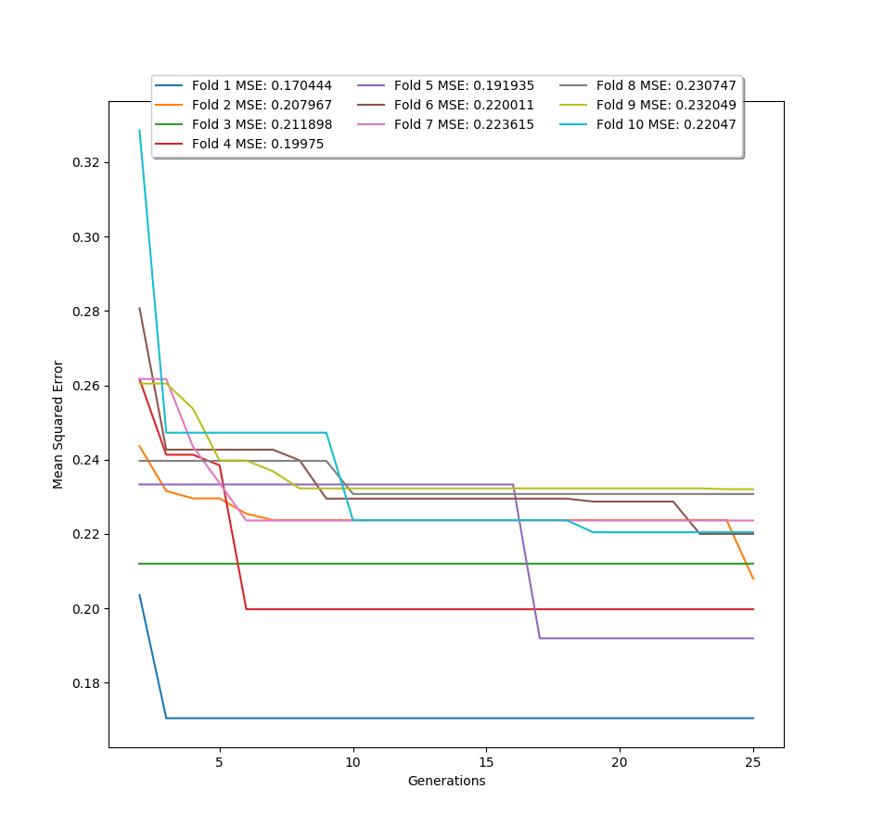
Results of 10 Fold Cross Validation Using Genetic Algorithm Sample 3
Fold: 1  Training MSE: 0.205153  Testing MSE: 0.228648  Average MSE: 0.2169005  Fold: 2  Training MSE: 0.224464  Testing MSE: 0.227633  Average MSE: 0.22604849999999999  Fold: 3  Training MSE: 0.212544  Testing MSE: 0.206681  Average MSE: 0.2096125  Fold: 4  Training MSE: 0.212001  Testing MSE: 0.233  Average MSE: 0.2225005  Fold: 5  Training MSE: 0.221353  Testing MSE: 0.275977  Average MSE: 0.24866499999999997  Fold: 6  Training MSE: 0.208764  Testing MSE: 0.225625  Average MSE: 0.2171945  Fold: 7  Training MSE: 0.211545  Testing MSE: 0.240404  Average MSE: 0.22597450000000002  Fold: 8  Training MSE: 0.222419  Testing MSE: 0.249324  Average MSE: 0.2358715  Fold: 9  Training MSE: 0.222702  Testing MSE: 0.228796  Average MSE: 0.225749  Fold: 10  Training MSE: 0.221235  Testing MSE: 0.232903  Average MSE: 0.227069 | Genetic Algorithm Stats  Population Size: 1000  Generation Limit: 5  Mutation rate: 600  Crossover rate: 800  Elite Rollover rate: 100  Layers: [4, 3, 3, 3, 3]  Best Scoring Beta (mse avg: 0.2096125)  Beta[0] = [  [[-3.8313 0. -1.8313]]  [[-1.2603 1.3532 0.4198]]  [[ 0.3449 0.7638 -0.096 ]]  [[0. 0.3849 0. ]]  [[-0.1437 -0.1583 -2.0234]]  ]  Beta[1] = [  [[ 2.3639 3.7158 -1.1939]]  [[1.1513 0.4687 0.0675]]  [[ 2.8499 -2.0249 0.2849]]  [[ 3.841 2.7193 -0.5505]]  ]  Beta[2] = [  [[ 1.6331 -0.9447 -1.3493]]  [[-0.3665 -0.3941 -2.7433]]  [[-0.7004 0.6278 -1.8901]]  [[-0.9329 2.7899 -0.5268]]  ]  Beta[3] = [  [[-2.7818 -0.2935 -1.9597]]  [[-3.8854 -0.598 1.9373]]  [[ 2.3901 1.9363 -0.7522]]  [[0. 0.1099 0.718 ]]  ]

Training Data using Genetic Algorithm for sample 3
