**Reset Password for Grenada Intranet Site.**

1. Click the “Login” button at the top right of the page. 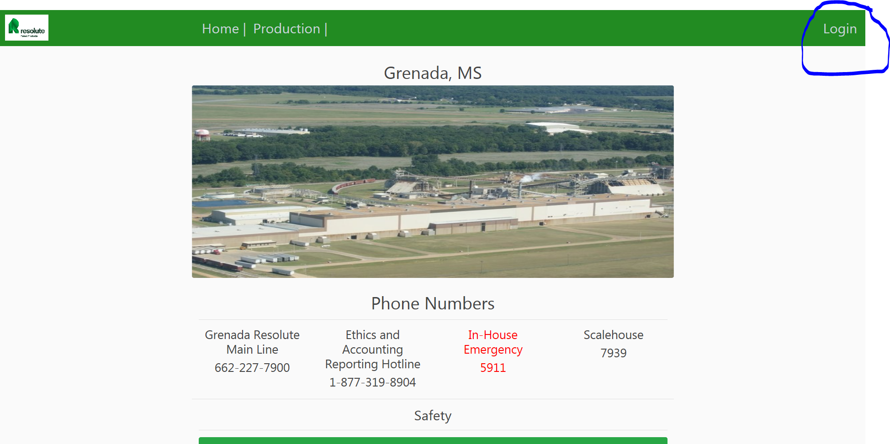
2. Click “Forgot Password?” link under the “Login” button. 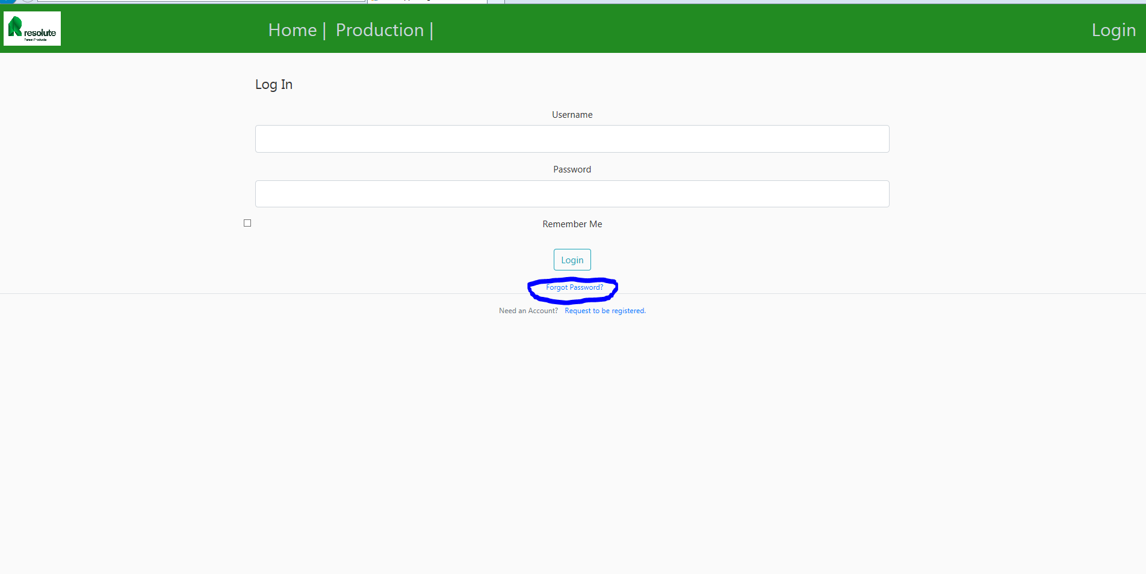
3. Enter your email resolute email and click “Request Password Reset” button. This will send an email to you with a link to reset your password. 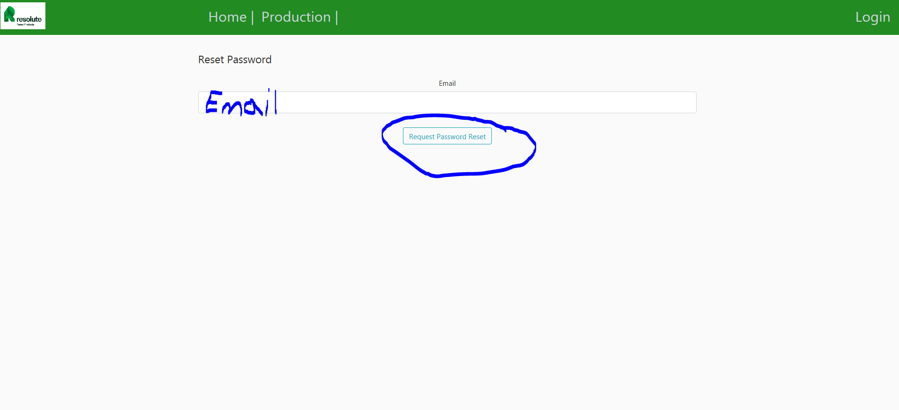
4. Open Lotus notes and click on email. 
5. Click on link in email. If you have problems with this working, after clicking on the link copy the address from the url in the Lotus Notes browser and placing it in the url in Google Chrome or Internet Explorer. 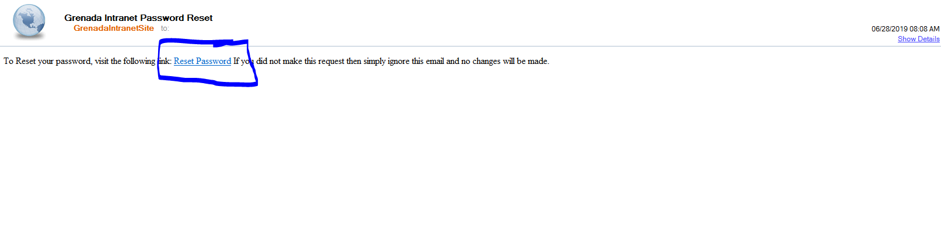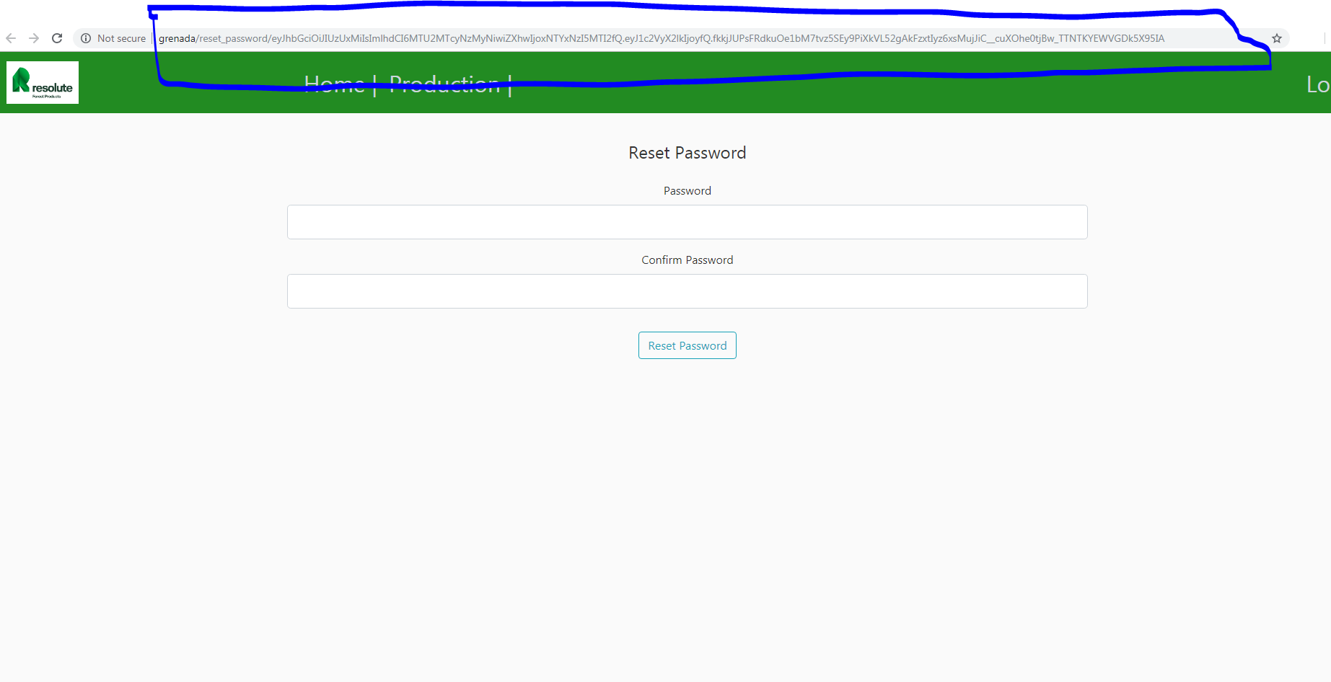
6. Type in new password and again to confirm. Then click “Reset Password” button. 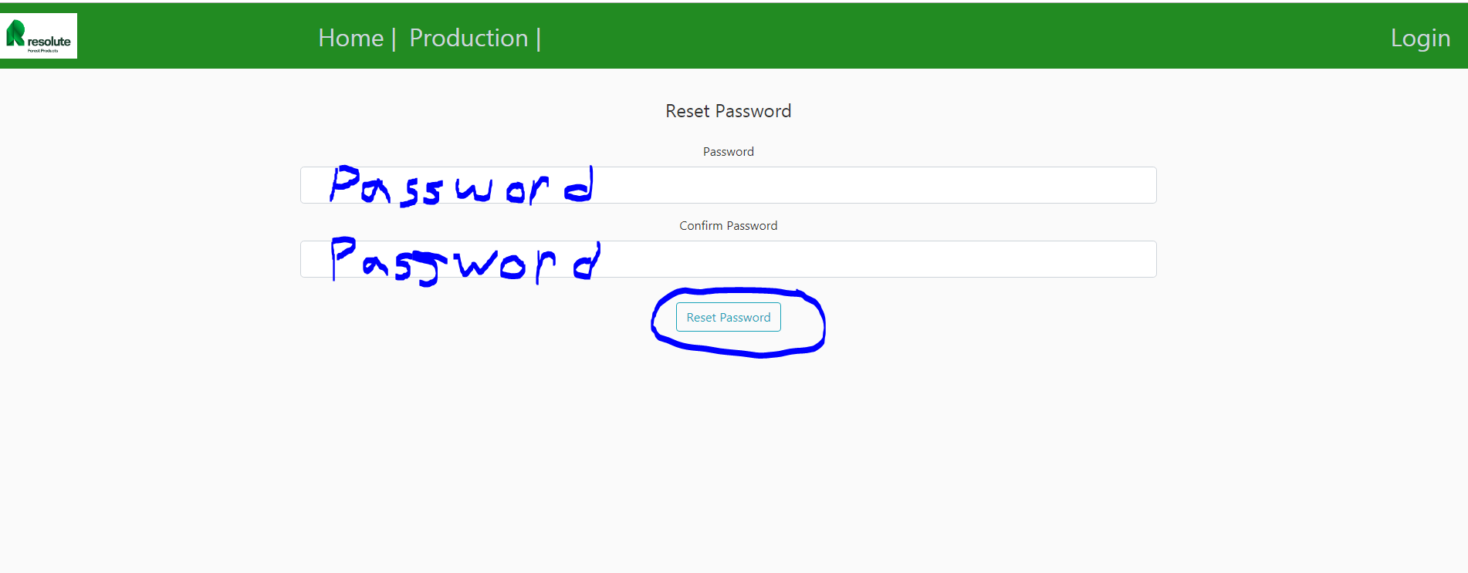
7. Now login. 