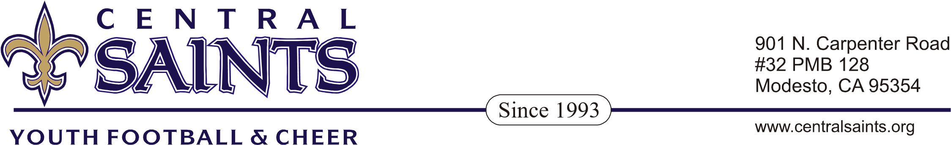

2020 BOARD MEMBER APPLICATION

Due no later than December 2nd (at Awards Banquet) New board members appointed in December for following season

Name:_________________________________________________________________

Address:_______________________________________________________________

City:______________________________________Zip:_______________________

Phone:____________________Work#________________Cell#_____________

e-mail:___________________________________________________________

Position Desired:___________________________________________________

Qualifications:_____________________________________________________

Past Board Experience:_____________________________________________
Briefly describe what you believe you can contribute to the Central Saints program:

References:

Name:_________________________________Phone:____________________

Name:_________________________________Phone:____________________

Please contact:
Scott Hallmon (President) 209-422-9562
(President@centralsaints.org)

