# Road Log Widget User Instructions

1. Click the Road Log widget tool
2. 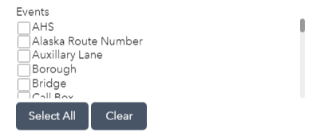Select the events you want included in your Road Log Report
3. Select the route you wish to run the report for
   1. 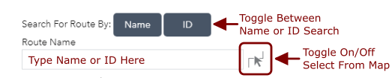To choose a route by text search, select if you wish to search by Name or ID. Begin typing in the search box. Suggestions will populate below. Click to choose your preferred selection.
   2. If you wish to choose a route by clicking on the map, click the button to the right of the text window and click directly on a route visible on the map. If a route is found it will populate the Name/ID text window. If more than one Route is near the location clicked, a list of possible candidates will be provided to choose between. If no route is found, a tooltip message will encourage you to click again.
4. 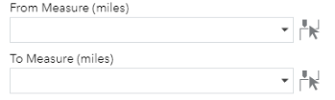If only a portion of the route is desired for the Road Log Report, specify “From” and “To” measures. If left blank, the entire route will be reported on.
5. Click “Run Report” to save .CSV report file to your computer.