**Mathematical Morphology Lab**

**Prepared by Abdul Qayyum**

**Introduction:**

Morphology, or mathematical morphology is a branch of image processing which is particularly useful for analysing shapes in images. Although morphology can be applied to grey-scale images, we shall only investigate binary morphology. Matlab has many tools for binary morphology in the image processing toolbox; most of which can be used for greyscale morphology as well.

**Q1: For each of the following images A,B,C and structuring elements Im1, Im2 and Im3:**

A =

0 0 0 0 0 0 0 0

0 0 0 1 1 1 1 0

0 0 0 1 1 1 1 0

0 1 1 1 1 1 1 0

0 1 1 1 1 1 1 0

0 1 1 1 1 0 0 0

0 1 1 1 1 0 0 0

0 0 0 0 0 0 0 0

B =

0 0 0 0 0 0 0 0

0 1 1 1 1 1 1 0

0 1 1 1 1 1 1 0

0 1 1 0 0 1 1 0

0 1 1 0 0 1 1 0

0 1 1 1 1 1 1 0

0 1 1 1 1 1 1 0

0 0 0 0 0 0 0 0

C =

0 0 0 0 0 0 0 0

0 0 0 0 0 1 1 0

0 1 1 1 0 1 1 0

0 1 1 1 0 1 1 0

0 1 1 1 0 1 1 0

0 1 1 1 0 0 0 0

0 1 1 1 0 0 0 0

0 0 0 0 0 0 0 0

Sm1 =

0 1 0

1 1 1

0 1 0

Sm2 =

1 1 1

1 1 1

1 1 1

Sm3 =

1 0 0

0 0 0

0 0 1

**Calculate the erosion, dilation, opening and the closing using MATLAB function.**

**Q2:** **Use the binary images and apply these structuring elements to view the erosion and dilation. Can you see any differences?**

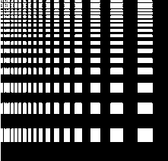

testpatternbinary

Sq1 =

1 1 1

1 1 1

1 1 1

Sq2=

0 1 0

1 1 1

0 1 0

diag =

0 0 1

0 1 0

1 0 0

Q3: Use the following binary image and apply these structuring elements to remove the noise based on opening and closing morphological functions. Can you see any differences?

(i) Sq1 =

1 1 1

1 1 1

1 1 1

(ii) Sq2=

0 1 0

1 1 1

0 1 0

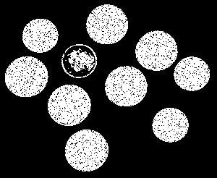

noisycoins

**Q3: Extract the boundary using the following operations with MATLAB function:**

Imb =

0 0 1 1 0 0

0 1 1 1 1 0

1 1 1 1 1 1

1 1 1 1 1 1

0 1 1 1 1 0

0 0 1 1 0 0

SE =

1 0 1

0 1 0

1 0 1

􀀀

(i) Imb -(Imb⊖ SE) “internal boundary”

(ii) (Imb ⊕ SE)- Imb “external boundary”

(iii) (Imb ⊕ SE)- (Imb⊖ SE)  morphological gradient

**Q4 : Apply these operations on the following image and interpret the results:**



(i) Imb -(Imb⊖ SE) “internal boundary”

(ii) (Imb ⊕ SE)- Imb “external boundary”

(iii) (Imb ⊕ SE)- (Imb⊖ SE) morphological gradient

**Q5: Transform Image A into Image B using the morphology operators:**

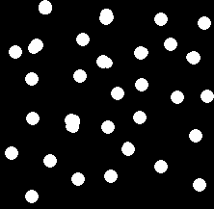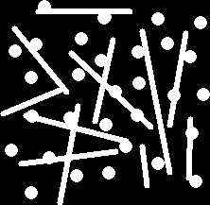

A B

**You can choose the structuring element from the following functions in order to complete the above task.**

# Please check the information on MATLAB with structuring elements.

<https://www.mathworks.com/help/images/ref/strel.html>

**Syntax**

[SE = strel(nhood)](https://www.mathworks.com/help/images/ref/strel.html#d120e224598)

[SE = strel('arbitrary',nhood)](https://www.mathworks.com/help/images/ref/strel.html#d120e224608)

[SE = strel('diamond',r)](https://www.mathworks.com/help/images/ref/strel.html#d120e224620)

[SE = strel('disk',r,n)](https://www.mathworks.com/help/images/ref/strel.html#d120e224632)

[SE = strel('octagon',r)](https://www.mathworks.com/help/images/ref/strel.html#d120e224653)

[SE = strel('line',len,deg)](https://www.mathworks.com/help/images/ref/strel.html#d120e224667)

[SE = strel('rectangle',[m n])](https://www.mathworks.com/help/images/ref/strel.html#d120e224688)

[SE = strel('square',w)](https://www.mathworks.com/help/images/ref/strel.html#d120e224701)

[SE = strel('cube',w)](https://www.mathworks.com/help/images/ref/strel.html#d120e224720)

[SE = strel('cuboid',[m n p])](https://www.mathworks.com/help/images/ref/strel.html#d120e224732)

[SE = strel('sphere',r)](https://www.mathworks.com/help/images/ref/strel.html#d120e224744)

**Q7: Apply connected component MATLAB function( already explained in theory part) on the following images(C and D) and do the analysis with the following structure elements. Where A and B are input images and C and D are binary segmentation masks.**

(i) cross element SE

(ii) square element SE

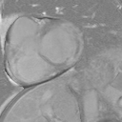 

(B)

(A)

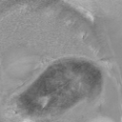 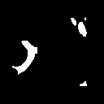

(D)

(C)

􀀀