LAB 9: Classification using deep learning models.
In keras library we need to follow the following steps for classification of images based on deep learning models.
1-Image folder
2- prepare dataset(training, testing and validation).
We can prepare the folder for training, validation and testing automatically using this library.
https://pypi.org/project/split-folders/
Either you prepare the image folder by random size or you can fix the size. Please the following commands.
! pip install split-folders
import split_folders

# Split with a ratio.
# To only split into training and validation set, set a tuple to `ratio`, i.e, `(.8, .2)`.
split_folders.ratio('input_folder', output="output", seed=1337, ratio=(.8, .1, .1)) # default values

# Split val/test with a fixed number of items e.g. 100 for each set.
# To only split into training and validation set, use a single number to `fixed`, i.e., `10`.
split_folders.fixed('input_folder', output="output", seed=1337, fixed=(100, 100), oversample=False) # default values

The structure of the folders should look like this.
output/
train/
class1/
img1.jpg
...
class2/
imga.jpg
...
val/
class1/
img2.jpg
...
class2/
imgb.jpg
...
test/
class1/
img3.jpg
...
class2/
imgc.jpg
...
Use the Images-processed folder for dataset that you can get from the following link.
https://github.com/UCSD-AI4H/COVID-CT

3. make the data generator that generate batches of images
batch_size = 16

# this is the augmentation configuration we will use for training
train_datagen = ImageDataGenerator(
rescale=1./255,
shear_range=0.2,
zoom_range=0.2,
horizontal_flip=True)

# this is the augmentation configuration we will use for testing:
# only rescaling
test_datagen = ImageDataGenerator(rescale=1./255)

# this is a generator that will read pictures found in
# subfolers of 'data/train', and indefinitely generate
# batches of augmented image data
train_generator = train_datagen.flow_from_directory(
'data/train', # this is the target directory
target_size=(150, 150), # all images will be resized to 150x150
batch_size=batch_size,
class_mode='binary') # since we use binary_crossentropy loss, we need binary labels

# this is a similar generator, for validation data
validation_generator = test_datagen.flow_from_directory(
'data/validation',
target_size=(150, 150),
batch_size=batch_size,
class_mode='binary')

4. Design deep learning model (scratch based or pretrained model)
from keras.models import Sequential
from keras.layers import Conv2D, MaxPooling2D
from keras.layers import Activation, Dropout, Flatten, Dense

model = Sequential()
model.add(Conv2D(32, (3, 3), input_shape=(3, 150, 150)))
model.add(Activation('relu'))
model.add(MaxPooling2D(pool_size=(2, 2)))

model.add(Conv2D(32, (3, 3)))
model.add(Activation('relu'))
model.add(MaxPooling2D(pool_size=(2, 2)))

model.add(Conv2D(64, (3, 3)))
model.add(Activation('relu'))
model.add(MaxPooling2D(pool_size=(2, 2)))

# the model so far outputs 3D feature maps (height, width, features)
model.add(Flatten()) # this converts our 3D feature maps to 1D feature vectors
model.add(Dense(64))
model.add(Activation('relu'))
model.add(Dropout(0.5))
model.add(Dense(1))
model.add(Activation('sigmoid'))

model.compile(loss='binary_crossentropy',
optimizer='rmsprop',
metrics=['accuracy'])

5. Train the model using model.fit function in keras.
model.fit_generator(
train_generator,
steps_per_epoch=2000 // batch_size,
epochs=50,
validation_data=validation_generator,
validation_steps=800 // batch_size)
model.save_weights('first_try.h5') # always save your weights after training or during training

6. save the model and load the model for testing.
model.save('myfirstmodel.h5')
loaded_model = tf.keras.models.load_model('myfirstmodel.h5')
loaded_model.layers[0].input_shape

Model.predict function used for testing the model
from sklearn.metrics import classification_report, confusion_matrix
#Y_pred = model.predict_generator(validation_generator, num_of_test_samples // batch_size+1)
Y_pred = model.predict_generator(test_generator, 74 // batch_size+1)
y_pred = np.argmax(Y_pred, axis=1)
#pred = model.predict_generator(validation_generator, steps=len(validation_generator), verbose=0)
# Get classes by max element in np (as a list)
y_pred = np.argmax(pred, axis=1)
print('Confusion Matrix')
print(confusion_matrix(test_generator.classes, y_pred))
print('Classification Report')
target_names = ['Covd', 'notCovd']
print(classification_report(validation_generator.classes, y_pred, target_names=target_names))

Q1: Implement the following architecture and check the performance.
Taken from recent published paper. “Automated Detection of COVID-19 Cases Using Deep Neural Networks with Xray Images”
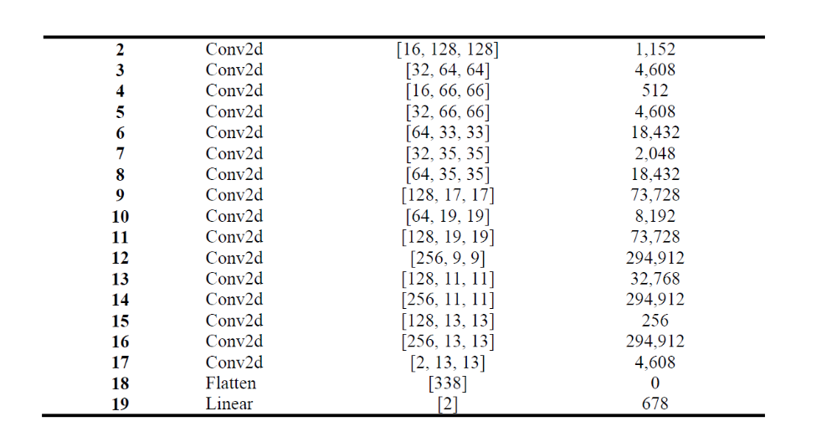
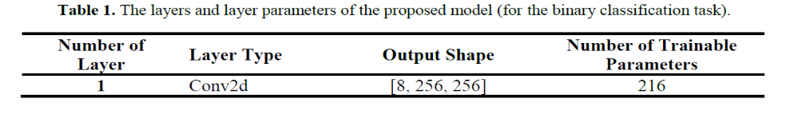

Q2: Use pretrained models and do some fine-tuning or transfer learning and classify based the COVD dataset and brain tumor dataset.
Valid or compare the results with scratch-based model.

Note: Repeat Q1 and Q2 for brain tumor dataset.

Q3: Extract the features from the last layers of the pretrained model and used machine learning classifiers for classification.

Q4: Try to implement this paper. You can use COVD19 dataset and all pre-trained models are available. You just fine-tuned the top layers and trained the models.
Here is the structure of the pre-trained model for example.
https://keras.io/guides/transfer_learning/
base_model = keras.applications.Xception(
weights="imagenet", # Load weights pre-trained on ImageNet.
input_shape=(150, 150, 3),
include_top=False,
) # Do not include the ImageNet classifier at the top.

# Freeze the base_model
base_model.trainable = False

# Create new model on top
inputs = keras.Input(shape=(150, 150, 3))
x = inputs

Fine-tune InceptionV3 on a new set of classes
from tensorflow.keras.applications.inception_v3 import InceptionV3
from tensorflow.keras.preprocessing import image
from tensorflow.keras.models import Model
from tensorflow.keras.layers import Dense, GlobalAveragePooling2D

# create the base pre-trained model
base_model = InceptionV3(weights='imagenet', include_top=False)

# add a global spatial average pooling layer
x = base_model.output
x = GlobalAveragePooling2D()(x)
# let's add a fully-connected layer
x = Dense(1024, activation='relu')(x)
# and a logistic layer -- let's say we have 200 classes
predictions = Dense(200, activation='softmax')(x)

# this is the model we will train
model = Model(inputs=base_model.input, outputs=predictions)

# first: train only the top layers (which were randomly initialized)
# i.e. freeze all convolutional InceptionV3 layers
for layer in base_model.layers:
layer.trainable = False

# compile the model (should be done *after* setting layers to non-trainable)
model.compile(optimizer='rmsprop', loss='categorical_crossentropy')

# train the model on the new data for a few epochs
model.fit(...)

# at this point, the top layers are well trained and we can start fine-tuning
# convolutional layers from inception V3. We will freeze the bottom N layers
# and train the remaining top layers.

# let's visualize layer names and layer indices to see how many layers
# we should freeze:
for i, layer in enumerate(base_model.layers):
print(i, layer.name)

# we chose to train the top 2 inception blocks, i.e. we will freeze
# the first 249 layers and unfreeze the rest:
for layer in model.layers[:249]:
layer.trainable = False
for layer in model.layers[249:]:
layer.trainable = True

# we need to recompile the model for these modifications to take effect
# we use SGD with a low learning rate
from tensorflow.keras.optimizers import SGD
model.compile(optimizer=SGD(lr=0.0001, momentum=0.9), loss='categorical_crossentropy')

# we train our model again (this time fine-tuning the top 2 inception blocks
# alongside the top Dense layers
model.fit(...)

Build a model
Now let's built a model that follows the blueprint we've explained earlier.
Note that:
- We add a Normalization layer to scale input values (initially in the [0, 255] range) to the [-1, 1] range.
- We add a Dropout layer before the classification layer, for regularization.
- We make sure to pass training=False when calling the base model, so that it runs in inference mode, so that batchnorm statistics don't get updated even after we unfreeze the base model for fine-tuning.
base_model = keras.applications.Xception(
weights="imagenet", # Load weights pre-trained on ImageNet.
input_shape=(150, 150, 3),
include_top=False,
) # Do not include the ImageNet classifier at the top.

# Freeze the base_model
base_model.trainable = False

# Create new model on top
inputs = keras.Input(shape=(150, 150, 3))
x = inputs

# Pre-trained Xception weights requires that input be normalized
# from (0, 255) to a range (-1., +1.), the normalization layer
# does the following, outputs = (inputs - mean) / sqrt(var)
norm_layer = keras.layers.experimental.preprocessing.Normalization()
mean = np.array([127.5] * 3)
var = mean ** 2
# Scale inputs to [-1, +1]
x = norm_layer(x)
norm_layer.set_weights([mean, var])

# The base model contains batchnorm layers. We want to keep them in inference mode
# when we unfreeze the base model for fine-tuning, so we make sure that the
# base_model is running in inference mode here.
x = base_model(x, training=False)
x = keras.layers.GlobalAveragePooling2D()(x)
x = keras.layers.Dropout(0.2)(x) # Regularize with dropout
outputs = keras.layers.Dense(1)(x)
model = keras.Model(inputs, outputs)

model.summary()

