Notification Engine (FSD-B06-T01)
Batch 1 Build Report
Team Lead: Reshma Ann Thomas · Date: 10 November 2026 · Branch: setup/foundation

1. Summary
All Batch 1 build tasks (T01–T23, T25) are done on the setup/foundation branch, and all 5 demo workflows run end to end. The 32 server unit tests pass and the client builds with no lint errors. Nothing has been committed yet.
The Notification Engine reads business data, keeps the rows that match a rule, and emails the right people on a schedule. It never sends the same reminder twice and logs every run. Batch 1 owns the engine, its APIs and its screens. Batch 2 owns the real database connectors.
Still to do: the Batch 2 connector swap (T26), the test and documentation deliverables (T24, T27–T31), and committing this work under JIRA keys.

2. How the system works
An admin sets up a job once; after that the server runs it on its schedule, or immediately when someone clicks Run now.
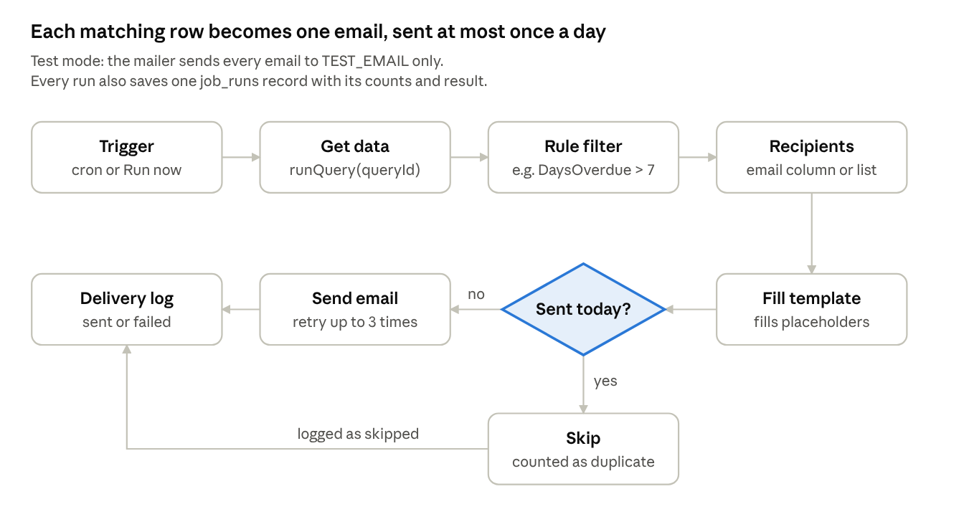
Figure 1. One job run: 7 steps and 1 decision
The "Sent today?" check is the dedupe key in sent_history. A send that still fails after 3 retries is logged as failed, and its key is removed so the next run can try again. Report jobs send one email to a named list with the matching rows attached as CSV.

3. Key concepts
Concept | What it is | Why it exists
Fake connector | engine/fakeConnector.js provides runQuery(queryId) and returns rows from the mock-data/ JSON files, in the common format { columns, rows }. | Batch 2 builds the real SQL Server and SAP HANA connectors. The fake one lets Batch 1 build and demo everything now. At integration (T26), one require line in engine/runner.js changes; nothing else does.
Test mode | When TEST_MODE=true in .env, the mailer replaces every recipient with TEST_EMAIL and drops CC and BCC. It is on unless .env says exactly TEST_MODE=false. | One mistake during development could email a real customer about a fake overdue invoice. All email goes through the mailer, so no job or screen can get around it. The header shows TEST MODE: ON.
Dedupe key | jobName:recordId:date, e.g. payment-reminder:INV-101:2026-11-10. sent_history has a unique index on it. | The database itself refuses a second send of the same reminder on the same day, even if two runs overlap.
Record ID | The first column of the query data: InvoiceNo, PONo or ItemCode. Report jobs use report. | Answers open question 4 in the team plan.
Retry | A failed send is retried up to 3 times. The error and retry count are logged. A failed email’s dedupe entry is removed. | One bad email never stops the rest of the run, and the next run can try that email again.
Roles | The login returns a JWT holding the user’s role. requireAdmin blocks every write for normal users with 403. The screens also hide admin buttons. | The server enforces roles; hiding a button in React is not security on its own.
Ethereal | A free fake SMTP inbox at ethereal.email. Its username and password go in SMTP_USER and SMTP_PASS. | Emails really send but land in a web inbox. With SMTP_USER empty, emails are only built and logged, not delivered.

4. What was built
The teammates’ remote branches (abhin, pavi, pranav) were empty, so all work went onto setup/foundation. That branch already had login, auth, models, the fake connector, the rule engine and the recipient lists API and screen.

4.1 Server: engine
File | What it does | JIRA | SRS
engine/rules.js | toObjects turns rows into objects; matches applies > >= < <= = != joined with AND. | T03 | FR-06
engine/template.js | render(text, row) fills {{placeholders}} with Handlebars and returns the missing ones; never throws. | T04 | FR-11, FR-12
engine/mailer.js | sendMail over SMTP; applies test mode in one place. | T02 | FR-14, BR-07
engine/scheduler.js | toCron for minutes, daily, weekly and monthly; a summary such as "every Monday at 09:00 IST"; registers enabled jobs with node-cron at startup and after every change. | T17, T19 | FR-07, FR-08, NFR-10
engine/runner.js | runJob: fetch, filter, recipients, fill template, dedupe, send with retry, log. Also report mode (one email, data attached as CSV) and test run (5 rows, sends nothing). | T11, T15, T16, T20, T22 | FR-09, FR-13, FR-15–FR-17, FR-19–FR-21

4.2 Server: APIs
Route | Endpoints | Access | JIRA
/api/jobs | List (with query name, schedule summary, last run), get, create, edit, delete, PATCH /:id/enabled, POST /:id/run, POST /:id/test-run | List: any user. Everything else: admin | T08, T20
/api/queries | List saved queries; GET /:id/sample returns columns and 5 sample rows through runQuery | Any user | T08
/api/runs | List with filters (job, status, from, to), newest first; GET /:id/logs | Any user | T14
/api/templates | List, get, create, edit, delete (refused while a job uses it), POST /preview with a sample row | Reads and preview: any user. Writes: admin | T05

Enabling a job is refused with a clear 400 if it is missing a query, schedule, recipients or template. Invalid CC or BCC addresses are refused with 400.

4.3 Seed data (T23)
npm run seed creates the 2 login users, 5 saved queries, 4 recipient lists (Finance Team, Sales Management, Purchase Team, Store Managers), 5 templates and 5 enabled jobs. It only adds or updates by name and never deletes.
Job | Mode | Rule | Recipients | Schedule
Payment Reminder | message | DaysOverdue > 7 | Email column | Daily 10:00 IST
PO Follow-up | message | DaysLate > 0 | Email column, CC purchase@test.com | Daily 10:30 IST
Low Stock Alert | message | Shortfall > 0 | StoreEmail column | Daily 08:00 IST
Daily Sales Report | report | none | Sales Management list | Daily 19:00 IST
Weekly Receivables Report | report | none | Finance Team list | Monday 09:00 IST

4.4 Screens
Screen | What it does now | JIRA
Job dashboard | Real jobs from the API; search and filters; Run now shows the result counts; Enable/Disable; Edit; Delete with confirmation. | T09
Job setup | Basics, rule rows, recipients (column or list, CC/BCC), template, schedule with a live summary, Save, and Test run with an email preview and missing-placeholder warnings. | T13, T21
Run history | Filters by job, result and dates; one row per run with a "Run now" tag; click a run to see each email’s recipient, subject, status, retries and error. | T18
Templates | Placeholders come from real query columns; server-side preview with a chosen sample row; "Placeholder {{X}} has no value" warning; update and delete. | T12
All screens | Admin-only buttons hidden for normal users; Job setup shows "Admins only". | T25

5. Verification
Every check below passed on 10 Nov 2026, run against a real MongoDB in a separate test database that was deleted afterwards. The screens compiled and the API answered through the Vite proxy, but no one has clicked through the screens in a browser yet.
Unit tests: npm test runs 32 tests, 0 failures, across auth, rules, template, scheduler and runner.
Check | Result
All 5 workflows with Run now | Payment Reminder: 5 fetched, 3 matched, 2 sent, 1 failed (no email). PO Follow-up: 2 sent. Low Stock Alert: 2 sent. Daily Sales Report: 1 sent. Weekly Receivables Report: 1 sent.
Dedupe | Second Payment Reminder run the same day: 0 sent, 2 skipped.
No email address | INV-105 logged as failed with "No email address"; the run kept going.
Retry | SMTP pointed at a dead port: each email retried 3 times, error "connect ECONNREFUSED" logged, run marked failed, sent_history left empty.
Test run | 5 rows fetched, 3 matched, 2 emails to send, 1 with no address, filled preview of the first email; nothing sent or saved.
Roles | user@test.com gets 403 on Run now and on template writes.
Enable an incomplete job | 400 "Cannot enable the job: Schedule: Choose a schedule frequency".
Invalid CC | 400 "Invalid CC email address: not-an-email".
Template preview | Fills the row and lists the placeholders with no value.
Delete a template in use | Refused: "Template is used by job …".

6. Setup and demo
You need Node 20 or later and MongoDB running locally on port 27017.
- cd server, copy .env.example to .env, and fill in SMTP_USER and SMTP_PASS from ethereal.email.
- npm install, then npm run seed.
- npm run dev and wait for "API on http://localhost:5000". Only one server can hold port 5000.
- In another terminal: cd client, npm install, npm run dev, then open http://localhost:5173.
- Log in as admin@test.com / Test@123, or user@test.com / Test@123 for the read-only view.
Demo order:
- Job dashboard: show the 5 jobs, then Run now on Payment Reminder.
- Run now again: 0 sent, 2 skipped (dedupe).
- Run history: open the run and show INV-105’s "No email address".
- Job setup: open a job and run Test run to show the counts and the email preview.
- Set SMTP_PORT=1, restart, Run now: 3 retries and the error in Run history.
- Log in as user@test.com: no admin buttons, and the API returns 403.
- Show the emails in the Ethereal inbox, all addressed to TEST_EMAIL.
Login fails with "Invalid email or password": check that only one API server is running and that npm run seed ran against the database in MONGO_URI.

7. Decisions, open questions and remaining work

7.1 Decisions made during the build
- A run is marked failed if any email fails, including "No email address". So Payment Reminder always shows failed because of INV-105. This may clash with "each runs successfully" on T23.
- Report jobs attach the query data as a CSV built at send time, not sample-report.csv. The screens cannot set a server file path, because emailing an arbitrary server file would be a security hole.
- Run history returns the newest 200 runs; paging can come later.
- Message bodies are sent as HTML with values escaped, so data cannot inject HTML.

7.2 Open questions (team plan section 9)
- Confirm the dedupe record IDs: InvoiceNo, PONo, ItemCode, and report for reports.
- Confirm that a row with no email is logged as failed and marks the run failed.
- Ask Batch 2 to return Shortfall and DaysLate from their queries.
- Fix the SRS 1.2 wording about who owns the fake connector.

7.3 Remaining work
- Commit this work on JIRA-keyed branches and open PRs for review.
- Click through every screen in a browser as admin and as normal user.
- Add Ethereal credentials to .env and capture inbox screenshots.
- T26: swap in the Batch 2 connector, or note in sprint notes that it is not ready.
- T24, T27: test cases (D08), unit test report (D07), run all tests and log bugs.
- T29: user manual and release notes (D13).
- T30: RTM and test summary (D10, D11).
- T31: demo video, final report (D14) and UAT walkthrough (D12).

