Note Deploying PHP APP
– We will build and deploy a simple, multi-tier web application using Kubernetes and Docker
ref : https://kubernetes.io/docs/tutorials/stateless-application/guestbook/#creating-the-redis-slave-deployment

1. Creating the Redis Master Deployment
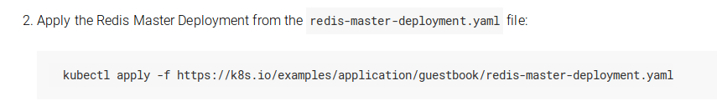
2. Creating the Redis Master Service
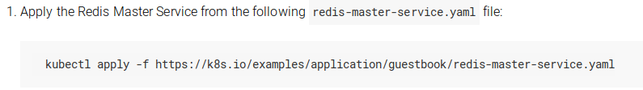
3. Creating the Redis Slave Deployment
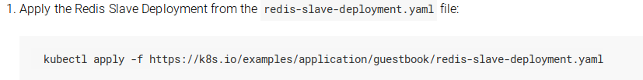
4. creating the Redis Slave Service
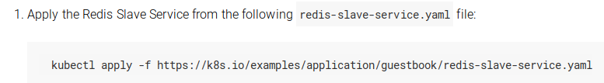

The guestbook application has a web frontend serving the HTTP requests written in PHP. It is configured to connect to the redis-master Service for write requests and the redis-slave service for Read requests

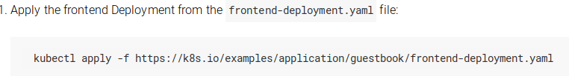
5. Creating the Guestbook Frontend Deployment
6. Creating the Frontend Service
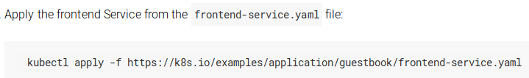

7. finding service’s url
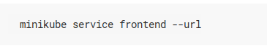

We’ve got : http://192.168.5.140:30811

