--- Installation ---
Normally, it’s better to lance the kubenetes on the host. Cause that kubenetes can communicate to the VM-driver which is installed on the host.

– however, if we have to run the kubernetes on a VM (Ubuntu), it’s possible to use minikube( a version reduced) on VM and with the start command :
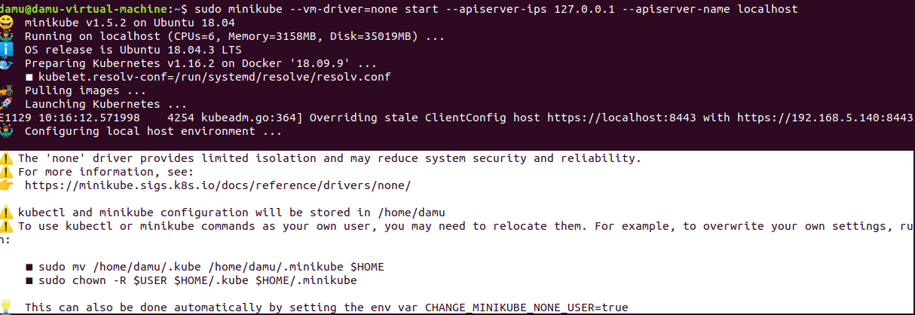
`minikube start --vm-driver=none --apiserver-ips 127.0.0.1 --apiserver-name localhost`

ref-link:(https://stackoverflow.com/questions/55298938/error-starting-minikube-on-ubuntu-vm-virutalbox)

If you didn’t do the apiserver configurations, you might meet the problems as below :
--- configuration ---
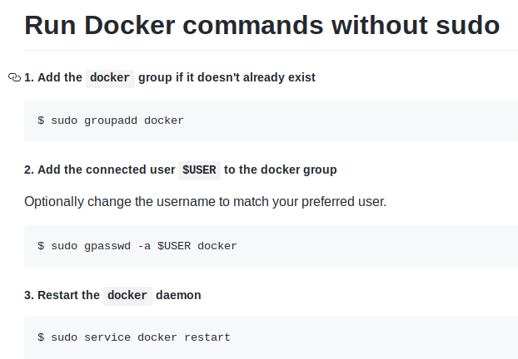

--- Utilization ---
After the configurations necessary, “kubectl” will be configured to use “minikube”

First tutorial – Hello-World
https://kubernetes.io/docs/setup/learning-environment/minikube/
Some notes :
1. deployment
2. expose the deployment
3. get the pod : kubectl get pod
4. Get the URL of the exposed Service
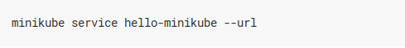

we can view the details of the cluster by visit this url

5. Delete
5.1 delete the Service


5.2 delete the Deployment

5.3 delete (Minicube) Cluster
stop : minikube stop
delete : minikube delete All the containers related on the docker will be deleted after this step

Starting a Cluster :
The minikube start command can be used to start your cluster. This command creates and configures a Virtual Machine that runs a single-node Kubernetes cluster. This command also configures your kubectl installation to communicate with this cluster.
→ Normally, one cluster is executed on one VM. ???

The VMs that we can use :
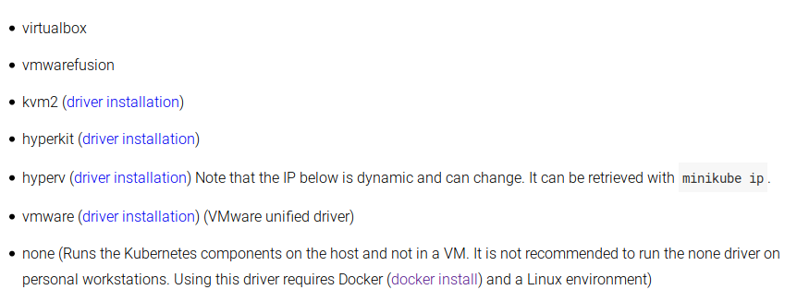

Components configuration by minikube ~
For example : --extra-config=apiserver.authorization-mode=RBAC
---------------------------------------------------------------
Dashboard : sudo minikube dashboard

