Note

– This exercise isn’t complicated, I have finished all the task without any problem.

BUT,

There is no limitation when we create the containers :
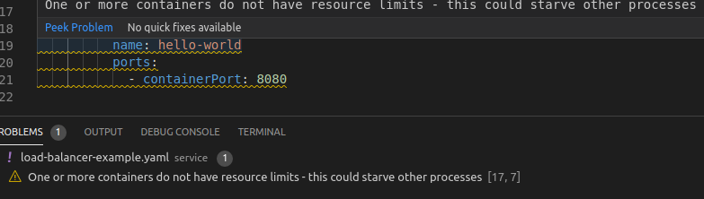

So we get the remind :
One or more containers do not have resource limits – this could starve other processes.

As a result, it took me a lot of time to deploy a simple service (expose the 5 Pods ip address) :
