Add logging and metrics to the PHP / Redis Guestbook example

Key Words: Lightweight log, metric

1. Start up the PHP Guestbook with Redis
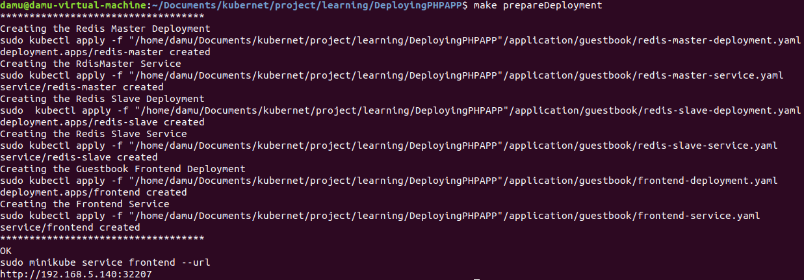
OK.
(I’ve wrote a Makefile to run the deployment commands)

2. Add a Cluster role binding
( ps : A role binding grants the permissions defined in a role to a user or set of users. It holds a list of subjects (users, groups, or service accounts), and a reference to the role being granted. Permissions can be granted within a namespace with a RoleBinding, or cluster-wide with a ClusterRoleBinding. )

kubectl create clusterrolebinding cluster-admin-binding \
--clusterrole=cluster-admin --user=<your email associated with the k8s provider account>
3. Install kube-state-metrics
(ps : Kubernetes kube-state-metrics is a simple service that listens to the Kubernetes API server and generates metrics about the state of the objects. Metricbeat reports these metrics. )

check if the kube-state-metrics exist :
if not :
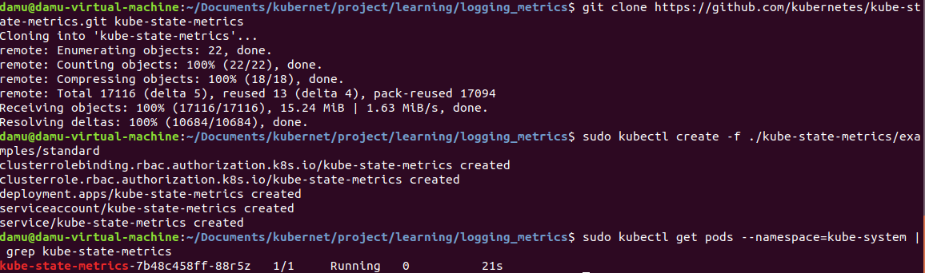
4. Clone the Elastic examples GitHub repo
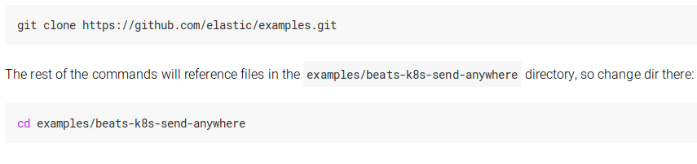
5. Create a Kubernetes Secret
(ps : A Kubernetes Secret is an object that contains a small amount of sensitive data such as a password, a token, or a key. Such information might otherwise be put in a Pod specification or in an image; putting it in a Secret object allows for more control over how it is used, and reduces the risk of accidental exposure.)

Start :
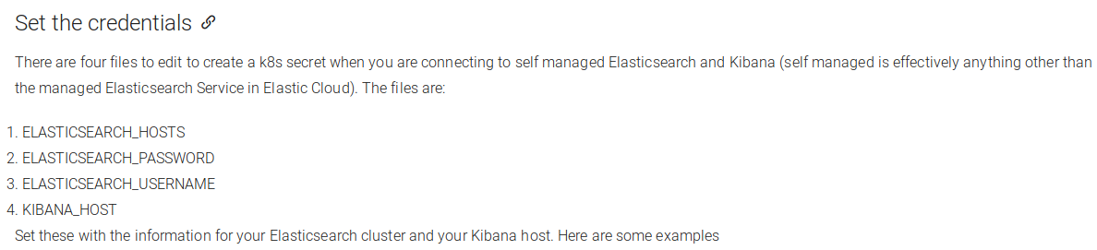
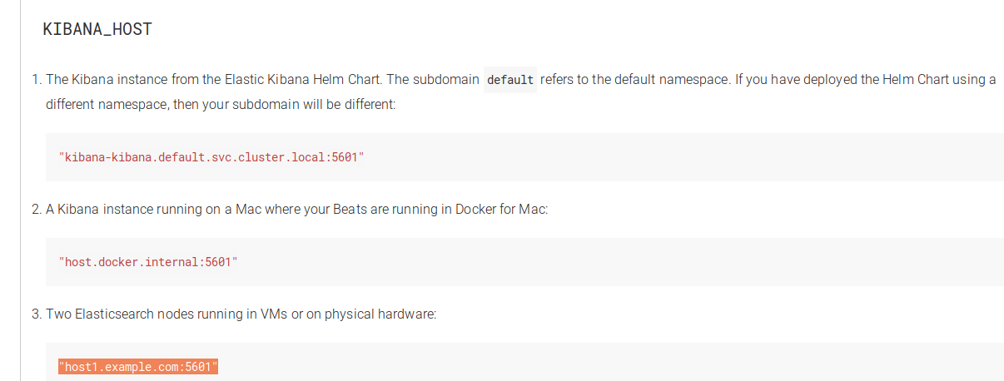
What is KIBANA_HOST used for ?

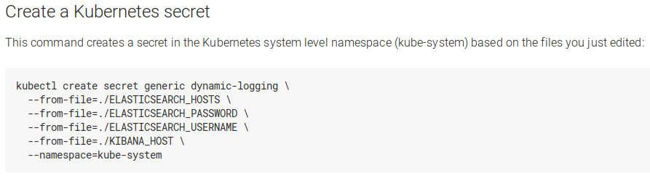

6. Deploy the Beats
(ps : Manifest files are provided for each Beat. These manifest files use the secret created earlier to configure the Beats to connect to your Elasticsearch and Kibana servers)

Filebeat will collect logs from the Kubernetes nodes and the containers running in each pod running on those nodes. Filebeat is deployed as a DaemonSet . Filebeat can autodiscover applications running in your Kubernetes cluster. At startup Filebeat scans existing containers and launches the proper configurations for them, then it will watch for new start/stop events.

However, it’s seemed that the running version of minikube on my device do not support this function.
I’ve got this :

https://kubernetes.io/docs/tutorials/stateless-application/guestbook-logs-metrics-with-elk/

To be done …
(I will continue this tutorial when I install a complete version of K8)

