StudentPay AI
Execution Evidence
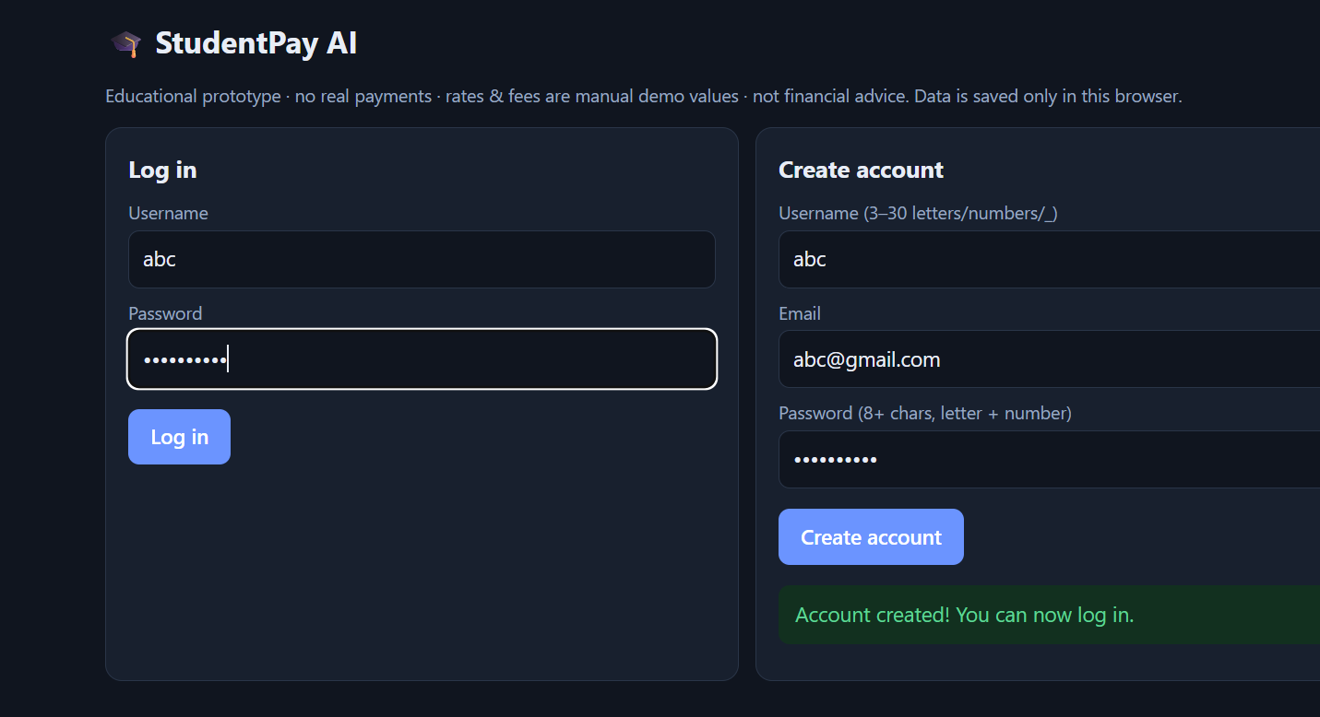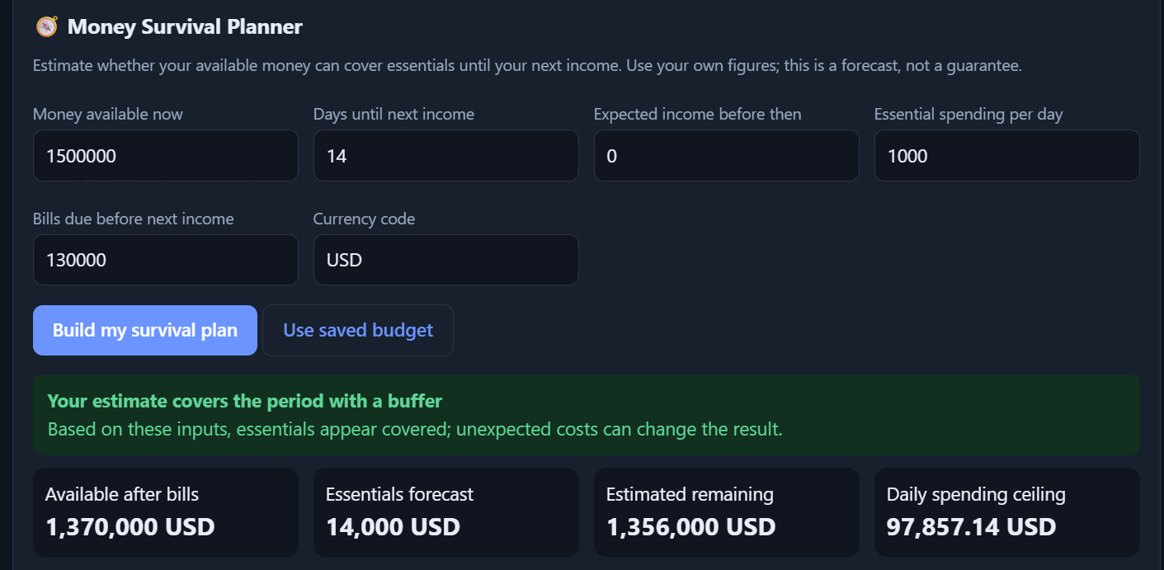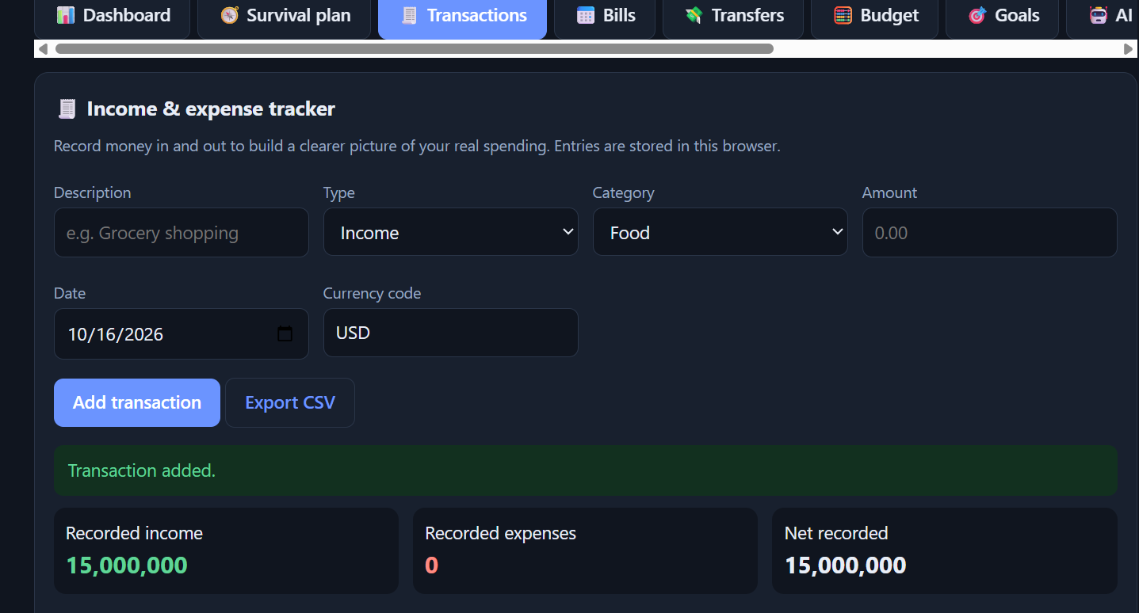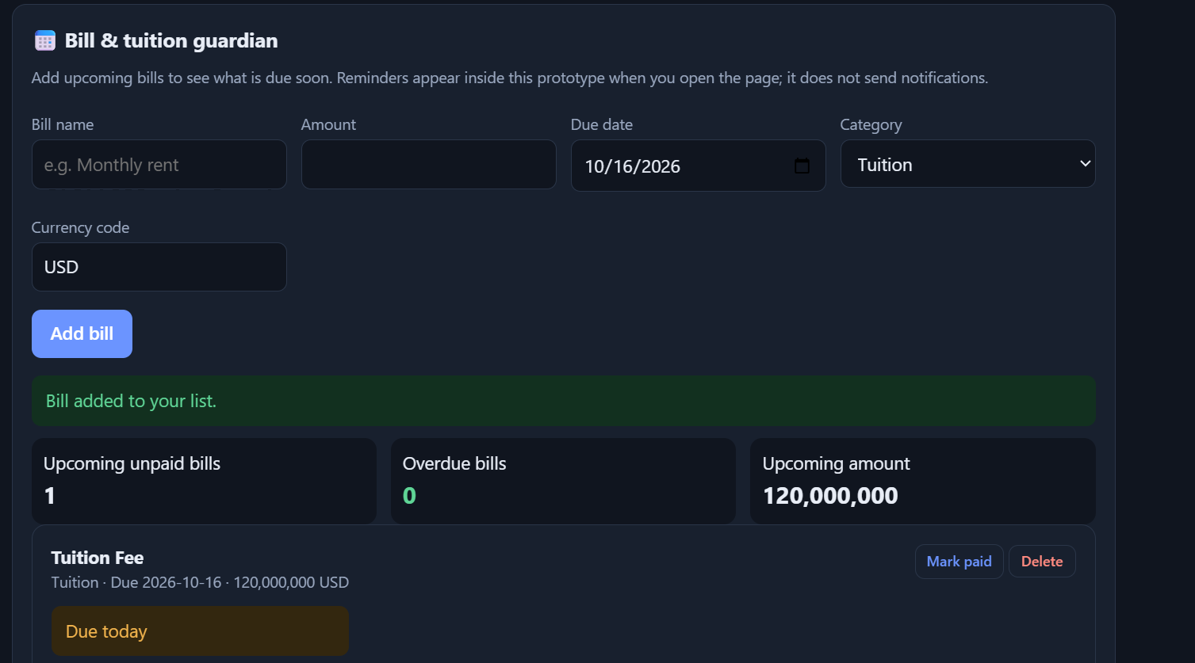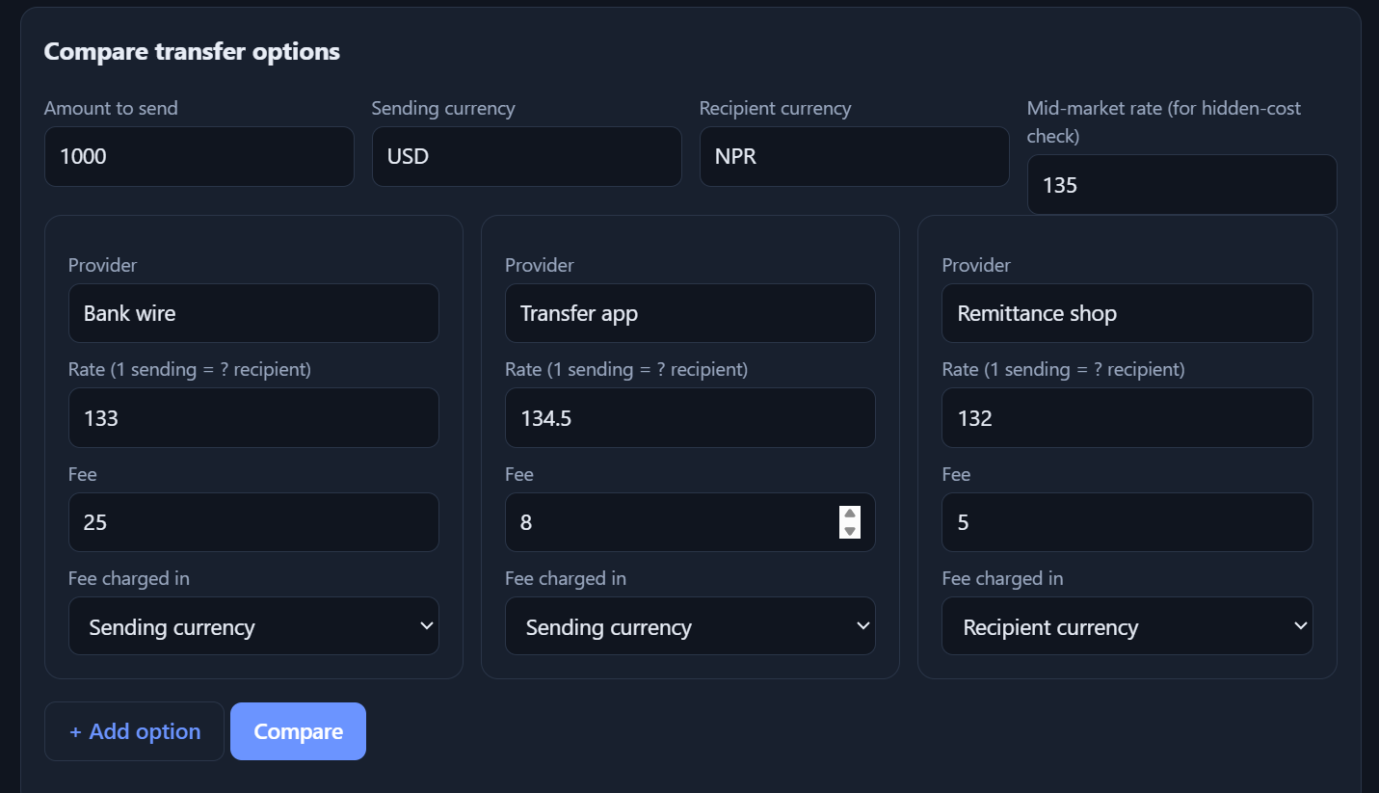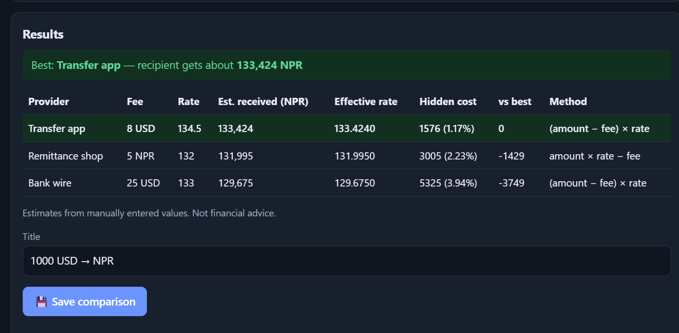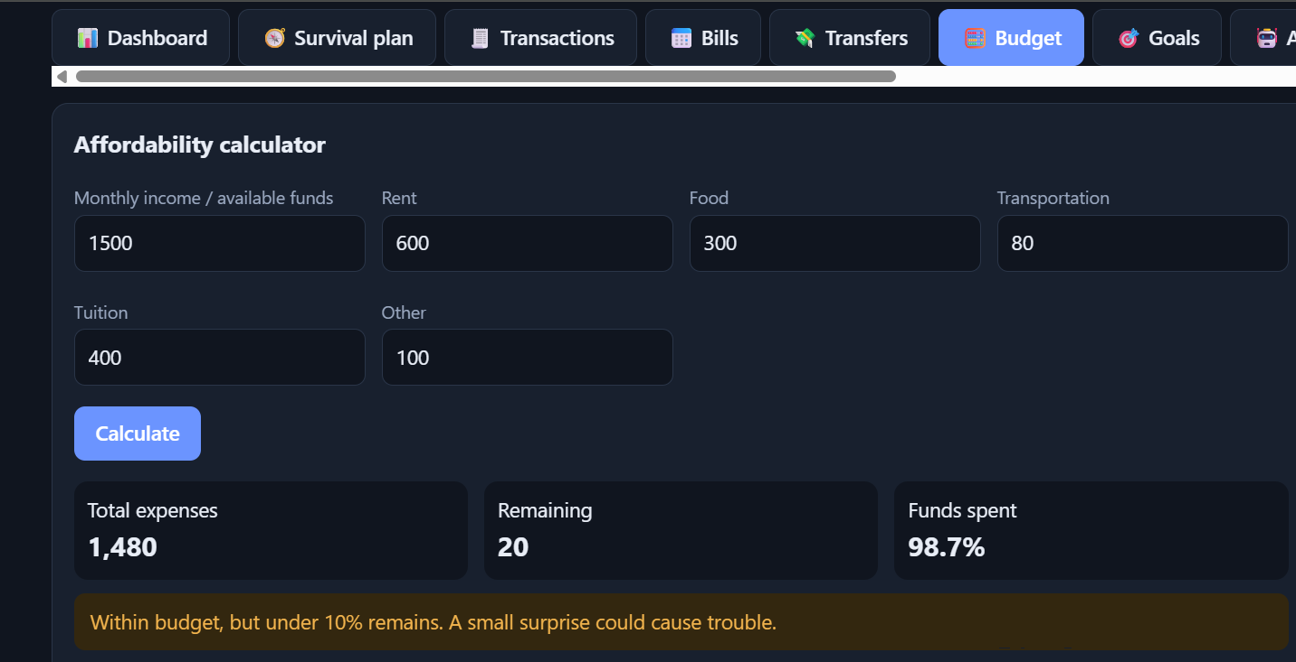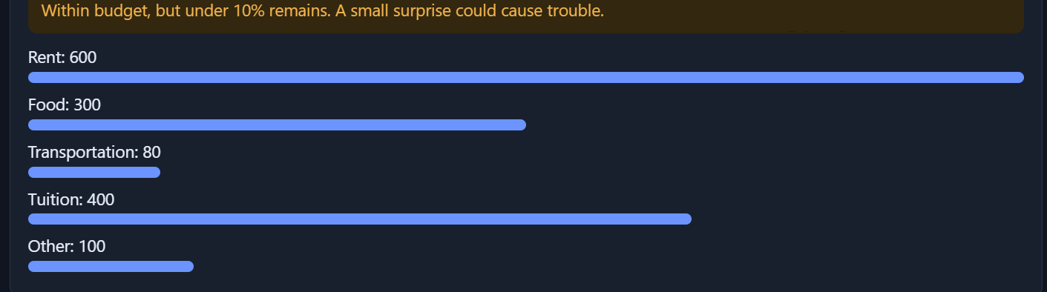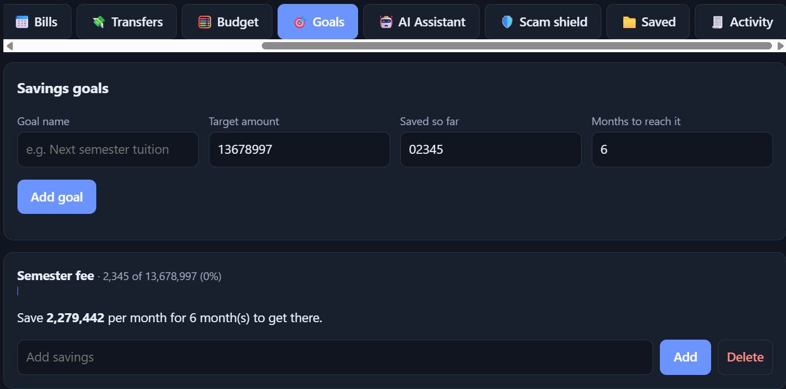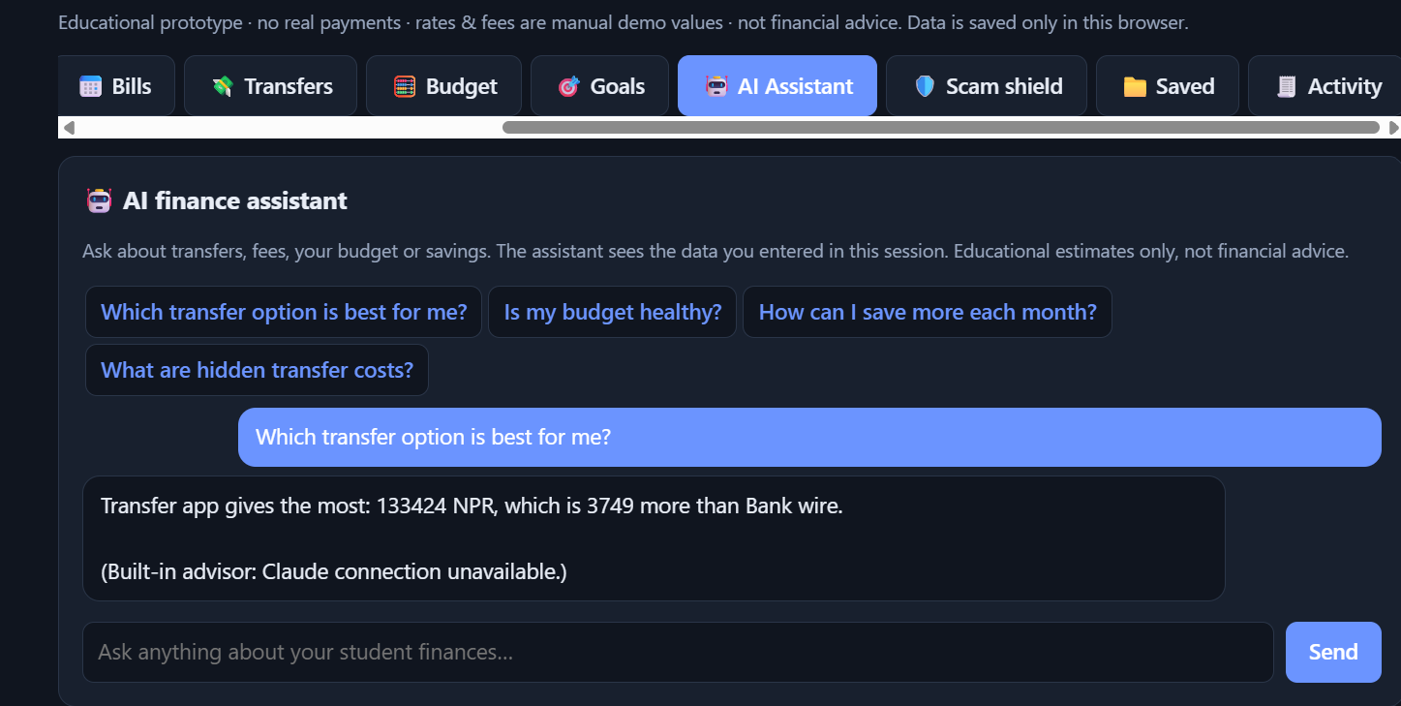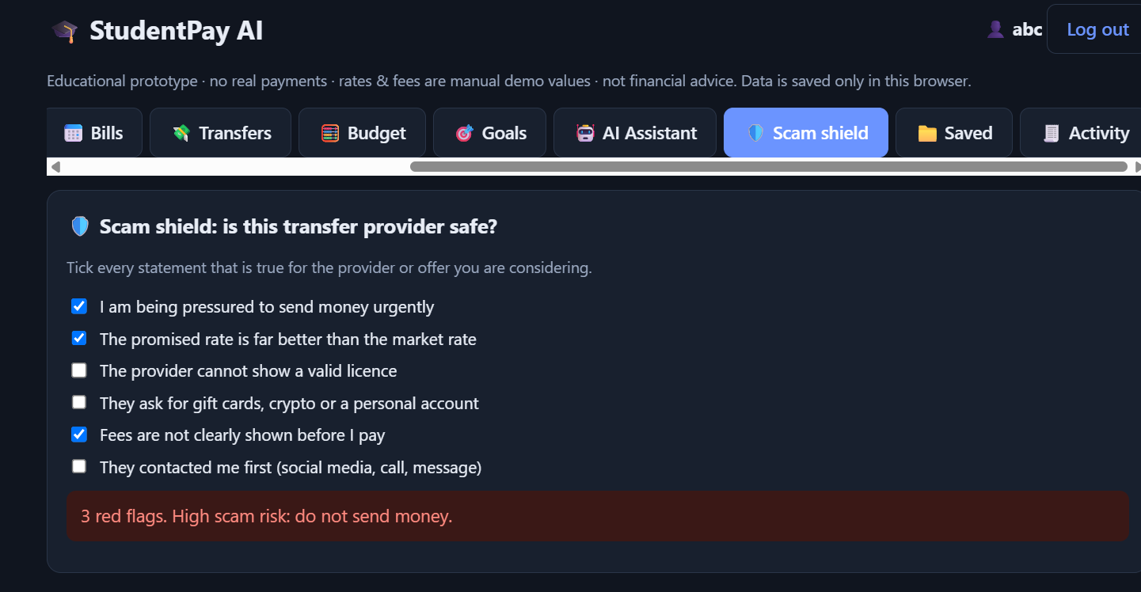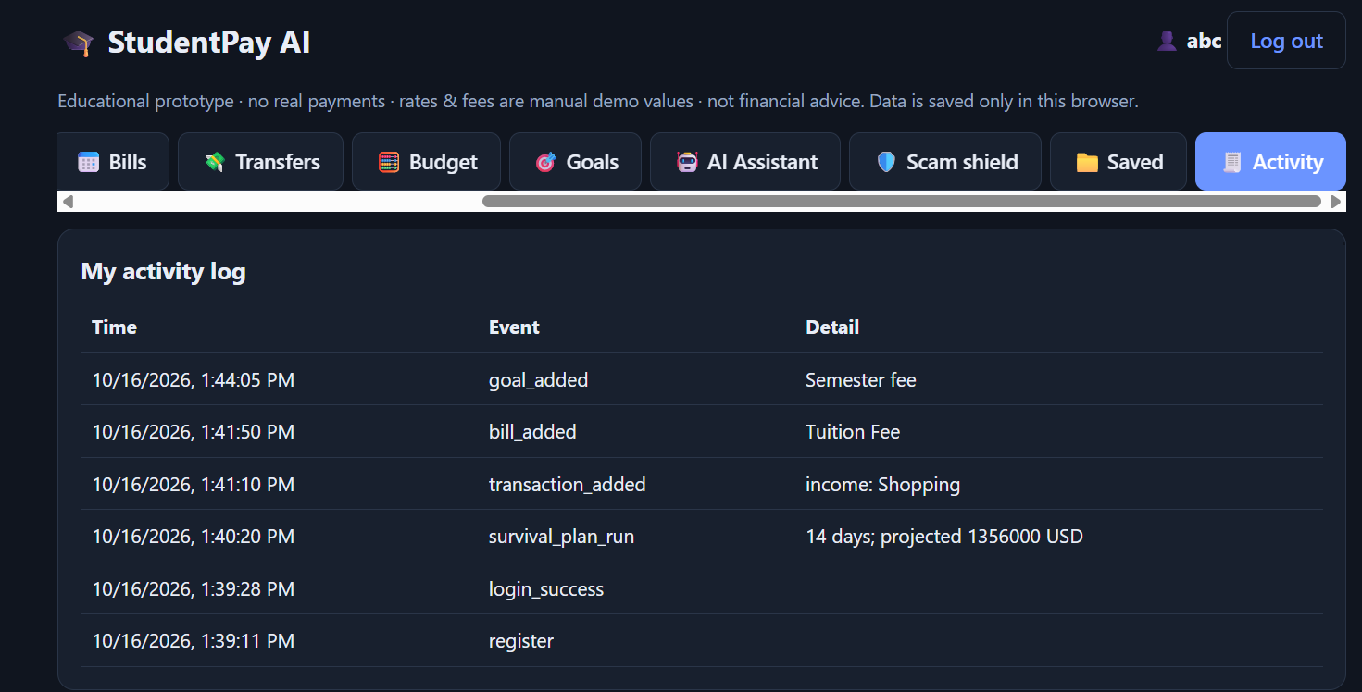

TC-01 — Registration — Valid
Test Action | Create a new account using a valid username, email, and password.
Expected Result | Account is created successfully.
Actual Result
Status | ☑ PASS

TC-02 — Registration — Duplicate
Test Action | Attempt to register using an existing username or email.
Expected Result | Duplicate registration is rejected.
Actual Result
Status | ☑ PASS

TC-03 — Login — Valid
Test Action | Log in using valid account credentials.
Expected Result | User is logged in and the application opens.
Actual Result
Status | ☑ PASS

TC-04 — Login — Invalid
Test Action | Enter an incorrect password for an existing account.
Expected Result | Login error is displayed and the failed attempt is recorded.
Actual Result
Status | ☑ PASS

TC-05 — Login Lockout
Test Action | Perform five failed login attempts within the lockout period.
Expected Result | Temporary account lockout is triggered.
Actual Result
Status | ☑ PASS

TC-06 — Transfer Comparison
Test Action | Enter a transfer amount and provider rates/fees.
Expected Result | Provider comparison is displayed and the best estimated result is identified.
Actual Result
Status | ☑ PASS

TC-07 — Transfer Hidden Cost
Test Action | Enter the mid-market rate, provider rate, and fee.
Expected Result | Hidden cost and percentage are calculated and displayed.
Actual Result
Status | ☑ PASS

TC-08 — Budget
Test Action | Enter monthly income and monthly expenses.
Expected Result | Total expenses, remaining amount, and budget status are displayed.
Actual Result
Status | ☑ PASS

TC-09 — Survival Planner
Test Action | Enter balance, days until income, daily essentials, bills, and expected income.
Expected Result | Estimated remaining amount and status are displayed.
Actual Result
Status | ☑ PASS

TC-10 — Transaction
Test Action | Add an income or expense transaction.
Expected Result | Transaction appears and totals are updated.
Actual Result
Status | ☑ PASS

TC-11 — CSV Export
Test Action | Create a transaction and export the transaction data.
Expected Result | CSV file is generated successfully.
Actual Result
Status | ☑ PASS

TC-12 — Bills — Upcoming
Test Action | Add a bill with a future due date.
Expected Result | Bill is displayed as Upcoming.
Actual Result
Status | ☑ PASS

TC-13 — Bills — Overdue
Test Action | Add a bill with a past due date.
Expected Result | Bill is displayed as Overdue.
Actual Result
Status | ☑ PASS

TC-14 — Savings Goal
Test Action | Create a savings goal with target amount, saved amount, and timeframe.
Expected Result | Progress and required monthly saving are displayed.
Actual Result
Status | ☑ PASS

TC-15 — Scam Shield
Test Action | Select multiple scam-warning indicators.
Expected Result | Risk level and warning guidance are displayed.
Actual Result
Status | ☑ PASS

TC-16 — AI Assistant
Test Action | Ask a relevant budgeting or transfer question.
Expected Result | An AI response or local fallback response is displayed.
Actual Result
Status | ☑ PASS

TC-17 — Activity Log
Test Action | Perform several application actions.
Expected Result | Relevant actions appear in the activity log.
Actual Result
Status | ☑ PASS

TC-18 — Persistence
Test Action | Save data, reload the prototype, and revisit the relevant module.
Expected Result | Previously saved prototype data remains available.
Actual Result
Status | ☑ PASS

