**7-1 Project 3-D Scene**

**Shaun Rester**

Department of Technology, Southern New Hampshire University

CS-330: Comp Graphic and Visualization

Dr. Brian Holbert

August 14, 2022

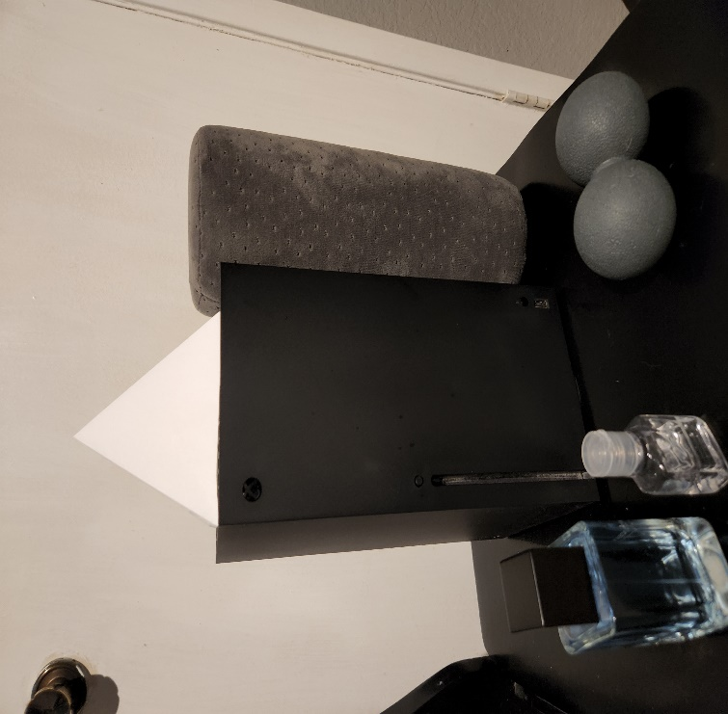

While trying to figure out what scene to create I chose to add multiple objects to give myself options to choose from. These objects were also chosen to give me practice with each type of primitive shape we could choose from. Due to a large number of outside forces, I ran into a brick wall while working on this project and chose to submit the objects I had fully functioning being a rectangular prism cologne bottle, a cube lid, and the plane, as well as the Xbox with the pyramid party hat. I am still working on the other 3 objects so I can complete the expectations I set upon myself. I positioned the objects with the proper spacings so I can keep working smoothly when possible. Using the power of my supreme hindsight I should have selected a different example for the Xbox, trying to find texture opens for Xbox that were copy right free were near impossible which led me to utilizing a basic black/grey texture that I felt reflected its colors well. Each object got its own texture, I do feel the cologne bottle could have benefited from having multiple maybe even a cube map type layout to show the different facets of the bottle. If my photo shop skills were better, I feel I could have made it much simpler. Choosing to texture the pyramid felt like a requirement, just leaving it white didn’t give a paper feel to the object. I chose some very basic lighting due to how reflective my objects looked once textured.

The screen navigation is pretty simplistic for my scene. One suggestion for the start of navigation is to scroll down to slow the speed, the camera starts out very quickly changing it to .5 is a change I plan on implementing. When navigation commences users can use WASD keys to move forward, left, backwards, and right. I also set up Q/E to handle moving the camera up and down. Our code utilizes process input functions to properly handle commands from keys. As stated in the first suggestion I established the scroll wheel to handle changing the speed of the camera with the recommendation of slow down from first use until the fix is implanted. Users can also utilize the mouse to look around the scene, mouse callback functions were established for mouse position and to acknowledge scrolling is happening.

One aspect I feel made my code more modular would most likely be the usage of #pragma region to create and bind the mesh. Breaking the code up into sections where textures, vertices for our objects, as well as our inputs and meshes were all kept together instead of each object and aspect being thrown about or having its own source file. I feel keeping them together and broken up into parts was efficient because it allows us to maintain every area in a quicker manner since we can make all adjustments to one section at a time working from top to bottom. When adding more pieces to the project it made it simpler by giving me the option to copy the previous lines and adjusting them accordingly for the new object.