jenkins下使用git获取源码的配置方法
一、 jenkins获取git上public(公有)的项目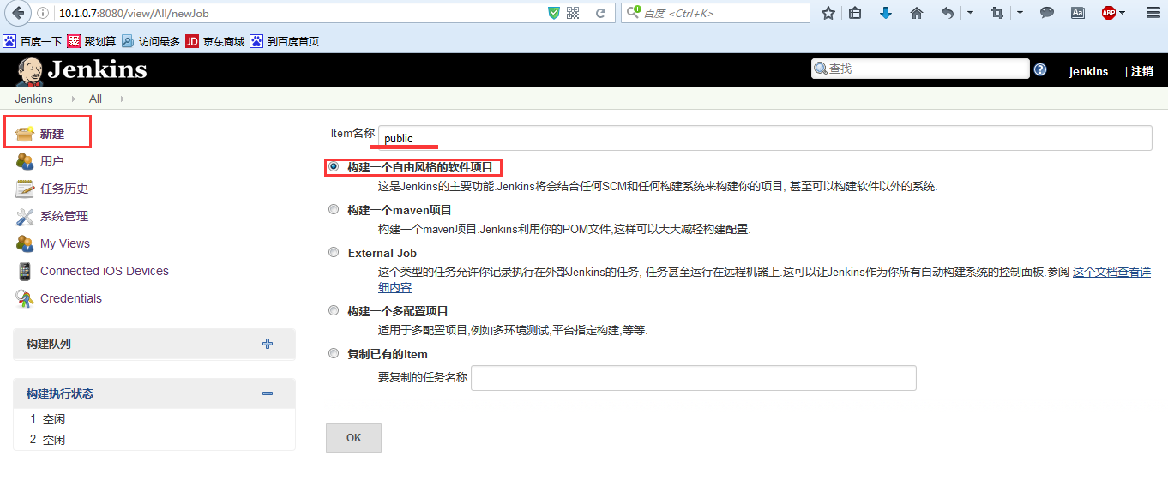

Repository URL https://github.com/devenfan/SpringBootDemo2.git
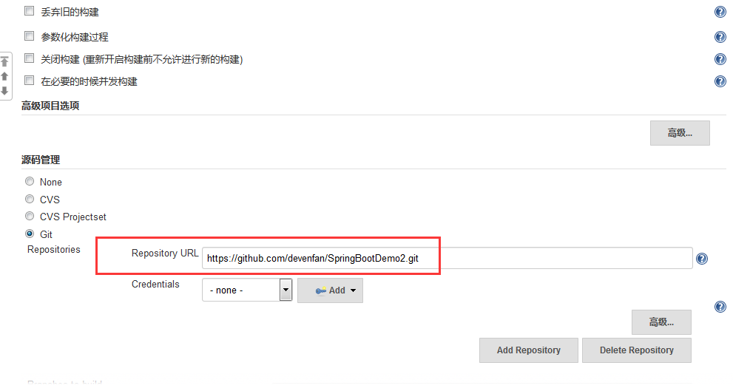
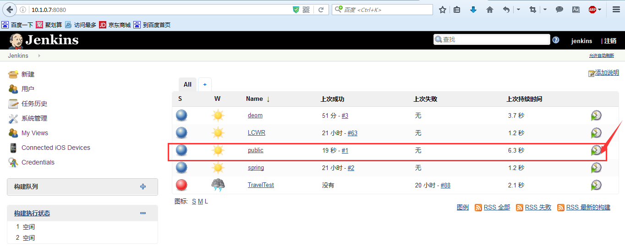
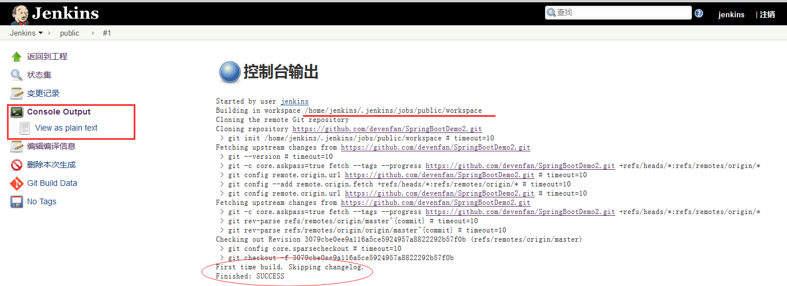二、jenkins获取git上private(私有)的项目

[root@haifeng ~]# git config --global user.name "seaapex"

[root@haifeng ~]# git config --global user.email "fittec@qq.com"

生成ssh key
[root@haifeng ~]# ssh-keygen -t rsa -C "fittec@qq.com"
Generating public/private rsa key pair.
Enter file in which to save the key (/root/.ssh/id_rsa):
Created directory '/root/.ssh'.
Enter passphrase (empty for no passphrase):
Enter same passphrase again:
Your identification has been saved in /root/.ssh/id_rsa.
Your public key has been saved in /root/.ssh/id_rsa.pub.
The key fingerprint is:
e8:fc:37:bd:9a:49:76:4e:d1:4b:b5:3c:01:6d:ad:68 fittec@qq.com
The key's randomart image is:
+--[ RSA 2048]----+
| .. .|
| .o.|
| ..o.|
| . E.o.o|
| . S .. o+ |
| o o ..|
| o o.o . |
| . oo*. |
| ..+oo. |
+-----------------+
[root@haifeng ~]# ls
conf data docker Dockerfile logs Main.java
[root@haifeng ~]# pwd
/root
[root@haifeng ~]# cd .ssh/
[root@haifeng .ssh]# ls
id_rsa id_rsa.pub
在github上添加ssh密钥，这要添加的是“id_rsa.pub”里面的公钥。
打开https://github.com/ ，登陆seaapex，然后添加ssh。
[root@haifeng .ssh]# ssh git@github.com
The authenticity of host 'github.com (192.30.253.112)' can't be established.
RSA key fingerprint is 16:27:ac:a5:76:28:2d:36:63:1b:56:4d:eb:df:a6:48.
Are you sure you want to continue connecting (yes/no)? yes
Warning: Permanently added 'github.com,192.30.253.112' (RSA) to the list of known hosts.
PTY allocation request failed on channel 0
Hi seaapex! You've successfully authenticated, but GitHub does not provide shell access.
Connection to github.com closed.
[root@haifeng .ssh]# git clone git@github.com:seaapex/SpringBootDemo2.git
正克隆到 'SpringBootDemo2'...
remote: Counting objects: 55, done.
remote: Total 55 (delta 0), reused 0 (delta 0), pack-reused 55
接收对象中: 100% (55/55), 50.59 KiB | 4.00 KiB/s, done.
处理 delta 中: 100% (6/6), done.
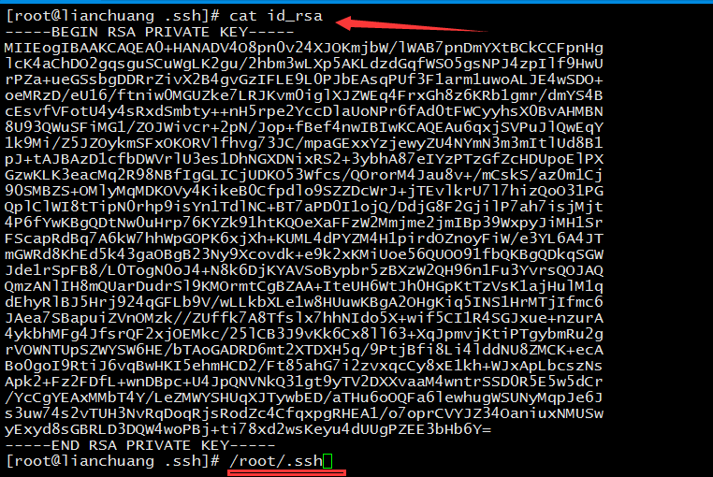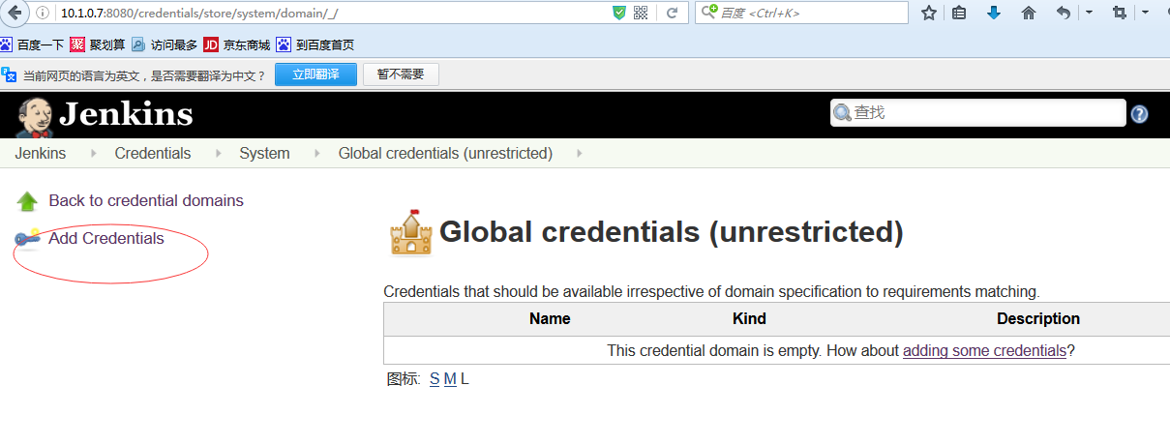

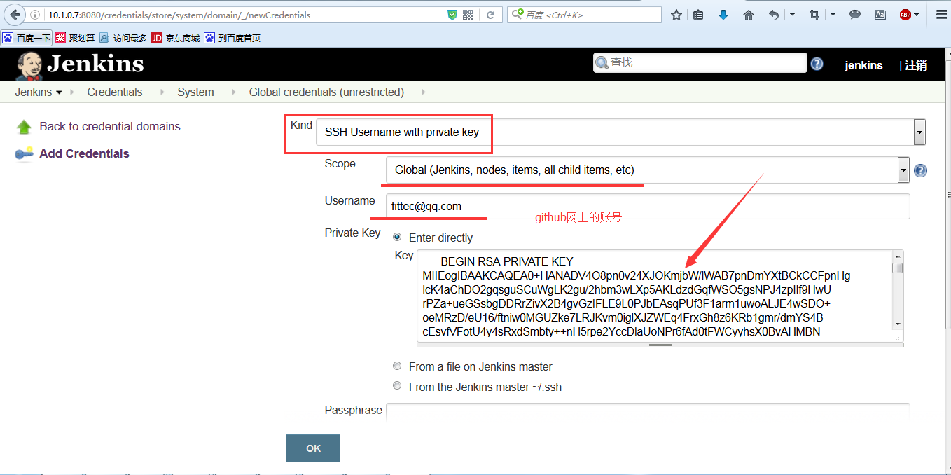

git@github.com:seaapex/SpringBootDemo2.git
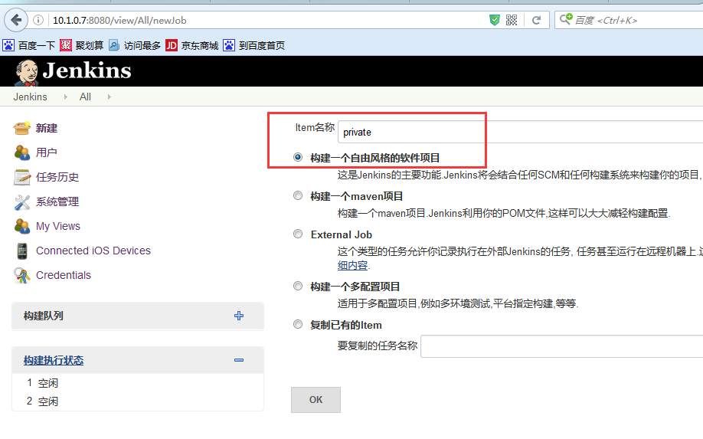

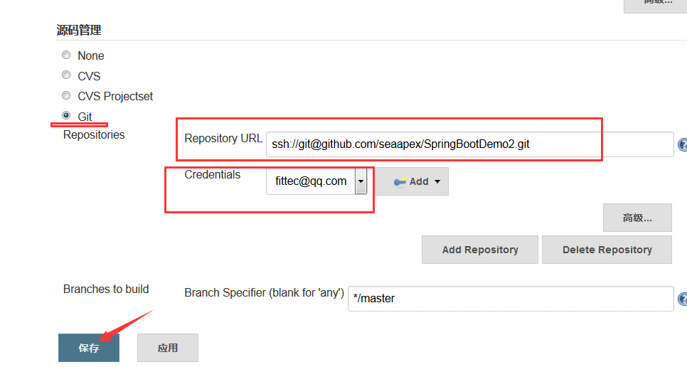
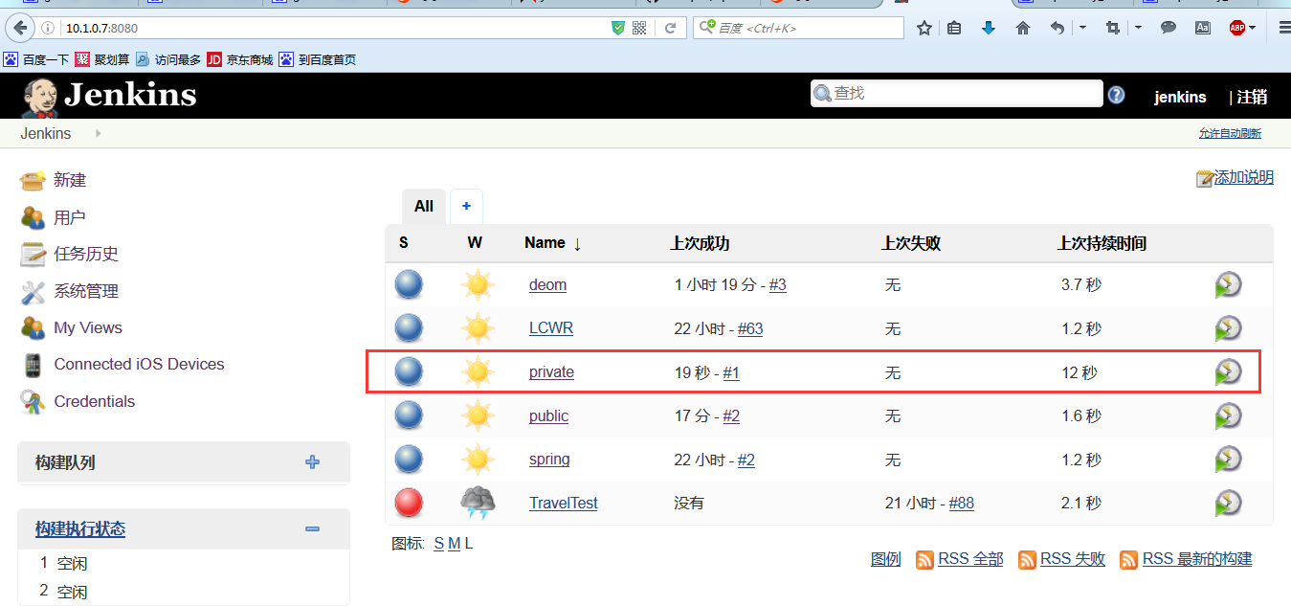
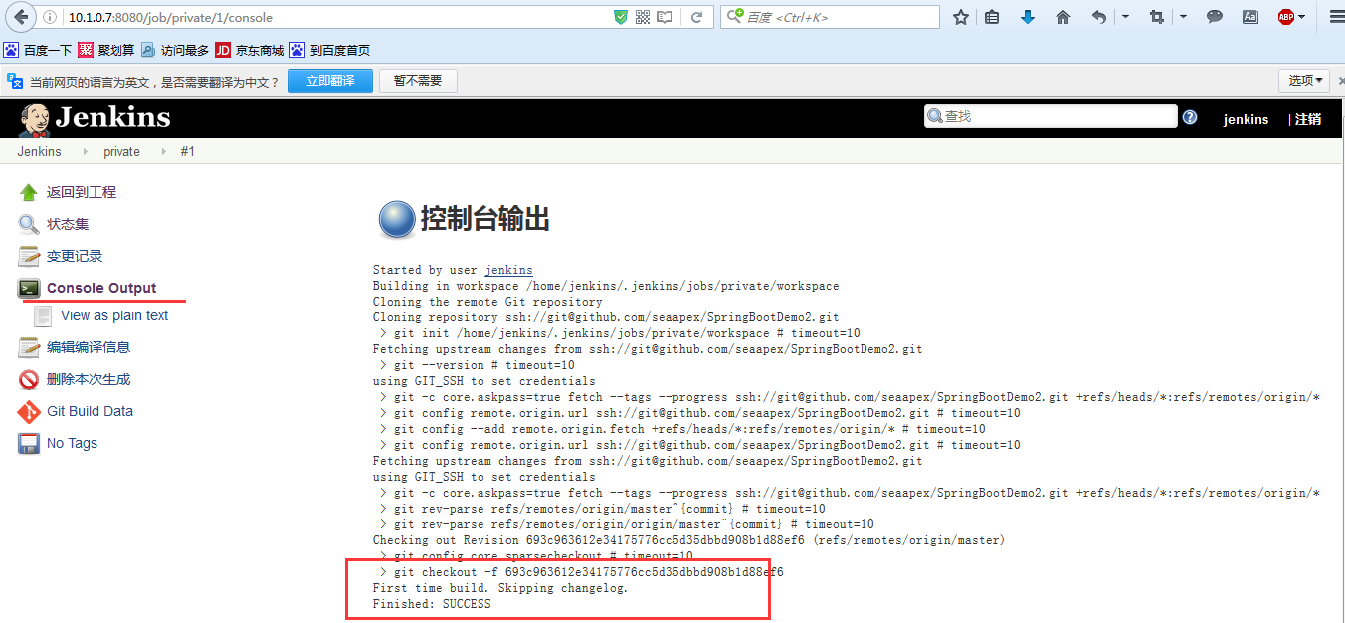

[jenkins@lianchuang ~]$ git clone https://github.com/seaapex/SpringBootDemo2.git
正克隆到 'SpringBootDemo2'...
remote: Counting objects: 52, done.
remote: Total 52 (delta 0), reused 0 (delta 0), pack-reused 52
展开对象中: 100% (52/52), 完成.
检查连接... 完成。
[jenkins@lianchuang ~]$ ls
apache-maven-3.3.9-bin.tar.gz jenkins.war nohup.out SpringBootDemo2
[jenkins@lianchuang ~]$ cd SpringBootDemo2/
[jenkins@lianchuang SpringBootDemo2]$ ls
a.txt demo2.log LICENSE logs pom.xml README.MD src
[jenkins@lianchuang SpringBootDemo2]$ touch index.html
[jenkins@lianchuang SpringBootDemo2]$ echo "This is a git test" >index.html
[jenkins@lianchuang SpringBootDemo2]$ cat index.html
This is a git test
[jenkins@lianchuang SpringBootDemo2]$ git add index.html
[jenkins@lianchuang SpringBootDemo2]$ git commit -m "index.html"
[master b56accb] index.html
1 file changed, 1 insertion(+)
create mode 100644 index.html
[jenkins@lianchuang SpringBootDemo2]$ git push origin master

(gnome-ssh-askpass:5085): Gtk-WARNING **: cannot open display:
error: unable to read askpass response from '/usr/libexec/openssh/gnome-ssh-askpass'
Username for 'https://github.com': fittec@qq.com

(gnome-ssh-askpass:5106): Gtk-WARNING **: cannot open display:
error: unable to read askpass response from '/usr/libexec/openssh/gnome-ssh-askpass'
Password for 'https://fittec@qq.com@github.com':
对象计数中: 3, 完成.
Delta compression using up to 8 threads.
压缩对象中: 100% (2/2), 完成.
写入对象中: 100% (3/3), 286 bytes | 0 bytes/s, 完成.
Total 3 (delta 1), reused 0 (delta 0)
To https://github.com/seaapex/SpringBootDemo2.git
693c963..b56accb master -> master

