Wyniki
2026-03-26
## ── Attaching core tidyverse packages ──────────────────────── tidyverse 2.0.0 ──
## ✔ dplyr 1.1.3 ✔ readr 2.1.4
## ✔ forcats 1.0.0 ✔ stringr 1.5.0
## ✔ ggplot2 3.4.3 ✔ tibble 3.2.1
## ✔ lubridate 1.9.2 ✔ tidyr 1.3.0
## ✔ purrr 1.0.2
## ── Conflicts ────────────────────────────────────────── tidyverse_conflicts() ──
## ✖ dplyr::filter() masks stats::filter()
## ✖ dplyr::lag() masks stats::lag()
## ℹ Use the conflicted package (<http://conflicted.r-lib.org/>) to force all conflicts to become errors
## Warning: package 'psych' was built under R version 4.3.3
##
## Attaching package: 'psych'
##
## The following objects are masked from 'package:ggplot2':
##
## %+%, alpha
## Warning: package 'effsize' was built under R version 4.3.3
##
## Attaching package: 'effsize'
##
## The following object is masked from 'package:psych':
##
## cohen.d
## Warning: package 'EnvStats' was built under R version 4.3.3
##
## Attaching package: 'EnvStats'
##
## The following objects are masked from 'package:stats':
##
## predict, predict.lm
## Warning: package 'lme4' was built under R version 4.3.3
## Loading required package: Matrix
##
## Attaching package: 'Matrix'
##
## The following objects are masked from 'package:tidyr':
##
## expand, pack, unpack
## Warning: package 'lmerTest' was built under R version 4.3.3
##
## Attaching package: 'lmerTest'
##
## The following object is masked from 'package:lme4':
##
## lmer
##
## The following object is masked from 'package:stats':
##
## step
## Warning: package 'emmeans' was built under R version 4.3.3
## Warning: package 'ggpubr' was built under R version 4.3.3
## Warning: package 'rstatix' was built under R version 4.3.3
##
## Attaching package: 'rstatix'
##
## The following object is masked from 'package:stats':
##
## filter
## Warning: package 'gridExtra' was built under R version 4.3.3
##
## Attaching package: 'gridExtra'
##
## The following object is masked from 'package:dplyr':
##
## combine
## Warning: package 'multcompView' was built under R version 4.3.3
## This is lavaan 0.6-21
## lavaan is FREE software! Please report any bugs.
##
## Attaching package: 'lavaan'
##
## The following object is masked from 'package:psych':
##
## cor2cov
## Warning: package 'foreign' was built under R version 4.3.3
##
## Attaching package: 'GPArotation'
##
## The following objects are masked from 'package:psych':
##
## equamax, varimin
## Warning: lavaan->lav_lavaan_step01_ovnames_checklv():
## Some latent variable names collide with observed variable names in the
## dataset: KWS_SS KWS_WOD KWS_JZ KWS_W KWS_CYN. Please provide alternative
## names for the latent variables, or switch off this check using
## check.lv.names = FALSE
## Warning: lavaan->lav_object_post_check():
## covariance matrix of latent variables is not positive definite ; use
## lavInspect(fit, "cov.lv") to investigate.
## lavaan 0.6-21 ended normally after 78 iterations
##
## Estimator ML
## Optimization method NLMINB
## Number of model parameters 48
##
## Number of observations 219
##
## Model Test User Model:
##
## Test statistic 387.811
## Degrees of freedom 142
## P-value (Chi-square) 0.000
##
## Model Test Baseline Model:
##
## Test statistic 1550.281
## Degrees of freedom 171
## P-value 0.000
##
## User Model versus Baseline Model:
##
## Comparative Fit Index (CFI) 0.822
## Tucker-Lewis Index (TLI) 0.785
##
## Loglikelihood and Information Criteria:
##
## Loglikelihood user model (H0) -5970.128
## Loglikelihood unrestricted model (H1) -5776.222
##
## Akaike (AIC) 12036.255
## Bayesian (BIC) 12198.930
## Sample-size adjusted Bayesian (SABIC) 12046.820
##
## Root Mean Square Error of Approximation:
##
## RMSEA 0.089
## 90 Percent confidence interval - lower 0.078
## 90 Percent confidence interval - upper 0.100
## P-value H_0: RMSEA <= 0.050 0.000
## P-value H_0: RMSEA >= 0.080 0.919
##
## Standardized Root Mean Square Residual:
##
## SRMR 0.081
##
## Parameter Estimates:
##
## Standard errors Standard
## Information Expected
## Information saturated (h1) model Structured
##
## Latent Variables:
## Estimate Std.Err z-value P(>|z|) ci.lower ci.upper
## KWS_SS =~
## KWS_1 1.000 1.000 1.000
## KWS_4 1.074 0.184 5.849 0.000 0.714 1.433
## KWS_8 1.420 0.218 6.517 0.000 0.993 1.847
## KWS_WOD =~
## KWS_2 1.000 1.000 1.000
## KWS_5 1.055 0.133 7.926 0.000 0.794 1.316
## KWS_9 0.861 0.131 6.593 0.000 0.605 1.117
## KWS_13 1.207 0.126 9.595 0.000 0.961 1.454
## KWS_16 1.341 0.138 9.696 0.000 1.070 1.612
## KWS_JZ =~
## KWS_3 1.000 1.000 1.000
## KWS_7 1.847 0.283 6.524 0.000 1.292 2.402
## KWS_12 1.967 0.295 6.674 0.000 1.389 2.544
## KWS_15 1.845 0.283 6.513 0.000 1.290 2.400
## KWS_W =~
## KWS_6R 1.000 1.000 1.000
## KWS_11 3.176 0.947 3.352 0.001 1.319 5.032
## KWS_14R 1.891 0.604 3.132 0.002 0.708 3.074
## KWS_18 1.691 0.541 3.126 0.002 0.631 2.752
## KWS_19 2.536 0.771 3.288 0.001 1.024 4.047
## KWS_CYN =~
## KWS_10 1.000 1.000 1.000
## KWS_17 1.602 0.387 4.137 0.000 0.843 2.361
## Std.lv Std.all
##
## 0.637 0.492
## 0.684 0.553
## 0.905 0.678
##
## 0.719 0.691
## 0.758 0.597
## 0.619 0.491
## 0.868 0.738
## 0.964 0.747
##
## 0.466 0.463
## 0.860 0.775
## 0.916 0.835
## 0.859 0.771
##
## 0.279 0.259
## 0.885 0.747
## 0.527 0.489
## 0.472 0.485
## 0.707 0.629
##
## 0.506 0.414
## 0.810 0.572
##
## Covariances:
## Estimate Std.Err z-value P(>|z|) ci.lower ci.upper
## KWS_SS ~~
## KWS_WOD 0.446 0.081 5.538 0.000 0.288 0.604
## KWS_JZ -0.192 0.046 -4.156 0.000 -0.282 -0.101
## KWS_W 0.108 0.038 2.810 0.005 0.033 0.183
## KWS_CYN 0.190 0.060 3.176 0.001 0.073 0.307
## KWS_WOD ~~
## KWS_JZ -0.220 0.046 -4.794 0.000 -0.310 -0.130
## KWS_W 0.095 0.033 2.829 0.005 0.029 0.160
## KWS_CYN 0.226 0.061 3.678 0.000 0.105 0.346
## KWS_JZ ~~
## KWS_W -0.084 0.029 -2.868 0.004 -0.142 -0.027
## KWS_CYN -0.136 0.041 -3.305 0.001 -0.217 -0.055
## KWS_W ~~
## KWS_CYN 0.106 0.040 2.659 0.008 0.028 0.184
## Std.lv Std.all
##
## 0.975 0.975
## -0.646 -0.646
## 0.607 0.607
## 0.589 0.589
##
## -0.657 -0.657
## 0.472 0.472
## 0.621 0.621
##
## -0.651 -0.651
## -0.578 -0.578
##
## 0.750 0.750
##
## Variances:
## Estimate Std.Err z-value P(>|z|) ci.lower ci.upper
## .KWS_1 1.271 0.130 9.770 0.000 1.016 1.526
## .KWS_4 1.060 0.112 9.424 0.000 0.840 1.280
## .KWS_8 0.964 0.121 7.984 0.000 0.728 1.201
## .KWS_2 0.564 0.063 8.919 0.000 0.440 0.688
## .KWS_5 1.041 0.109 9.543 0.000 0.827 1.255
## .KWS_9 1.209 0.122 9.939 0.000 0.970 1.447
## .KWS_13 0.630 0.075 8.430 0.000 0.483 0.776
## .KWS_16 0.735 0.088 8.311 0.000 0.562 0.908
## .KWS_3 0.797 0.080 10.022 0.000 0.641 0.953
## .KWS_7 0.493 0.062 7.916 0.000 0.371 0.615
## .KWS_12 0.365 0.056 6.566 0.000 0.256 0.473
## .KWS_15 0.505 0.063 7.982 0.000 0.381 0.629
## .KWS_6R 1.084 0.106 10.251 0.000 0.876 1.291
## .KWS_11 0.621 0.095 6.538 0.000 0.435 0.807
## .KWS_14R 0.883 0.093 9.515 0.000 0.701 1.065
## .KWS_18 0.722 0.076 9.536 0.000 0.574 0.871
## .KWS_19 0.762 0.090 8.438 0.000 0.585 0.939
## .KWS_10 1.239 0.137 9.049 0.000 0.971 1.507
## .KWS_17 1.347 0.218 6.167 0.000 0.919 1.775
## KWS_SS 0.406 0.114 3.546 0.000 0.182 0.630
## KWS_WOD 0.516 0.094 5.491 0.000 0.332 0.701
## KWS_JZ 0.217 0.064 3.383 0.001 0.091 0.343
## KWS_W 0.078 0.045 1.719 0.086 -0.011 0.166
## KWS_CYN 0.256 0.105 2.425 0.015 0.049 0.462
## Std.lv Std.all
## 1.271 0.758
## 1.060 0.694
## 0.964 0.541
## 0.564 0.522
## 1.041 0.644
## 1.209 0.759
## 0.630 0.455
## 0.735 0.442
## 0.797 0.786
## 0.493 0.400
## 0.365 0.303
## 0.505 0.406
## 1.084 0.933
## 0.621 0.442
## 0.883 0.761
## 0.722 0.765
## 0.762 0.604
## 1.239 0.829
## 1.347 0.673
## 1.000 1.000
## 1.000 1.000
## 1.000 1.000
## 1.000 1.000
## 1.000 1.000
## Warning in alpha(KWS): Some items were negatively correlated with the first principal component and probably
## should be reversed.
## To do this, run the function again with the 'check.keys=TRUE' option
## Some items ( KWS_3 KWS_7 KWS_12 KWS_15 ) were negatively correlated with the first principal component and
## probably should be reversed.
## To do this, run the function again with the 'check.keys=TRUE' option
##
## Reliability analysis
## Call: alpha(x = KWS)
##
## raw_alpha std.alpha G6(smc) average_r S/N ase mean sd median_r
## 0.62 0.59 0.74 0.07 1.4 0.033 3 0.42 0.13
##
## 95% confidence boundaries
## lower alpha upper
## Feldt 0.55 0.62 0.69
## Duhachek 0.56 0.62 0.69
##
## Reliability if an item is dropped:
## raw_alpha std.alpha G6(smc) average_r S/N alpha se var.r med.r
## KWS_1 0.59 0.55 0.72 0.064 1.2 0.036 0.088 0.14
## KWS_2 0.57 0.52 0.70 0.057 1.1 0.038 0.082 0.12
## KWS_3 0.67 0.65 0.78 0.095 1.9 0.029 0.080 0.15
## KWS_4 0.58 0.54 0.72 0.061 1.2 0.037 0.085 0.12
## KWS_5 0.57 0.53 0.71 0.059 1.1 0.038 0.085 0.12
## KWS_6R 0.60 0.56 0.73 0.067 1.3 0.035 0.090 0.13
## KWS_7 0.67 0.65 0.77 0.092 1.8 0.028 0.077 0.15
## KWS_8 0.55 0.51 0.70 0.056 1.1 0.040 0.083 0.12
## KWS_9 0.60 0.56 0.73 0.067 1.3 0.036 0.085 0.13
## KWS_10 0.61 0.57 0.74 0.069 1.3 0.034 0.090 0.14
## KWS_11 0.58 0.54 0.71 0.062 1.2 0.037 0.084 0.12
## KWS_12 0.69 0.67 0.78 0.101 2.0 0.027 0.070 0.15
## KWS_13 0.57 0.53 0.70 0.058 1.1 0.038 0.081 0.13
## KWS_14R 0.62 0.59 0.74 0.074 1.4 0.033 0.089 0.15
## KWS_15 0.68 0.65 0.77 0.094 1.9 0.028 0.076 0.15
## KWS_16 0.56 0.52 0.70 0.057 1.1 0.039 0.079 0.12
## KWS_17 0.59 0.55 0.73 0.064 1.2 0.036 0.087 0.12
## KWS_18 0.59 0.55 0.72 0.063 1.2 0.036 0.086 0.12
## KWS_19 0.59 0.55 0.72 0.063 1.2 0.036 0.086 0.13
##
## Item statistics
## n raw.r std.r r.cor r.drop mean sd
## KWS_1 219 0.48 0.46 0.42 0.34 2.8 1.30
## KWS_2 219 0.63 0.63 0.64 0.55 3.9 1.04
## KWS_3 219 -0.29 -0.26 -0.40 -0.40 2.3 1.01
## KWS_4 219 0.55 0.54 0.51 0.43 2.9 1.24
## KWS_5 219 0.60 0.59 0.57 0.48 3.7 1.27
## KWS_6R 219 0.39 0.41 0.34 0.27 3.2 1.08
## KWS_7 219 -0.21 -0.18 -0.28 -0.34 3.2 1.11
## KWS_8 219 0.69 0.67 0.68 0.59 2.9 1.34
## KWS_9 219 0.43 0.40 0.35 0.29 3.3 1.26
## KWS_10 219 0.38 0.37 0.29 0.23 3.2 1.23
## KWS_11 219 0.53 0.53 0.53 0.42 2.4 1.19
## KWS_12 219 -0.41 -0.39 -0.51 -0.52 3.3 1.10
## KWS_13 219 0.63 0.62 0.63 0.53 3.4 1.18
## KWS_14R 219 0.25 0.25 0.18 0.12 2.5 1.08
## KWS_15 219 -0.25 -0.22 -0.33 -0.37 3.4 1.12
## KWS_16 219 0.66 0.65 0.67 0.56 3.4 1.29
## KWS_17 219 0.50 0.48 0.43 0.35 2.7 1.42
## KWS_18 219 0.47 0.49 0.46 0.37 2.1 0.97
## KWS_19 219 0.49 0.50 0.48 0.37 2.1 1.13
##
## Non missing response frequency for each item
## 1 2 3 4 5 miss
## KWS_1 0.20 0.27 0.14 0.31 0.09 0
## KWS_2 0.02 0.11 0.15 0.41 0.32 0
## KWS_3 0.22 0.37 0.28 0.09 0.03 0
## KWS_4 0.15 0.26 0.26 0.22 0.11 0
## KWS_5 0.05 0.20 0.15 0.25 0.36 0
## KWS_6R 0.05 0.20 0.42 0.17 0.16 0
## KWS_7 0.07 0.22 0.27 0.33 0.11 0
## KWS_8 0.16 0.26 0.20 0.21 0.16 0
## KWS_9 0.08 0.26 0.17 0.28 0.20 0
## KWS_10 0.10 0.20 0.29 0.24 0.17 0
## KWS_11 0.25 0.39 0.16 0.14 0.06 0
## KWS_12 0.09 0.15 0.27 0.40 0.10 0
## KWS_13 0.05 0.24 0.18 0.34 0.20 0
## KWS_14R 0.14 0.44 0.22 0.14 0.06 0
## KWS_15 0.08 0.12 0.33 0.32 0.16 0
## KWS_16 0.09 0.20 0.20 0.26 0.25 0
## KWS_17 0.28 0.24 0.16 0.17 0.15 0
## KWS_18 0.32 0.40 0.21 0.05 0.02 0
## KWS_19 0.40 0.31 0.17 0.08 0.04 0
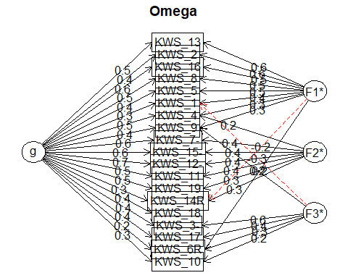
## Omega
## Call: omegah(m = m, nfactors = nfactors, fm = fm, key = key, flip = flip,
## digits = digits, title = title, sl = sl, labels = labels,
## plot = plot, n.obs = n.obs, rotate = rotate, Phi = Phi, option = option,
## covar = covar)
## Alpha: 0.87
## G.6: 0.9
## Omega Hierarchical: 0.62
## Omega H asymptotic: 0.69
## Omega Total 0.9
##
## Schmid Leiman Factor loadings greater than 0.2
## g F1* F2* F3* h2 u2 p2
## KWS_1 0.33 0.37 -0.34 0.37 0.63 0.29
## KWS_2 0.44 0.58 0.54 0.46 0.35
## KWS_3- 0.40 0.62 0.57 0.43 0.29
## KWS_4 0.46 0.27 0.20 0.34 0.66 0.62
## KWS_5 0.38 0.46 0.36 0.64 0.40
## KWS_6R 0.23 0.20 0.34 0.21 0.79 0.25
## KWS_7- 0.58 0.41 0.50 0.50 0.67
## KWS_8 0.46 0.48 0.45 0.55 0.47
## KWS_9 0.38 0.27 0.24 0.28 0.72 0.52
## KWS_10 0.26 0.24 0.15 0.85 0.48
## KWS_11 0.50 0.36 0.41 0.59 0.60
## KWS_12- 0.67 0.37 0.61 0.39 0.73
## KWS_13 0.45 0.60 0.57 0.43 0.36
## KWS_14R 0.30 -0.21 0.29 0.25 0.75 0.36
## KWS_15- 0.59 0.39 0.52 0.48 0.68
## KWS_16 0.58 0.48 0.61 0.39 0.54
## KWS_17 0.36 0.43 0.34 0.66 0.38
## KWS_18 0.42 0.25 0.75 0.71
## KWS_19 0.45 0.34 0.33 0.67 0.63
##
## With Sums of squares of:
## g F1* F2* F3*
## 3.82 1.83 0.94 1.06
##
## general/max 2.09 max/min = 1.94
## mean percent general = 0.49 with sd = 0.16 and cv of 0.32
## Explained Common Variance of the general factor = 0.5
##
## The degrees of freedom are 117 and the fit is 1.38
## The number of observations was 219 with Chi Square = 287.41 with prob < 2.4e-16
## The root mean square of the residuals is 0.06
## The df corrected root mean square of the residuals is 0.07
## RMSEA index = 0.081 and the 10 % confidence intervals are 0.07 0.094
## BIC = -343.11
##
## Compare this with the adequacy of just a general factor and no group factors
## The degrees of freedom for just the general factor are 152 and the fit is 2.93
## The number of observations was 219 with Chi Square = 615.11 with prob < 5.6e-57
## The root mean square of the residuals is 0.13
## The df corrected root mean square of the residuals is 0.14
##
## RMSEA index = 0.118 and the 10 % confidence intervals are 0.109 0.128
## BIC = -204.03
##
## Measures of factor score adequacy
## g F1* F2* F3*
## Correlation of scores with factors 0.81 0.79 0.58 0.80
## Multiple R square of scores with factors 0.66 0.63 0.33 0.63
## Minimum correlation of factor score estimates 0.32 0.25 -0.33 0.26
##
## Total, General and Subset omega for each subset
## g F1* F2* F3*
## Omega total for total scores and subscales 0.90 0.83 0.80 0.57
## Omega general for total scores and subscales 0.62 0.41 0.55 0.21
## Omega group for total scores and subscales 0.19 0.42 0.25 0.35
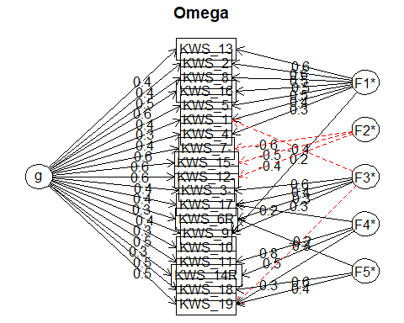
## Omega
## Call: omegah(m = m, nfactors = nfactors, fm = fm, key = key, flip = flip,
## digits = digits, title = title, sl = sl, labels = labels,
## plot = plot, n.obs = n.obs, rotate = rotate, Phi = Phi, option = option,
## covar = covar)
## Alpha: 0.87
## G.6: 0.9
## Omega Hierarchical: 0.62
## Omega H asymptotic: 0.68
## Omega Total 0.91
##
## Schmid Leiman Factor loadings greater than 0.2
## g F1* F2* F3* F4* F5* h2 u2 p2
## KWS_1 0.31 0.45 -0.35 0.41 0.59 0.22
## KWS_2 0.44 0.56 0.53 0.47 0.36
## KWS_3- 0.41 0.63 0.61 0.39 0.28
## KWS_4 0.45 0.28 0.34 0.66 0.59
## KWS_5 0.38 0.45 0.37 0.63 0.40
## KWS_6R 0.26 0.34 0.29 0.29 0.71 0.22
## KWS_7- 0.59 -0.60 0.72 0.28 0.49
## KWS_8 0.45 0.52 0.49 0.51 0.42
## KWS_9 0.38 0.24 0.27 0.32 0.68 0.46
## KWS_10 0.26 0.15 0.85 0.46
## KWS_11 0.50 0.76 0.84 0.16 0.30
## KWS_12- 0.65 -0.42 0.65 0.35 0.65
## KWS_13 0.45 0.61 0.61 0.39 0.33
## KWS_14R 0.27 0.50 0.37 0.63 0.20
## KWS_15- 0.59 -0.54 0.65 0.35 0.53
## KWS_16 0.57 0.47 0.61 0.39 0.53
## KWS_17 0.35 0.38 0.21 0.35 0.65 0.36
## KWS_18 0.47 0.60 0.58 0.42 0.38
## KWS_19 0.46 -0.23 0.30 0.38 0.53 0.47 0.41
##
## With Sums of squares of:
## g F1* F2* F3* F4* F5*
## 3.81 1.81 0.98 1.05 1.04 0.69
##
## general/max 2.11 max/min = 2.6
## mean percent general = 0.4 with sd = 0.13 and cv of 0.32
## Explained Common Variance of the general factor = 0.41
##
## The degrees of freedom are 86 and the fit is 0.54
## The number of observations was 219 with Chi Square = 112.82 with prob < 0.028
## The root mean square of the residuals is 0.03
## The df corrected root mean square of the residuals is 0.04
## RMSEA index = 0.037 and the 10 % confidence intervals are 0.013 0.056
## BIC = -350.64
##
## Compare this with the adequacy of just a general factor and no group factors
## The degrees of freedom for just the general factor are 152 and the fit is 2.94
## The number of observations was 219 with Chi Square = 618.91 with prob < 1.3e-57
## The root mean square of the residuals is 0.13
## The df corrected root mean square of the residuals is 0.14
##
## RMSEA index = 0.118 and the 10 % confidence intervals are 0.109 0.129
## BIC = -200.23
##
## Measures of factor score adequacy
## g F1* F2* F3* F4* F5*
## Correlation of scores with factors 0.81 0.81 0.73 0.82 0.85 0.72
## Multiple R square of scores with factors 0.66 0.65 0.53 0.67 0.72 0.52
## Minimum correlation of factor score estimates 0.32 0.31 0.06 0.33 0.44 0.04
##
## Total, General and Subset omega for each subset
## g F1* F2* F3* F4* F5*
## Omega total for total scores and subscales 0.91 0.84 0.84 0.59 0.73 0.63
## Omega general for total scores and subscales 0.62 0.38 0.49 0.27 0.20 0.30
## Omega group for total scores and subscales 0.18 0.46 0.36 0.32 0.53 0.33
##
## f1 f2 f3 f4 f5
## KWS_1 0.380* 0.655* .
## KWS_2 0.776* .
## KWS_3 0.609* 0.343* .
## KWS_4 . 0.378* . .
## KWS_5 0.648* .
## KWS_6R -0.310* . 0.301*
## KWS_7 . 0.929*
## KWS_8 0.704* . .
## KWS_9 .* .* -0.311*
## KWS_10 . .*
## KWS_11 1.109* 0.301
## KWS_12 . . 0.613*
## KWS_13 . 0.802* .
## KWS_14R . . 0.632*
## KWS_15 . 0.824*
## KWS_16 . 0.643* .
## KWS_17 -0.365* . .
## KWS_18 . 0.788*
## KWS_19 .* 0.448* 0.368*
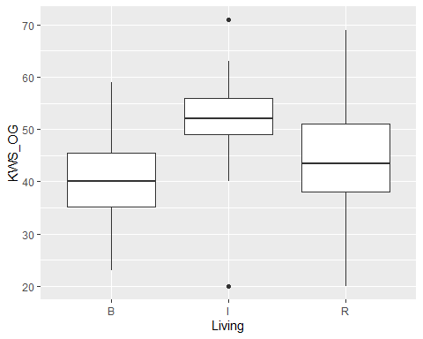
## Analysis of Variance Table
##
## Response: KWS_OG
## Df Sum Sq Mean Sq F value Pr(>F)
## Living 2 754.9 377.45 4.0047 0.0196 *
## Residuals 216 20358.3 94.25
## ---
## Signif. codes: 0 '***' 0.001 '**' 0.01 '*' 0.05 '.' 0.1 ' ' 1
## Tukey multiple comparisons of means
## 95% family-wise confidence level
##
## Fit: aov(formula = (lm(KWS_OG ~ Living, data = df2)))
##
## $Living
## diff lwr upr p adj
## I-B 10.021368 1.1604440 18.882291 0.0222091
## R-B 4.261706 -0.5385786 9.061990 0.0931948
## R-I -5.759662 -13.5813660 2.062042 0.1935316
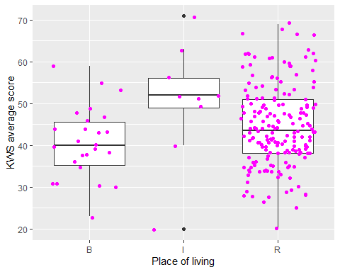
## Analysis of Variance Table
##
## Response: KWS_SS
## Df Sum Sq Mean Sq F value Pr(>F)
## Living 2 51.38 25.6896 3.107 0.04674 *
## Residuals 216 1785.94 8.2682
## ---
## Signif. codes: 0 '***' 0.001 '**' 0.01 '*' 0.05 '.' 0.1 ' ' 1
## Tukey multiple comparisons of means
## 95% family-wise confidence level
##
## Fit: aov(formula = (lm(KWS_SS ~ Living, data = df2)))
##
## $Living
## diff lwr upr p adj
## I-B 2.0598291 -0.564639137 4.684297 0.1553074
## R-B 1.4142977 -0.007472134 2.836067 0.0515577
## R-I -0.6455314 -2.962198917 1.671136 0.7882531
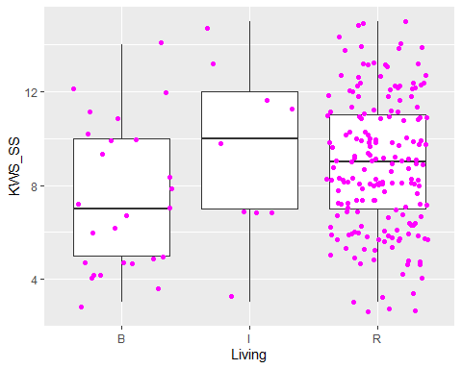
## Analysis of Variance Table
##
## Response: KWS_WOD
## Df Sum Sq Mean Sq F value Pr(>F)
## Living 2 123.5 61.757 3.2211 0.04184 *
## Residuals 216 4141.3 19.173
## ---
## Signif. codes: 0 '***' 0.001 '**' 0.01 '*' 0.05 '.' 0.1 ' ' 1
## Tukey multiple comparisons of means
## 95% family-wise confidence level
##
## Fit: aov(formula = (lm(KWS_WOD ~ Living, data = df2)))
##
## $Living
## diff lwr upr p adj
## I-B 4.282051 0.2855977 8.2785048 0.0324704
## R-B 1.278428 -0.8865960 3.4434522 0.3460549
## R-I -3.003623 -6.5313680 0.5241216 0.1123756
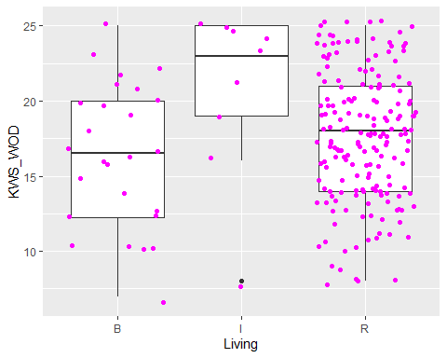
## Analysis of Variance Table
##
## Response: KWS_JZ
## Df Sum Sq Mean Sq F value Pr(>F)
## Living 2 141.81 70.905 6.32 0.002151 **
## Residuals 216 2423.35 11.219
## ---
## Signif. codes: 0 '***' 0.001 '**' 0.01 '*' 0.05 '.' 0.1 ' ' 1
## Tukey multiple comparisons of means
## 95% family-wise confidence level
##
## Fit: aov(formula = (lm(KWS_JZ ~ Living, data = df2)))
##
## $Living
## diff lwr upr p adj
## I-B -4.435897 -7.493044815 -1.37875006 0.0021218
## R-B -1.731187 -3.387355120 -0.07501946 0.0381497
## R-I 2.704710 0.006108563 5.40331173 0.0493414
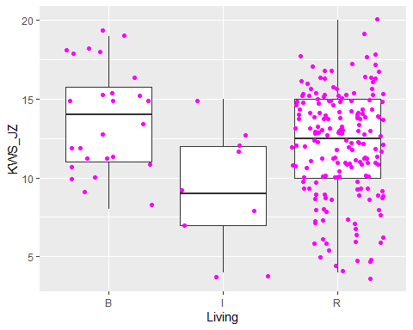
## Analysis of Variance Table
##
## Response: KWS_W
## Df Sum Sq Mean Sq F value Pr(>F)
## Living 2 32.34 16.170 1.3368 0.2649
## Residuals 216 2612.77 12.096
## Tukey multiple comparisons of means
## 95% family-wise confidence level
##
## Fit: aov(formula = (lm(KWS_W ~ Living, data = df2)))
##
## $Living
## diff lwr upr p adj
## I-B 2.0940171 -1.080360 5.268395 0.2667425
## R-B 0.8591137 -0.860562 2.578789 0.4669838
## R-I -1.2349034 -4.036986 1.567180 0.5524398
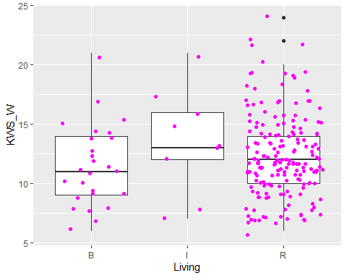
## Analysis of Variance Table
##
## Response: KWS_CYN
## Df Sum Sq Mean Sq F value Pr(>F)
## Living 2 19.49 9.7455 2.2737 0.1054
## Residuals 216 925.83 4.2863
## Tukey multiple comparisons of means
## 95% family-wise confidence level
##
## Fit: aov(formula = (lm(KWS_CYN ~ Living, data = df2)))
##
## $Living
## diff lwr upr p adj
## I-B 1.5854701 -0.3041511 3.4750913 0.1195719
## R-B 0.7098662 -0.3138102 1.7335427 0.2325511
## R-I -0.8756039 -2.5436081 0.7924004 0.4316312
