# Introduction

Whist **Resumer 3D** is compatible with most of the FDM Prusa style 3D printers currently available, we obviously can’t test it with every individual printer. If you find that it doesn’t work properly with your particular printing setup, or if you discover any other issues with either the hardware or the software, then please get in touch with us. You can reach us at [Eryone3d@gmail.com](mailto:Eryone3d@gmail.com) – we’ll do our best to get back to you within 24 hours, then we can work together to sort everything out.

**Resumer 3D** currently only works with files printed from the SD/TF card in your 3D printer. At the moment it’s not compatible with printing files directly from your computer.

The G-code file must be stored in the root directory of the SD/TF on your printer. It cannot be in a separate folder, as **Resumer 3D** will not be able to access the file.

# Initial Setup

Before you can connect your **Resumer 3D** module to your printer, you need to set the baud rate for its USB connection to your printer. **The module baud rate must exactly match the baud rate on your 3D printer.** You can easily find your printer baud rate in the settings of any software that you currently use, or in your printer instruction manual.

This process is very straightforward, and only needs to be done once. You can either configure the **Resumer 3D** module using our **BoxTool** software (compatible with Windows 7, 8, and 10) or manually using G-Codes from the terminal in your existing Windows, Mac or Linux based printer software (such as Repetier-Host).

**Do not plug your Resumer 3D into your printer before you complete the Initial Setup.**

**To use our Windows software, you will need to download the drivers and software from:**

[**https://github.com/Resumer3d/info**](https://github.com/Resumer3d/info)

2.1 Initial Setup using BoxTool from a Windows computer

Before you start, download both the latest **CP2102 Windows Driver** and the **BoxTool** package from <https://github.com/Resumer3d/info> and extract the zip files to your computer. The **CP2102 Driver** is fully 32/64 bit compatible and **BoxTool** is compatible with Windows 7, 8 and 10.

1. Connect your **Resumer 3D** to your computer using the micro USB cable provided (Do not connect it to your printer yet). You will be prompted for the driver package that you downloaded earlier as Windows connects to the **Resumer 3D**.
2. Once you have installed the Windows drivers, leave your **Resumer 3D** connected to your computer and run **BoxTool**. You should see this screen:  
     
    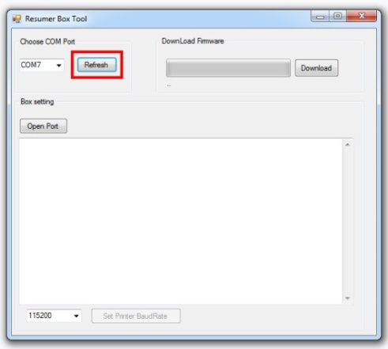
3. Click the **Refresh** button to automatically detect the com port that **Resumer 3D** is using to connect to your computer. In this example it is using “COM7”.  
     
    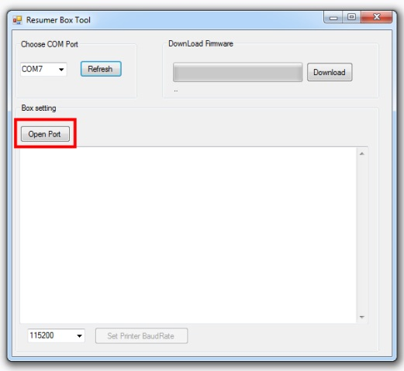 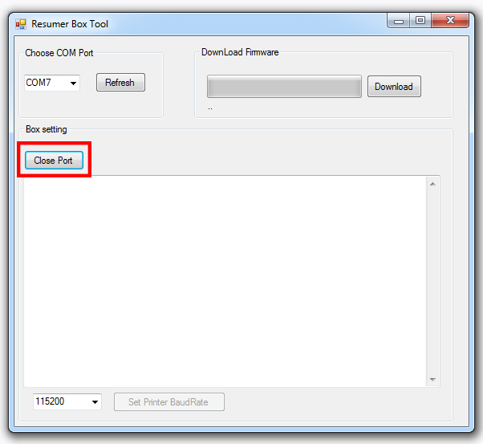  
     
   Now click the **Open Port** button.   
     
   Please note that as soon as BoxTool connects to your **Resumer 3D** and the port becomes active, the **Open Port** button will change to a **Close Port** button.
4. We now need to set the Resumer 3D module baud rate so that it matches your 3D Printer baud rate. In this example, we are using a baud rate of “115200” although yours may be different.  
     
    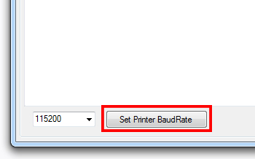
5. Click the **Set Printer BaudRate** button to configure the baud rate on your **Resumer 3D**
6. When the baud rate has been set successfully, you will see a message similar to this:  
     
    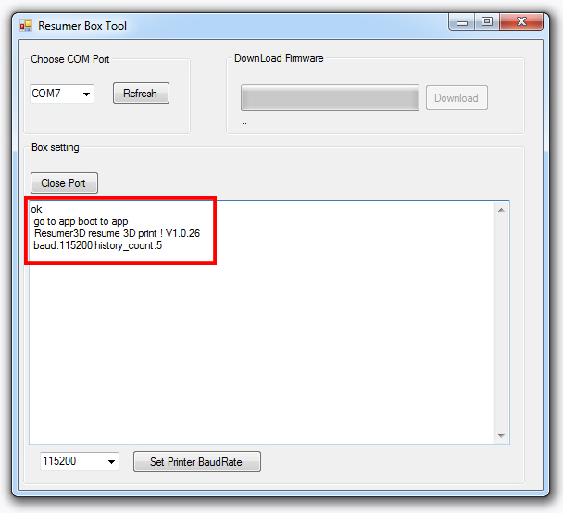
7. You can now click the **Close Port** button, close **BoxTool** and disconnect your **Resumer 3D** from your computer

You are now ready to connect the Resumer 3D to your printer.

2.2 Initial Setup using G-Codes and standard printer software

If you already have your printer connected to your Windows, Mac or Linux computer using standard printing software, such as Repetier-Host, you can easily complete the Initial Setup manually using your existing software. The only thing that you will need is the 3D printer baud rate setting from your existing software settings, or from the printer instruction manual (common baud rate settings are 115200, 250000, or 256000).

1. Connect your 3D printer to your computer as normal and launch your printer software.
2. Open the printer “Terminal” in your software.
3. Enter a G-Code into the terminal to test your connection with your printer.  
   e.g. G28 – which will auto-home your printer  
     
   **G28** and press the return key
4. Check that your printer runs its auto-home routine, or responds to your command
5. Without changing anything else, unplug the 3D printer USB cable from your computer. In its place, connect your **Resumer 3D** **to the same USB socket on your computer** via the micro USB cable that came with your **Resumer 3D**.
6. Enter M5000 followed by the baud rate into the terminal and press the return key.   
   e.g. to set a baud rate of 115200, enter this command:  
     
   **M5000 115200** and press the return key

The terminal screen will display a message similar to this to confirm that you have successfully completed the Initial Setup:  
  
   
  
  
 You are now ready to connect the Resumer 3D to your printer.

# Connecting your printer to your Resumer 3D for the first time

Once you have completed the Initial Setup and set the baud rate on your **Resumer 3D**, you can finally plug it in to your 3D printer. Disconnect your **Resumer 3D** from your PC, make sure that your 3D printer is powered off, then connect it to your **Resumer 3D** via the USB cable.

As your **Resumer 3D** is powered from the 3D printer USB port, it will automatically power on when your printer does. Please note that a small number of 3D printers have been found to not provide enough power to run the **Resumer 3D** properly. In this case, you can use an external power supply (not provided) to power your **Resumer 3D** via the micro USB cable.

Once your **Resumer 3D** is connected, power on your 3D printer. If nothing lights up on your **Resumer 3D** when the 3D printer is powered up, a separate external power supply will be needed to power it via the micro USB cable. It is important to remember that your **Resumer 3D** must remain connected to the 3D printer while it is printing.

If your **Resumer 3D** lights up when your 3D printer powers on, this shows that it has passed its internal diagnostics and that your 3D printer is providing sufficient power for it to run properly. We can now test the communications between your **Resumer 3D** and your 3D printer.

# The lights in your multifunction OK button

Glowing **Blue** – permanently on

* Your **Resumer 3D** has connected to your 3D printer successfully.

Glowing **Blue** – flashing quickly

* Your **Resumer 3D** cannot communicate with your 3D printer properly. If this continues for longer than 20 seconds, please check that the baud rate setting on your **Resumer 3D** exactly matches the setting on your 3D printer.

Glowing **Blue** – flashing slowly

* Your 3D printer is printing, Resumer 3D is working properly and it’s recording data.

Glowing **Red** – permanently on

* The printer has stopped and there is live print data that can be resumed.

# Resuming a print after a power outage

If your print is stopped by a power outage, or if you interrupt the printing process intentionally, the multifunction **OK** button will glow **Red**. Press the multifunction **OK** button once, and your print will resume automatically from the point that it stopped.

# Resuming a print from a specified Z-axis height

If your print has failed because of a nozzle jam or tangled filament, you may need to adjust the Z-axis height. Resumer 3D can resume printing from any height that you specify. You can select the Z-axis height either by using the **+** and **–** buttons on your **Resumer 3D** or by using the controls built into your 3D printer.

# Resume from any printed layer

7.1 Adjusting the Z-axis height using the + and – buttons

When the **+** and **–** buttons are glowing, this indicates that the height of the Z-axis is adjustable.

* The **+** button will increase the Z-axis height by 0.2mm on each press.
* The **–** button will decrease the Z-axis height by 0.2mm on each press.

When you have moved the Z-axis to your desired height, press the multifunction **OK** button once. **Resumer 3D** will then resume printing from the height that you set.

7.2 Adjusting the Z-axis height using the 3D printer controls

You can also easily adjust Z-axis height using the control knob on your 3D printer. Different printers have different approaches to doing this. If you are uncertain how to do this on your setup then please refer to your 3D printer user manual.

**Note**: If your firmware is Marlin 1.1.0 or above, you will have to home X Y Z first, then adjust your Z-axis height using the control knob on your 3D printer. You should **not** use the **+** and **–** buttons on your **Resumer 3D**. This is because the behaviour of the **G92** G-code command has been changed in recent Marlin releases.

You can easily revert the behavior of the **G92** G-code command in your copy of Marlin 1.1.0 or above back to its old Marlin 1.0 behavior. Just enable “NO_WORKSPACE_OFFSETS” in Configuration_adv.h and recompile/reupload your 3D printer firmware.

# Clearing the memory on your Resumer 3D

If a print is stopped or interrupted and you do not want to resume it, you can clear the memory on your **Resumer 3D**. This will delete any G-code from your **Resumer 3D**, but will not erase the original file from the SD/TF card in your 3D printer.

You clear the memory by pressing and holding both the **+** and **–** buttons down at the same time, then whilst holding both the buttons down, pressing the multifunction **OK** button once. The multifunction **OK** button will change from glowing **Red** to glowing **Blue**, which indicates that you have successfully cleared the memory on your **Resumer 3D**.

# Filament detector connection

IN：signal input interface of filament detector, active low, internal pull up resistors，the input voltage should be less than 3.3V

5V：5V out put

GND：Ground

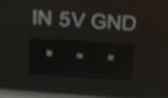

Wire connection: please only connect “IN” pin and “GND”pin to your filament detector. Note: Leave 5V pin alone.

# Octprint connection

Octprint connection and setting will come later.