Guide for Resurs Banks WooCommerce-plugin

The main page for settings for the Resurs Bank plugin.

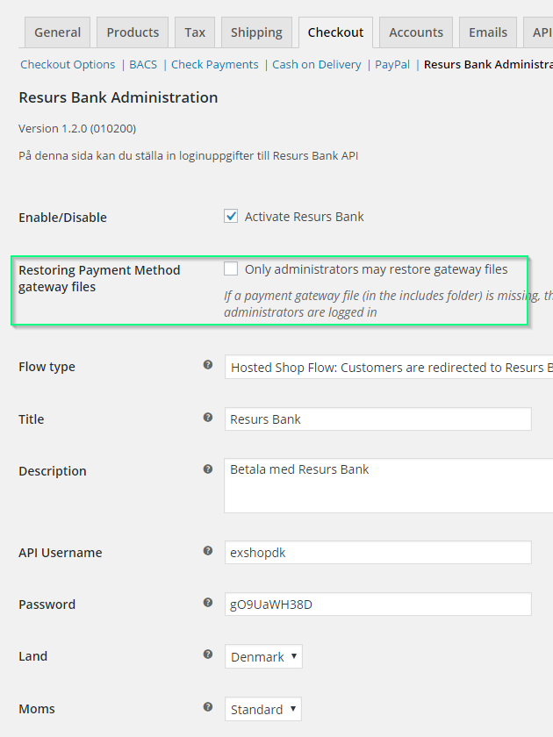

At this page everything is mandatory except for the two parameters marked with green that are optional.

In the fields for API Usernamne and Password you enter the service login from Resurs Bank.

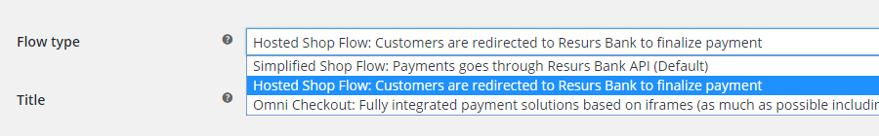

Select a flow type.

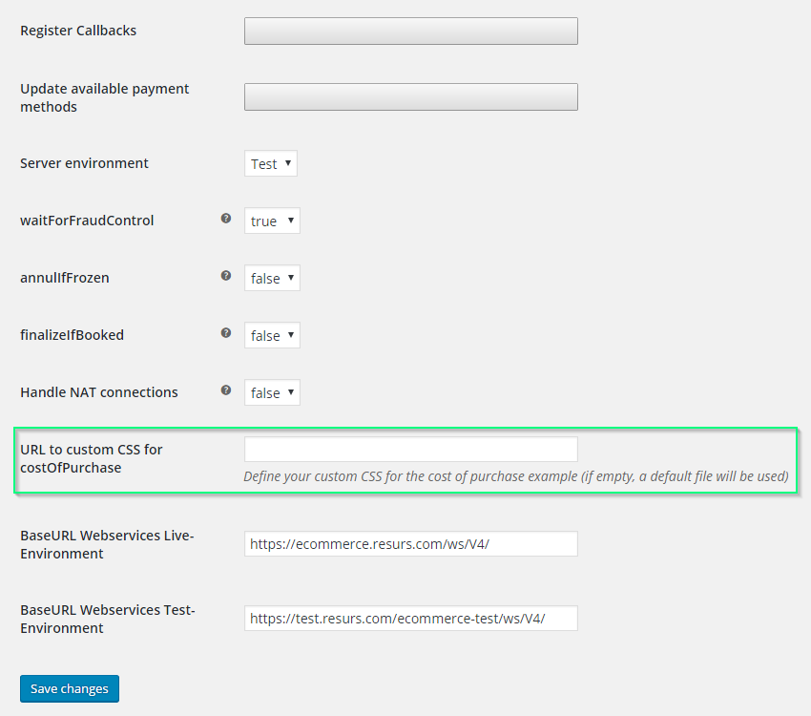

The two gray rectangels at “Register Callbacks” and “Update available payment methods” are actually buttons.

You have to save the changes also after you have invoked the registration of callbacks and update of payment methods.

Each payment method must be enabled and saved

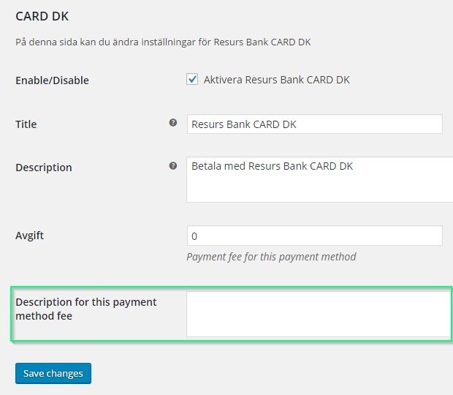

The fields are mandatory except for the one marked with green, which is optional.

The “Title” is what the customer will see as name for this payment method in the list of methods and “Description” is what the customer will see as a description when this method is selected.

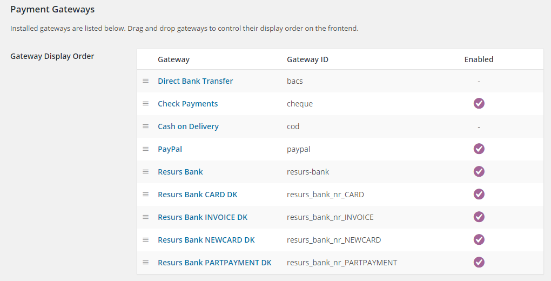

In the checkout options > payment gateways you can see a list of the methods and their status.