Homework:

Develop and Enhance 2D Game

|  |
| --- |
| Name:  Ret Raksmey  Tep Pisey |

Step 1: Create Canvas in unity

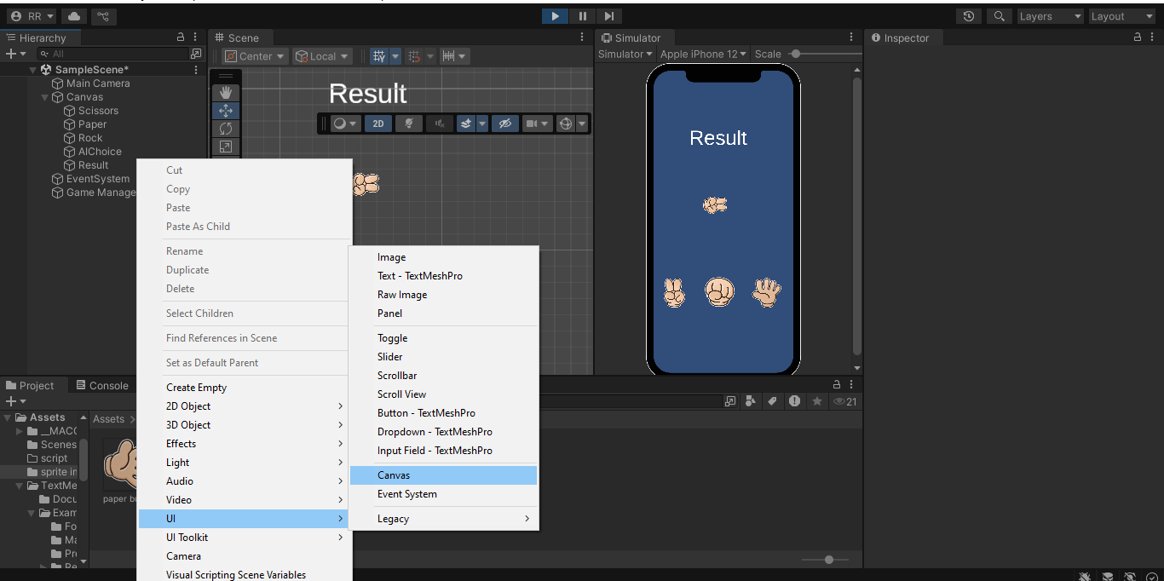Step 2: create image to take image rock scissor paper and AIChioce in unity

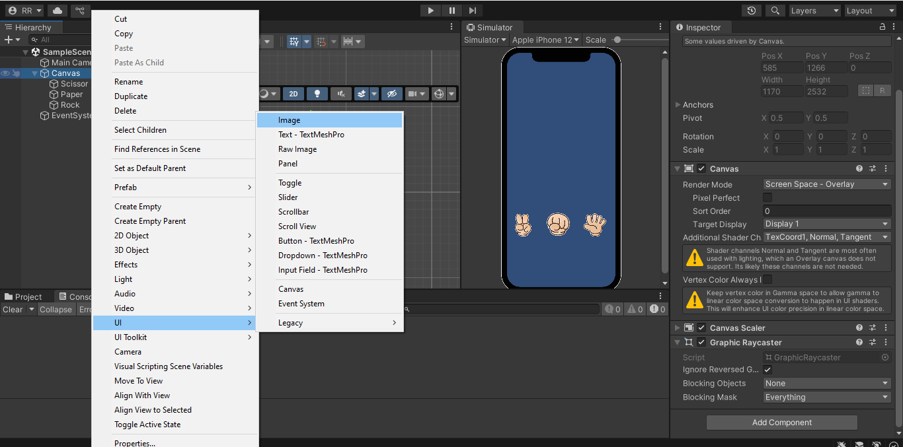Step 3: create text to display the results of game

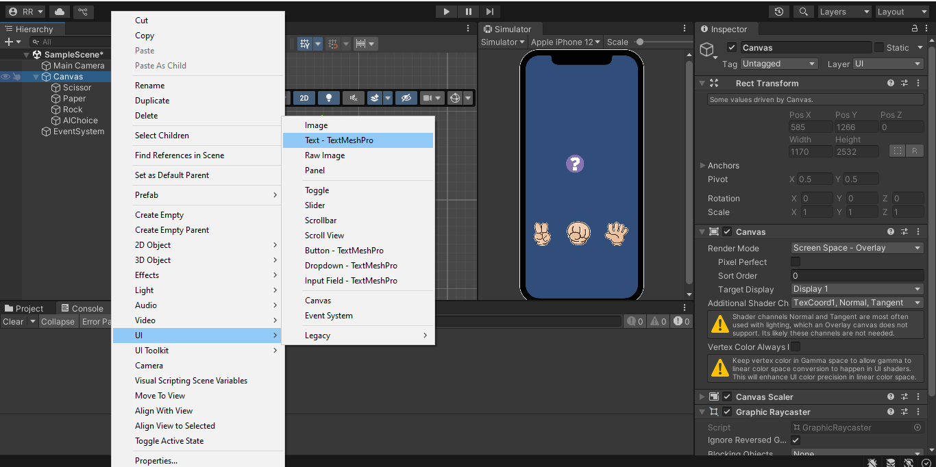Step 4: create game manager to connect file to file

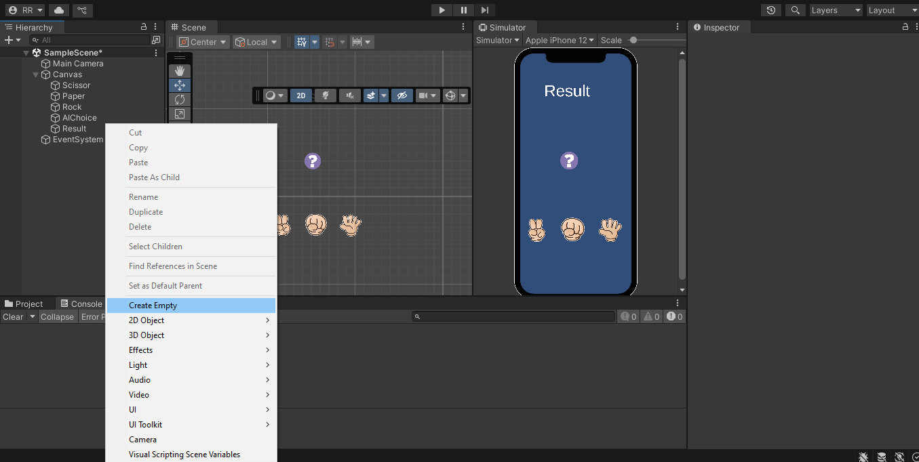Step 5: Create a script to write code for the game walk.

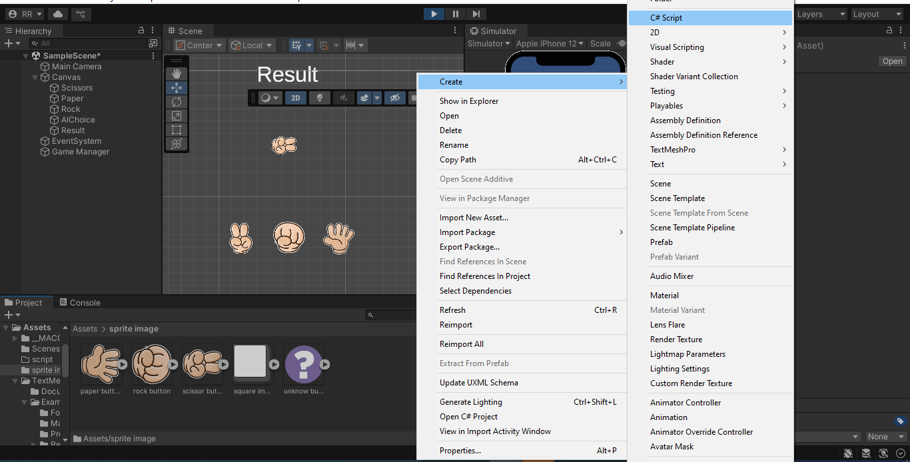Step 6: This is the code we write to execute the action that we want to display the results.

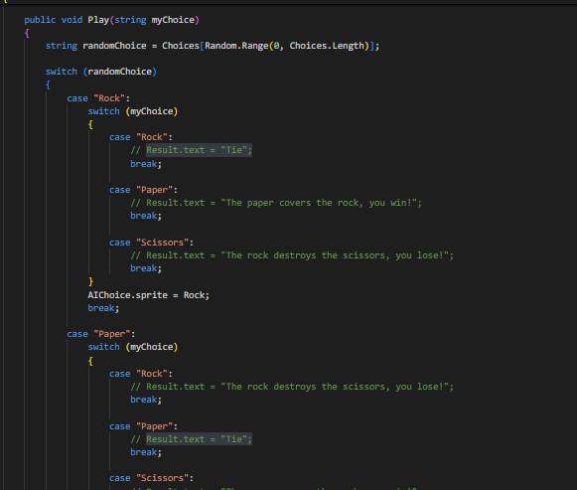

Step 7: We were at all file to input in Game Manager.

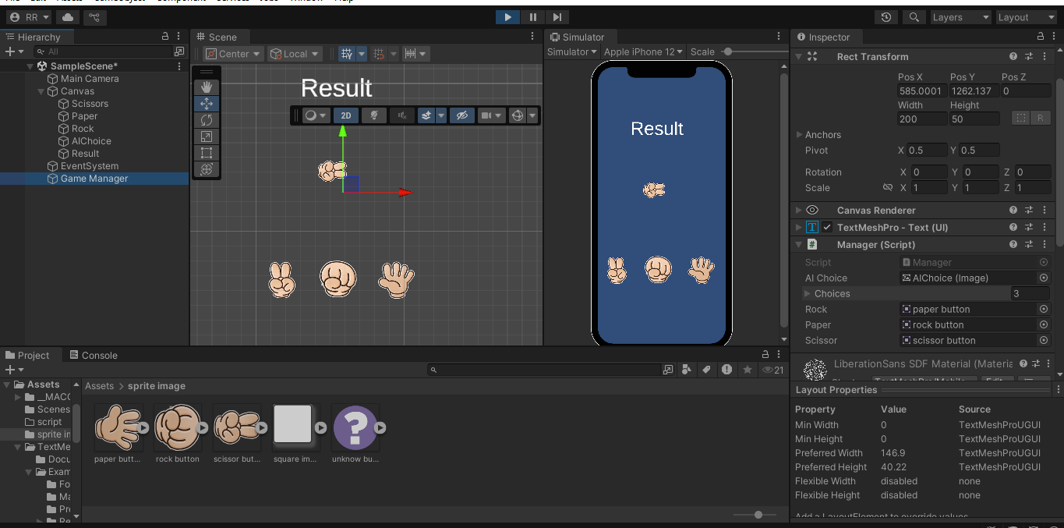Step: This is the result of game.

