**Step by Step Explanation of Application**

Before preceding you must have enabled internet in your phone and follow steps explained below

Step 1:

Install the APK from <https://github.com/RetailAugmentedReality/RetailAugmentedReality.github.io/tree/master/Android_APK>

Note: if you are unable to install go to settings -> security in your Phone Check unknown source is enabled or not if not, enable it and install it.

Step 2:

After installation Open the App and you get splash screen of the developer for a second and app will start

Please see below screen shot

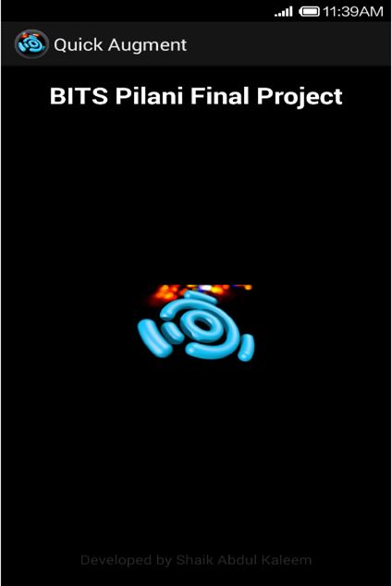

Step 2:

App will open with QR code reader, They are two sections of app one is just knowing about one product in Shop and other to know the list of items in shop and augment on top of it .

a) If you want to know only about specific product in the shop just scan the QR code of the Product as shown below:

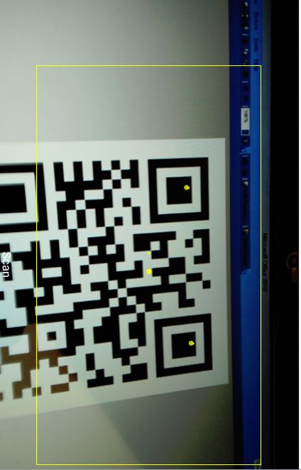

b) If you want to check what are the products in Shop just scan the shop QR code which is in front of shop you will get list of items as shown below screenshot:

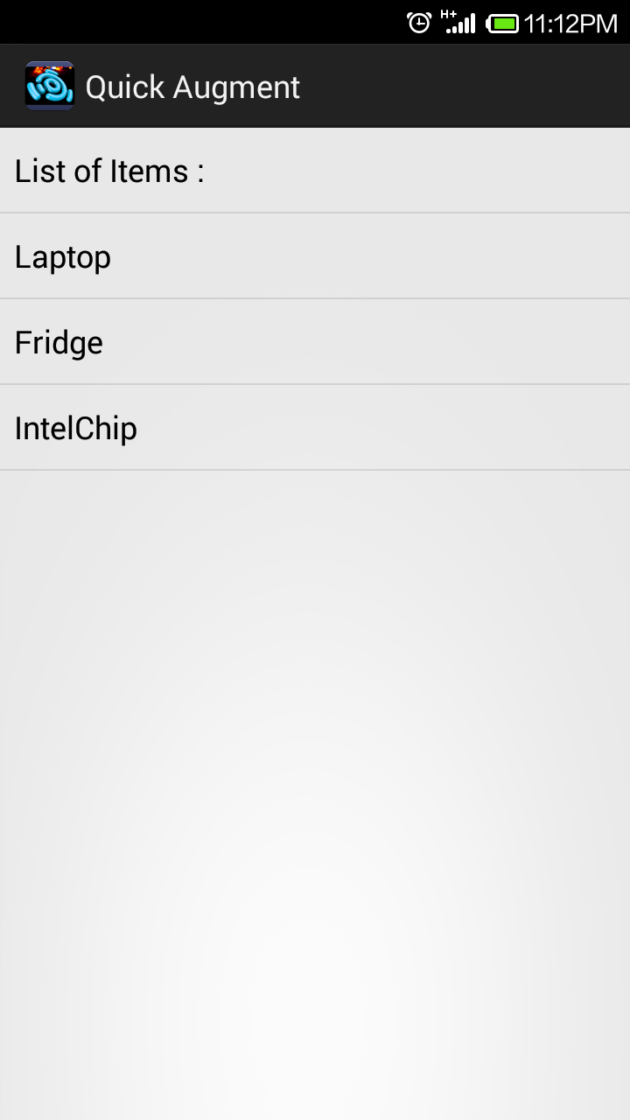

Step 3:

Sample example demo

If you are following Step 2 a) section then scan this code

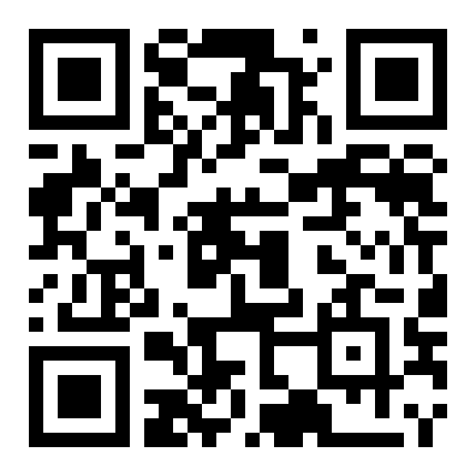

QR will be decoded and your Architect view will open (Camera will open) and see the below product (image) from camera

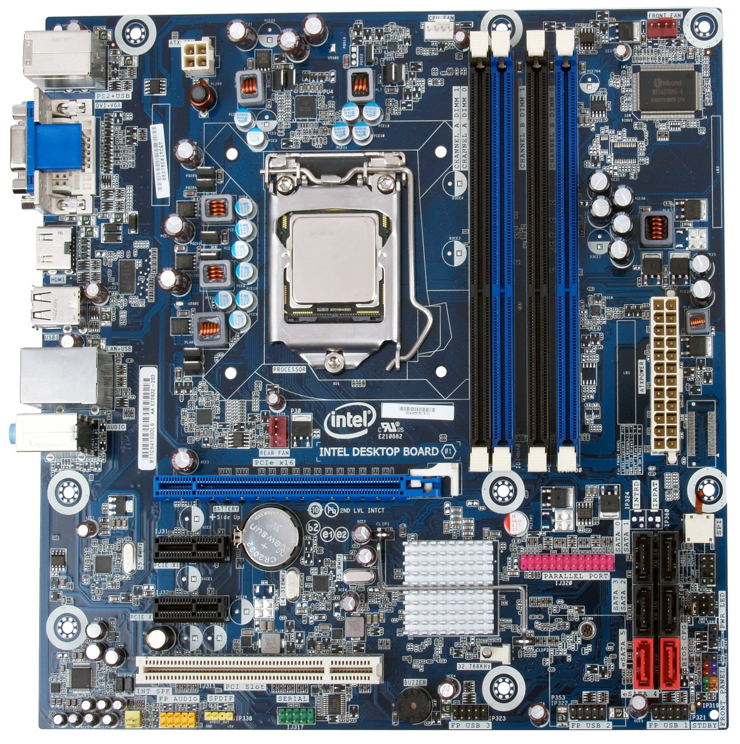

The App will start augmenting and will overlay on it.

The augment which is overlaid is intuitive you can click on it and get the relevant information then and there itself see below figure:

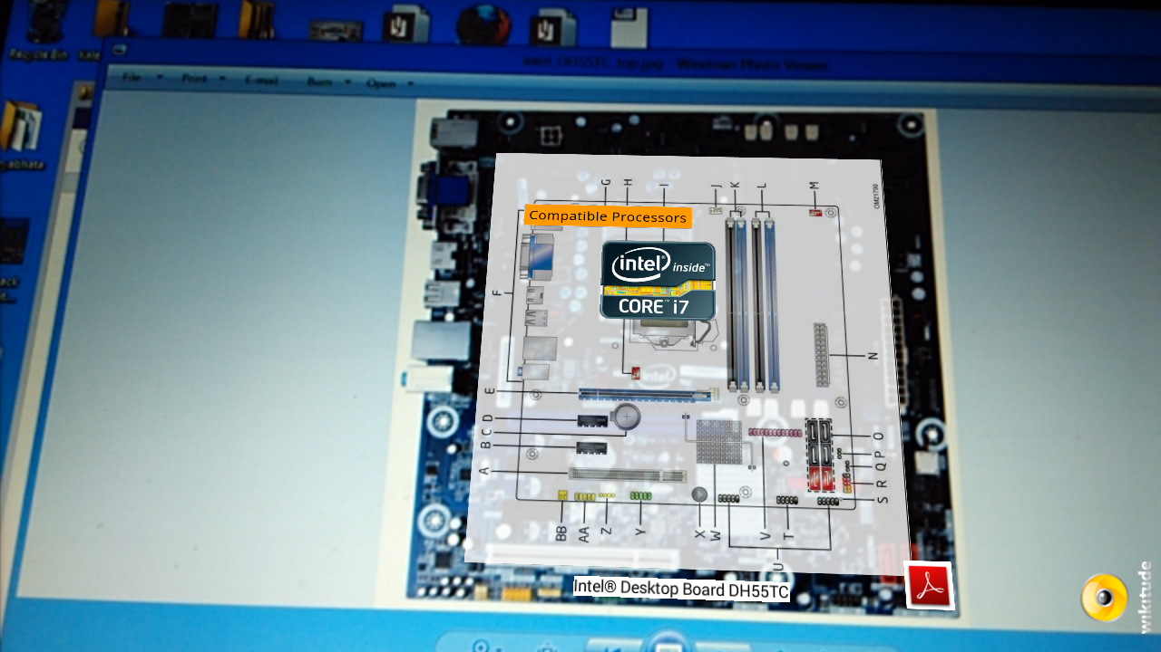

If you are following Step 2 b) section then scan this code

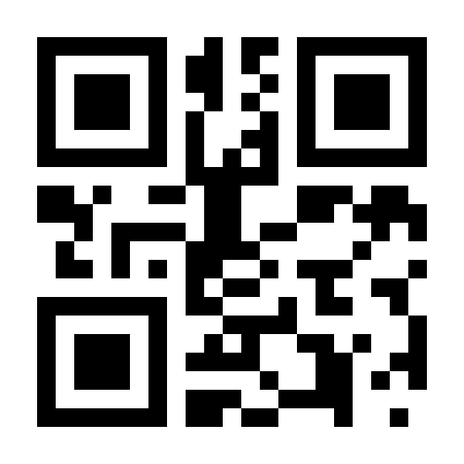

After scanning this code it will get you products list

See below screenshot will appear



Choose any one of them and see augmentation on it for example I selected laptop and it opens camera and see the laptop from camera

See on below image

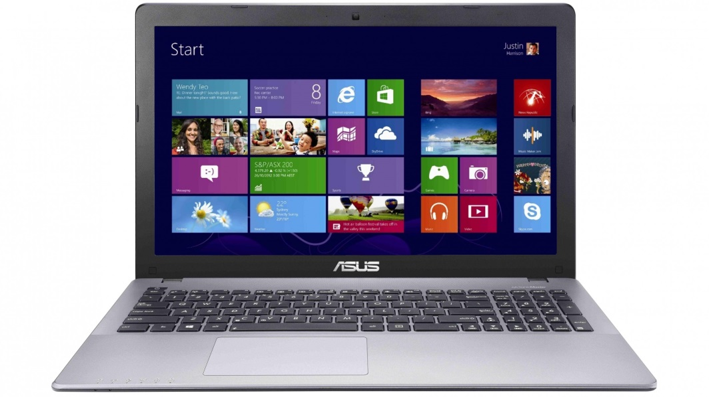

It will augment on laptop see below image

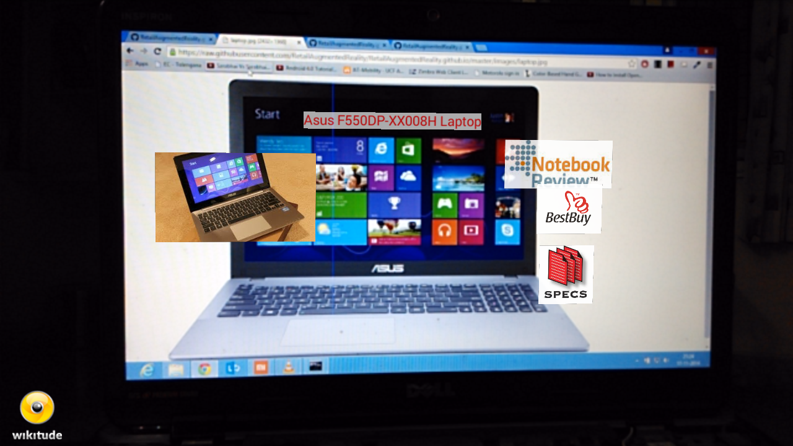

The augment will overlay on it and augment which is overlaid is intuitive you can click it and get the relevant information then and there itself

To experiment on other products in the list I have placed all data required for project in Github:

Please find below link to the project:

<https://github.com/RetailAugmentedReality/RetailAugmentedReality.github.io>