Relational Schema:
Publishers (publisher_ID:integer (PK), name:string, address:string, phone:integer)
Authors (author_ID:integer (PK), first_name:string, last_name:string)
Books (ISBN:integer (PK), title:string, publisher_ID:integer (FK to Publishers), publication_year:year, genre:string)
Book_Authors (ISBN:integer (FK to Books), author_ID:integer (FK to Authors)) Library_Branches (branch_ID:integer (PK), name:string, location:string) Book_Copies (book_copy_ID:integer (PK), ISBN:integer (FK to Books), branch_ID:integer (FK to Library_Branches), status:ENUM (“Available“, “On Loan”, “Reserved”))
Members (member_ID:integer (PK), first_name:string, last_name:string, email:string (UNIQUE), phone:integer, address:string, date_registered:date)
Loans (loan_ID:integer (PK), book_copy_ID:integer (FK to Book_Copies), member_ID:integer (FK to Members), issue_date:date, due_date:date, return_date:date (NULL if not returned), fine_amount:integer)
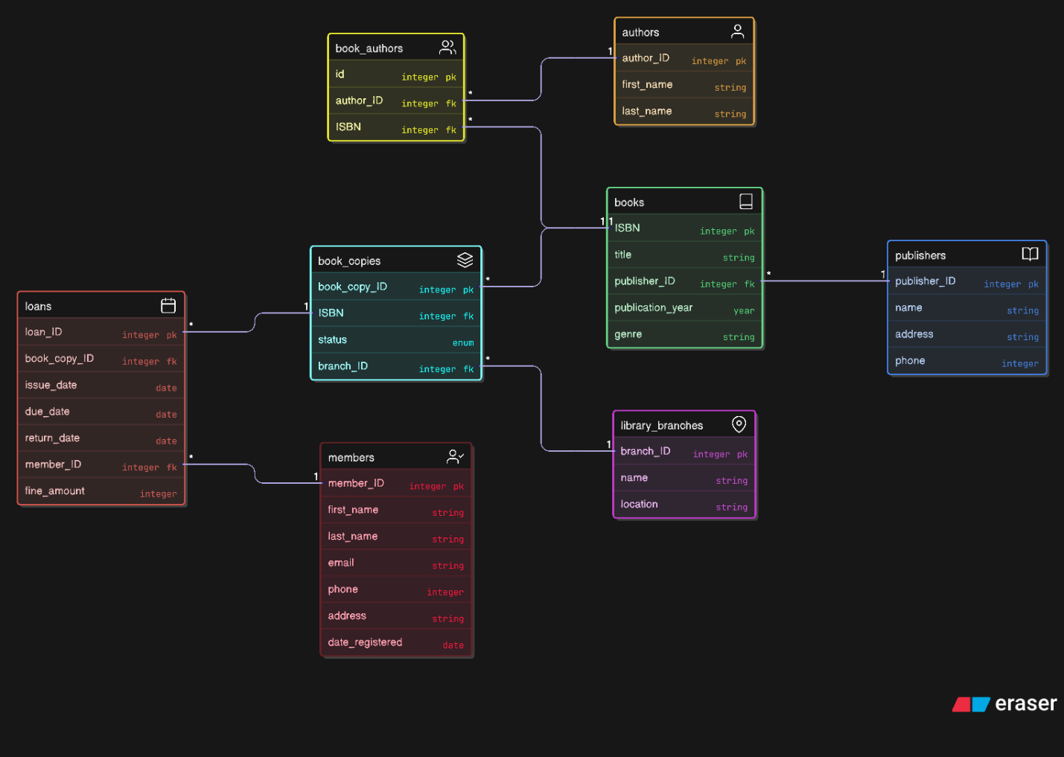
ER Diagram:
