
SmartBite
AI Recipe Maker

Mahmoud Samer | 231006523
Youssef Karim | 231014449
Rokaya Hamdy | 231006586
Youssef Mahmoud | 231006058
Retaj Ali | 231005689
Rawan Atef | 231005789

Introduction:

Smart Bite is an AI-driven recipe maker created to transform ordinary kitchen ingredients into practical, healthy meals. By combining a camera-based ingredient scanner with an intelligent recipe engine, it solves the everyday question: “What should I cook?”, Instead of guiding users on what to buy or offering professional dietary plans, Smart Bite focuses on a clear purpose of connecting the ingredients people already have to meals they can make.
This app is designed for students, busy professionals, families, and anyone short on time or cooking experience, Smart Bite reduces food waste, saves money, encourages healthier eating habits and simplifies decision-making by instantly turning available items into cost-effective, nutritious recipes.

Problem Statement:

Difficulty scaling recipe to available ingredients, limited cooking knowledge, food waste, high cost of eating out, time constraints on meal planning and growing need for health-conscious/nutrition-aware meals.

Project goals:

  - Provide users with instant, personalized recipes based on the ingredients they already have at home.
  - Reduce food waste by helping users utilize leftover or soon-to-expire items.
  - Promote healthier eating habits through nutritious, balanced meal suggestions.
  - Help users save money by encouraging the use of existing ingredients and reducing unnecessary purchases.

Stakeholders:
Stakeholder | Role | Interest
End users (Primary) | Users the Smart bite App | Reduce food waste, save money and have healthier diet
Investors | Provide funding for the project | Want growth, user engagement, and return on investment
Recipe database | Supply recipe information, nutritional data, and ingredient details | Provide various up-to-date recipes
Advertisers | Advertise and Generate revenue for the platform | Want high user traffic
AI Model | Processes ingredient input, Generates recipe suggestions, Provides smart recommendation | Need high quality data and continuous improvement

System Scope:
In-Scope:
- Ingredient input by users
- AI-generated recipe suggestions
- Internal recipe database access
- Displaying nutritional information
- User-friendly interface for browsing recipes
- Saving and sharing your favorite recipes
- Displaying advertisements to Users
- Optional subscription to remove ads
- Basic user accounts
Out-of-Scope:
  - Online grocery delivery or shopping services
  - Professional diet plans or medical nutrition advice
  - Cooking video tutorials
  - Real-time collaboration between users
  - Recipe creation by chefs within the app
  - Full e-commerce system beyond subscription for ads removal

Stakeholder Analysis Template:
Stakeholder | Type | Responsibilities | Needs | Power
End users (Primary) | Primary | Use the app to input ingredients, browse recipes, save favorites, manage subscriptions | Easy-to-use interface, quick recipe suggestions, healthy and cost-effective meals, ad-free option if subscribed | High interest, Medium power
Investors | Secondary | Provide funding, monitor project progress | Return on investment, app success and growth | High power, Medium interest
Recipe database | Secondary | Store and organize recipes, provide data to AI for suggestions | Clean, structured, and updated data for accurate recommendations | Medium power, High interest
Advertisers | Secondary | Display targeted ads to users, generate revenue | High user engagement, ad visibility | Medium power, Medium interest
AI Model | Secondary | Process user input, generate personalized recipe suggestions | Accurate and structured input data, access to recipe database | Medium power, Medium interest

Elicitation Plan Template:
Elicitation Objectives:
- Understand user needs
  - Identify what users want from a meal-planning app
  - Learn about cooking habits, ingredient availability, and time constraints
  - Understand users’ preferences for ads or ad-free options
- Identify core features
  - Determine essential functionalities like AI-generated recipes, internal recipe database, subscription for ad removal, saving favourite recipes
  - Decide on optional features like nutritional info display, recipe sharing
- Discover constraints
  - Find any technical, financial, or operational limits
  - Understand data availability and integration requirements
  - Identify device/platform limitations
Techniques Used:
- Interview
- Questionnaire
Stakeholders Involved:
- Primary: End users (students, families, working professionals, home cooks)
- Secondary: Investors, Recipe Database, Advertisers, AI Model
Output / Deliverables:
- A clear list of user requirements
- Prioritized core features for Smart Bite
- Identified constraints and limitations for development
- Recommendations for app design, AI model, and subscription system

Interview:
Interview Purpose: The purpose of this interview is to understand how users currently decide what to cook, how they use the ingredients available at home, and what problems they face with meal planning, food waste, and healthy eating, in order to define accurate functional and non-functional requirements for the SmartBite AI recipe maker application
Questions:
- How often do you feel stuck not knowing what to cook, even though you have ingredients at home?
- How important is it for you to see nutrition information (calories, protein, etc.) when choosing a recipe?
- How do you currently find recipes (for example: YouTube, Google, TikTok, cookbooks, family)? What do you like or dislike about these methods?
- Have you ever thrown away food because it expired or you did not know how to use it? How often does this happen?
- If an app could scan your ingredients and suggest recipes, what is the most important thing it should get right for you (speed, accuracy, difficulty level, health, cost, etc.)?
Closing Questions:
- Is there anything we missed?
Interview Notes:
Interviewee: Youssef Karim
Date: 26/10/2025
Notes:
Questions | Answer | Observation
How often do you feel stuck not knowing what to cook, even though you have ingredients at home? | “Almost every day, especially at night.” | Strong pain point; opportunity for daily-use feature.
How important is it for you to see nutrition information (calories, protein, etc.) when choosing a recipe? | "Important" | Nutrition is important but must be simple and clear.
How do you currently find recipes (for example: YouTube, Google, TikTok, cookbooks, family)? What do you like or dislike about these methods? | "Youtube, virtual, different languages” | User/customer is not sure how to decide
Have you ever thrown away food because it expired or you did not know how to use it? How often does this happen? | "Yes, Twice a month" | Confirms food-waste problem; supports requirement for using existing ingredients.
If an app could scan your ingredients and suggest recipes, what is the most important thing it should get right for you (speed, accuracy, difficulty level, health, cost, etc.)? | “Accuracy and speed” | The interviewee strongly prioritizes performance and reliability, indicating that SmartBite must respond quickly and detect ingredients accurately for them to trust and keep using the app.

Questionnaire:

Q1. How often do you use applications for cooking or recipe ideas?
• Daily
• Weekly
• Monthly
• Rarely
• Never

Q2. What type of recipes do you prefer the app to generate?
( ) Quick meals
( ) Healthy/low-calorie recipes
( ) Budget-friendly recipes
( ) International cuisines
( ) Desserts & sweets
( ) Vegan/vegetarian
( ) High-protein meals

Q3. How important are the following features?
Feature | Importance (1–5)
Personalized recipes based on ingredients |
Step-by-step cooking instructions |
Nutrition facts (calories, protein, etc.) |
Saving favourite recipes |
Video or image guides |
Shopping list generator |
Time-based filtering (e.g., 10-min meals) |

Q4. What is the main reason you would use a recipe-generation app?
( ) To save time
( ) To learn new dishes
( ) To eat healthier
( ) To manage ingredients at home
( ) For fun and creativity
( ) Other:

Q5. Which platforms do you prefer for using the app?
• Mobile (Phone)
• Tablet
• Laptop/Desktop
• All of the above

Q6. Would you like the app to adapt recipes to your dietary restrictions?
( ) Yes
( ) No
If yes, specify: ________________

Q7. How likely are you to use an AI-generated recipe?
1 – Not likely
2 – Slightly likely
3 – Neutral
4 – Likely
5 – Very likely

Use case list template:

ID | Use Case Name | Actor(s) | Description
UC-1 | Login | End User | Allows a registered user to securely access their personalized account and app features
UC-2 | Register | End User | Enables a new visitor to create an account by providing personal details and credentials
UC-3 | Access Camera and Gallery | End User | Allows users to capture or select an image from their device for uploading within the app
UC-4 | Logout and delete account | End User | Ends the user’s session and prevents further access to private features until they log in again and Permits users to permanently remove their account and associated data from the system.
UC-5 | Save, Share, Sort, and Filter recipes | End User | Allows users to manage recipe lists by saving, sharing, sorting, and filtering.
UC-6 | Have option to subscribe for removing ads | End User | Lets users pay for an ad-free experience and unlock premium usability.
UC-7 | Detect ingredients | AI Model | Automatically identifies ingredients from an uploaded photo or typed input.
UC-8 | Generate recipe according to input ingredients | AI Model | Suggests recipes based on ingredients the user has on hand.
UC-9 | Calculate calories and all details of the recipe | AI Model | Displays nutritional information and recipe statistics for user awareness.
UC-10 | Request ads | Advertisers | Allows advertisers to submit ad content and parameters for potential display within the app.
UC-11 | Receive approval | Advertisers | Enables the system or admin to review, approve, or reject ad submissions before publication.
UC-12 | Ads revenue | Advertisers | Tracks ad performance, calculates earnings, and manages revenue distribution.

Use case description:

Use case ID & Name: UC-1 Login
Primary Actor: End User
Secondary Actors: System, Database
Preconditions: The user already has an existing account
Postconditions: The user is logged in and can access their personalized features
Main flow:
- User opens the app
- Enter the email password
- System checks the credentials in the database
Alternative Flows / Exceptions:
A1. If the email or password is incorrect, an error message appears
A2. If the account is locked, the user is asked to reset their password

Use case ID & Name: UC-3 Access Camera and Gallery
Primary Actor: End User
Secondary Actors: Device
Preconditions: The user is logged in and has granted permission to access the camera or gallery
Postconditions: The selected or captured image is uploaded or available for us in the app
Main flow:
- User chooses to upload or capture an image
- System opens the camera or gallery
- User selects or takes a photo
Alternative Flows / Exceptions:
A1. If Permission not granted, system asks for camera or gallery access
A2. If upload fails, systems shows an error message

Use case ID & Name: UC-8 Generate recipe
Primary Actor: AI Model
Secondary Actors: End User
Preconditions: The user is logged in and entered the ingredients
Postconditions: The AI model generates a recipe based on the given ingredients
Main flow:
- User enters available ingredients
- User clicks “Generate Recipe”
- The AI model processes the input and shows recipe suggestions
Alternative Flows / Exceptions:
A1. If the input is incomplete, the system asks the user to add more ingredients
A2. If the AI model fails to generate, an error message appears

Use case diagram:

- Actors:
- End User
- AI Model
- Advertisers
- Use Cases:
- Login
- Register
- Access camera and gallery
- Logout and delete account
- Save, Share, Sort, and Filter recipes
- Have option to subscribe for removing ads
- Detect ingredients
- Generate recipe according to input ingredients
- Calculate calories and all details of the recipe
- Request ads
- Receive approval
Ads revenue
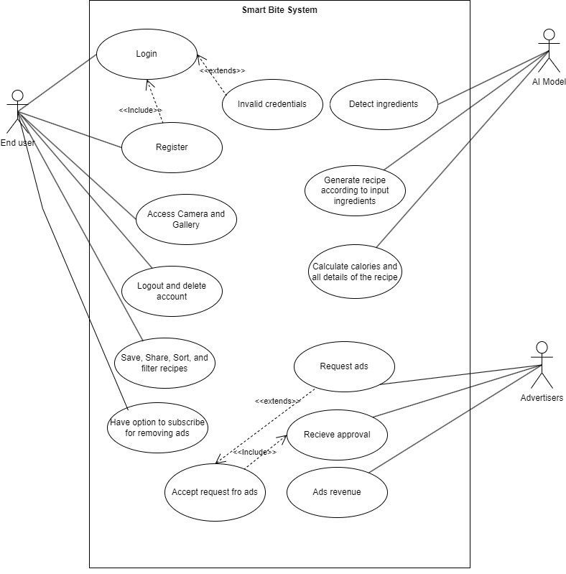

Domain Model / Class Diagram:
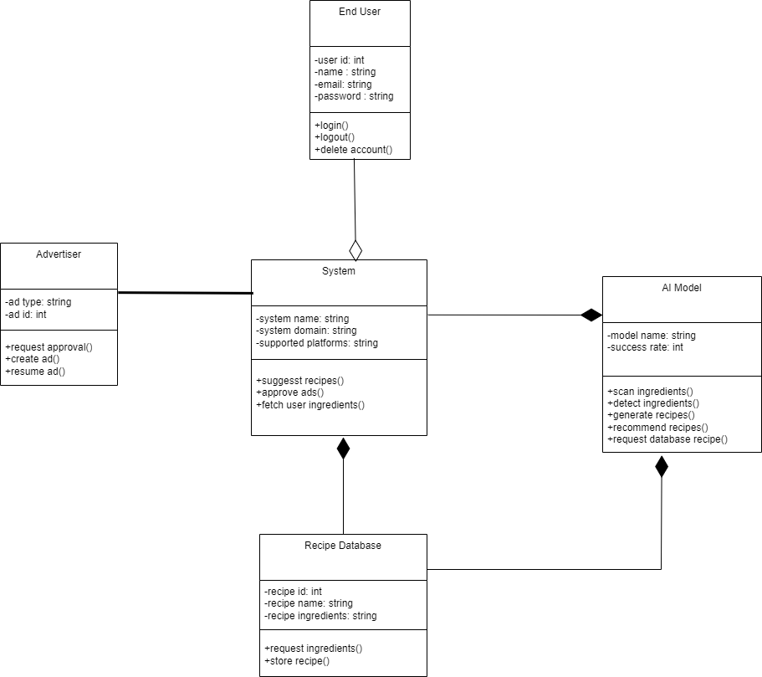

Functional Requirements:
ID | Description | Priority
FR-01 | The System should allow Users to Login or Register. | Medium
FR-02 | The System should allow Users to Logout or delete accounts. | Medium
FR-03 | The System should allow Users to edit on their accounts. | Medium
FR-04 | The System should ask Users to give access to the camera and gallery. | High
FR-05 | The AI photo scanner should detect ingredients. | High
FR-06 | The AI photo scanner should generate recipes. | High
FR-07 | The System should show detail of recipes. | Medium
FR-08 | The System should allow Users to share and filter. | Low
FR-09 | The Users have the option to subscribe to remove ads. | Medium
FR-10 | The admin should be able to monitor User activity and usages statistics and feedback. | High
FR-11 | The admin should be able to manage refunds requests, subscription and ads. | High

Non-Functional Requirements:
ID | Category | Requirement
NFR-01 | Performance | The AI photo scanner must scan photo within 10 seconds.
NFR-02 | Peformance | The AI recipe generation must be under 10 seconds.
NFR-03 | Security | Users Data must be encrypted.
NFR-04 | Security | Database must have encryptions.
NFR-05 | Security | The System must support 2FA.
NFR-06 | Reliability | The System should maintain an uptime of 98% per month.
NFR-07 | Reliability | If a critical service fails a backup service should be available within 60 seconds.
NFR-08 | Scalability | The System should be able to withstand 5000 Users at once.
NFR-09 | Usability | Interface must be consistent, Modern and easy to understand.
NFR-10 | Usability | Error messages must be clear.
NFR-11 | Usability | AI must be able to detect rotten ingredients
NFR-12 | Compatibility | The System must be available on android, IOS and Web.

Traceability Matrix Template (RTM):
Req ID | Source | Related Use Case | Design Element | Test Case
FR-06 | Questionnaire Q1 & Q3 (importance of personalized recipes) | UC-8 – Generate recipe based on ingredients | Recommendation Module | TC-01 – Verify app generates recipes from entered ingredients
FR-08 | Questionnaire Q3 (Saving favorite recipes) | UC-5 – Save, Share, Sort, and Filter recipes | Recipe Management Module | TC-02 – Verify user can save and view favorite recipes
FR-05 & FR-06 | Questionnaire Q6 (dietary restrictions) | UC-7 – Detect ingredients & UC-8 – Generate recipe | AI Personalization Engine | TC-03 – Verify recipes adapt to selected dietary restrictions
FR-07 | Questionnaire Q3 (Nutrition facts importance) | UC-9 – Calculate calories and recipe details | Nutrition Analysis Module | TC-04 – Verify nutritional information is calculated correctly

Change Request:

CR Number: CR-01
Requested By: SmartBite Team
Date: 02/12/2025
Description of Change: Update the recipe screen layout to make the ingredients and steps easier to read.
Reason for Change: Users mentioned in the questionnaire that step-by-step instructions and clear ingredient lists are important. Improving layout increases usability.
Impact Analysis:
• Affected Requirements:
- FR-1: Personalized recipe display
- FR-2: Recipe saving and viewing
• Affected Diagrams:
- UI mockups (only visual changes)
- No changes to use cases
• Risks:
- Minor delay in UI design updates
- No technical risks
Approved?
☐ Yes
☑ No
Updated SRS Version: Version 1.0.1

Diagrams:

Use Case



Class Diagram


Sequence Diagram

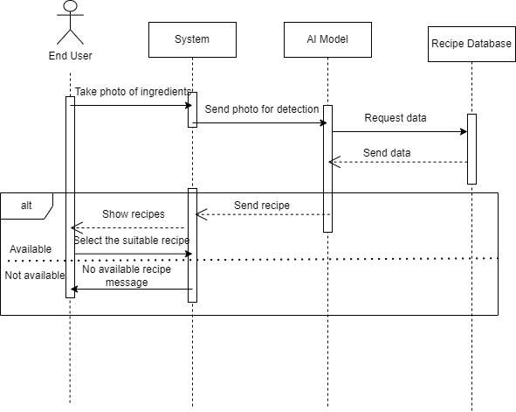
Activity Diagram

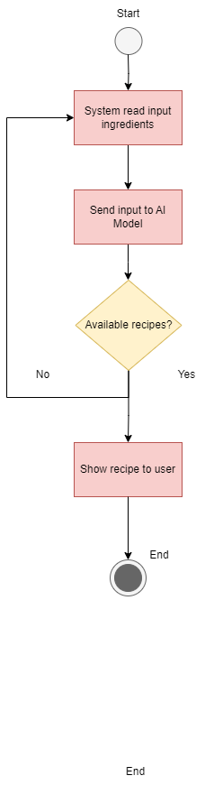

Context Diagram
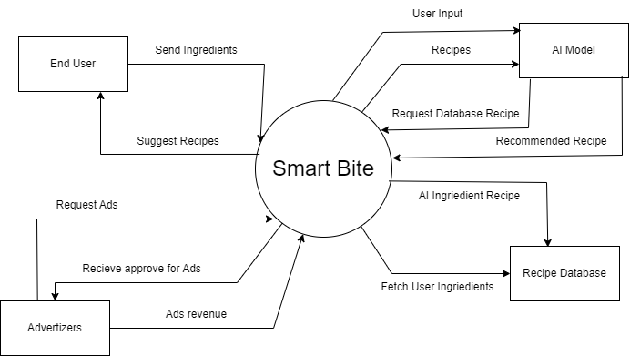

Feature Tree

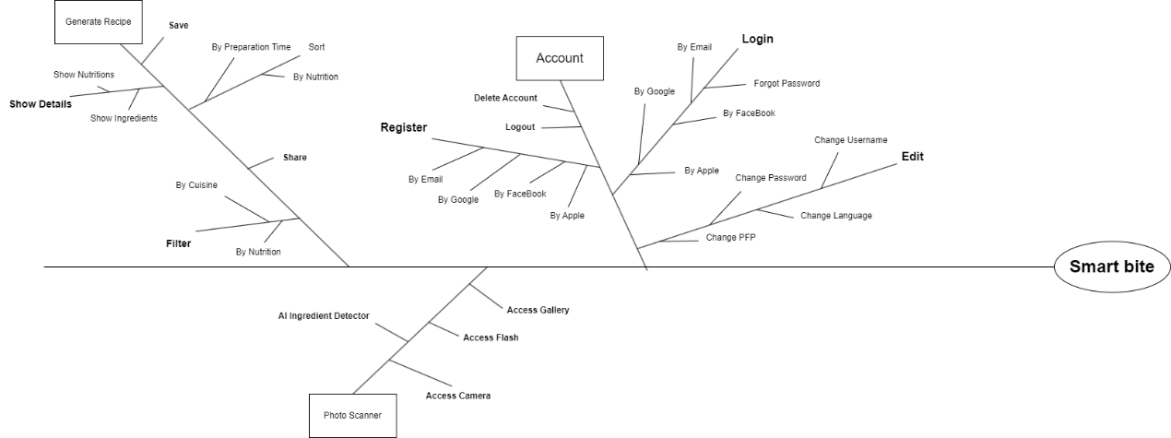

Success Metrics
