DBT ASSIGNMENT-4

1.) Write a select command that produces the order number, amount,and date for all rows in the order table?


2.) Write a query that produces all rows,from the customers table for which the salesperson’s number is 1001?


3.) Write a query that displays the salespeople table with the columns with the columns in the following order city,sname,snum,comm?

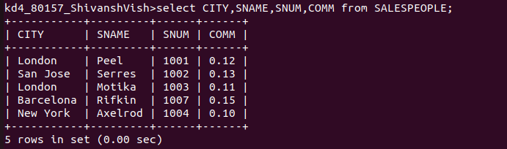
4.) Write a select command that produces the rating followed by the name of each customer in San Jose?
