DBT ASSIGNMENT-5

1.) Write a query that will give you all orders for more than rs.1000?


2.) Write a query that will give you the names and cities of all salespeople in London with a commission above .10?
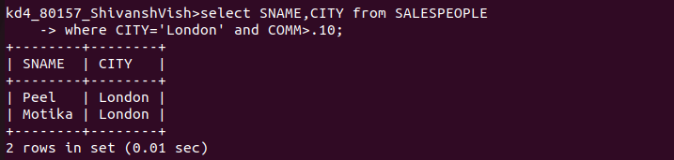

3.) Write a query on the customers table whose output will exclude all customers with a rating <= 100, unless they are located in Rome?

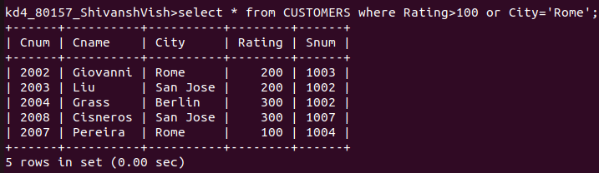

4.) What will be the output from the the following query?
Select *from orders where (amt<1000 OR NOT (odate = ‘1990-10-03’ AND cnum>2003));

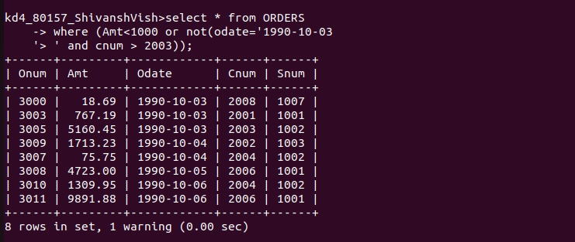
5) what will be the output of the following query?
select*from orders where NOT ((odate=’1990-10-03’ OR snum >1006 ) AND amt>= 1500);
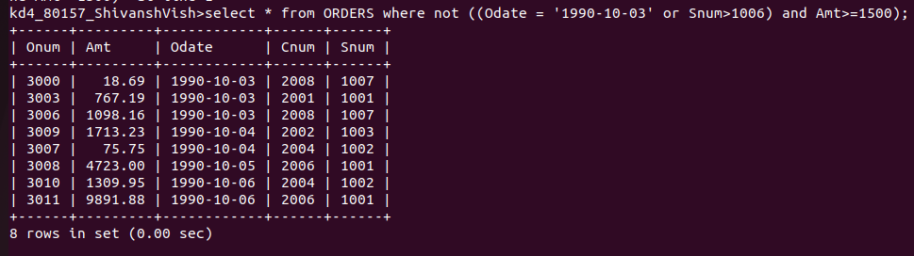
6) What is a simpler way to write this query select snum, sname,city,comm from salespeople where(comm>.12 OR comm<.14);



